Thursday 30 September 2021

Thursday 30 September 2021

Representation to Government
Spending Review 2021 Representation by London Councils

London Councils represents London’s 32 borough councils and the City of London. It is a cross party organisation that works on behalf of all its member authorities regardless of political persuasion.

Introduction

London Councils welcomes the opportunity to make a representation to the Government ahead of Spending Review 2021. We support the Government’s Levelling Up agenda: everyone, wherever they live, should have the chance to find a good job and progress in a career in their town, city or region. These proposals will support growth and prosperity across the UK as well as levelling up the inequalities within London. We welcome the commitment to work closely with local leaders.

London is the UK’s global city and, with Government support, can recover strongly from the pandemic. The economies of Britain’s cities, towns and regions are interdependent and a strong recovery in London will support economic recovery in the UK as a whole. Through the London Recovery Board, in partnership with the Mayor, London businesses and voluntary and community sector groups, we are already working to maximise the potential of key growth sectors. With the right funding, freedoms and flexibilities, the London boroughs can ensure a strong, green, inclusive recovery – for Global London as part of Global Britain.

The impact of the pandemic has been felt as hard in the capital as anywhere in the UK, with the highest number of Covid cases and highest death rate of any region. The challenges faced by people on low incomes, in insecure work, with fewer skills and qualifications are the same, wherever they live. Many of London’s communities share the same challenges as those in other towns and cities across the UK and live with some of the highest levels of deprivation in the country. These Spending Review proposals will help to level up inequalities within London.

The response to the pandemic has proven the value of local government to the economic and social fabric of communities across the country. London boroughs have been at the forefront of the response to both the public health and economic crises, coordinating the emergency response across the capital, supporting vulnerable residents and thousands of businesses through the last 18 months.

The Review comes during a period of prolonged uncertainty for local government funding, following two single year Spending Reviews and effectively three single year local government finance settlements in a row. A period of financial stability and certainty is now required.

Our priorities for the Spending Review reflect the Government’s: 1) Levelling up opportunity particularly for
young Londoners; 2) supporting a green recovery so London can drive lead the transition to Net Zero; 3)

unlocking housing through infrastructure as part of the plan for growth; 4) advancing Global Britain by supporting Global London; and 5) ensuring strong and innovative local public services. We realise the fiscal context is tight, but we urge Government to ensure London boroughs can help deliver these objectives.

This submission is set out in three sections.
- The first section sets out the case for investment in London to support the recovery.
- The second sets out the overall scale of the financial challenges facing London local government.
- The third outlines our priorities for delivering the strong and innovative local public services Londoners deserve over the next three years.

A. Investing in London’s recovery

London has been hit hard by the pandemic but has the potential for rapid, green and inclusive growth which will benefit the whole country. The outlook for growth remains strong post-pandemic. London is the UK’s world city and its success is critical to Global Britain. It is a principal location of many of the sectors where we hold a global competitive advantage, which must be maximised: life sciences, cultural & creative industries, tech and digital, higher education, finance and professional services. The continued success of these sectors helps London’s economy and provides opportunities for companies and organisations across the country.

However, the unique make-up of London’s economy means it is facing some of the biggest economic challenges emerging from the pandemic. It is not clear that heavily hit sectors will fully recover, for example the visitor economy and cultural and entertainment sectors. Without significant investment in people – most notably through joined-up approaches to employment and skills – and places, specifically in housing, transport and green infrastructure - a sustainable, inclusive, green recovery is far from guaranteed.

Londoners have been disproportionately hit by the pandemic.
- The capital has experienced the biggest increase in unemployment, peaking at 7.2% in the three months ending in February 2021, which was already above the national average. For the three months ending in July, London’s unemployment rate was 6.0% compared with 4.6% for the UK and by August over 1 million Londoners were still claiming Universal Credit.
- It has experienced the largest number of people on furlough - 1.6 million since the start of the pandemic - and is home to eight of the ten local authorities with the highest proportion of jobs on furlough.
- London is also showing the slowest labour market recovery with 297,100 people still on furlough (a take up rate of 8% compared to 5% nationally) and the slowest recovery in unemployment.

There are particular groups of Londoners whose future prosperity and wellbeing will be critically harmed without immediate investment and intervention. We are particularly concerned about the prospects of young Londoners, for whom unemployment today could have a lifelong impact.

The pandemic led to more effective partnerships between London’s government, business and community leaders. All tiers of London government are working together to deliver a plan for recovery, endorsed by business and community leaders through the London Recovery Board. Our economic recovery framework is focused on five pillars: Jobs, Business, Thriving Neighbourhoods, Connected City and Global London, underlined by principles of equality of access and sustainability. We are building on this by bringing forward investment, helping people to re-skill and get back into work, attracting back visitors to the city and supporting growth sectors.

With investment in key areas we can do more to support the many Londoners who desperately need to share in the city’s future prosperity, to speed up London’s recovery and that of the UK overall. Our focus in this submission is on four areas where investment will deliver a stronger, greener and more inclusive recovery:
- A new deal for young Londoners
- A green recovery
- Unlocking housing through infrastructure
- Promoting “Global London”

A new deal for young Londoners

Young Londoners have been adversely affected by the pandemic in many ways: disruption to education; digital exclusion for some; a drop in apprenticeship opportunities and record levels of youth unemployment. For the most vulnerable young Londoners, the disruption of the pandemic will be profound for their mental health and wellbeing, household finances and aspiration for the future. The foundations of a strong recovery depend on ensuring young Londoners get a good start in life, the opportunity to fulfil their potential, develop key skills and gain employment.

London’s labour market has been the worst hit by the pandemic in the UK and young Londoners (18-24 year olds) are among the worst affected groups. London is also experiencing the slowest recovery of any region: only 10% of boroughs have recovered to pre-crisis levels of employment, only 40% of boroughs have recovered 80% of employment lost. While some sectors are bouncing back, there is the significant risk of a ‘K-shaped’ recovery, where some groups face long-term social and economic scarring. This is the risk for many young Londoners.

By July 2021 there were over 98,000 young unemployed Londoners, with youth unemployment peaking at 25.7% in July-September 2020, decreasing until April 2021, but rising steadily since then to 20.1% in May-July 20213. In addition, London has an estimated 40,000 young people on furlough (the highest in the country) who potentially face unemployment when the scheme ends in September. Economic recovery for young Londoners is uncertain and slower than in other areas: immediate action is required.

For many young Londoners entering or re-entering the labour market, vacancies are predominantly in lower paid sectors, in roles which offer less career progression. Not only is this a barrier to them fulfilling their potential, but a missed opportunity to ensure London’s growth sectors, where there is high potential for progression, have the skilled workers needed to thrive.

We want to work with government to mitigate the adverse impact of the pandemic on young Londoners, particularly the most vulnerable and disadvantaged, so all young Londoners can reach their full economic potential. We have two sets of proposals: extending and tailoring current employment schemes and co-developing a London Youth Employment Pledge.

Extending and tailoring national employment schemes to support young Londoners into work

The Government’s support for employment during the pandemic is without precedent; however, for young Londoners more tailored support is urgently needed to deliver a sustainable recovery and prevent long term economic scarring. We offer a package of reforms to existing schemes including:
- Repurposing remaining Kickstart funding when the scheme ends into a co-designed
‘London Kickstart Plus’ – to provide more tailored support for disadvantaged young Londoners and widen its eligibility to include young people not claiming Universal Credit. We estimate the unutilised £116 million could pay for over 15,800 Kickstart Plus placements at a London-adjusted average minimum wage of £9.01 per hour.
- Offering early entry as a voluntary stream to the Restart Scheme. Time spent by young people on furlough should be considered as a period of unemployment. There should be more intensive day-one support available to young people who have spent over six months on furlough and for young people who have more barriers to getting a job. We want to review the eligibility criteria for large employment schemes so that some young Londoners can get access to more intensive support quickly.
- Sharing data on national programme implementation with Local Authorities to enhance their ability to form a real-time picture of active support programmes.

- Recognising and reflecting the London Living Wage in local distribution of national employment programmes. The London Living Wage is currently set at £10.85 per hour, which is
£1.96 higher per hour than the National Living Wage.7 Government should also adopt a proportional boost to local application of minimum wage rates for 18-20 and 21-22 year old cohorts, and explore boosting the apprentice wage rate to the relevant age bracket minimum wage rate.

Co-developing a London Youth Employment Pledge

In addition, London Councils is proposing a longer-term employment pledge for young people. Working with the Government and wider partners, we will target those young people in most need of support, with public commitments of support and time to meet the pledge’s standards. A London Youth Employment Pledge is a compelling way to shift London towards growth sectors and a more inclusive economy, working towards a better coordinated employment and skills system.

Our pledge is to leave no young person behind and to design and implement an integrated employment and skills support system that enables all to achieve their potential.

The initial commitments, designed to build momentum around the pledge, would include:
- Providing capacity support to SMEs and Boroughs through the Apprenticeship Levy so that London boroughs accelerate progress to meet the public sector target of apprenticeships equal to at least 2.3% of their overall staff.6 Across all boroughs, this could generate 1,880 more positions.
- Working with the GLA to coordinate major anchor employers in London to deliver the Apprenticeship Levy target, emphasising the quality and purpose of new apprenticeships.
- Working with Government and TfL to extend the Zip card scheme to Londoners ages 18-24 for the first 6 months of employment.
- Establishing a co-designed ‘London Kickstart Plus’ (as above).

The Pledge would be designed with the input of young Londoners, and further potential commitments that partners could co-develop would include, but not be limited to:
- London boroughs committing to use the Apprenticeship Levy to create new positions, with a focus on entry level with progression opportunities.
- Linking JCP youth hubs into a holistic pan-London network that leverages VCS, education, and business partners. Hubs could link with existing skills academies and support ‘no wrong door’.
- Creating new routes into employment opportunities in priority and growth sectors at all levels, with a co-ordinated and integrated offer across providers.
- Establishing a London-wide careers offer linked to the youth hubs, matching careers services with jobs and skills in high demand at local level.
- Working with anchor institutions and foundational economy employers to strengthen progression pathways, particularly in health and social care.
- Exploring new mechanisms and pilots to support the broader youth offer through locally-led provision, e.g. Local Area Agreements.

Many of London’s young people face additional challenges to re-joining the labour market. We know that BME communities, people with low skills, disabilities and caring responsibilities have been disproportionately hit as well. Many young Londoners also share these challenges on top. Given the disproportionate impact of the pandemic on London’s labour market and its lagging recovery, alongside the

differential impact on groups and areas in London, it is vital that London secures adequate future resources such as the UK Shared Prosperity Fund (UKSPF) and the Adult Education Budget (AEB) to support recovery in the labour market and address the labour market challenges that London is experiencing. This also requires London government to set the priorities for the UKSPF in the capital.

Employment and skills provision in the capital is complex and can be difficult to navigate by Londoners and employers. As part of London’s recovery work, we are developing a ‘No Wrong Door’ approach to improve co-ordination and referral networks among providers, so that Londoners can access the right type of employment and skills support at the right time. It is an ambitious programme, with some core seed funding, but further resources are needed.

We ask that the Government:
- Provides as much funding to London as it received from the previous EU structural funds through the UKSPF and devolves this funding to local areas.
- Works with London local government to tailor and extend existing employment support and support the development of our ambitious ‘No Wrong Door’ approach with additional resources.
- Works with London local government on a London Youth Employment Pledge to help young people fulfil their potential and provide London’s growth sectors the skills and talent they need.

A Green Recovery

Net Zero
The majority of London boroughs have put in place ambitious commitments for reaching net zero in their own operations and London Councils is leading an ambitious, pan-London climate change programme, assigning seven lead local authorities to develop action plans across the city.

With wide responsibilities, local authorities are ideally placed to help deliver net zero as part of their place- shaping, economic recovery and health & wellbeing roles, and are well placed to convene other local partners. This role must be supported financially by the Government in the short-, medium- and long-term. Currently, funding is too fragmented, as the NAO recently concluded1. Both the public and the private sector need the certainty of funding availability to invest in the capacity to deliver net zero. This does not yet exist sufficiently within London. A recent London Councils survey found 74% of boroughs believe lack of workforce capacity, and 96% funding, are, to a great extent, barriers to their ability to tackle climate change.

We therefore ask that the SR includes:
- £3.5 million of funding to support programme management and delivery costs for London Councils’ seven climate change programmes over the next two years, in order to fully capitalise on their potential.
- A commitment to work with London boroughs to identify the funding required to ensure they have the skilled staff and training for elected members required to deliver net zero.

Green investment

1 NAO, 2021, Local Government and Net Zero in England

London is poised to become a green economic hub, given its existing £48 billion green economy. We recognise that a significant proportion of the funding required to meet net zero targets must come from private investment, and that is why – together with Core Cities and the Connected Places Catapult – we have established the UK Cities Climate Investment Commission (UKCCIC). The Commission will develop, for the first time, approaches to credibly attract private financing to meet the £244 billion cost of delivering net zero in the UK’s 12 biggest cities which, importantly, will be replicable in all local areas.

Further revenue funding is required for the next stage of this work to trial the models and mechanisms identified in the Commission’s research that have potential to attract investment into local areas, and to undertake a thorough skills capacity assessment to identify councils’ readiness to develop investable propositions, and explore how skills support and resourcing could most effectively be delivered.

To support the continuation of this vital work we ask that the Spending Review:
- includes £30 million of technical assistance funding to support the UKCCIC to build an internationally unique approach to delivering net zero at scale, in partnership with local authorities.
- Establishes a separate PWLB rate to support low cost financing of all net zero activities.

Domestic retrofit
Retrofitting London’s homes is central to delivering net zero targets, while boosting the construction sector. To reach net zero London will need 196,000 new FTE across specialist and non-specialist roles at a cost of £98 billion.2 The Retrofit London programme - a collaboration by London boroughs, BEIS, DLUHC, GLA, the Greater South East Energy Hub, Housing Associations and London First – has adopted a comprehensive Retrofit London Housing Action Plan, to help drive market confidence and build local supply chains. Activities will include developing a spending commitment by local partners for retrofit and working with existing training schemes to develop local skills. Putting boroughs at the heart of retrofit delivery allows them to combine this work with tackling fuel poverty – and its disproportionate impacts on London’s poorest communities – and delivering on the building safety agenda.

However, working alone, boroughs cannot deliver the funding and financing, regulatory and skills support, or market confidence needed to meet net zero targets, and support low income households through this transition. While welcome, the £58 million from the Green Homes Grants and Social Housing Decarbonisation Fund Demonstrator is far below the scale of what is needed. The UKCCIC work is seeking to leverage greater private finance, but Government must commit to the funding pledged in its manifesto and deliver wider policy reforms.

To support the delivery of domestic retrofit, we ask that Government:
- Confirms the full £3.8 billion Social Housing Decarbonisation Fund and £2.5 billion Home Upgrade Grant scheme pledged in the Conservative manifesto.
- Reduces VAT rates on domestic energy efficiency measures and low carbon heating, provided the whole property is brought above certain EPC thresholds.
- Establishes financial support and incentives for councils to encourage private retrofitting, including green mortgages, a fiscally neutral, variable Stamp Duty Land Tax for more efficient homes, a revolving loan fund and/or low-cost finance for home energy retrofitting.

Green economy & skills

2 Parity Projects analysis

The London Recovery Board’s Green New Deal mission aims to double the size of the green economy in London. We know that there is significant potential to grow green jobs in London which will support jobs and opportunity in other parts of the UK. The development of demand for green skills, underpinned by direct funding, will generate confidence amongst training providers that such courses are worth running.

London boroughs are keen to play their part in supporting the recommendations of the Green Jobs Taskforce, by joining the national coordination body, and helping to lead the Local Transition Bodies it recommends establishing. The Government should involve local authorities more actively in the design and delivery of green recovery policies, since understanding local conditions will be critical to transitioning to net zero, particularly in housing or supporting industrial clusters3.

We ask that the Government uses the SR to:
- Increase funding for green skills and training to ensure the transition to net zero is just, creating jobs, prosperity and security for all of London’s communities.
- Enable councils to use existing funding to accelerate low carbon skills development by joining up the National Skills Fund, the National Retraining Scheme and the Apprenticeship Levy at local level and align this with place-based employment and business support systems.

Unlocking housing through infrastructure

Boosting Housing delivery

Housing delivery is central to driving London’s economic recovery and regenerating its local communities. London boroughs have a crucial place-shaping role in this, alongside the Mayor and the Government.

There are a number of sub-regional housing and transport projects that will be particularly important to ensuring the continued economic success of the capital, for example the developments at Old Oak and Park Royal, Meridian Water, the Royal Docks and Thamesmead, but they are dependent upon improved transport infrastructure. We are working with our sub-regions to develop a priority list for housing and transport projects that will have the greatest impact in driving London’s recovery and want to have a continual dialogue with Government throughout the SR period.

London’s housing crisis has worsened since the pandemic hit. New estimates by Savills indicate 90,000- 100,000 new homes are needed each year to meet demand and improve affordability, almost double the 52,000 homes recently outlined in the new London Plan4. London’s affordable housing delivery is exceeded by demand by a factor of 8 (compared to the national average of 2.6 in England). Significant investment in social housing is therefore a critical priority for London’s post-pandemic recovery.

Housing delivery is hugely constrained by boroughs finances. Housing Revenue Accounts (HRAs) have been under significant pressure in recent years, following the Government cut to social rents between 2016-17 and 2019-20, the impact of Right to Buy (RtB), fire safety costs (since the Grenfell Fire tragedy) and as a result of the pandemic.
- Social rents policy – the cut between 2016-17 and 2019-20 reduced investment by around £800 million (equivalent to 4,000 new homes). The return to a CPI+ 1% policy from 2020 was welcome, but longer-term certainty than five years is required to provide security over rental income needed to enable greater borrowing to help meet delivery targets.

3 https://www.instituteforgovernment.org.uk/publications/building-green-recovery
4 ‘Delivering on London’s Housing Requirement: interim report’, London Housing Directors’ Group/G15, August 2021

- Right to Buy (RtB) sales have been three times greater than anticipated when first introduced, meaning an estimated £400 million of lost income between 2013 and 2021. With only 30% of the cost of replacement allowed to come from RtB receipts, boroughs are struggling to create viable replacement programmes and reinvest in the quality and safety of their remaining stock. Greater flexibility is desperately needed, especially to open up more complex sites for development.
- Fire safety costs - Government funding has only covered the remediation costs of ACM cladding for social blocks and has not addressed all fire risks (such as fire doors or flammable cladding below 18 meters). The estimated cost of remedial work across just half of London boroughs is over £0.5 billion. The larger building safety fund generally excluded local authorities. The opportunity cost of these unanticipated costs is felt on maintenance and refurbishment plans for existing stock and hinders investment in new social housing.
- Covid-19 - has cost over £100 million in lost income and increased spending in the last 2 years. While the Government has provided general revenue funding, to date there has been no specific HRA compensation. London boroughs have incurred nearly half the total pressures nationally.

London also faces a shortage of specialist and supported housing, including to meet the needs of London’s aging population. Developments are currently challenging to bring forward due to the difficulty of securing revenue funding alongside capital grant funds.

It is crucial that the Government recognises the need to support London boroughs with both funding and flexibilities to borrow and leverage further investment to deliver new housing to both alleviate the homelessness crisis and boost the local economy.

We ask that the Government uses the SR to:
- Make a 30-year social rent policy commitment, allowing councils local flexibility to increase rents by up to CPI + 1%; and allow further increases for councils that can demonstrate a positive correlation between additional house building and housing benefit reductions.
- Grant full local flexibility over the use of Right to Buy receipts - including removal of the spending timeframe, local flexibilities to set discount rates and enabling pairing of RtB receipts with grant funding.
- Fully fund the ongoing costs of building safety remediation.
- Make a long-term commitment to fund the Affordable Homes Programme at a higher capital grant rate, focus on delivering homes at social rent levels, and revenue grant funding to support specialist and supported housing developments.

Sustainable transport system

London’s recovery is dependent on having a sustainable and safe public transport system. The transport network is vital to the capital’s role as a world city. Ensuring it returns to business-as-usual in a safe and sustainable way is a high priority for London’s businesses and residents, who rely on public transport more than any other urban area in the UK. Whilst usage of public transport is increasing, it remains well below pre-pandemic levels. Funding certainty for TfL, will enable London boroughs to plan better and work with TfL to get the most benefit from their projects, as well as the active travel agenda that is more relevant to the local area. We support the move to a multi-year investment, similar to control periods that exist for Network Rail.

We therefore urge the Government to deliver a sustainable medium-term financial settlement for TfL at the Spending Review to provide certainty for London’s businesses and residents.

Most of the funding for borough transport projects comes from TfL via the London Implementation Plan (LIP) process. Public realm projects require certainty of funding and the short-term funding deals negotiated between TfL and Government are impacting on the local delivery of projects. Close collaboration between the boroughs and TfL over the £20 million Active Travel Fund has enabled 94 schemes to be implemented, including Low Traffic Neighbourhoods and School Streets, but successful delivery requires funding certainty.

We are asking Government to:
- De-couple £75 million of Active Travel and Healthy Streets funding (boroughs LIP funding) from the wider funding negotiations with TfL, giving certainty to Londoners that active travel remains a priority.
- Include London’s local authorities in any future active and sustainable travel funding schemes to support them to promote sustainable travel modes.

London’s highway assets are central to enabling more active travel and achieving the net zero goals in the capital. London boroughs are responsible for 95% of the capital’s roads but have a highways maintenance backlog of £1.1 billion, with an annual funding shortfall to “keep assets in good repair” of over £100 million.

In addition, the recent flash flooding events in London have shown that well maintained drains are necessary to help with dealing with surface water flooding, and the recent IPCC report suggests these events will become more frequent leading to personal hardship and damage across the capital5.

London currently pays around £500 million in Vehicle Excise Duty (VED), which is almost completely invested on roads outside the capital even though 90% of Londoners’ journeys take place entirely on London’s roads.

We ask that the Government uses the Spending review to:
- Devolve VED to London Government to help fund the investment that is so desperately needed to maintain London’s highway infrastructure.
- Increase funding for drainage and waste-water management plans and surface water schemes for London boroughs to minimise the impact of flooding events.

Electric Vehicle Infrastructure

The Government’s commitment to ban new petrol and diesel cars from 2030 will require an accelerated roll out of electric vehicle (EV) infrastructure across the UK. London has more than 7,500 public charge points (a third of the UK total), the majority of which have been delivered by London boroughs through the Go Ultra Low Cities Scheme (GULCS) and On-Street Residential Chargepoint Scheme (ORCS).

Over 44,000 public charge points are required to accommodate a million more electric cars in London by 20306, with annual investment of £55 million required. Private finance alone will not deliver this quickly enough. This includes the funding of a dedicated resource to lead on the planning and delivery of charge point infrastructure and decarbonisation of local authority fleets. The success of GULCS and ORCS shows London boroughs are uniquely placed to pilot new and innovative solutions.

5 https://www.ipcc.ch/report/ar6/wg1/downloads/report/IPCC_AR6_WGI_Full_Report.pdf
6 Based on average costs of £10,000 per slow/fast charge point and £50,000 per rapid charge point it is estimated that £340m will be needed to support the roll out of slow - fast charge point infrastructure and £180m will be needed to support the roll out of rapid charge point infrastructure.

We ask that the Spending Review provides:
- An ongoing ORCS fund to 2030, to support local authority roll out of slow, fast and rapid charge points, trial new charging technologies, and employ dedicated resource to lead on delivery.
- A national fund to support fleet electrification in local authorities and the wider public sector.

Promoting “Global London”

Global London is key to delivering the Government’s vision for Global Britain. London has a global competitive advantage in key sectors which are critical to driving the UK’s future growth and productivity. These include culture & creative industries, financial & professional services, life sciences, environmental goods & services, tech & digital and higher education. London’s world-leading green finance sector will be vital in supporting growth and achieving sustainability.

London is home to more major company headquarters than any city in Europe. London’s success attracts people from across the globe to work and study in this country, bringing their expertise, talent and investment. It is a global hub attracting investment, international trade and access to key markets that benefits companies across the UK. London is also the world’s third most popular city with 21.7 million visitors in 2019 and as the UK’s single biggest draw for foreign visitors, it plays a critical role in attracting tourists to all regions of the UK. Its world leading creative industries, in hubs like Soho, must be supported to bring visitors back to the capital and the wider country. Growth opportunities such as the Thames Freeport, the Thames Estuary Production Corridor and the Innovation Corridor around life and health sciences span London and the wider South East. In all these ways, London’s recovery can support the UK’s recovery.

The recovery plans set out above will enable London to support the recovery of the whole country. However, to continue to prosper on the world stage, further support is needed at the Spending Review including to help the capital to:
Improve its digital infrastructure to remain competitive with other global cities and ensure that world class clusters such as gaming companies in Soho have the latest and best digital connectivity, whilst improving poor connectivity in other parts of the capital.
Invest in growth sectors such as life sciences, creative and cultural, tech and finance and higher education to generate growth and jobs within London and the wider South East.
Maximise the potential of Innovation Districts in London through infrastructure investment, trade promotion; skills support and developing their supply chains. For example, investing in the redevelopment of Euston Station supports an outstanding life sciences sector that stretches across the South East region.
Relaunch London’s international visitor economy to build a strong pipeline of investment opportunities, secure worldwide export markets for the UK’s goods and services and bring tourists back to the capital and other regions across the UK.

B – The financial challenge facing London local government

The immediate financial challenge
Local government is facing considerable financial challenges over the next three years and so, above all, the Spending Review must provide sustained investment and funding certainty for councils to be able plan and deliver the vital local services required to help the country recover.

The Review comes during a period of prolonged uncertainty, following two single year SRs and three single year LGF settlements. This short-term approach prevents local authorities from deploying their resources in the most efficient and effective way. Repeated delays to the conclusion of the Review of Relative Needs and Resources, the reset of the business rates retention scheme, and uncertainty over further retention, have created uncertainty about medium-term funding. Urgent clarity is needed over these reforms.

The underlying financial context
The outlook for local government finances was already challenging prior to Covid-19, having experienced greater funding cuts than nearly all public services over the last decade. London boroughs’ resources are nearly a quarter lower in real terms than in 2010-11, while overall departmental resource spending increased by 7%, and total public spending (Total Manged Expenditure) grew by 15% in real terms over the same period (see Figure 1).

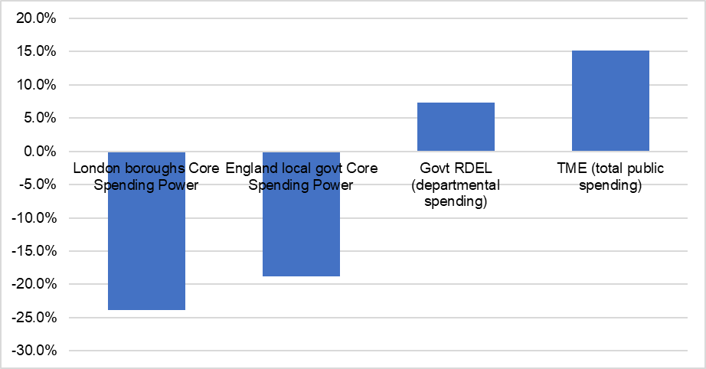
Figure 1 – Cumulative like-for-like change in public spending - 2010-11 to 2021-22
Source: OBR – historical official forecasts database; DLUHC (LGF Settlements 2011-12 to 2021-22)

Over the last decade, demand for services increased significantly as London’s population grew by 12%: almost twice the rate of growth across the rest of England (7%). London boroughs now serve nearly a million more people than in 20107. New policies and legislation transferred responsibilities - and associated costs - from central government adding up to £1 billion in costs, for example, from: the National Living Wage; localisation of Council Tax Support; transfer of public health duties; and rising demand resulting
from the Care Act 2014, Children’s and Families Act 2014 and Homelessness Reduction Act 2017.

London boroughs responded by protecting spending on social care, meaning other services have borne a greater share of austerity. Since 2010, spending on planning & development services has been cut by 65% and cultural services by over 40%. Boroughs have coped by restructuring; investing in demand reduction;

7 ONS – Mid-year estimates and Sub-national population projections

renegotiating contracts; sharing services and back office functions; embracing digitisation; and becoming more commercial. They are now more efficient, leaner organisations – with 51,000 (27%) fewer staff than in 20108. With so much already done, councils were already running out of options prior to Covid-19.

The financial impact of Covid-19

The overall financial impact across London boroughs in 2020-21 was around £1.8 billion and is forecast to be £750 million in 2021-22 (excluding tax losses which hit budgets in later years). Government funding and compensation has been vital to meet these pressures. While enough funding, at the overall London level, has been provided to meet pressures for the first half of this year; a £200 million gap will appear in the second half of the year without further funding.

London boroughs have seen a disproportionate level of income losses, with the highest losses per capita (and as a share of revenue spending) of any authority type (see Figure 2). The ending of furlough in September, reduction in business rates reliefs and ending of business support grants will continue to impact business rates, commercial income and sales, fees and charges (SF&C). With compensation for lost SF&C ending in June, an estimated £100 million of losses will not be compensated in the rest of 2021-
22. Fundamental changes to the economy, working and shopping patterns mean income may never return to pre-pandemic levels. It is vital that this is factored into the overall funding settlement for local government at the SR.

Figure 2 - Estimated per capita income losses due to Covid-19 - Q1+Q2 2021-22 - by authority type
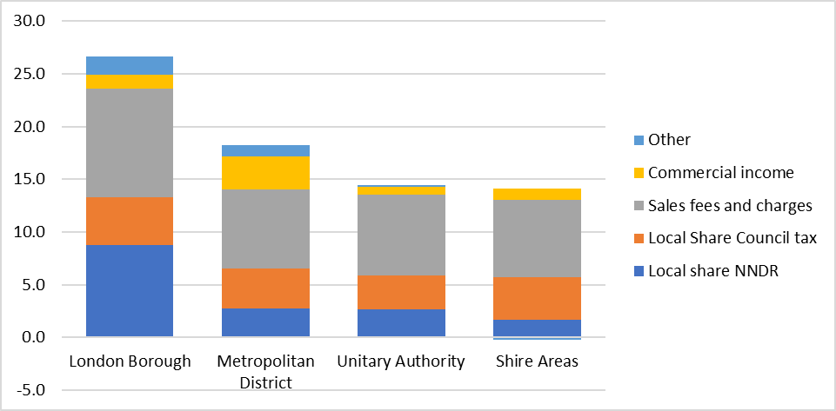
Source: DLUHC, Local authority COVID-19 financial impact monitoring information, Round 13 (June 2021)

London Councils is very concerned there is no tax loss compensation scheme in 2021-22. London boroughs and the GLA reported almost two thirds of the total tax losses in England for the first half of the year – and will be disproportionately affected if no compensation is provided. As it stands, even if the impact of the pandemic on tax completely rebounds next year, boroughs will be starting the SR period around £300-400 million down compared to previous forecasts, with further losses of £100 million in 2023-24 because of the delayed impact of spreading a third of the losses from 2020-21 and the full losses from 2021-22.

8 ONS, Quarterly Public Sector Employment Survey, https://www.local.gov.uk/ons-quarterly-public-sector-employment-survey

In the short term, London Councils seeks immediate support from the Government in the Spending Review by:
extending the SF&C compensation scheme to cover the whole of 2021-22;
implementing a compensation scheme for tax losses in 2021-22, and extending the flexibility to spread losses over three years; and
ensuring funding for ongoing spending pressures relating to the pandemic in 2021-22.

The long-term impacts of the pandemic are still unknown but increased spending pressures and lost income will continue to be significant over the next three years and must be reflected in the Spending Review settlement for local government.

We estimate inflation and demographic pressures alone mean the sector will require annual increases of around £2.5 billion per annum– around £400 million in London – simply to stand still over the SR period. Adding the estimated ongoing impact of Covid-19 on spending and income losses, London boroughs will require up to £2 billion of additional investment over the SR period. The average increases to core spending power seen in the last 2 years (5%), must be the minimum baseline for the next three years.

We therefore ask that the Government provides:
Funding increases to local government of at least 5% per annum over the next three years.
Funding certainty via a 3-year LG finance settlement, but if this can’t be delivered, the overall envelope for local government should be set out for the next 3 years including confirmation of council tax principles and a minimum funding guarantee for all local authorities.
Urgent clarity over the timetable and scope of the Review of Relative Needs and Resources and the reforms to the Business Rates Retention scheme.

Reforming the finance system

Fundamental reform of local government finance is required if councils are to be put on a sustainable footing over the long term. The Government must begin to consider reforms within this parliament, to reduce the growing proliferation of specific grants for different purposes, and the growing reliance on council tax and business rates, which now fund 75% of local government spending but neither tax is fit for purpose. While both require fundamental reform, they cannot fund the growth in demand for local services expected over the next decade. The ongoing financial pressures on residents mean annual council tax increases of 4-5% are not sustainable, and any reduction to business rates yield (that may result from the reforms to the tax due in the autumn) suggests wider funding streams will be required.

London Councils believes any system of funding for local government should be underpinned by the fundamental principles of stability, certainty and transparency. We have long advocated greater fiscal devolution, as well as broadening the range of funding sources available to local government rather than being exposed to the flaws of two centrally prescribed taxes. Towns, cities and local councils that are more responsible for their own destiny and more accountable for their own success, would design better taxes and provide better services. London Government has demonstrated, through the pan-London business rates pilots and the 2020-21 pool, that they are ready to take on more responsibilities and resources to deliver stronger outcomes for Londoners.

In reforming the LG Finance system, we believe the Government must: Deliver a system that is simple, stable, and predictable.

Pause any further business rates retention until the fundamental review is complete and the pandemic impact is known.
Ensure no authority is worse off as a result of the Fair Funding Review.
Reform business rates to be less complex; have greater local control; more responsive to local economic need.
Reform council tax by ending capping and the ASC Precept, providing flexibilities to add CT bands, and removing central prescriptions around LCTS.
Provide a greater balance of revenue raising powers including exploring devolution of an overnight levy, VED and the Apprenticeship Levy over the course of this SR period.
Consider assignment of national taxes in the longer term as the only way to meet growing demographic and service pressures by 2030.

C – Supporting London’s local services

London – like other large cities - has huge levels of inequality and faces many social challenges. When accounting for housing costs, London has higher rates of relative poverty than any other part of the UK. Around 1.5 million adults and 400,000 children in London suffer from low or very low food security. Health inequalities, air and noise pollution, congestion and crime levels are higher in London and urban centres than their surrounding areas. These factors drive high levels of need for local public services and higher costs of delivery.

London boroughs now face a further set of challenges due to the legacy of Covid-19. The health and social impact of the pandemic has been felt as hard in the capital as anywhere in the UK, for example:
- By 20th September 2021, over 1,037,000 people in London had contracted Covid-19 – the highest of any region of England and as many as Scotland, Wales and Northern Ireland combined⁹.
- London boroughs account for five of the six local authorities with the highest death rates in the country and the highest rate overall of all regions at 248 per 100,000 population.¹⁰ Covid-19 mortality rates correlate with higher levels of deprivation and ethnicity. London is home to 5 of the 25 most deprived council areas in England, and over 40% of Londoners are BAME.
- During the crisis, more than 5,200 people have been supported into settled accommodation by the London boroughs and GLA, while 2,272 former rough sleepers are in emergency accommodation.11

The most acute pressures facing London boroughs are in adult social care and children’s services – the largest areas of spending – as well as services for some of the most vulnerable people: the homeless, those in need of local welfare support; people with No Recourse to Public Funds; and, most recently, resettlement of thousands of vulnerable Afghan evacuees. Ensuring there is enough funding to meet growing demand in these areas should be a key priority for the Government if it is to deliver an effective social recovery alongside the economic one.

The pandemic has also shown the important role local authorities can play in supporting communities and delivering frontline care to residents. In several areas, for example public health and local welfare, London boroughs are ready and willing to build on the role they have stepped into during the pandemic, and – if properly resourced to do so - are best placed to continue providing vital support to local communities as they recover from the pandemic.

Adult Social Care

London boroughs spend £2.7 billion on social care per annum; more than a third of overall spending. Growing pressure on ASC in London has been driven by factors including an aging population, increased prevalence of chronic diseases and higher levels of need for working-aged individuals. Even before the impact of the pandemic, we estimate London’s adult social care sector required £400 million of funding over the next three years just to meet inflation and demand pressures.

The idea that these pressures can be met through ongoing efficiencies is false. London boroughs have already become much more efficient: reducing per capita spending by nearly £100 (17%) in real terms over

9 https://www.statista.com/statistics/1102151/coronavirus-cases-by-region-in-the-uk/
10 ONS - Deaths due to COVID-19 by local area and deprivation, April 2021:
https://www.ons.gov.uk/peoplepopulationandcommunity/birthsdeathsandmarriages/deaths/datasets/deathsduetocovid19byloca lareaanddeprivation

11 London monthly accommodation data return – data for 31 July 2021

the decade between 2010-11 and 2019-20, and boroughs now spend almost £220 per capita less than the highest spending authority type (see Figure 3).

Figure 3 - Real terms change in ASC spend per capita (adult popn) - by authority type - 2010-11 to 2019-20
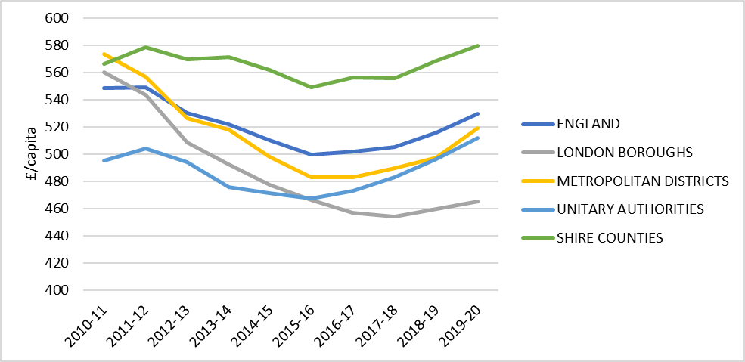
Source: DLUHC revenue outturn data and ONS 2020 Mid-Year population estimates

An efficient social care sector eases the burdens faced by the NHS. London boroughs save the NHS approximately £5 million a year by reducing delays in transfer of care,12 which is why health and social care should be recognised as two parts of an interlinked system. Investment in ASC to support a more resilient care market would support the financial sustainability of the NHS. London Councils welcomes the Government’s support for a 10-year plan for the social care sector13 which would enable long-term strategic planning, aligned with NHS partners, and encourage investment in transforming services over the medium- to long-term.

We are concerned the £500 million recently set out to support the workforce will not address the scale of investment needed. The high vacancy rates, of more than 10% in London, reflect a care system in need of reform and long-term funding certainty. Despite recent progress during the pandemic, where the Proud to Care recruitment portal was rolled out across London, providing improved access to jobs and training and promoting care as a viable career option, low pay and growing instability in the care market create retention challenges and high staff turnover – estimated to be 33% in 2019-2014. For care staff employed directly by local authorities, where pay was £4.53 higher on average than in the independent sector, the turnover rate was less than 11%.

Covid-19 has led to additional spending of over £500 million in the last two years and pressures as a result of changes to the mixture of provision and a growing number of adults suffering the effects of “Long Covid” will persist indefinitely. One borough has calculated the costs of Long Covid to be £2.5 million in 2021-22 resulting from increased pressures on both domiciliary care and home placements. The long-term costs associated with maintaining discharge to assess is another urgent concern with one borough estimating increased spending of £13 million in 2021-22 resulting from an 11% increase in discharges from hospital compared with last year. Another borough has seen a 56% in-year rise in discharges of all three pathways and is estimating additional costs of up to £5.6 million as a result of Pathway 3 discharges into care homes

12 London Councils (2019), State of Adult Social Care in London Report
13 Johnson, B (2021), Liaison Committee: Oral Evidence from the Prime Minister, HC 1144
14 Ibid.

becoming the responsibility of the local authority. These ongoing costs must be factored into the Spending Review settlement for local government.

The long-term funding of social care remains one of the key public service challenges facing the country and, if not resolved, could threaten the financial sustainability of local government. The short-term approach to funding social care with additional annual top-ups to grant funding in the last 5 years have hindered the strategic planning of services, and the ASC precept have not delivered funding to where it is needed most, while representing central hypothecation over the one local tax councils have any control over.

London Councils, therefore, welcomed the recent announcement of long-term reforms to ASC funding, the focus on affordability concerns, and the commitment to integrate health and social care provision.
However, there remain considerable uncertainties which must be answered in the Spending Review and forthcoming White Paper. We are particularly concerned the announcement:
- Provides no certainty of funding support to meet the existing £400 million budget pressure facing boroughs over the SR period.
- Does little to set out investment in supporting working age adult service users, a particular pressure on London boroughs.
- Does not tackle the workforce recruitment and retention difficulties facing London.
- Potentially adds significant financial burdens on councils as suppliers pass on the NI levy to local authorities.
- Fails to set out how the proposed £5.4 billion investment in councils has been calculated and will meet the full cost of implementing reform.
- Adds complexity to the funding arrangements rather than consolidating and simplifying funding streams.

We therefore strongly urge the Government to use the Spending Review to:
- Ensure the new ASC funding reforms are fully funded and commit to additional funding should £5.4 billion be insufficient.
- Set out the assumptions being made within the £5.4 billion cost of the reforms including any ongoing cost burden of delivering a fair rate of care.
- Confirm that the increased costs of the National Insurance Contributions on local authority suppliers are being taken into account in the overall local government funding package.
- Provide immediate support for ASC demand pressures to address the underlying £400 million shortfall expected across London over the next 3 years, including the needs of working age ASC service users, and the rising demand for ASC resulting from Covid-19.
- Provide 3-year ASC grant funding allocations to promote more strategic use of resources and replace the ASC precept with grant.
- Provide a 10-year plan for ASC with funding increases linked to those of the NHS to ensure more efficient spending within the whole health and care system.

Public Health
The pandemic has shown the importance of well-funded public health services to the daily life of every person in the country. London boroughs have been crucial in delivering the frontline response through supporting people to self-isolate; outreach and communications campaigns; outbreak control and management; testing; local contact tracing; and supporting the vaccination programme – especially

targeting harder-to-reach cohorts. It is clear much of this work needs to be done at a hyper-local level and boroughs have been important system leaders, working with schools, care providers and local communities.

We believe London boroughs are best placed to continue this local role, supporting residents to live with the virus, and to deliver wider local public health services in a more joined-up way with the NHS. London’s Public Health teams have taken innovative approaches to promoting wider public health issues during the pandemic, for example by adapting weight management programmes to run remotely15, supporting participants to achieve an average weight loss of 3kg, thereby saving the NHS money (the Government’s obesity strategy found that if all people living with obesity lost just 2.5kg, it could save the NHS £105 million over the next 5 years16). London boroughs have shown how successful investment in prevention, through treatments like PrEP, can help reduce demand and must become a core part of health and care provision.

However, any expanded role must come with sustainable resources. Boroughs are forecasting £120 million of additional spending in 2021-22 and managing the ongoing impact of Covid-19 will continue over the SR period. Core public health funding was already facing significant pressures and is now 16% lower in real terms than when transferred in 2013-14. Figure 4 below shows not only that funding has been cut in real terms, but the marked contrast between NHS funding (which has risen by 40%) and public health grant (PHG), which has remained at the same cash value as in 2013-14 (adjusted for the transfer of responsibilities for 0-5yr olds in 2015).

Figure 4 - Cumulative % change in Public Health Grant vs NHS DEL – 2013-14 to 2021-22
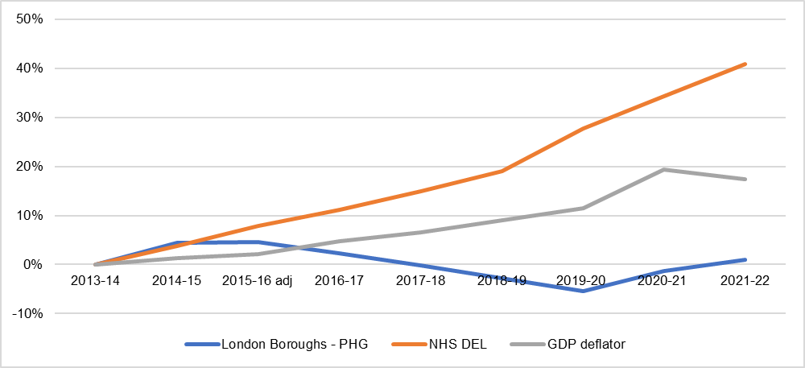
Source: HMT PESA; and DLUHC allocaitons of Public h|ealth grant since 2013-14 (adjusted for funding transferred whith responsibilites for 0-5yr olds in 2015)

The PHG has not been updated since 2013-14 and must be updated to reflect current distribution of need and underlying demography, with a particular focus on the drivers of sexual health and drug and alcohol misuse and reflect the characteristics of deprived and BAME communities – who have been disproportionately affected by Covid-19.

Finally, we believe public health funding increases must be linked to those of the NHS to ensure consistency across the whole health and care system. Funding allocations over multiple years would allow

15 https://assets.publishing.service.gov.uk/government/uploads/system/uploads/attachment_data/file/915274/WMS_Report.pdf
16 https://www.gov.uk/government/publications/tackling-obesity-government-strategy/tackling-obesity-empowering-adults-and- children-to-live-healthier-lives

strategic medium-term planning and provide certainty third sector organisations contracted to work in partnership with boroughs, which greatly enrich the human capital of London.

The Government must use the Spending Review to:
- Support councils to deliver an expanded, but appropriately resourced, role in public health building on the successes of the pandemic and vaccine programme.
- Provide funding increases that mirror those of the NHS to ensure that funding is spent more efficiently within the whole health and care system.
- Provide medium-term (3 year) funding allocations to promote more strategic use of public health resources.
- Update the PHG funding formula in the next year to better reflect local need.

Children’s social care
Nothing is more important to London boroughs than protecting London’s children from harm and supporting all of London’s children and young people to have the opportunity to fulfil their potential. However, for many boroughs, children’s social care (CSC) is the area of greatest financial concern.
Despite CSC being the only area of London boroughs’ spending that has increased since 2010 (by 13% in real terms) 85% of boroughs are overspending (up from 50% in 2010-11). Between 2017-18 and 2019-20 boroughs persistently overspent by around £200 million – part of a wider national trend (see Figure 5 below).

Figure 5 - Children's Social Care - Annual overspend/underspend (£m) by authority type
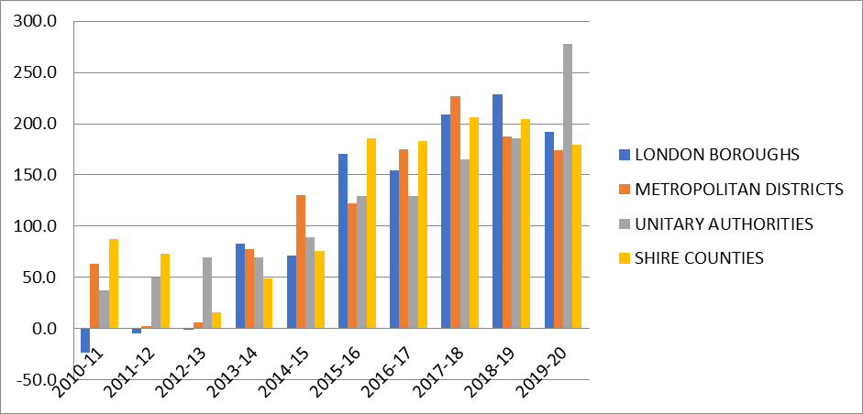
Source: DLUHC – revenue account budget and outturn data

Growing demand for CSC has been driven by disproportionate child population growth (up 14% over the last decade compared with just 6% across the rest of England), but also due to some unique pressures in the capital.

Firstly, London boroughs support a disproportionate number of Unaccompanied Asylum-Seeking Children (UASC), due to higher migration levels and its international ports of entry. In 2020-21, London had around 1,600 UASC (a third of the national total) and around 3,500 UASC care leavers. The recent uplift in Home Office funding for UASC, while welcome, will not be enough to cover the funding pressures with almost 9 in

10 boroughs reporting a funding shortfall, totalling around £20 million across London17. The recent Home Office reform of the National Transfer Scheme has yet to be tested; however, we remained concerned the voluntary nature of the scheme will not lead to a sustainable, fair and equitable national system for supporting children. London Councils continues to call for the NTS to be made mandatory.

Secondly, despite looked after children numbers falling marginally since 2010, expenditure rose by nearly a quarter. This is a different trend to other areas and is driven by several unique London-specific factors18, but notably the scarcity of land and high barriers to entry in the placements market which drive high-cost out-of-borough placements; and a very expensive and growing cohort of young people with complex adolescent needs for whom the placement market is inadequate and very high cost.

Covid-19 has added further financial pressures. Additional spending has totalled over £110 million in 2020- 21 and 2021-22. However, while the full impact on children and young people of repeated lockdowns, disrupted education and worsening social and economic circumstances will not be known for some time, it is already resulting in growing pressures through rising numbers of children in need (in some boroughs up by a quarter in the past year); a spike in court hearings postponed during lockdowns and associated legal support; and rising child protection cases, domestic abuse, substance misuse and teenagers involved in gang activity.

The current Government review of children’s social care offers a real opportunity to take positive steps towards prioritising children in post-pandemic recovery work and we hope this features in the Government’s forthcoming Levelling Up White Paper. London’s slight reduction in LAC numbers in the last decade was partly a result of using the limited preventative budgets which remained; notably, the Troubled Families (now “Supporting Families”) Programme. Up-stream investment is vital to supporting the longer- term life chances of young Londoners.

The Government must use the Spending Review to:
- Provide flexibility to spend any further Social Care Precept on either children’s or adult social care, were it to continue in 2022-23.
- Increase the rates of Home Office grant for UASC and former UASC Care Leavers to ensure full cost recovery to London boroughs.
- Provide capital support to boroughs’ collective efforts to transform the care market serving London’s children.
- Commit to continue funding the Supporting Families programme over the SR period.

Supporting children with SEND
The funding shortfall in the High Needs block of the Dedicated Schools Grant (DSG) for pupils with Special Educational Needs and Disabilities (SEND) has become the single biggest financial pressure for some London boroughs who are fast running out of options for recovering deficits. If left unaddressed, it could place several boroughs in extreme financial difficulty in the next few years.

London boroughs will spend over £1.4 billion on children with SEND this year, funded by the High Needs block within the DSG. In 2021, London had 72,000 children and young people on an Education, Health and Care Plan (EHCP) – an increase of 97% since 2010 and 75% since the introduction of the Children’s and

17 London Councils survey carried out in August 2021 which received responses form 23 boroughs.
18 London Councils commissioned ISOS Partnership to undertake detailed research in relation to children’s social care and High Needs costs across London in early 2019. The final report – which supports this list – can be found here: https://www.londoncouncils.gov.uk/download/file/fid/25047

Families Act 2014, which expanded the age of eligibility for support to 25 and raised parental expectations (see Figure 6 below).

Figure 6 - Cumulative % change in children with statements/EHCPs since 2010 – London and rest of England
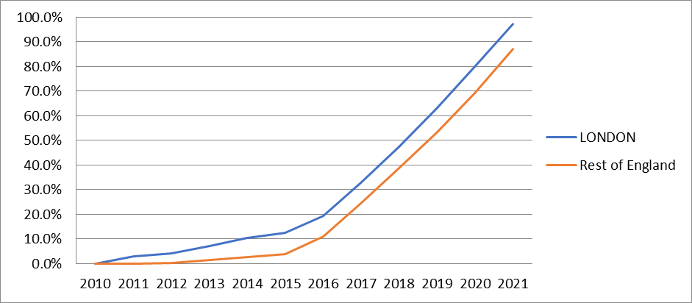
Source: DfE, SEN2 data

Funding has failed to keep pace with demand. Over half of London boroughs estimate they will have an accumulated Dedicated Schools Grant (DSG) deficit by the end of the year, totalling over £300 million. The scale for those in deficit averages around 13% of the DSG – but for some it will be almost 40%, meaning they have little prospect of recovering deficits over the next three years

While the commitment to increase high needs block funding by £7.1 billion between 2020-21 and 2022-23 is very welcome, the 8% increase for London boroughs in indicative 2022-23 allocations is still below the recent annual increases in EHCP numbers (10 % in 2021) and so is barely enough to stand still.

The pandemic has increased demand for services alongside a rise in complexity of need for some children, with a related increase in costs. This is affecting the whole of London with examples of inner and outer boroughs reporting rises of 10% to 15% since the start of the pandemic. SEN transport services have also been disrupted and had to be adapted to be Covid-secure. For many boroughs, this has meant increasing vehicle numbers to adhere to social distancing guidelines, using additional buses where available and resorting to costly taxis.

While we welcome the DfE’s attempts to tighten the ring-fence on the DSG via secondary legislation and the statutory override introduced last year, these changes are temporary and do not resolve the underlying deficits. Recent changes to the high needs block formula were also welcome, to ensure funding meets ongoing need, but also fail to resolve deficits. A clear, robust strategy is required, rather than the current “Safety Valve” approach which focusses only on the handful of outlying authorities, particularly to support the growing number of authorities where deficits are now typically £20 million or more.

We are disappointed with the delay to the DfE’s SEND Review, which must be published as soon as possible. It is vital this takes a holistic view across the system, including health partners. We are concerned that, while the Review may provide updated guidance and recommendations to improve local practice, it may not be effective unless accompanied by legislation, so we urge this to be considered as part of any long-term solution.

The Government must use the Spending Review to:

- Increase High Needs block funding to keep up with current demand over the next three years.
- Provide a robust plan, aligned to the SEND Review, that goes beyond the “Safety Valve” process, to support all councils to eliminate these deficits in the longer term.
- Review the impact of Covid-19 on services for children with SEND, including transport, and provide additional funding to enable services to cover costs incurred due to the pandemic.

Homelessness & rough sleeping
Homelessness

London’s homelessness crisis is unique. The capital has 60,000 households (including 84,000 children) in temporary accommodation – two thirds of the national total and an increase of 63% compared to 2011.
Around 25,000 households were owed a homelessness relief duty in 2019-20 (more than twice as many as in 2010-11)19. These pressures have driven up spending on London’s homelessness services from £160 million in 2010-11 to a budgeted £411 million in 2021-22. Figure 7 below shows not only the different scale of spending by London boroughs, but also the extent of the increase in spending since 2015-16.

Figure 7: Net expenditure on homelessness by authority type, 2010-11 to 2021-22 (£m)
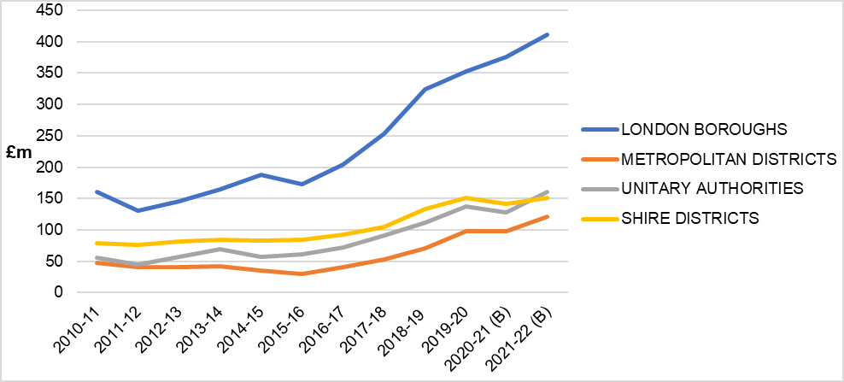
Source: DLUHC – revenue outturn data

Several very specific factors have driven London’s homelessness crisis including:
- Disproportionate population growth over the last decade – with the overall population growing by a million people (12%).
- Disproportionate growth in house prices - home ownership remains unaffordable for many Londoners, with median house prices now £498k, up 74% over the past decade. The house price- to-income ratio has increased over the past decade from 8.7 to 12.5 in London and is far higher than the average 7.8 across England20.
- An overly-inflated private rental sector - Median private market rent for a two-bed property in London is more than double that in the rest of England (£1,450 a month compared to £700).21 .

19 Live table on homelessness: Detailed local authority level tables: financial year 2019-20 – change in terminology reflects changes in local authorities’ statutory duties following the Homelessness Reduction Act.
20 Analysis of Office for National Statistics data
21 Analysis of Office for National Statistics data

The high cost and insecurity of renting is a key driver of homelessness, with 27% of prevention duties in 2019-20 resulting from termination of an Assured Shorthold Tenancy.22
- Rising levels of in-work poverty – with Shelter now claiming that over half of those statutory homeless are working23.
- An increase in councils’ homelessness responsibilities – following the introduction of the Homelessness Reduction Act in 2017. Independent research by the LSE found that unit cost in London were more than twice as high as the figures used by DLUHC in its new burdens assessment for the Homelessness Reduction Act.
- The impact of welfare reform - including the Local Housing Allowance freeze.

The pandemic has underlined the importance of a robust safety net that supports households through financial hardship. The number of London households subject to the benefit cap increased by 169% in the six months to November 2020. Increasing LHA rates to the 30th percentile improved affordability for many households at risk of homelessness24, but despite these changes, LHA payments for 129,000 London households do not cover their rent. The increase in LHA rates did not apply to TA placements, which are still subject to the 90% of January 2011 rates.25 Analysis by Savills shows that just 0.3% of rented properties listed over the two years to Q1 2021 are affordable to a single parent household requiring a three-bedroom home.26

Despite the national Discretionary Housing Payment (DHP) budget increasing to £180 million in 2020-21, London’s allocation did not reflect demand with 11 boroughs topping up their programmes from wider budgets. The pressure is even greater in 2021-22 as a result of the 22% reduction in national funding.

Prior to the pandemic London boroughs were already spending over £200 million per annum more than they receive from specific homelessness grant funding, putting growing pressure on general funding and council tax. The increases in general fund contributions seen in the last decade are not sustainable.
Greater medium-term certainty over homelessness funding is required, funded by specific grant funding outside of the core finance settlement through a formula that reflects local need and – importantly – higher area costs in densely populated urban areas like London.

While temporary measures helped to prevent a surge in homelessness during the pandemic, London potentially faces a “perfect storm” in demand for support due to the ending the evictions ban, and as the furlough scheme and temporary increase in Universal Credit both end after September. This has significant implications for the life chances of its residents and the sustainability of funding for local authorities.

The Government must use the Spending Review to:
- Continue funding for Covid-19-related Homelessness & Rough Sleeping pressures.
- Deliver a multi-year funding settlement for homelessness services outside of core local government funding to provide councils with greater certainty to develop local strategies for reducing homelessness.
- Abolish the caps on LHA and peg rates to the 30th percentile of market rents and increase LHA rates for TA to the 30th percentile where higher than 90% January 2011 rate.

22 DLUHC Detailed Local Authority-Level Statutory Homelessness Tables
23 Shelter 2018, https://england.shelter.org.uk/professional_resources/policy_and_research/policy_library/working_homelessness
24 Stat-Xplore
25 66 of London’s 70 temporary accommodation rates are now on average £78 per week lower than for an AST.
26 Savills, 2021, Delivering on London’s Housing Requirement: interim report, https://www.londoncouncils.gov.uk/our-key- themes/housing-and-planning/housing-and-planning-reports/delivering-london%E2%80%99s-housing

- Establish a needs-based funding model for Discretionary Housing Payments and allow unspent DHP to be rolled forward to future years (where it is less than 10%).

Rough Sleeping

London boroughs made huge strides as part of the national ‘Everyone In’ effort, with more than 5,200 people supported into settled accommodation in London, while 2,272 former rough sleepers are still in emergency accommodation.27 London Councils welcomed this focussed approach and hope it continues. We also welcome the funding made available for emergency and move-on support; particularly, the combination of capital and revenue grant funding via the Rough Sleeping Accommodation Programme (RSAP).

The pandemic has also exposed the previously ‘hidden’ homelessness of young people in London, with 11% of all rough sleepers since March 2020 under the age of 25, a 48% increase across July to September compared to 2019, and a doubling of numbers amongst young women28. London Councils is working with specialist youth charities and DLUHC to better meet the needs of young homeless people through youth emergency accommodation, and would welcome further opportunities, working with government, to develop housing solutions for young people that deliver long-term cost benefits29.

An increase in capital grant funding is needed to ensure delivery of the current RSAP targets. GLA data suggest the average allocation per property is £81,000 (covering 487 homes), leaving an average of
£35,000 per unit for the remaining 250 homes to be delivered. An additional £12 million would support delivery of the remaining programme at a viable grant rate.

The Government must use the Spending Review to:
- Bring forward a longer-term Rough Sleeping Initiative programme to end rough sleeping, building on the learning from ‘Everyone In’, matched by sufficient grant funding for local authorities.
- Provide £12 million of additional capital grant funding to ensure delivery of the remaining RSAP delivery target in London, and a further £16.2m of capital and £6.5m of revenue grant funding to extend this target by 200 homes.
- Extend the RSAP beyond its existing 2023-24 timeframe.

Local welfare support
Covid-19 has underlined the vital importance of a robust safety net that is able to support households when they experience financial hardship. Issues such as food security and digital exclusion have undoubtedly been worsened by it. To renew and support levelling up between and within places, we need investment and services which mean that everyone has access to the basics they need to take control of their lives.

Despite the significant increase in the level of support available through the national welfare system, boroughs have seen an unprecedented surge in demand for locally administered welfare. Applications to London Local Welfare Assistance (LWA) schemes during lockdown were 190% higher than the same period in 2019 and throughout 2020-21, London boroughs made around 39,000 LWA awards totalling £9.3 million. This suggests Universal Credit is not sufficient for many households. Although funding was provided through the Council Tax Hardship scheme, the emergency fund from DEFRA to tackle food poverty, COVID local grants and additional funding for local council tax support schemes in 2021-22, these

27 London monthly accommodation data return – data for 31 July 2021
28 Rough sleeping in London (CHAIN reports), A year like no other – Youth homelessness during the COVID pandemic
29 A new safe space for young Londoners sleeping rough

one-off emergency grants have now ended and LWA schemes remain under-funded in the long-term. As the economy adjusts to fundamental changes once the furlough scheme ends, local authorities must be supported financially to continue to deliver support to the most vulnerable residents.

Investment in LWA can help to prevent problem debt, sustain employment and end long-term complex dependency, which stores up costs for public services and is a drag on productivity. This means moving beyond simple emergency support and creating an expanded role for local authorities, where they are given the freedom and resources necessary to design services that meet local needs. In the short term, this means restoring a dedicated funding stream for LWA.

Beyond this, we want to work with the Government over the SR period to define and develop a new model of local welfare that brings together existing responsibilities and funding streams to create a new focus on holistic and preventative support that the pandemic has shown only local authorities can deliver.

The Government must use the Spending Review to:
- End the Universal Credit 5-week wait by replacing advance payments with a non-repayable grant and make the £20 increase in the Universal Credit standard allowance permanent.
- Restore a separately identified dedicated funding stream for Local Welfare Assistance. The amount of funding should reflect need but at a minimum it should be £176 million per annum, the same level as in 2013/14 when it was first devolved.
- Bring together existing funding pots and responsibilities to create an expanded role for local authorities within local welfare provision that provides a holistic service to address the root causes of financial instability.

Supporting people with No Recourse to Public Funds
People with No Recourse to Public Funds (NRPF) are some of the most vulnerable in society. London boroughs support almost 2,000 households with NRPF each year costing around £40 million each year30, met entirely from local resources.

These vulnerable people have been disproportionately affected by the pandemic, as they are more likely to be in casual, zero-hours or temporary work and have been impacted by sudden loss of employment.
Unlike the wider community, they cannot access large parts of the safety net of benefits and are ineligible for statutory sick pay. NRPF households account for 47% of residents in emergency accommodation in London and the legal support councils can provide is unclear. The latest data (June 2021) shows, of the 2,828 people currently in emergency accommodation resulting from “Everyone In”, a fifth are non-EEA nationals with NRPF. Of the 573 people currently sleeping rough in London, 8% are non-EEA nationals with NRPF.

The Government must use the Spending Review to:
- Provide direct council funding for people with NRPF, on whom London boroughs spend around £40 million a year.
- Review immigration-based restrictions on welfare rules to allow rough sleepers with NRPF to access mainstream support.
- Suspend the NRPF condition for at least 12 months to enable NRPF households to access a wider range of benefits whilst the pandemic continues.

30 NRPF Network, “NRPF Connect – Annual data report 2020-2021: local authority support for people with No Recourse to Public Funds (NRPF)”, September 2021

Ensuring councils can provide vital support for the Afghan resettlement
London boroughs and London Councils have been working tirelessly with the Home Office and other departments to support the safe resettlement of Afghan evacuees since the end of August in response to the unfolding humanitarian crisis. Boroughs are offering to support as many families as they can via the two resettlement schemes while managing existing pressures and priorities. They stand shoulder-to- shoulder with councils across the country, contributing to the overall national response.

One of the main barriers to London boroughs signing-up to ARAP (Afghan Relocations and Assistance Policy) and ACRS (The Afghan citizens' resettlement scheme) is the lack of affordable housing, and the limited availability of family-sized housing. The new support offer for both schemes is a great start, but more detail is needed on how areas with higher cost bases will be supported.

Many Afghan arrivals are currently accommodated in ‘Bridging Hotels’ pending longer term offers of resettlement. There are fourteen such hotels in London as of 20th September. London boroughs already have huge numbers of asylum seekers placed in hotels due to London’s status as a hub for migrants and a point of entry to the country. This, alongside other pressures such as supporting UASC and conducting age assessments, may also impact London boroughs’ ability to house and support Afghan families.

The offer from the Home Office to fund boroughs for immediate support alongside the hotels is welcome, especially as it is backdated. We are keen to work with the Home Office on medium- and longer-term packages of support, taking on a broader range of needs. The impact of education provision, in particular, will be significant, with 1,200 children placed in hotels in one borough alone, who will require an education offer.

As of 30th September, there is not a clear resettlement offer for evacuees who are British Citizens but have no onward accommodation in the UK. There is a very high risk of homelessness pressures falling on a small number of London boroughs if this is not addressed – so far 115 applications have been received.

The Government must use the Spending Review to:
- Ensure London boroughs providing support to Afghan evacuees in hotels are funded appropriately for medium term support, including education provision.
- Ensure that British Citizens are included in the resettlement programme to avoid a small number of boroughs shouldering large homelessness costs.

