London Business 1000

On behalf of London Councils and London Chamber of Commerce and Industry

## Contents

About the London Business 1000 3

Method 3

Executive summary 5

Devolution and government 5

London’s business environment 5

Skills and training 5

Recruitment 6

Apprenticeships 6

Sustainability strategies 6

Crime 7

Devolution and government 8

Priorities for national government 8

Priorities for business rates 9

Support for devolution 10

London’s business environment 13

Impacts of inflation 13

Diversity and inclusion 15

Skills and training 17

Skills challenges 17

Recruitment 20

Past and future recruitment plans 20

Roles recruited 22

Difficulties recruiting 22

Apprenticeships 27

Employment of apprentices 27

Use of apprenticeship funding 28

Engagement around apprentices 31

Sustainability 34

Actions taken to reduce emissions 34

Barriers and motivators to lower emissions 35

Crime 39

Experiences of crime 39

Reducing vulnerabilities 40

Conclusions 43

Appendix A: Sub regional spotlight 45

Central London 45

East London 47

South London 48

West London 49

## About the London Business 1000

For a seventh year, London Chamber of Commerce and Industry (LCCI) and London Councils have commissioned an annual survey of more than one thousand London businesses. The research provides insights into employers’ recruitment plans and their skills needs as they continue to deal with the cost of living crisis. This report also provides insights into businesses’ approach to delivering a more environmentally sustainable economy, crime in the capital, and the apprenticeships levy.

### Method

All figures, unless otherwise stated, are from YouGov Plc. YouGov surveyed 1,271 senior London business decision-makers online between 28th September and 30th October 2023.

The sample frame included 1,000 core responses representative of business size and an additional 250 responses from large businesses (with 250 employees or more). The final achieved figures have been weighted to be representative of London businesses by size and industry. Charts and analysis are based on figures to two decimal places and so bars may not align or sum to the net percentage figure due to rounding. The weighted proportions are representative of the London business population by size and therefore micro and small businesses are the predominant view in the weighted data.

This report is the seventh annual London Business 1000. Where questions have been consistently asked in the same way, some comparison with previous years has been included in the report. YouGov also conducted the previous London Business 1000s between 2020 and 2022, with the same sampling and weighting scheme, so direct comparisons have been provided. While effort has been made to ensure the sample and questions remain consistent across previous wave of the London Business 1000, direct comparisons of figures with pre-2020 waves are only indicative and should be considered with caution.

1. Breakdown of achieved sample by size, region, and industry

|  |  |  |
| --- | --- | --- |
|  | Unweighted base | Weighted base |
| Business size |  |  |
| Micro/ Small (1 to 49 employees) | 871 | 1251 |
| Medium (50 to 249 employees) | 111 | 17 |
| Large (250+ employees) | 289 | 4 |
| Office region |  |  |
| Central | 676 | 591 |
| East | 226 | 255 |
| South | 143 | 175 |
| West | 226 | 249 |
| Industry |  |  |
| Production/ agriculture, forestry and fishing | 69 | 42 |
| Construction/ property | 133 | 180 |
| Motor trades/ wholesale/ transport and storage | 77 | 105 |
| Retail | 126 | 109 |
| Accommodation & food services/ arts, entertainment, recreation and other services | 135 | 154 |
| Information & communication/ professional, scientific and technical | 339 | 417 |
| Finance & insurance/ business administration and support services | 249 | 151 |
| Public administration and defence/ education/ health | 128 | 102 |
| Other | 15 | 10 |
| Total | **1271** | **1271** |

## Executive summary

### Devolution and government

* London decision-makers think the top priorities for the next UK government should be tackling climate change and increasing house-building (both 29%). The latter has a consensus across all business sizes and London regions.
* Consistent with previous years, the top priority for investment of business rates is improving public transport (46%), but there has been a sharp rise in appetite to use business rates for building more homes (26% 2021, 39% 2023).
* There is strong support from London businesses for devolution of powers to local councils, with agreement strongest for housing – 32% strongly agreed that local councils should have more freedoms to fund and build houses.
* A ‘hotel tax’ also sees strong support, with six in ten (60%) supporting the introduction of a scheme for overnight visitors to London. Over half (56%) of businesses in accommodation and food services/ arts and recreation would support its introduction.

### London’s business environment

* Businesses are increasingly taking action as a result of rises to inflation and the associated cost of living crisis – three quarters (77%) have made operational changes, and 61% have made workforce changes.
* The most common operational change continues to be increasing prices for products/ services (36%). However, micro/ small businesses are less likely than last year to say they are reducing profit margins as a result of inflationary pressures (30% 2022, 25% 2023).
* Consistent with 2022, a quarter of London businesses are increasing their wages/ incentive schemes (25%) as a result of the rises to cost of living, although a fifth (19%) say they are now freezing/ cutting wages and incentive schemes.
* Most London businesses undertake at least one listed diversity, equality, and inclusion activity (61%), with the vast majority of large businesses doing so (86%). A third (32%) of London businesses have a dedicated diversity and inclusion policy.

### Skills and training

* Wages and retention remain the top labour market challenges facing London businesses in the next 12 months. Concerns about lacking applicants have diminished, although a fifth (19%) continue to report this as a concern.
* Three quarters (76%) currently have challenges with their current workforce’s skills, with decision-makers in large businesses particularly likely to say this (84%).
* Although challenges with technical/ job-specific skills remain the most common, the proportion reporting this has fallen notably since 2022 (31% 2022, 24% 2023). Challenges with other skills have increased, with around a fifth now reporting challenges around their staff’s management/ interpersonal skills (20%), commercial awareness (19%), time management (19%), or leadership (18%).

### Recruitment

* Two thirds of companies have recruited or tried to recruit over the last 12 months or expect to recruit staff over the next 12 months (both 65%). This sustains the trend since 2020 of an increased desire for businesses to recruit staff in the past 12 months (44% 2020, 49% 2021, 63% 2022) or will do so in the next year (41% 2020, 54% 2021, 61% 2022).
* Likewise, consistent with a growth in desire to recruit staff since 2020, the proportion of London businesses that say their headcount will increase over the next year is now significantly higher than three years ago (26% 2020, 42% 2021, 44% 2022, 47%, 2023).
* Professional/ managerial roles remains the top priority (60%), which continues an ongoing trend since 2018, with London companies increasing their demand for professional/ managerial staff from 43%, 45% in 2019, 47% in 2020, 50% in 2021, 54% in 2022 to 60% in 2023.
* Around two-thirds (65%) of London businesses said they had difficulties recruiting staff in 2023, down slightly from 2022 (71%). There was an increase in the proportion of firms that did not experience difficulties between 2022 and 2023 (19% and 25%, respectively).
* However, difficulties in recruiting may be in part due to costs of housing or transport, with many businesses saying the cost of housing (50%) or transport (44%) in London has a negative impact on their ability to recruit/ retain staff.

### Apprenticeships

* There has been a marked increase in the proportion of businesses that employ apprentices with one in five companies now employing apprentices (13% 2020, 7% 2021, 14% 2022, 20% 2023), with there also being a rise in awareness of their requirement to pay the Levy (7% 2020, 5% 2021, 14% 2022, 18% 2023).
* However, businesses still face barriers to employing apprentices; when prompted, just over a third (35%) cite that they do not meet the needs of their business. One fifth of firms report issues revolving around the extra workload that this would involve, whether this be the administration time or the extra management that it would require (both 22%).
* A majority of businesses (55%) still report no engagement at all from their local authority, although this has fallen from 60% in 2022. There is strong appetite for making improvements to the Apprenticeships Levy too, with making the Levy system simpler (51%) and allowing the Levy to contribute to paying for wages (50%) proving most popular.

### Sustainability strategies

* Consistent with previous years, most London businesses report to have taken action to reduce their emissions (71% 2020, 69% 2021, 71% 2022, 74% 2023).
* When focusing upon particular methods to reduce emissions, adapting products (34%) to be greener has overtaken using greener technology (32%) by a small margin – a shift from 2020 where using greener technologies was a more popular method of reducing emissions (37%).
* Costs appear to be the main barrier to reducing emissions, with almost a quarter of businesses citing high initial upfront costs (23%) and a similar proportion selecting higher operating costs (22%) and lack of resources and time (21%).
* When considering what could help them reduce their emissions, businesses are most receptive to financial support, whether this be green grants (28%) or tax breaks for environmentally friendly companies (37%).
* However, there is also clear support amongst businesses for greater involvement from local councils both in terms of providing enhanced recycling services (29%) and providing more information about how to improve sustainability (25%).

### Crime

* Half (50%) of London businesses believe crime has increased in the last 12 months and one in five (20%) say their business has directly experienced at least one incident over the same period.
* Among those whose businesses have experienced crime, the most common is theft/ armed burglary (54%) or physical damage to goods/ property (38%).
* Most (75%) decision-makers say their business has taken some steps to reduce their vulnerability to crime. These are typically installing security measures (33%), insurance (32%), or investing in cyber protection (30%).
* Half (48%) think greater resources for police would reduce the likelihood of crimes in London, while a third (34%) think more involvement from local councils would help.

## Devolution and government

### Priorities for national government

Building more homes is top of the national agenda from the perspective of London businesses. When asked for the top three areas the next UK government should prioritise, housing is joint top with tackling the impacts of climate change (figure 2). Prioritising housing has no significant differences across London regions (31% Central, 30% East, 28% South, 23% West) or business sizes (29% micro/ small, 31% medium, 27% large), while large businesses are more likely than SMEs to prioritise climate change (29% micro/ small, 29% medium, 36% large).

Businesses in Central London are the most likely to say national government should focus on tackling the impacts of climate change (34% Central, 28% East, 25% South, 21% West). However, they are less concerned with reforming business rates, while those in West London are more likely to choose this as a top-three priority (18% Central, 24% East, 25% South, 29% West). Both Central and West London businesses are agreed about trade – around three in ten say a priority for the next UK government should be easing international trade restrictions (30% Central, 17% East, 22% South, 28% West).

Reducing visa restrictions to the EU is a key priority for decision-makers within the motor trades/ wholesale/ transport and storage industry (37%), significantly more so than any other industry. Those in the IT and communications industry are more focused on tackling climate change and its impacts (36%).

1. Priorities for the next UK government (three selections allowed)

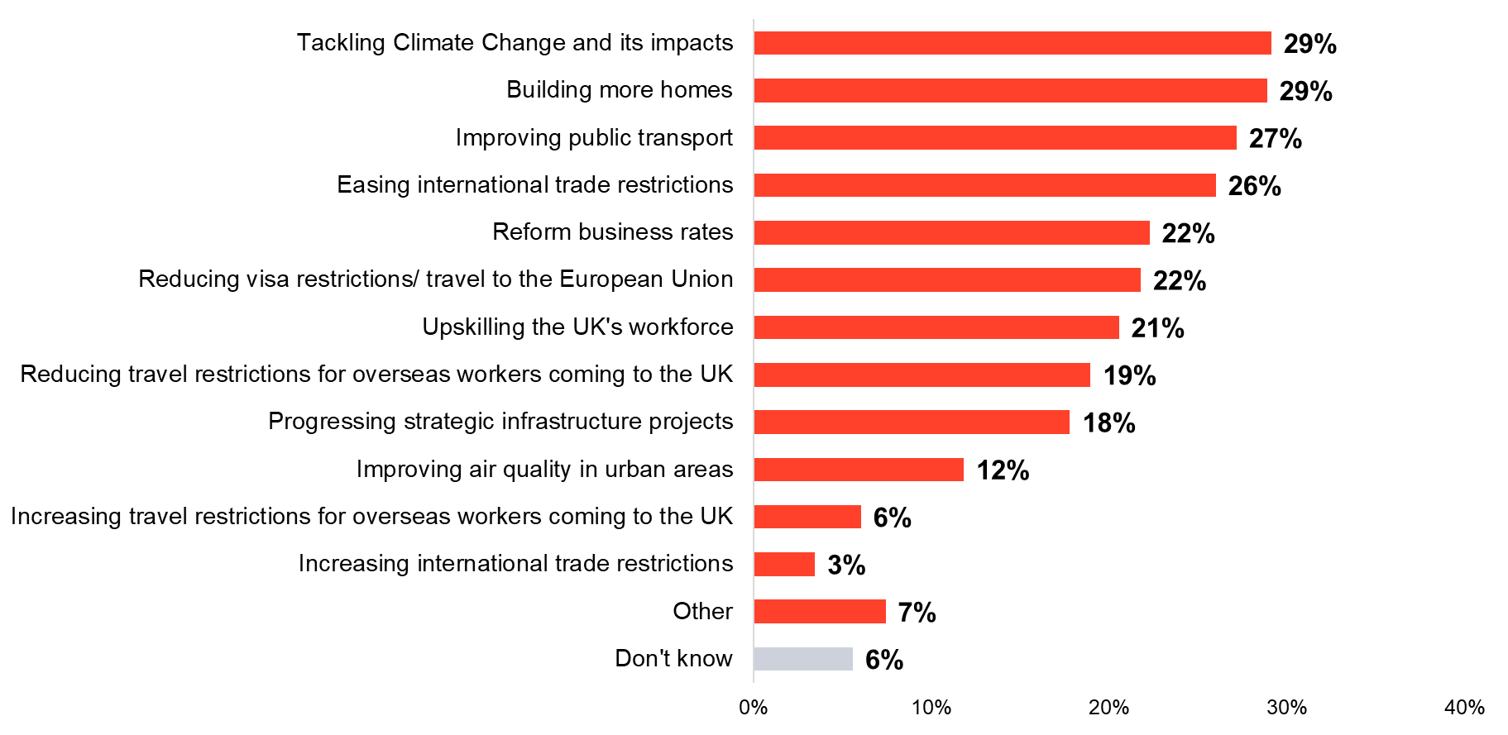 Base: All respondents (2023=1,271)

### Priorities for business rates

Consistent with previous years, when told that London boroughs and GLA are continuing to make the case to retain revenue from business rates instead of passing it to central government, London businesses prioritise public transport. In fact, public transport appears to have grown in importance – in 2021, two fifths (39%) of London businesses thought this was a key priority for business rates, compared to 46% in 2023. Previously, there had been a disparity in which industries were keen for investment in public transport – now, most industries are broadly in agreement with no significant differences between them. Those in Central London are the most likely to think public transport is a priority (53% Central, 39% East, 42% South, 39% West).

There has been an even greater rise for the importance of spending business rates on housing, in line with their priorities for the national government. In 2021, around three in ten (28%) thought this was key compared to two fifths in 2023 (39%). The appetite for building more homes is universal – there are no significant variations across the London regions (43% Central, 38% East, 37% South, 34% West) or business sizes (39% micro/ small, 38% medium, 45% large).

Building affordable workplaces has seen slightly slower growth as a key priority for business rates but is now higher than when first measured in 2020 (19% 2020, 23% 2023). Businesses in East London are the most likely to see affordable workspaces as a key priority for the revenue from business rates (21% Central, 31% East, 21% South, 23% West).

In contrast, there is now lower demand for spending business rates on upskilling London’s workforce – after a quarter said upskilling was a priority in 2021 and 2022, this has now dropped back to around a fifth (20%) of London businesses, consistent with the proportion seen in 2020.

1. Priorities for investment of business rates

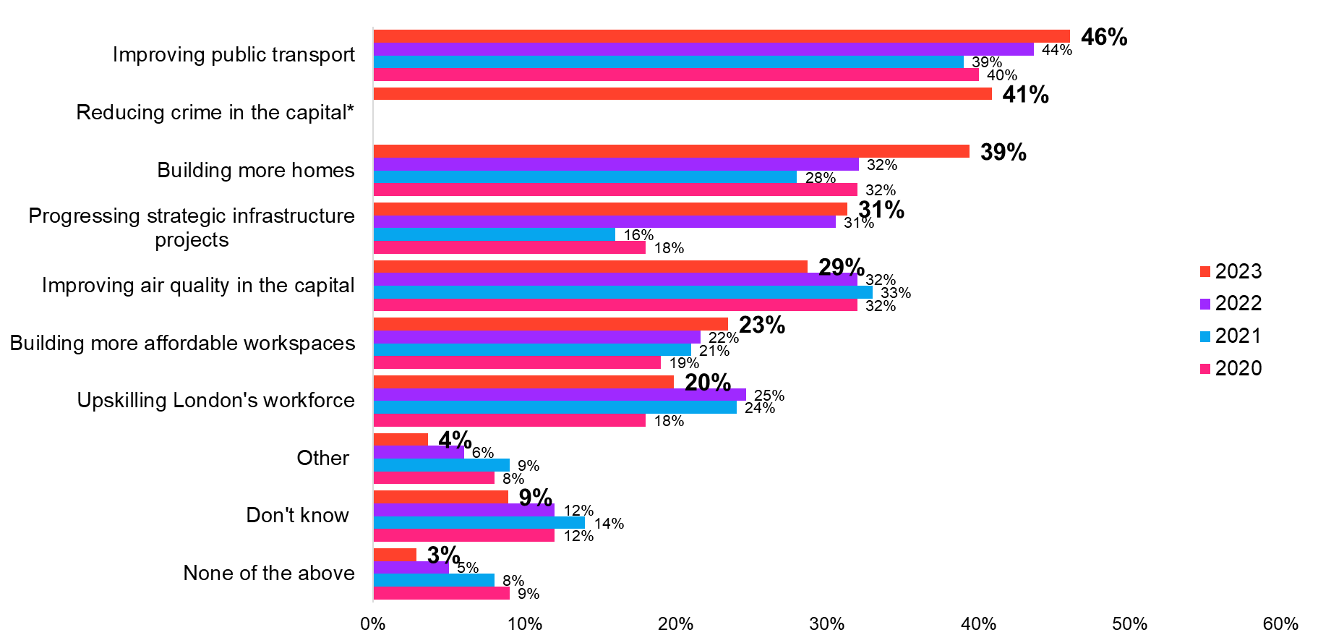   
Base: All respondents (2020=1,251; 2021=1,276; 2022=1,369; 2023=1,271)  
*option not asked in all years

### Support for devolution

Broadly, there is strong support from London businesses for devolution of powers to local councils – around seven in ten agreed with each statement given about increased powers and freedoms (Figure 4). There is broad consensus across the London business community with no significant differences at the overall level across London regions or business sizes.

Agreement for devolution is strongest around housing. Around a third (32%) of London businesses strongly agreed that local councils should have more freedoms to build houses – echoing the growing sense that housing is a key priority for business rates (figure 3). This is consistent across the London regions (34% Central, 35% East, 32% South, 27% West) and business sizes (32% micro/ small, 29% medium, 29% large).

Seven in ten (72%) London businesses agree that local London councils should have greater powers around community safety and policing. Looking at London industries, over nine in ten in production/ agriculture are in agreement (94%), compared to two thirds (67%) of those in information and communication/ professional, scientific, and technical services. Although levels of agreement are broadly consistent across London regions, those in Central London are most unsure (14% Central, 9% East, 10% South, 11% West).

1. Agreement with statements about local London councils

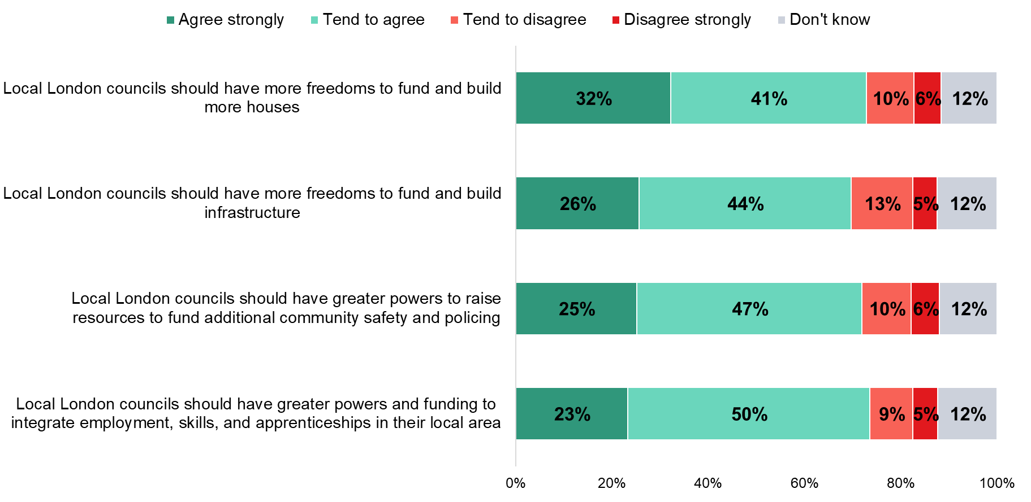 Base: All respondents (2023=1,271)

In addition to supporting devolution, there is general support for the introduction of a ‘hotel tax’ in London that would be levied by accommodation providers and support local services. There are no significant differences in support across industries – over half (56%) of businesses in accommodation and food services/ arts and recreation support the suggested introduction. Senior decision-makers in the motor trades/ wholesale/ transport and storage industry are the most likely to support a ‘hotel tax’ (73%).

1. Support for a ‘hotel’ tax in London

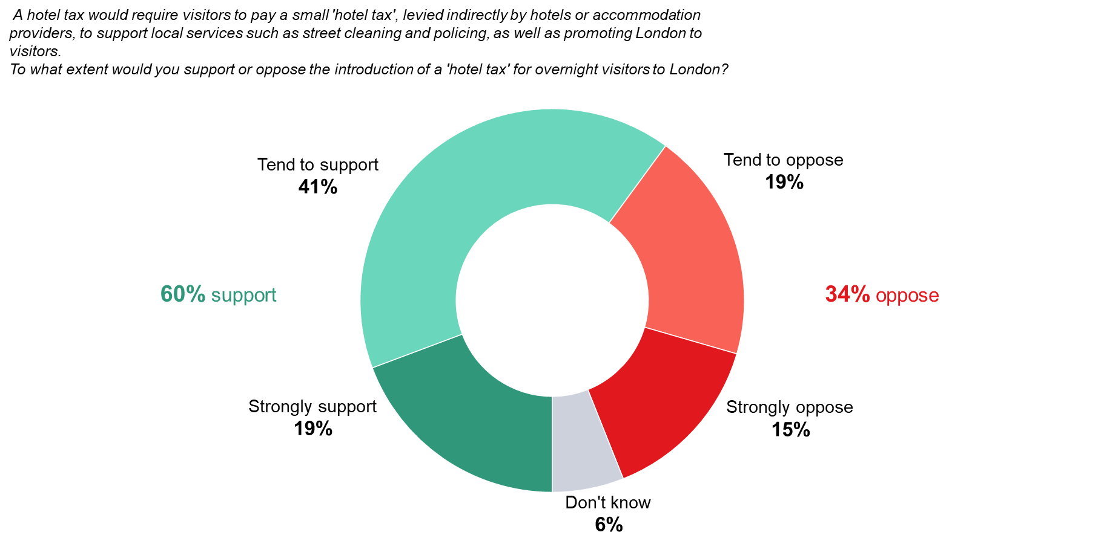 Base: All respondents (2023=1,271)

## London’s business environment

### Impacts of inflation

An increasing number of London businesses say they are making operational changes in response to rises in inflation and the associated cost of living issue – three quarters (77%) now say this compared to 68% last year. However, those in Central London are the least likely to say they are making an operational change as a result of inflationary pressures (72% Central, 85% East, 82% South, 79% West).

Consistent with last year, the most common activity is to increase prices for goods / services (36%), followed by reducing profit margins (25%). However, the latter has fallen compared with 2022, with a quarter (25%) saying they have/ will reduce profit margins compared to three in ten last year. The shift has predominantly come from micro/ small businesses – now only 25% say they have/ will reduce profit margins as a result of rises in inflation compared to 30% who said this in 2022.

Although over a third say their response is to increase prices, there has been a marked rise in the proportion of London businesses who are reducing prices of their products/ services or introducing new product lines into their offering (figure 6). Businesses in East London are the most likely to say they are either reducing prices (7% Central, 18% East, 14% South, 13% West), increasing investment (7% Central, 18% East, 9% South, 8% West), or introducing new lines (16% Central, 26% East, 20% South, 14% West).

Across industry, a third of decision-makers in the motor trades/ wholesale/ transportation and storage industries say they are introducing new product/ service lines (32%) while those in the retail industry are the most likely to be reducing prices (21%). Nearly half (47%) of those in the accommodation and food service/ arts, entertainment and recreation industry are increasing their prices.

1. Operational changes as a result of rises in inflation and the cost of living issue

Base: All respondents (2022=1,369; 2023=1,271)  
*option not asked in all years

Similarly, an increased proportion of London businesses plan to/ have already made workforce changes in response to rises in inflation – only half (49%) of London businesses reported this in 2022, compared to 61% in 2023. However, a third (33%) of micro/ small businesses have not/ do not plan to make any workforce changes – a much higher level than medium (17%) or large (14%) businesses.

The most common workforce change continues to be increasing wages and incentive schemes with a quarter (25%) of businesses doing this. Three in ten within East London are/ plan to do this, nearly double the proportion of West London (27% Central, 31% East, 25% South, 17% West).

Otherwise, there has been a significant rise in the proportion of businesses doing all other listed workforce activities (figure 7). In particular, a fifth (19%) of London businesses say they are now freezing or cutting wages and incentive schemes compared to only one in ten (11%) saying they were doing this last year.

A third (33%) of large businesses are freezing or reducing their headcount, compared to only a fifth of micro/ small (21%) or medium (20%) businesses in London. There are no significant differences by industry or London region – business size is the main driver of reduced headcount as a response to the cost of living. However, large businesses are also the most likely to provide employee helplines (36%) or interest-free loans (18%).

1. Workforce changes as a result of rises in inflation and the cost of living issue

Base: All respondents (2022=1,369; 2023=1,271)

### Diversity and inclusion

Broadly, most London businesses do at least one of the listed diversity, equality, and inclusion activities (62%). There is an upward trend by business size, with large businesses the most likely to be undertaking the activities (62% micro/ small, 72% medium, 86% large).

Across the regions, businesses in East London are the most likely to be doing at least one diversity and inclusion activity (64% Central, 70% East, 55% South, 53% West). However, those in Central London are by far the most likely to have a diversity and inclusion policy (40% Central, 28% East, 24% South, 21% West) or have implemented inclusive employee development (26% Central, 18% East, 15% South, 12% West).

The retail industry is the most likely to have implemented inclusive people management (36%), more than double that of those in the construction/ property industry (14%). They are also much more likely than the construction/ property industry to adapt their products and services to be more inclusive (32% retail, 9% construction). Decision-makers in motor trades/ wholesale/ transport and storage as well as those in production/ agriculture are particularly likely to say they are using inclusive procurement policies (27% production/ agriculture, 25% motor trades/ wholesale/ transport and storage).

1. Diversity and inclusion activities

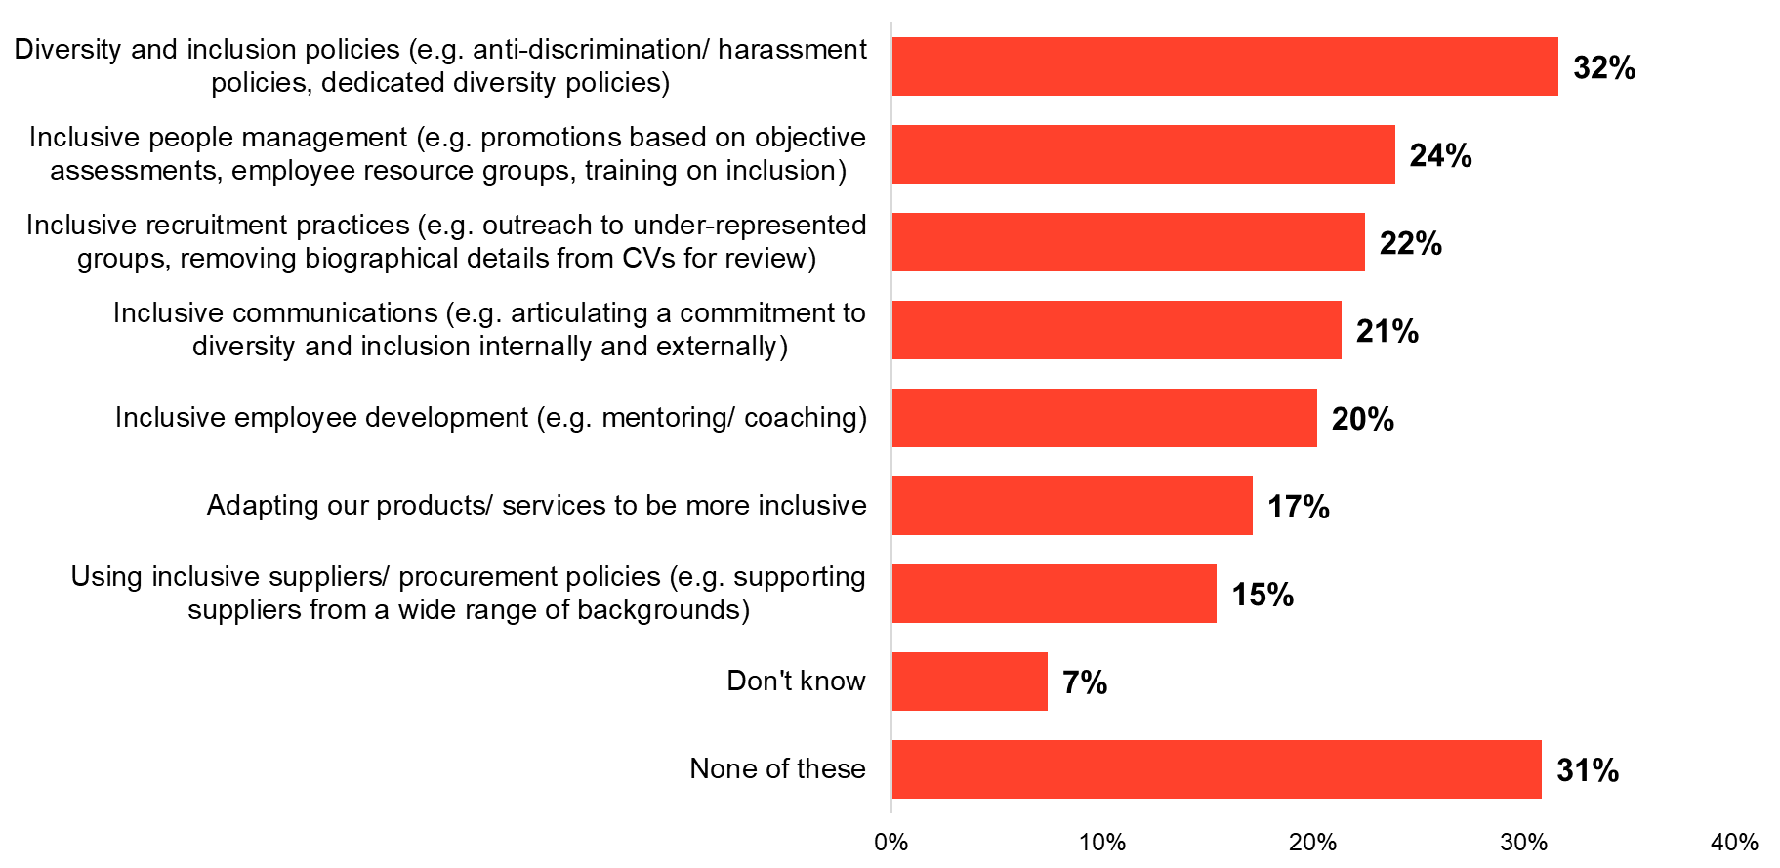 Base: All respondents (2023=1,271)

## Skills and training

### Skills challenges

The top workforce challenges facing London businesses over the next 12 months are broadly consistent with those reported in 2022. The main challenge remains pressure to increase wages (40%), while a quarter are concerned about staff retention (27%), resources for recruiting (24%) and skills shortages amongst applicants (24%). There has been a significant fall in the proportion of London businesses who think a lack of applicants will be a challenge over the coming year – returning to around a fifth (19%) of London businesses, consistent with 2021.

In 2022, the production/ agriculture industry had overtaken motor trades/ wholesale/ transport and storage as the most likely to face pressure to increase wages. This has not been sustained. Now, decision makers in the motor trades/ wholesale/ transport and storage are back to being the most likely to face pressure to increase wages (51% motor trades/ wholesale/ transport and storage, 28% production/ agriculture). Instead, those in production/ agriculture are the most likely to say productivity is a key workforce challenge for the coming year (41%), double that of most other industries (for example, 21% in finance and insurance/ business administration say the same).

Those in Central London are the most likely to say they are facing pressure to increase wages (45% Central, 39% East, 32% South, 35% West) while those in South London are the least likely to cite concerns about staff retention (29% Central, 23% East, 18% South, 29% West). Decision-makers in East London are concerned about skills shortages in their existing staff (15% Central, 23% East, 13% South, 16% West) or about staff ill with COVID-19 (5% Central, 14% East, 9% South, 8% West).

Workforce challenges vary across business size too, with medium-sized businesses the most concerned about skills shortages in their existing staff (17% small/ micro, 28% medium, 20% large). Large businesses are more concerned about flexible working arrangements (19% micro/ small, 17% medium, 29% large).

1. Main skills and labour market challenges over the next 12 months (top five)

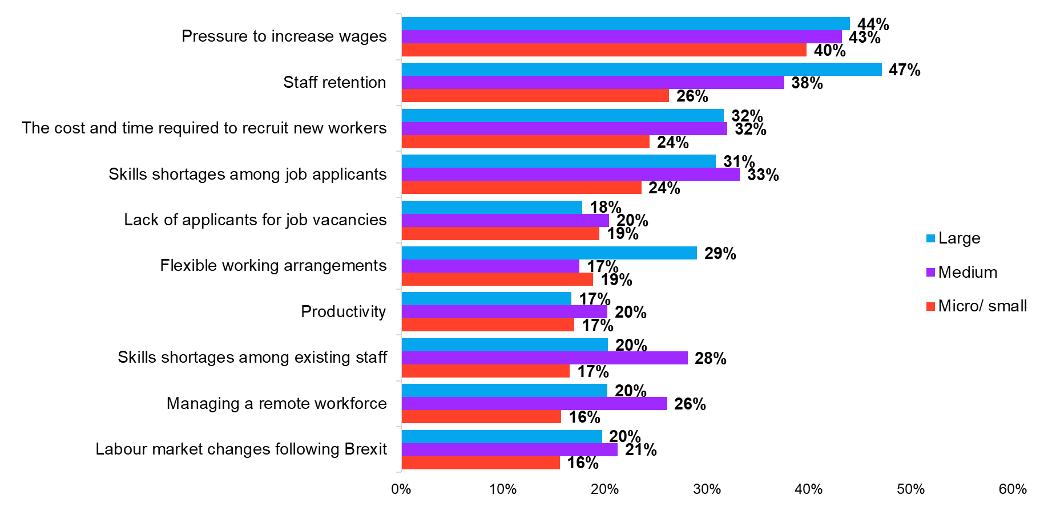 Base: All respondents (2023: micro/ small=871; medium=111; large=289)

Three quarters (76%) of London businesses currently have issues with the skills in their current workforce, although smaller businesses are less likely than large businesses to have skills challenges (76% small/ micro, 86% medium, 84% large). Those in East London are more likely than overall to be facing skills challenges among their current workforce (74% Central, 82% East, 75% South, 76% West).

A quarter (24%) cite technical or job-specific skills. However, this is a marked shift downward from 2022, when three in ten (31%) were experiencing challenges with this. By contrast, challenges with other skills have increased. Issues with management/ interpersonal skills have been steadily increasing since 2020, with a fifth (20%) of businesses now seeing this as a challenge in their current staff. A similar proportion now also see challenges with commercial awareness, time management skills and leadership skills (figure 10).

Large businesses remain the most likely to have issues with their technical/ job-specific skills, although this has fallen since 2022 (28% 2020, 35% 2021, 48% 2022, 38% 2023). Both medium and large businesses are more likely than small/ micro businesses to have issues with management/ interpersonal skills (20% small/ micro, 32% medium, 28% large). Those in the production/ agriculture industries are the most likely to say they are experiencing challenges around management/ interpersonal skills – a third (32%) report this.

1. Types of skills businesses face challenges within their workforce (top five)

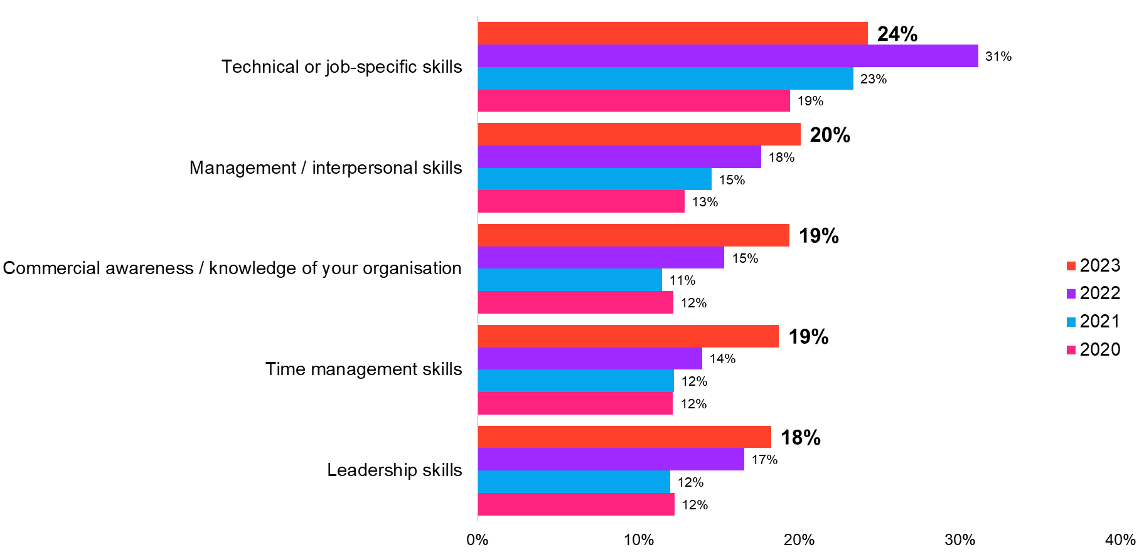 Base: All respondents (2020=1,251; 2021=1,276; 2022=1,369; 2023=1,271)

## Recruitment

### Past and future recruitment plans

Despite London businesses continuing to experience rising expenses in the context of the ongoing cost of living crisis, a majority of businesses still have recruitment plans. Two thirds of companies have recruited or tried to recruit over the past 12 months, and the same proportion of businesses expect to recruit staff next year (both 65%). This sustains a trend since 2020 of an increased desire for businesses to recruit staff in the past 12 months or intend to do so next year (figure 11).

This story of sustained growth since 2020 is highlighted in all London regions. Businesses in East London have seen a strong increase in efforts to recruit more staff in the past 12 months, from 43% in 2020 to six in ten this year (45% 2021, 55% 2022, 62% 2023). The same pattern is also apparent when focusing upon recruitment intentions over the next year; in 2020, two fifths of businesses in East London said they intended to recruit in the coming 12 months, rising each year to two thirds wanting to recruit staff in 2023 (37% 2020, 41% 2021, 54% 2022, 67% 2023).

Large and medium sized businesses are most likely to have attempted to recruit staff over the last year (64% micro/ small, 90% medium, 92% large) or have intentions to recruit in the future (64% micro/ small, 88% medium, 89% large). There has been a sizeable rise since 2022 in the proportion of medium sized businesses who have attempted to recruit staff over the past 12 months (83% 2022, 90% 2023).

1. Recruitment in the past 12 months and expected recruitment in next 12 months

Base: All respondents (2020 n=1,251; 2021 n=1,276; 2022 n=1,369; 2023 n=1,271)

Consistent with a trend since 2021 and a rejuvenated desire to recruit staff since 2020, the proportion of London businesses that report that their headcount will increase over the next year has slightly increased, now significantly higher than three years ago (26% 2020, 42% 2021, 44% 2022, 47%, 2023).

This increase becomes clearer at a regional level where there has been a marked change since last year in the proportion of businesses that say their headcount will increase; last year, Central London businesses were most likely to report that their headcount would increase (49% Central, 39% East, 40% South, 35% West). However, this year sees a notable increase in the proportion of South and East London businesses who have intentions to increase their headcount, rising to a higher level than Central London businesses (45% Central, 51% East, 57% South, 42% West).

Interestingly, there has also been a notable shift at industry level, with the proportion of companies in the retail industry who report that their headcount will increase has almost doubled since last year from just three in ten (30%) to almost six in ten this year (58%). This illustrates a strong recovery for the retail industry in London – in 2022 it was least likely out of all other industries to increase its headcount; this year, they are most likely to increase their headcount.

1. Expected headcount change

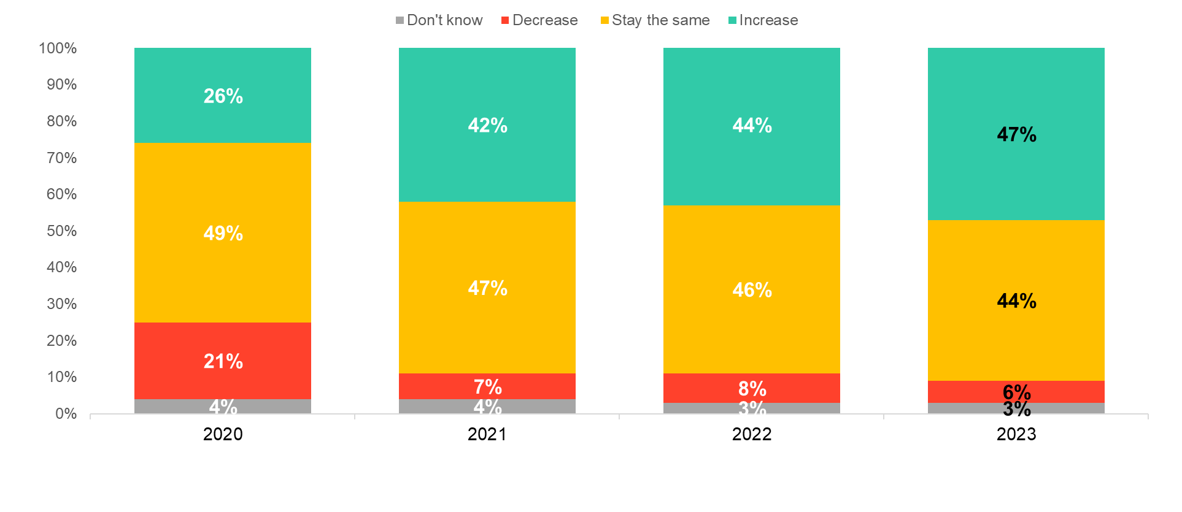

Base: All respondents (2020 n=1,251; 2021 n=1,276; 2022 n=1,369; 2023 n=1,271)

### Roles recruited

Amongst companies that have attempted to recruit staff in London over the past year, demand for professional/ managerial roles remains the top priority (60%). This continues an ongoing trend since 2018, with London companies increasing their demand for professional/ managerial staff from 43% in 2018, 45% in 2019, 47% in 2020, 50% in 2021, and 54% in 2022, to 60% this year.

Central London businesses are more likely than any other London region to want these professional/managerial roles (67% Central, 54% East, 57% South, 52% West). Demand for these roles is also evident across all business sizes, with particular growth amongst micro/small businesses since 2020 (46% 2020, 49% 2021, 53% 2022, 60% 2023). Three quarters of both medium and large sized companies recruited for professional/managerial roles in 2023 (77% both).

Desire for un/ semi-skilled staff has also rebounded to a level last seen in 2021 after a decline in 2022 (22% 2020, 23% 2021, 19% 2022, 24% 2023). This rise has largely been driven by a renewed appetite amongst companies in South London to recruit un/ semi-skilled staff (29% 2020, 33% 2021, 18% 2022, 35% 2023).

1. Types of roles recruited over past 12 months

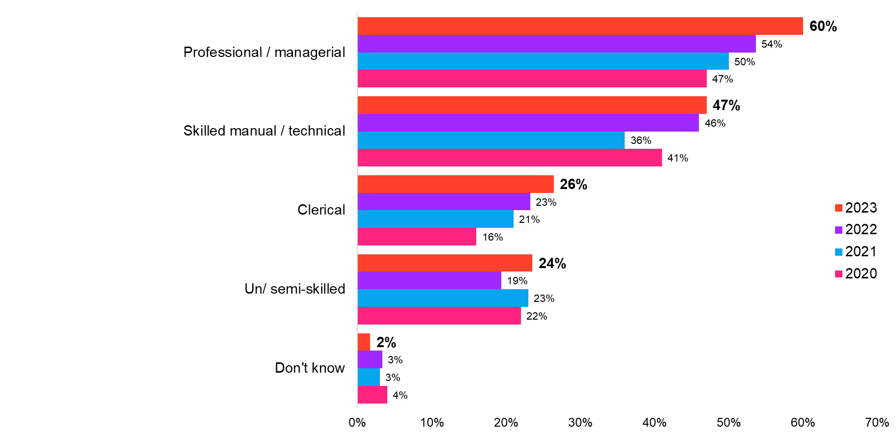 Base: All respondents (2020 n=668; 2021 n=755; 2022 n=970; 2023 n=926)

### Difficulties recruiting

In the same vein for there being increased demand for professional/managerial staff across London, businesses also report experiencing difficulties recruiting for these roles (figure 14).

This becomes most evident amongst companies based in East London who are much more likely than any other business region to report that they have experienced difficulties in recruiting professional/managerial staff (33% Central, 43% East, 31% South, 31% West).

There has also been a shift in the industry area that experiences difficulties recruiting professional/managerial staff. Last year, businesses in the information and communication sector were most likely to report experiencing difficulties recruiting staff for professional/managerial roles (48% 2022, 37% 2023). However, companies in the finance and insurance related sector are now most likely to report experiencing difficulties recruiting for professional/managerial staff (43%) – a marked rise from just over a third (35%) reporting these challenges the previous year.

Yet, difficulties in recruiting staff for any role have largely been sustained when compared with last year rather than the marked year on year rises which had been prevalent since 2020. Instead, a quarter of companies who have attempted recruiting now report not experiencing any difficulties recruiting staff; while this is still far lower than 2020, it is a notable rise from 2022 and represents a return to a similar level seen two years ago (48% 2020, 28% 2021, 19% 2022, 25% 2023). Central and West London based companies are most likely to report experiencing no difficulties recruiting, with three in ten reporting to not meet any difficulties compared with one in eight amongst companies based in East and South London (29% Central, 15% East, 16% South, 29% West).

1. Types of roles businesses had difficulty recruiting for

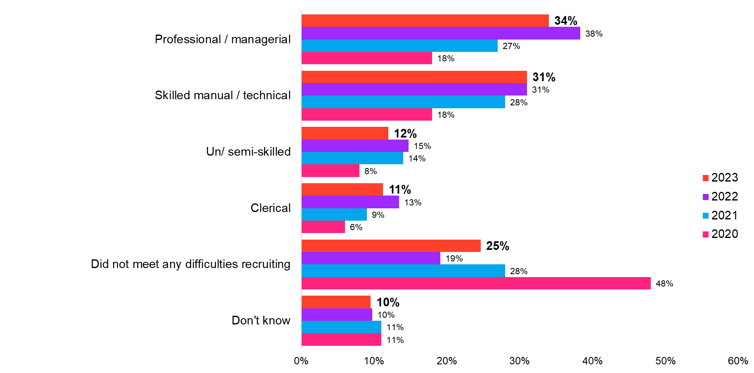 Base: Those who have recruited for the following roles in the last 12 months   
(2020 n=643; 2021 n=728; 2022 n=943; 2023 n=902)

When senior decision-makers in London are asked specifically about the types of recruiting difficulties they were facing, the most commonly cited reasons are that applicants lacked the sufficient technical abilities/ skills and lacked sufficient experience (both 43%). This correlates with the skills challenges that businesses report to be facing seen earlier in the report, with businesses being most likely to cite lacking skills in technical or job-specific skills (24%). The problem in recruiting staff with sufficient technical abilities/ skills is also a similar percentage to the previous two years (figure 15). However, interestingly, recruitment impediments have shifted in 2023, with the issue of businesses having a low number of applicants being less evident than in the last two years – a notable drop to two in five businesses this year (40%) from approximately half in 2022 (51%) and 2021 (52%).

While these top three issues are prevalent across London regions and remains broadly consistent amongst company sizes, businesses in East London are much more likely than other London regions to report that they experience too much competition from other employers (15% Central, 33% East, 25% South, 19% West) and that applicants lacked sufficient CV writing/ interviewing skills (9% Central, 31% East, 18% South, 18% West).

1. Main difficulties faced when recruiting

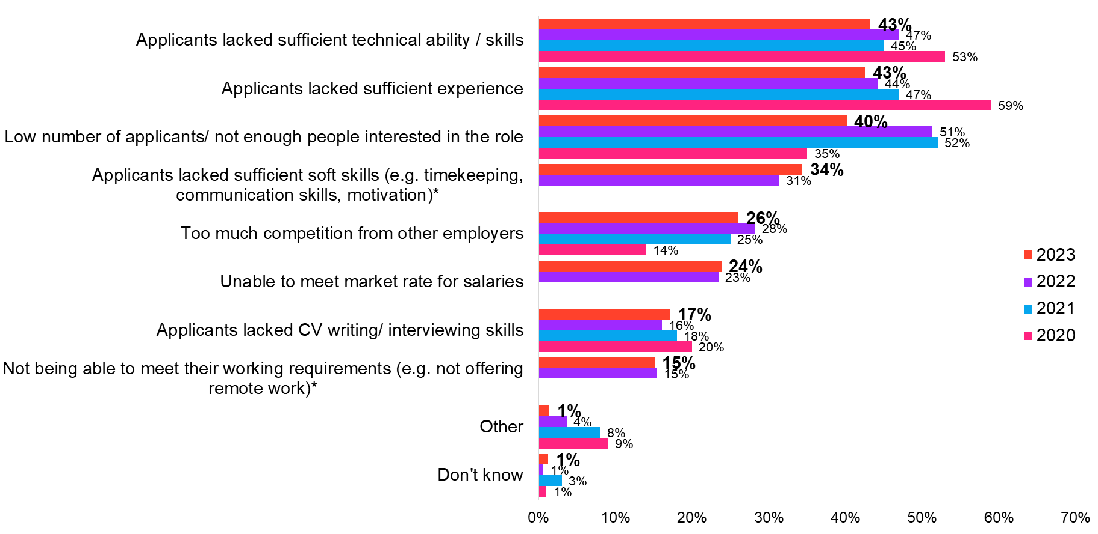 Base: All who faced difficulties recruiting   
(2020 n=270; 2021 n=437; 2022 n=676; 2023 n=576)  
*option not asked in all years

These impediments when recruiting staff have not been helped by the impact of the cost of transport and the cost of housing on London businesses over the last 12 months. Only one in ten companies in London believe that the cost of housing (10%) or the cost of transport (11%) in London have a positive impact on their ability to recruit or retain staff. Conversely, just over two in five believe the cost of transport (44%) has a negative impact, while half of London businesses believing the cost of housing (50%) is detrimental to their ability to recruit or retain staff.

Locational factors appear to play an important role in determining the level of impact the cost of transport and housing on businesses’ ability to recruit or retain staff. Central London businesses report to be far more adversely affected by the cost of housing and transport than any other London region, with half believing that cost of transport has a negative impact on their ability to recruit or retain staff (52% Central, 34% East, 36% South, 39% West). This rises to six in ten when they were asked about the cost of housing in London (62% Central, 36% East, 35% South, 47% West). Interestingly, East London businesses are far more optimistic than other London regions about the cost of housing and transport on their ability to recruit/ retain staff. One in five report that the cost of transport (9% Central, 21% East, 7% South, 9% West) or the cost of housing (7% Central, 20% East, 7% South, 10% West) have a positive impact on their ability to recruit/ retain staff.

Those in the accommodation and food services industry are the most likely to be negatively impacted by the cost of housing and transport. Approximately half (53%) believe the cost of transport in London has negatively impacted their ability to recruit or retain staff over the last 12 months, a figure that rises to approximately six in ten (63%) when they are asked about the cost of housing. Those in large businesses are the most likely to say transport costs have a negative impact on their ability to recruit/ retain staff (44% micro/ small, 37% medium, 55% large).

1. Impact of cost of housing and transport on ability to recruit or retain staff over the last 12 months

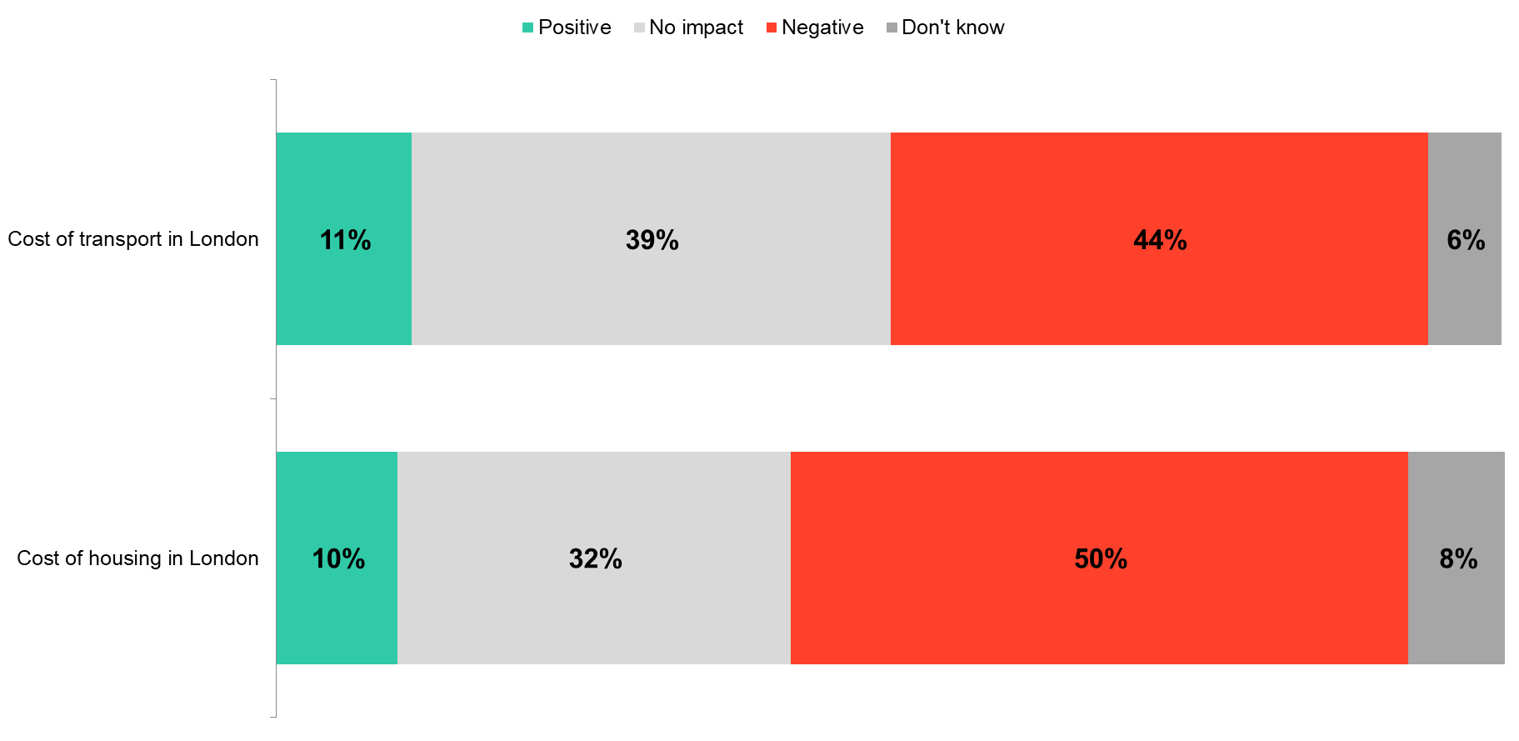 Base: All respondents (2020 n=1,251; 2021 n=1,276; 2022 n=1,369; 2023 n=1,271)

## Apprenticeships

### Employment of apprentices

This year sees a marked rise in the proportion of businesses that employ apprentices, rising to one in five London businesses. Indeed, this builds on the growth seen in previous London Business 1000 surveys, with one in five companies now employing apprentices (13% 2020, 7% 2021, 14% 2022, 20% 2023).

While trends by business size cannot be tracked pre-2020 due to small sample size, there has been a notable growth since last year in the proportion of micro/small companies that employ apprentices, continuing a growing trend seen since 2021 (figure 17). Last year’s growth for medium businesses has not been sustained, but at a regional level there has been a considerable shift since last year. Companies based in East (19% 2022, 37% 2023), South (7% 2022, 30% 2023), and West London (13% 2022, 21% 2023) are much more likely than last year to report that they employ apprentices; conversely, those in Central (14% 2022, 9% 2023) London saw a marked decline since 2022 in apprenticeship uptake.

Retail businesses were the most likely to increase their headcount in the next 12 months, and also reported the highest rate for employing apprentices. Four in ten companies within the retail sector cite this to be the case (40%); a four fourfold increase from last year, where only one in ten businesses (10%) in the retail industry reported that they employ apprentices.

1. Proportion of London businesses that employ apprentices

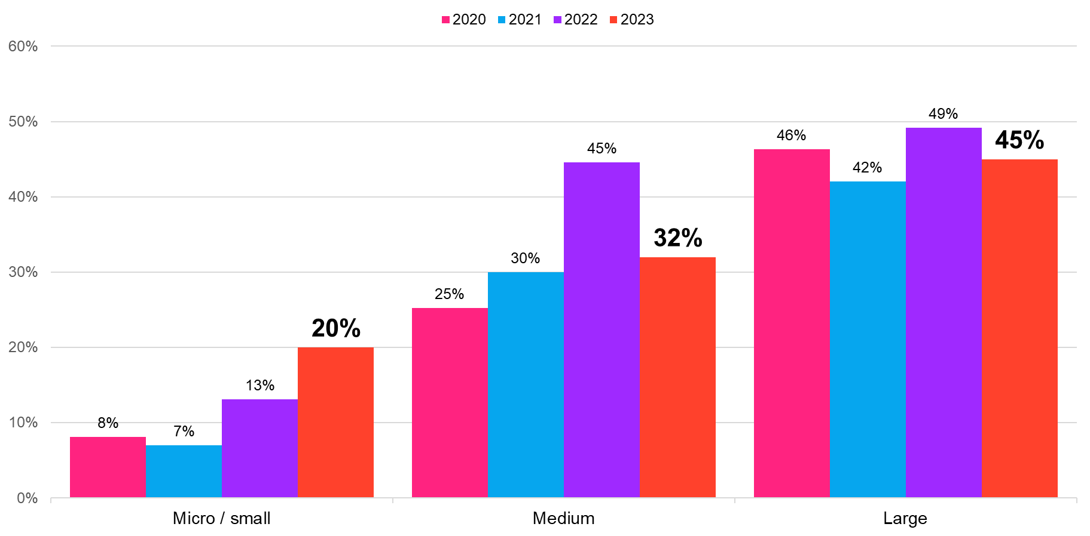  
Base: All respondents (2020 n=1,251; 2021 n=1,276; 2022 n=1,369; 2023 n=1,271)

### Use of apprenticeship funding

The apprenticeship levy is applied to all UK employers that have an annual wage bill of more than £3 million. These businesses make an annual levy payment of 0.5% of their wage bill above £3 million. All UK employers can access funding from the Apprenticeships Levy to support apprenticeship training. To the best of their knowledge, almost one in five companies (18%) report that they are required to pay the Apprenticeship Levy, a sustained rise from 2020 (5% 2021, 14% 2022).

Regional factors also appear to have a role in reported awareness; businesses in East and South London are particularly aware of the need to pay for the Levy – a considerable rise since last year (East: 18% 2022, 35% 2023; South: 8% 2022, 25% 2023). Contrastingly, awareness in Central London has almost halved since last year to a far lower level than other regions, with only West London businesses having comparable levels of awareness compared to last year (Central: 14% 2022, 8% 2023; West: 15% 2022, 19% 2023).

In line with increased employment of apprentices and awareness of the Levy, intentions to use apprenticeship funding over the next 12 months has also increased since last year – one in five (19%) now plan to use apprenticeship funding compared with one in seven last year (14%). This is largely driven by micro/small companies, while uptake amongst medium sized companies sees a marked decline within the same period (figure 18). Consistent with increased awareness of the Levy amongst companies based in East and South London, the same narrative is seen regarding uptake, with these companies based in these areas being much more likely than other London regions to use apprenticeship funding over the next 12 months (9% Central, 38% East, 27% South, 18% West).

1. London businesses that plan to use apprenticeship funding over the next 12 months

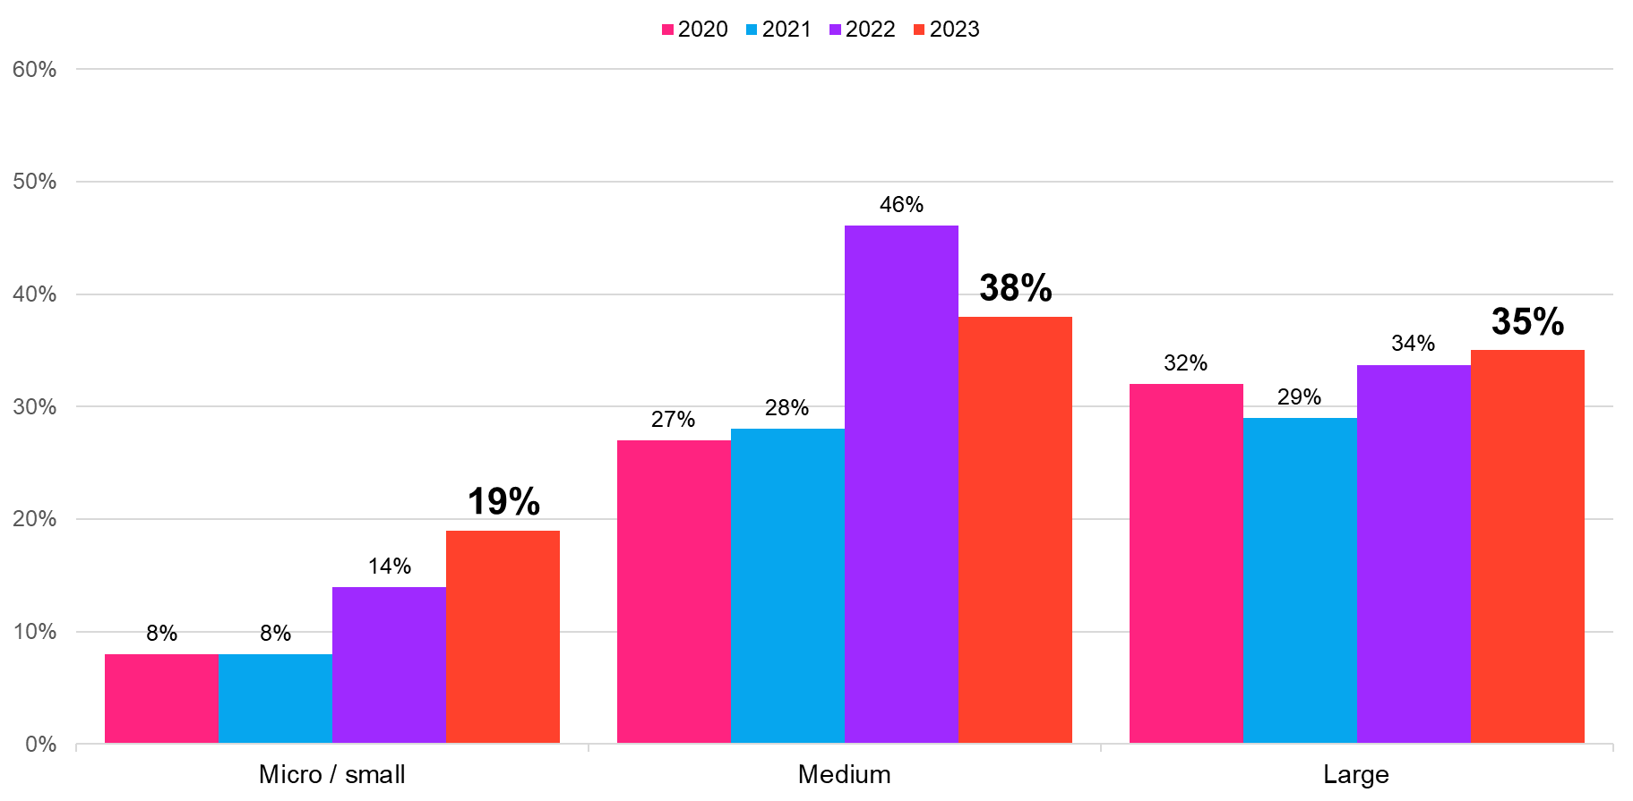 Base: All respondents (2020 n=1,251; 2021 n=1,276; 2022 n=1,369; 2023 n=1,271)

Of those who report that they intend to use apprenticeship funding over the course of next year, two fifths (41%) say that they will use it to employ more apprenticeships – a sharp rebound since last year (31%), with a similar percentage reporting that they will employ the same number of apprentices (43%). This is followed by over a third using it to train existing apprentices (36%); while just one in five (21%) would employ fewer apprentices – a notable fall from three in ten the previous year (31%).

A similar pattern also emerges amongst the amount of funding that senior decision-makers report that they would use over the year. Three in ten (28%) businesses now report that they would use over half of their apprenticeship funding – a notable rise compared to last year where only one in ten (10%) reported this to be the case, or indeed, when companies were asked in 2021 (19%) or 2020 (21%).

1. Percentage of apprenticeship funding that London businesses plan to use

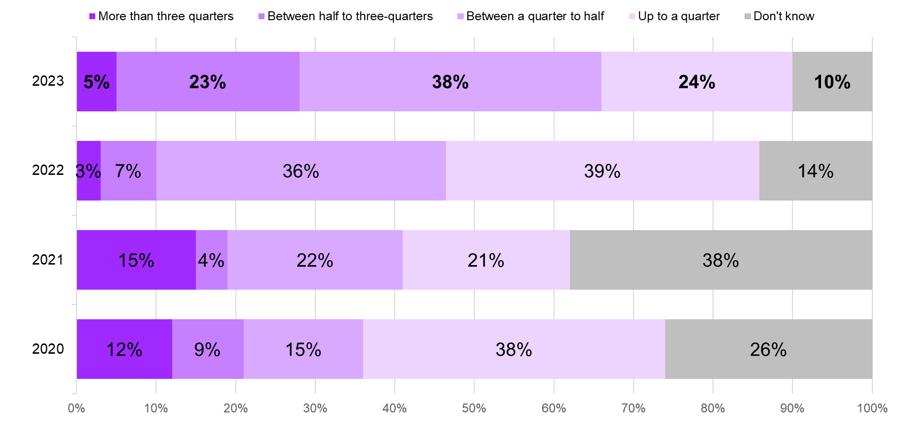  
Base: All respondents who plan to use apprenticeship funding   
(2020 n=172; 2021 n=178; 2022 n=283; 2023 n=315)

This year’s London Business 1000 survey also asked senior decision-makers what would be effective in improving the Apprenticeship Levy for their business. While all companies believe that any of the proposed options would be more effective than ineffective, it is evident that they are most receptive to making the Levy system simpler (51%) and allowing the Levy to contribute to paying for wages (50%).

While there are no significant differences in this regard amongst business size, at a regional level it is evident that East London businesses are far more supportive of making the Levy simpler (63%) and allowing the Levy to contribute to paying apprentices’ wages (60%) than businesses in Central London (43% both measures). Interestingly, these regions are also where apprenticeship employment over the last 12 months is highest (in the East) and lowest (in Central London), indicating a correlation between the level of apprentices that are employed and the perceived effectiveness of changes to the Levy.

1. Effectiveness of improving the Apprenticeship Levy

Base: All respondents (2023=1,271)

### Engagement around apprentices

When senior decision-makers are prompted to choose an option regarding the barriers to employing apprentices, just over a third (35%) cite that they do not meet the needs of their business – a figure which is comparable with last year (32%). One fifth reported issues revolving around the extra workload that this would involve, whether this be the administration time or the extra management that it would require (both 22%), with there being little change in opinion since last year in this regard.

Like last year, micro/ small firms are more likely than large businesses to say that apprentices do not meet the needs of their business (35% micro/ small, 30% medium, 26% large). This is an issue that becomes more prevalent when focusing on a regional level, with those in West and Central London being considerably more likely to find this as a barrier than those in East and South London (37% Central, 30% East, 29% South, 39% West).

1. Main barriers to business making more use of apprenticeships

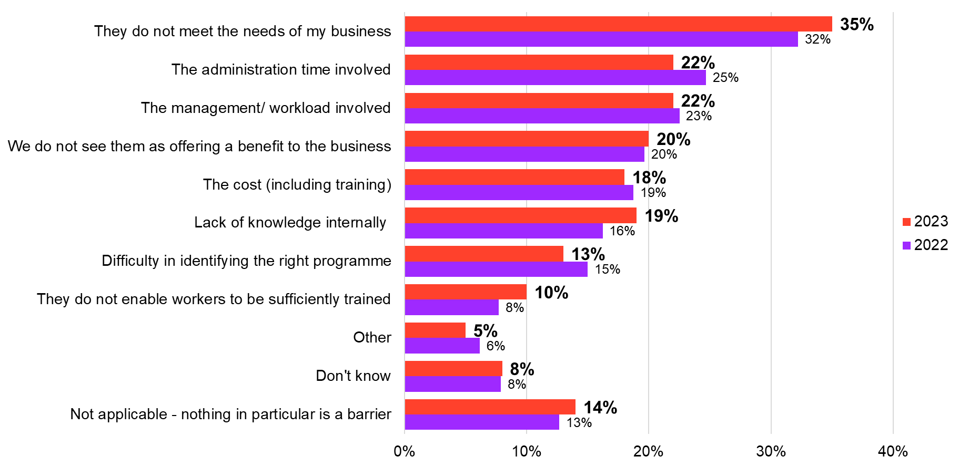  
Base: All respondents (2022 n=1,369; 2023 n=1,271)

One in five senior decision-makers have engaged with their local authority about apprenticeships (21%), a considerable rise from just 13% who reported this to be the case last year. However, a majority of businesses still report to have no engagement at all from their local authority (55%), an issue that was also prevalent last year (60%).

Businesses in Central London particularly feel that they do not engage with their local authority about apprenticeships. Only one in ten say that they have a great deal/ fair amount of involvement from their council – a figure that is more than four times lower than the level seen amongst East London businesses and significantly lower than all other London regions (8% Central, 38% East, 31% South, 25% West). A similar narrative is seen for micro/small firms (70%), who are significantly more likely than large (56%) or medium (49%) sized companies to say that they have received either little or no engagement at all from their local authority.

1. Level of engagement with local authority on apprenticeships

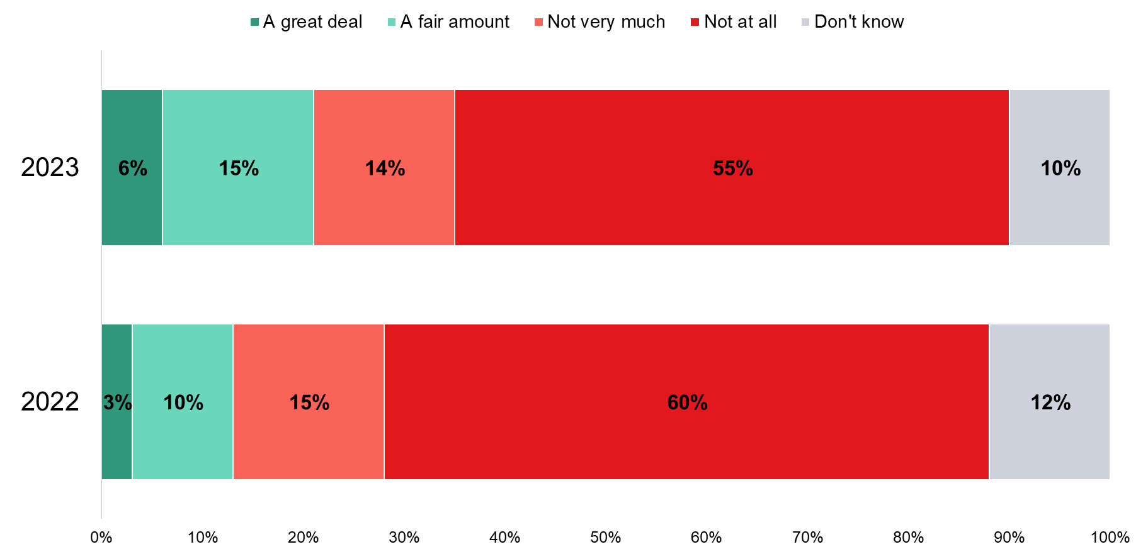  
Base: All respondents (2022 n=1,369; 2023 n=1,271)

Sustainability

### Actions taken to reduce emissions

Consistent with previous years, most London businesses report to have taken action to reduce their emissions (71% 2020, 69% 2021, 71% 2022, 74% 2023). Large (84%) and medium (87%) business sizes are much more likely to have taken action than micro/small firms (74%). At an industry level, retail firms are now far more likely than most industries to have taken action to reduce their emissions, with nine in ten reporting this to be the case – a substantial rise from seven in ten the previous year (69% 2022, 90% 2023).

When focusing upon particular methods to reduce emissions, adapting products (34%) to be greener has overtaken using greener technology (32%) by a small margin – a shift from 2020 where using greener technologies was a more popular method of reducing emissions (37%). East London businesses are driving the growth in support for using greener technologies, rising from just a quarter (25%) last year to over a third (35%) choosing this method now.

Fewer companies are also encouraging staff to utilise remote working to reduce emissions, falling from almost four in ten (37%) using this method in 2020 to three in ten now (29%), with companies in West London being particularly unlikely to use this option to lower emissions (32% Central, 32% East, 28% South, 17% West).

1. Actions taken to reduce emissions

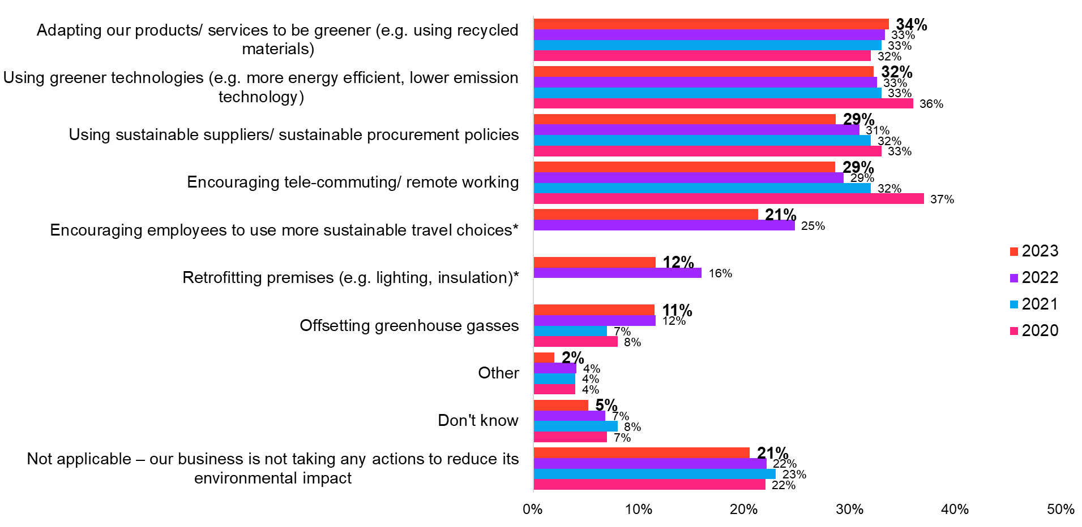Base: All respondents (2020=1,251; 2021=1,276; 2022=1,369; 2023=1,271)  
*option not asked in all years

### Barriers and motivators to lower emissions

Given that businesses continue to face pressures from the ongoing cost of living crisis, it is perhaps unsurprising that businesses cited financial reasons as the biggest barrier to lowering emissions. Almost a quarter cited high initial upfront costs (23%) and a similar proportion selecting higher operating costs (22%) and lack of resources and time (21%).

This is consistent across business sizes and London regions; however, it is notable that London businesses in the retail (32%) and construction/ property (28%) sectors are far more likely than average to find that higher operating costs is one of the barriers to reducing their businesses’ emissions.

Costs continue to be seen as a priority for businesses when asked to choose a single main barrier to reducing their greenhouse gas emissions – about one in ten say either the initial (9%) or operating (11%) costs are the primary barrier. However, a similar proportion report reducing greenhouse gases is not appropriate for their business (12%) and this rises to a fifth (21%) of businesses in East London.

In a similar vein to when companies were asked to choose multiple barriers, issues concerning costs continues to be largely consistent across business sizes and by London region, while at an industry level, those in construction/ property (18%) and retail (20%) are most likely to cite higher operating costs as their barrier to lowering emissions.

1. Barriers to taking action to reduce emissions

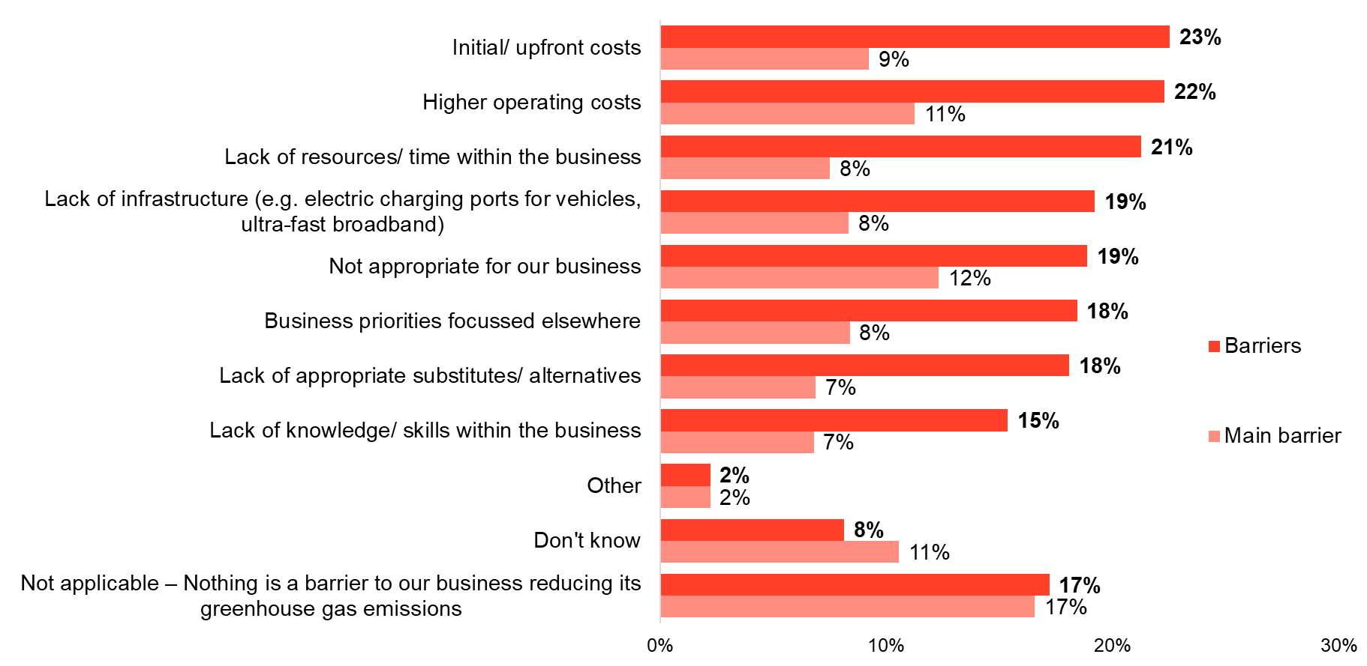  
Base: All respondents (2023=1,271)

Despite these barriers, there has been a rise since 2021 in the proportion of businesses that say they have the skills to successfully reduce their emissions (31% 2021, 32% 2022, 39% 2023). Comparable with previous London Business 1000 surveys, large businesses are significantly more likely than micro/ small firms to say that they have the necessary skills (39% micro/ small, 55% medium, 56% large). The divide becomes more apparent given that micro/ small firms are also three times more likely than large businesses to report that they do not have access and do not know how to access the necessary skills (21% micro/ small, 10% medium, 7% large).

Regional factors also appear to have an impact on whether a business reports to have the skills necessary to reduce emissions, with Central London companies being far less likely than any other region to believe they have the necessary skills to reduce their emissions (34% Central, 46% East, 45% South, 41% West).

Interestingly, unlike other years where companies in the information and communication/ professional services industries were most likely to say they have the necessary skills, those in the motor trades, wholesale transport and storage and retail industries (both 54%) are now the most likely to say they have the necessary skills to reduce their emissions – a strong recovery from over three in ten reporting this to be the case last year (wholesale transport and storage: 33%; retail: 31%). In contrast, those in the construction/ property (31%) and accommodation & food services (30%) sectors are least likely to say they have the skills to reduce their emissions – a figure which is comparable with last year.

1. Whether business has necessary skills to reduce carbon emissions

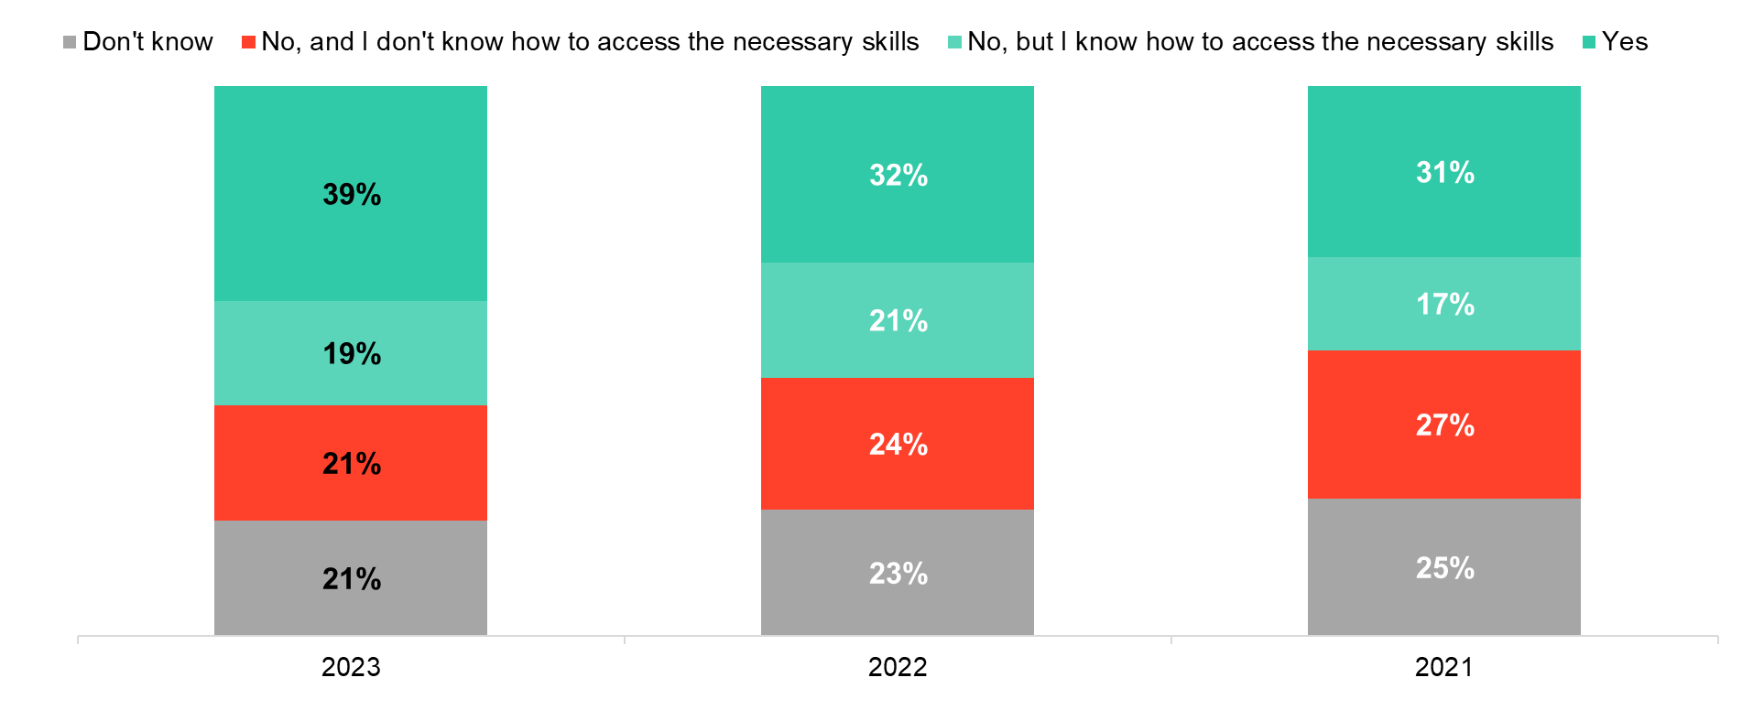Base: All respondents (2021=1,276; 2022=1,369; 2023=1,271)

As mentioned earlier in the chapter, large proportions of businesses find costs as a key barrier to reducing their emissions. It therefore follows that financial incentives to lower emissions prove to be popular amongst London businesses (28% cite a desire for green grants and 37% for tax breaks for environmentally friendly businesses).

While firms of all sizes are receptive to tax breaks for environmentally friendly businesses, large businesses are significantly more likely than micro/small firms to want green grants for energy efficiency work (28% micro/ small, 32% medium, 37% large). Differences for such financial support become more pronounced at a regional level, with companies based in Central London being far more receptive than any other London region to tax breaks for environmentally friendly businesses (43% Central, 29% East, 30% South, 35% West).

There is also clear support amongst businesses for greater involvement from local councils both in terms of providing enhanced recycling services (29%) and providing more information about how to improve sustainability (25%). Businesses based in East London report to be particularly receptive to direct council support to be more sustainable whether this be green skills support and business opportunities (24%) or more information about how to improve sustainability (30%).

In contrast, businesses in South London (24%) are more much more likely than average to believe that there is nothing their local borough can do to help them improve their sustainability. A similar story is seen amongst micro/small firms, who are far more likely than large businesses to believe that there is nothing their local council can do to improve their sustainability (15% micro/ small, 10% medium, 10% large).

1. Desired support from local councils

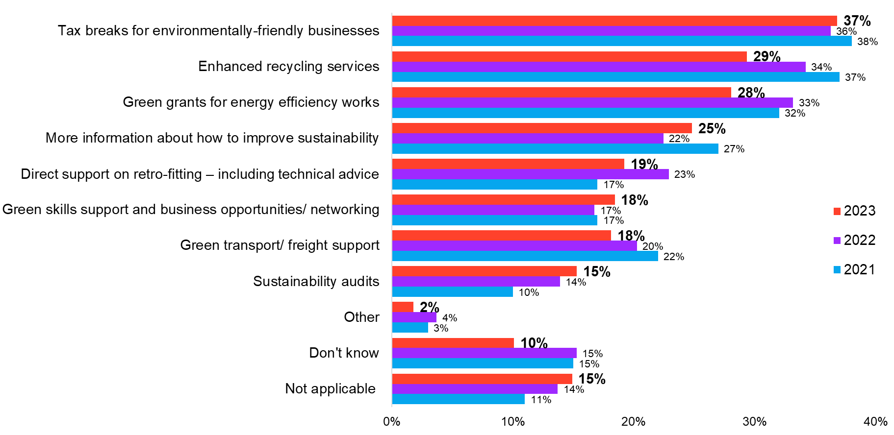Base: All respondents (2021=1,276; 2022=1,369; 2023=1,271)

## Crime

### Experiences of crime

This year, a new module of questions was included, exploring London businesses’ perceptions and experiences of crime in the capital. Half of London businesses think that the level of crime has increased in the last 12 months. One in five (20%) say their business has directly experienced crime in the last 12 months.

The perception of crime is consistent across London regions and business sizes, but there is variation across industry. Those in motor trades/ wholesale/ transport and storage (58%) as well as those in construction/ property (56%) are the most likely to believe the level of crime has increased over the last year. Around half of those in the retail industry think that the level of crime has stayed about the same (47%), although 38% believe it has increased.

Three in ten businesses in the East of London have experienced a crime (17% Central, 31% East, 17% South, 19% East). A similar proportion in the construction/ property industry report experiencing a crime (29%).

1. Perception and experience of crime in last 12 months

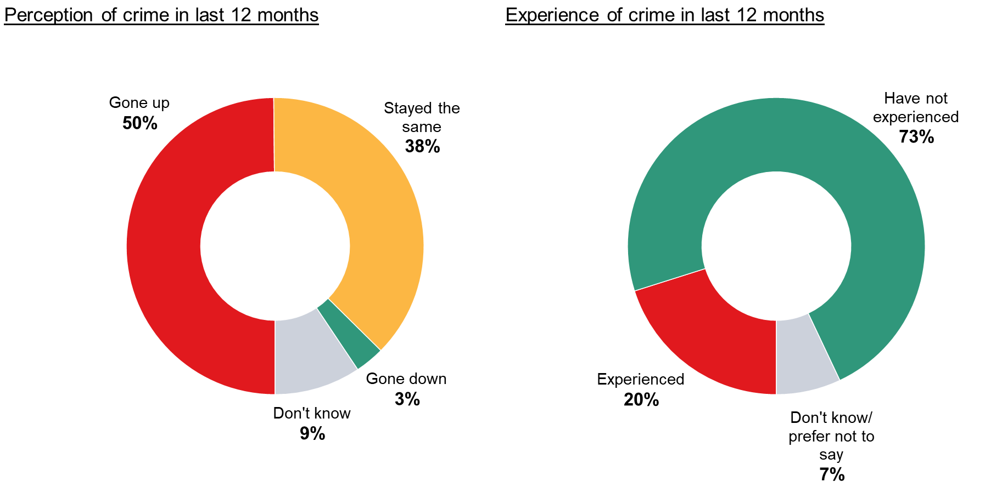 Base: All respondents (2023=1,271)

The most common form of crime experienced is theft/ armed burglary (54%), followed by physical damage to goods or property (38%). The latter is very likely in East London, where around half of those who have experienced crime in the last 12 months say it was physical damage to goods/ property (48%). A fifth of London businesses who have experienced crime say it was fraud (21%) or workplace violence (20%).

1. Of those who experienced crime, type experienced

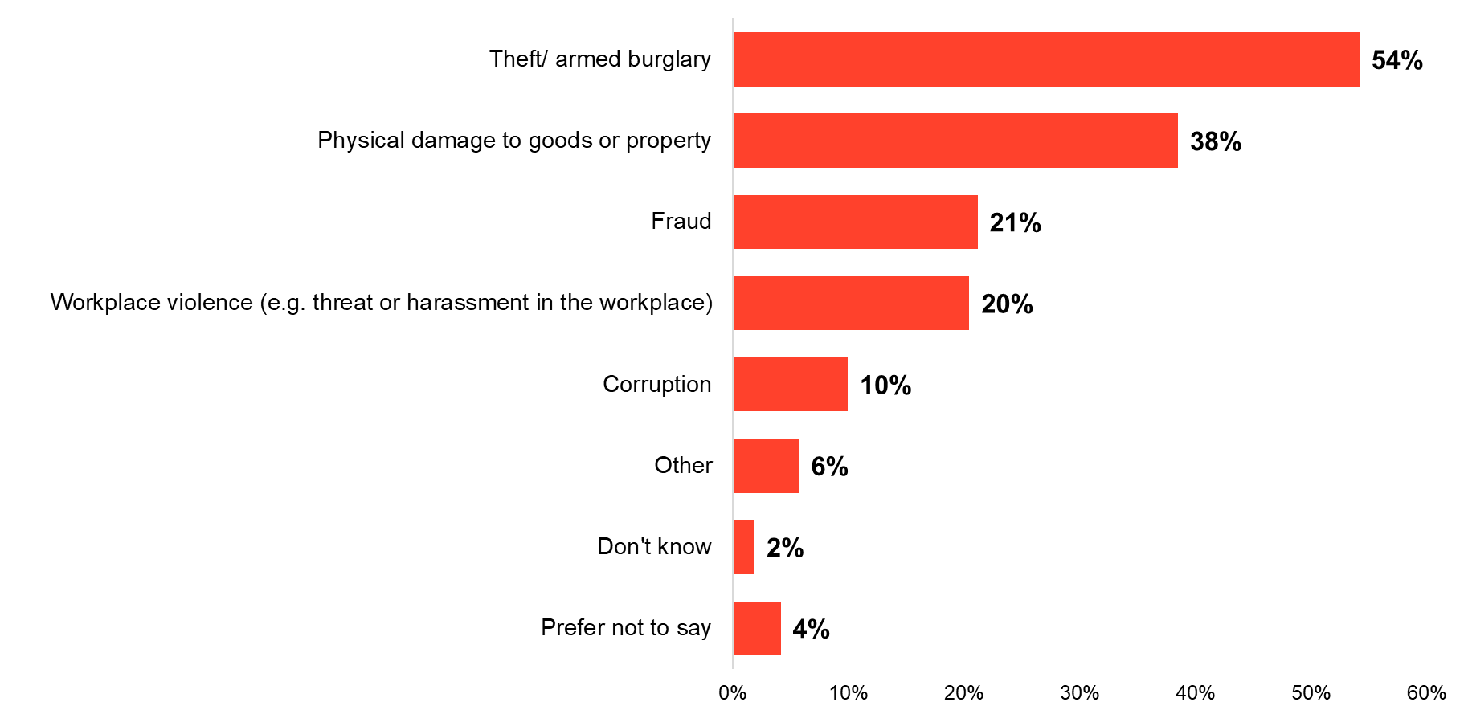 Base: All whose business has experienced crime (2023=285)

### Reducing vulnerabilities

Three quarters (75%) of London businesses take some action to reduce their vulnerability to crime. The most common activities are to install security measures (33%), take out insurance (32%), or invest in cyber protection (30%).

Over half (52%) of large businesses said they had invested in cyber protection for their firm, much higher than for micro/small (30%) and medium sized (39%) companies. Large businesses tend to be much more likely to do each activity to prevent their vulnerability to crime. The exception is insurance, where around a third take this step regardless of business size (32% micro/ small, 34% medium, 35% large).

Those in East London are the most likely to install security measures (30% Central, 40% East, 32% South, 34% West). Half of those in the motor trades/ wholesale/ transport and distribution industry say they do this (51%), with a similar proportion in the production/ agriculture sectors (47%). Those in production/ agriculture are also the most likely to conduct background checks (29%), followed by those working in public administration and defence/ education/ health (26%).

1. Actions taken to reduce vulnerability to crime

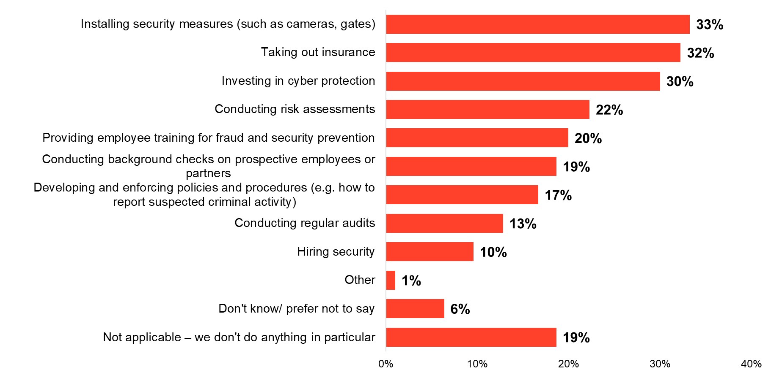 Base: All respondents (2023=1,271)

When it comes to what would reduce the likelihood of crimes against businesses in London, half (48%) think greater resources for police is the answer – although this falls to two fifths in East London (51% Central, 42% East, 50% South, 47% West). A third (34%) think greater involvement of local authorities would help, which is consistent across all London regions, while three in ten think support from cyber security firms (29%) or greater involvement from government agencies would help (29%).

In line with their greater likelihood to take steps for cyber protection, large businesses are more likely than micro/small firms to think support from cyber security firms would be useful (29% micro/ small, 29% medium/ 36% large). Medium-sized organisations are more likely than micro/small firms to turn to resources from industry associations (15% micro/ small, 23% medium, 19% large).

Retail businesses are the least likely to think greater resources for police would reduce crime in London (34%), compared to over half (56%) of those in the motor trades/ wholesale/ transportation and storage industry. Those in retail are the most likely to say they would welcome more support and resources from industry associations (28%).

1. What would reduce likelihood of crimes against businesses in London

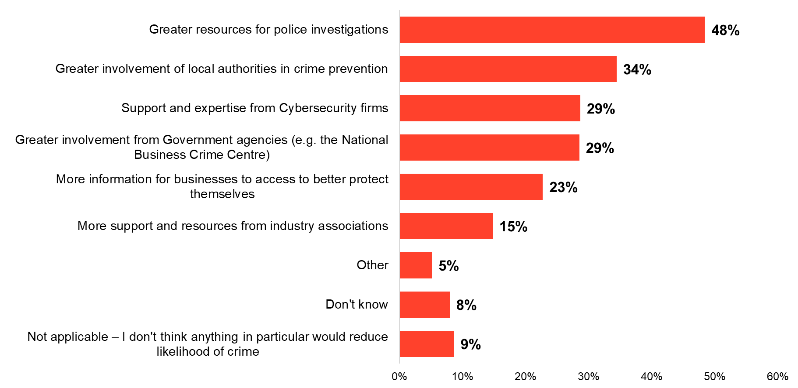 Base: All respondents (2023=1,271)

## Conclusions

London businesses are clear – building new homes should be a key focus for national and local government. It is a top priority identified for the next UK government, joint with tackling the impacts of climate change. Locally, while public transport remains the top choice for investment of business rates, there has been a sharp rise in the proportion saying it should be used to build new homes. There is also support for increasing devolution on housing, with a third strongly agreeing that local councils should have more freedoms to fund and build new homes. The impact of a shortage of homes is seen across the capital, with half of businesses saying that the cost of housing has a negative impact on their ability to recruit and retain staff.

Housing is not the only pressure facing businesses, although the cost of living issue is an underlying factor across many challenges. The cost of transport is also detrimental to recruitment and retention of staff for over two fifths of businesses, and investing in public transport remains the top priority for investment of business rates. Businesses are responding to rises in inflation themselves, with three quarters making operational changes and six in ten making a change to their workforce. A quarter of London businesses say that one of the workforce changes is to increase their wages/ incentive schemes, but pressure to increase wages remains the top workforce challenge over the coming year.

Despite these challenges, two thirds of businesses are intending to recruit over the next year and nearly half plan to grow their headcount rather than simply back-fill roles. Professional/ managerial roles remain the most in-demand, continuing an upward trend since 2018. This recruitment focus echoes the demand for managerial skills, with a fifth now reporting challenges around their current workforce’s management/ interpersonal skills or leadership skills.

New staff are often a key source of getting new skills into the business and there has also been strong uptake of apprenticeships among micro/ small businesses. Further gains could be made here – only a fifth report employing an apprentice, and uptake amongst medium or large businesses has not grown. Businesses still see barriers to employing apprentices, with a third continuing to report that apprentices do not meet their businesses’ needs. Although there appears to be increased engagement with local authorities around apprenticeships, a majority still report that they have had no engagement on this point at all.

More support would be welcomed on a range of topics, including sustainability. Although three quarters of London businesses have taken some form of action to reduce their emissions, costs are a particular barrier. Just over a fifth cite either the upfront or operating costs as a barrier to their business lowering emissions and the most popular form of support would be tax breaks for environmentally friendly businesses. However, a quarter of businesses simply want more information about how to improve their sustainability – an area which local authorities could directly impact.

London businesses would also welcome direct involvement from local authorities to reduce crime – over a third think this would help reduce crime in the capital. Half of businesses think the level of crime in London has increased in the past 12 months while a fifth have directly experienced an incident of crime against their business. While most are taking steps to reduce their own vulnerability, the appetite for engagement with local councils is clear.

## Appendix A: Sub regional spotlight

While data was collected for London as a whole, in this section it has been split out into four sub-regions. London’s boroughs are currently divided into four sub-regional partnerships:

* Central London
* East London
* South London
* West London

### Central London

#### Devolution and government

* Decision-makers within Central London businesses are the most likely to think that the next national government should prioritise tackling climate change (34% Central, 28% East, 25% South, 21% West). They agree with those in West London that the top three national priorities should include easing international trade restrictions (30% Central, 17% East, 22% South, 28% West).
* Thinking about priorities for investing business rates, just over half in Central London think the revenue should go towards improving public transport (53% Central, 39% East, 42% South, 39% West)
* Central London businesses are the most unsure about whether local London councils should have more community safety and policing powers (14% Central, 9% East, 10% South, 11% West).

#### Skills and training

* Those in Central London are the most likely to say that pressure to increase wages is a key challenge for the next 12 months (45% Central, 39% East, 32% South, 25% West). They are the least likely to name challenges around automation (5% Central, 9% East, 9% South, 12% West) or staff ill with COVID-19 (5% Central, 14% East, 9% South, 8% West).
* Central London businesses are more likely to struggle with technical/ job-specific skills in their current workforce (29% Central, 22% East, 16% South, 21% West), but are less likely to face challenges around other skills.

#### Recruitment

* Central London businesses are more likely than any other London region to demand for professional/ managerial roles (Central: 67%; East: 54%; South: 57%; West: 52%).
* Moreover, decision-makers in Central London are far more likely than any other region to say that the cost of housing (Central: 62%; East: 36%; South: 35%; West: 47%) and cost of transport (Central: 52%; East: 34%; South: 36%; West: 39%) in London over the past 12 months had an impact on their ability to recruit staff.

#### Apprenticeships

* Those in Central London are least likely to report that they currently employ apprentices (Central: 9%; East: 37%; South: 30%; West: 21%) and are similarly least likely to know their company is required to pay the Apprenticeship Levy (Central: 8%; East: 35%; South: 25%; West: 19%).
* Likewise, Central London businesses are also far less likely than other London regions to say that they will apprenticeship funding over the next 12 months (Central: 9%; East: 38%; South: 27%; West: 18%).
* One in ten Central London companies report that they had engagement from their local authorities regarding apprenticeships – a far lower reported level than any other London region (Central: 8%; East: 38%; South: 31%; West: 25%).
* Similarly, Central London businesses are also far more sceptical than other regions about the effectiveness of any changes to the Levy, as seen by views regarding making the Levy simpler (Central: 43%; East: 63%; South: 57%; West: 52%), making it a wider training Levy (Central: 35%; East: 57%; South: 52%; West: 46%), allowing more Levy funds to be transferred to other employers you work with (Central: 30%; East: 56%; South: 41%; West: 49%), and allowing it to contribute to paying for wages (Central: 43%; East: 60%; South: 54%; West: 54%).

#### London’s business environment

* Firms in Central London are the least likely to be undertaking an operational change in response to inflationary pressures (72% Central, 85% East, 82% South, 79% West). In particular, they are the least likely to say they are reducing prices of their products/ services (7% Central, 18% East, 14% South, 13% West).
* Those in Central London are the most likely to say their business has a diversity and inclusion policy (40% Central, 28% East, 24% South, 21% West) or that they have implemented inclusive employee development (26% Central, 18% East, 15% South, 12% West).

#### Sustainability strategies

* Central London businesses are far less likely than other London regions to believe they have the necessary skills to reduce their emissions (Central: 34%; East: 46%; South: 45%; West: 41%).
* Central London businesses are more likely than any other business region to be receptive to receiving tax breaks for being environmentally friendly (Central: 43%; East: 29%; South: 30%; West: 35%).

### East London

#### Devolution and government

* Decision-makers in the East of London are the most likely to think that building affordable housing is a key priority for investing the revenue from business rates (21% Central, 31% East, 21% South, 23% West).

#### Skills and training

* When thinking about their workforce challenges for the next 12 months, those in the East of London are the most concerned about skills shortages in their current staff (15% Central, 23% East, 13% South, 16% West) or about staff ill with COVID-19 (5% Central, 14% East, 9% South, 8% West).
* Businesses in East London are the most likely to be facing skills challenges among their current workforce (74% Central, 82% East, 75% South, 76% West). In particular, the most common skills challenges in East London are commercial awareness (17% Central, 24% East, 21% South, 18% West) and management/ interpersonal skills (22% Central, 24% East, 16% South, 15% West).

#### Recruitment

* East London (a similar level to South London businesses) businesses are least likely to say that they *did not* have difficulties in recruiting staff (29% Central, 15% East, 16% South, 29% West). Those in East London are also far more likely than other regions to report that they have difficulties in recruiting staff for professional/managerial roles (33% Central, 43% East, 31% South, 31% West).
* Those in East London are much more likely than other regions to report that the main difficulty in recruiting staff over the last 12 months was that they lacked CV writing/ interviewing skills (9% Central, 31% East, 18% South, 18% West).

#### Apprenticeships

* Decision-makers in East London are far more likely to find that a barrier to their business making more use of apprenticeships is that they do not enable workers to be efficiently trained (6% Central, 19% East, 9% South, 11% West).

#### London’s business environment

* In response to rises in inflation and the associated cost of living crisis, those in East London are the most likely to say they are taking any action (72% Central, 85% East, 82% South, 79% West). In particular, they are the most likely region to reduce prices (7% Central, 18% East, 14% South, 13% West), increase investment (7% Central, 18% East, 9% South, 8% West), or introduce new lines (16% Central, 26% East, 20% South, 14% West).
* Those in East London are also the most likely to take some form of workforce action in response to the cost of living crisis (60% Central, 69% East, 62% South, 57% West). They are the most likely to say they have/ plan to increase wages/ incentive schemes as a result (27% Central, 31% East, 25% South, 17% West).
* Consistent with their higher levels of action, those in East London are also the most likely to be doing at least one listed diversity, equality, and inclusion activity (64% Central, 70% East, 55% South, 53% West).

#### Crime

* Decision-makers in East London businesses are far more likely than other regions to report their business has directly experienced an incident of crime in the last 12 months (17% Central, 31% East, 17% South, 19% East). Of those who have experienced an incident, half say it was theft (52%) or physical damage to goods/ property (48%) and a fifth (20%) say it was related to corruption.
* They are the most likely to have taken some form of action to reduce their vulnerability to crime (71% Central, 85% East, 73% South, 76% West), and two fifths of businesses in East London have installed security measures to reduce their vulnerability to crime (30% Central, 40% East, 32% South, 24% West).
* However, they are the least likely to think greater resources for police would reduce the likelihood of crime (51% Central, 42% East, 50% South, 47% West). Rather, they are the most likely to think more information for businesses to better protect themselves would help (20% Central, 29% East, 20% South, 24% West).

### South London

#### Skills and training

* Although one of the top challenges overall, those in South London are the least likely to say that staff retention will be a workforce challenge for their business over the next 12 months (29% Central, 23% East, 18% South, 29% West).
* Those in the South are the least likely to face issues with their current staff’s technical/ job-specific skills (29% Central, 22% East, 16% South, 21% West).

#### Recruitment

* South London businesses are most likely to say that their headcount will increase over the course of the next 12 months (45% Central, 51% East, 57% South, 42% West).

#### Sustainability strategies

* Businesses in South London are more likely than any other region to cite that one of the barriers to taking more action to reducing emissions is that it is not appropriate to their business (15% Central, 21% East, 31% South, 16% West).
* Likewise, when asked to choose a single barrier, South London businesses were still more likely than any other region to believe that it is not appropriate for their business (10% Central, 13% East, 21% South, 11% West). Contrastingly, they are far less likely to believe that that a barrier to reducing carbon emissions is a lack of appropriate substitutes (7% Central, 10% East, 2% South, 8% West).

#### Crime

* Less than a fifth of senior decision-makers in South London businesses report experiencing a crime in the last 12 months (17% Central, 31% East, 17% South, 19% East).
* Businesses in South London are the least likely to provide employee training on security and fraud prevention (23% Central, 24% East, 12% South, 15% West).

### West London

#### Devolution and government

* Those in West London are the most likely to say reforming business rates should be one of the next UK government’s top three priorities (18% Central, 24% East, 25% South, 29% West). In line with Central London, they think one of the national priorities should include easing international trade restrictions (30% Central, 17% East, 22% South, 28% West).

#### Skills and training

* Decision-makers in West London are the least likely to say that pressure to increase wages is a challenge for the next 12 months (45% Central, 39% East, 32% South, 25% West). However, they are the most likely to say automation is a concern (5% Central, 9% East, 9% South, 12% West).

#### Recruitment

* West London senior decision makers are least likely to report that they expect to recruit staff over the next 12 months (67% Central, 67% East, 65% South, 54% West). Likewise, West London businesses are also least likely and much less likely than Central London businesses to say that they had recruited staff over the past 12 months (67% Central, 62% East, 66% South, 57% West).

#### London’s business environment

* West London businesses are the least likely to be increasing wages/ incentive schemes in response to the cost of living issue (27% Central, 31% East, 25% South, 17% West). Over a third (37%) say their business is not making any workforce changes at all.
* Those in West London are the least likely to be doing any listed diversity, equality, or inclusion activity (64% Central, 70% East, 55% South, 53% West).