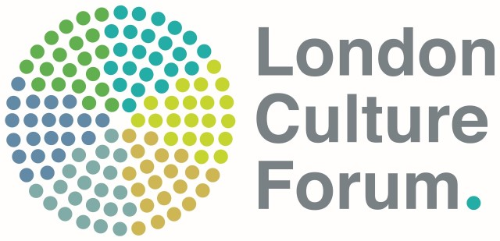

Evolve Collaborative fund criteria and application process

What is Evolve?
Evolve is led by the London Culture Forum in response to a desire to create opportunities to enable learning from the legacy of London Borough of Culture, as well as supporting the professional development of local authority culture officers. Evolve is funded by the Greater London Authority.

Evolve was developed consultation with local authority culture officers in London Boroughs, and a key element of the programme is focussed on creating opportunities to develop collaborative working across the Capital through cross-borough partnerships.

The Evolve Collaborative Fund

Through a dedicated fund, Evolve will support 2 partnerships to work together to identify potential projects or approaches to addressing common strategic priorities.

The partnerships can consist of up to 4 boroughs who will work collaboratively to develop and/ or deliver a project between January and June 2021. We are happy to consider applications, where this initial 6 month phase is used as development time, working towards a more significant project.

What is on offer for successful applicants?
Each of the successful partnerships will be offered:

- A grant of £3k. This can be used to support the development of the partnership and the project – for example, as seed funding, or to bring in relevant expertise.

- Up to four facilitated reflective learning sessions to support everyone involved in each partnership to develop the project, and to have an opportunity to reflect on their own professional practice. These will take place between January and June 2021, with the timeframe set wth each partnership.

How to apply:
To apply, please submit a written proposal (max 2 pages) that sets out:
- The aims of your project, and the strategic priorities it addresses
- The names/ boroughs of all partners involved – and confirmation of the lead borough, who will receive the grant
- How you intend to ensure a collaborative process to the project
- Your anticipated outcomes of the project; and of working collaboratively
- Proposed timeline
- A description of your commitment to include diversity and inclusion within the project
- Confirmation that you will be able commit staff time to deliver the project
- Anticipated budget, and proposed use of the Evolve grant – to include any in-kind costs to help increase the impact and reach of the project

Deadline for applications is 5pm on 11 January 2021
Please submit applications to: hello@amandasmethurst.com

How will the successful partnerships be selected?
A sub-group of the London Culture forum will assess the proposals, against criteria of:
- Commitment to collaborative working
- Potential impact of the project
- Value for money
Successful applicants will be notified by 20 January 2021.
The grant will be paid in two parts - 80% at the beginning of the partnership, and the remaining 20% on completion of a project report.

Evaluation:
Successful applicants will be asked to contribute to the evaluation of the Evolve programme, which may include submitting a short and simple report, and an evaluation interview with Sarah Boiling, Evolve evaluator.

