

***Lewisham: ‘Moving towards a Trauma-informed Youth Offending Service: more effective work with young people and partners, better support for staff***



* Consistent and meaningful contact and trusting relationships
* ‘Voice’ of young person heard
* Removal of bias labelling and re-victimisation
* Moving to secure, organised attachments
* Reducing fear through reduced stress/anxiety
* Partners co-delivery of the approach
* Monthly 1-1 clinical supervision for staff
* Co-production and case formulation
* Intensive and consistent practitioners
* Interventions that process trauma to manage behaviour

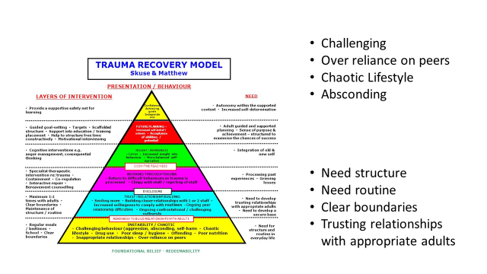

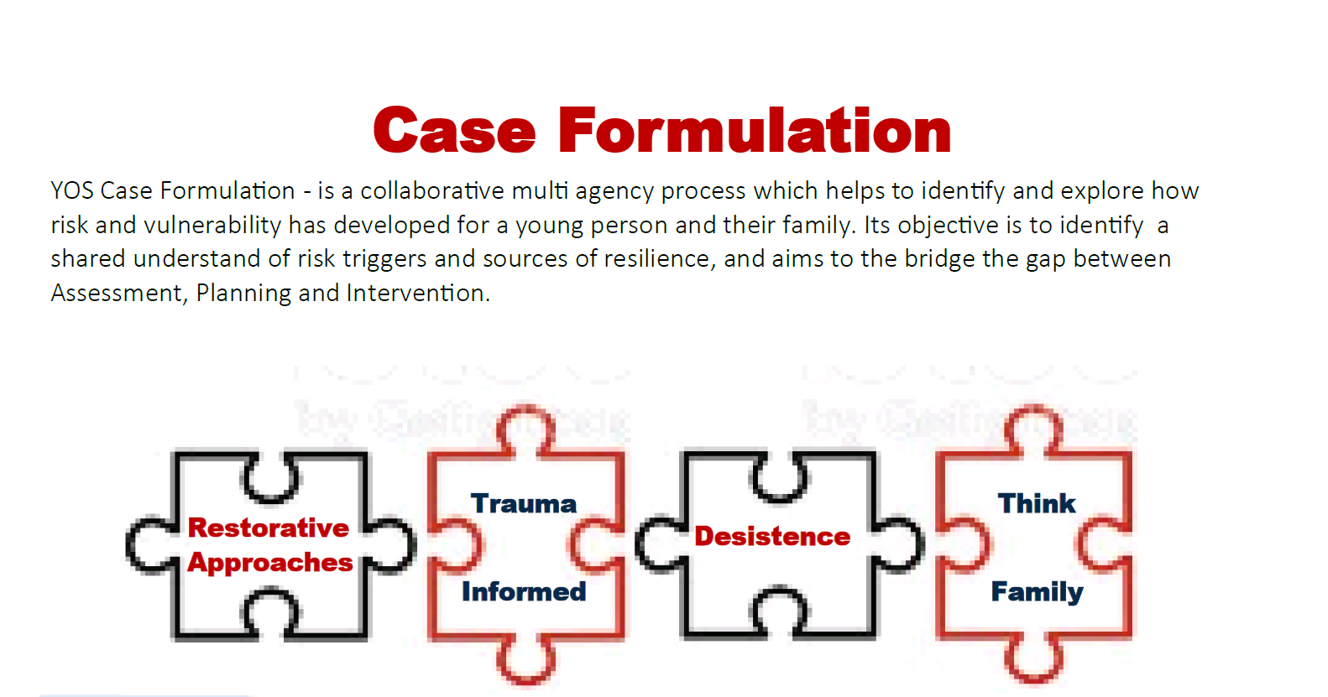

**Improved knowledge and awareness for staff around the impact and effects of both early childhood and accumulative trauma:**

Studies of trauma among groups of young people found that:

* 91% of violent young offenders have experienced abuse or loss
* 40% of female and 25% of male youth in custody have suffered violence at home
* 33% of female offenders have suffered sexual abuse

Research also indicates that offenders are more likely than non-offenders to have suffered adverse effects from traumatic experiences, which appear to be linked to offending behaviour. Trauma can result in inappropriate aggression and is strongly associated with a range of problematic behaviour including violence, antisocial/criminal conduct, sex offending and substance misuse.

As such, it is important that all professionals working with young people have a firm understanding of the neuro scientific impact of trauma and are equipped with the skills to deliver effective interventions across the voluntary, statutory and private sectors, including youth clubs, health centres, schools and alternative education provision.

Professionals working with young people who are at any risk of offending, who are known to have offended and are involved in serious violence should be aware of the impact that trauma can have on these young people’s behaviour and should have the skills to deliver interventions in a trauma informed manner. Additionally, the emphasis on staff self-care, wellbeing and resilience as the key to effective practice is a significant benefit.

**Linking Restorative Practice with a Trauma-informed Response allows a specific focus on an incident** to create opportunities for emotional learning and shift from blame and shame thereby contributing to greater capacity to address historical trauma.

Lewisham Youth Offending Service is committed to supporting other key services and environments who work with children in developing Restorative and Trauma-informed approaches.

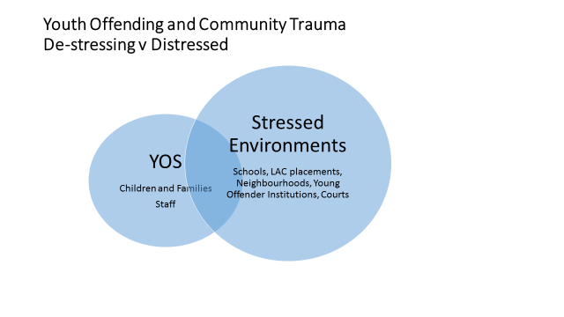

**What are we doing differently?**

* Training for all staff 8 and 3 days of training + ongoing clinical support
* Training for managers 3 full day
* Clinical supervision– Vicarious Trauma acknowledged and exists
* Use of a new narrative for explanations and conclusions. Pathways and Planning: ACES, Resilience, name it – neglect, abuse, DV, CSE
* Use of learning opportunities to reinforce training. Practice forum, team meetings, and whole service meetings.
* Revision of all policies and programs including the piloting of a Trauma-Informed Violence Reduction Program for YOS cohort

**What difference for Staff?**

* Increased commitment and connection to the workplace
* Being mindful of self-care to perform and deliver improved outcomes
* Greater awareness of others welfare; partner services, peers and managers
* Model to understand and respond to high risk and violence
* Compatibility with other approaches which address victim-offender cycle ( restorative, contextual risk)
* Relevance to wider partnership approaches to reduce re-offending: police, schools, social work, neighbourhood, business community

Keith Cohen – Lewisham Strategic Youth Offending Service Manager

**Points from HMIP Inspection (2018) APPENDIX 1**

**Key Points for recording:**

**ASSESSMENT**

***Assessment is well-informed, analytical and personalised, actively involving the child or young person, their parents/carers.***

**PLANNING**

***Planning is driven by the assessment, holistic and personalised, actively involving the child or young person, their parents/carers.***

**IMPLEMENTATION & DELIVERY**

***High-quality, well-focused, personalised and coordinated services are delivered, engaging and assisting the child or young person.***

**REVIEWING**

***Reviewing of progress is well-informed, analytical and personalised, actively involving the child or young person, their parents/carers.***

**Lessons for recording:**

* Specifically record how you are actively involving the YP / family & significant others
* How is your recording reflecting your relationship & engagement with the young person?
* Every area of YOS case management activity (assessment / planning / implementation & delivery / reviewing) is unique & specific to that young person. Avoid repeating standard headings where possible particularly within objective planning.
* Wide sources of information are expected – *young person, their parents/carers and significant others* – to inform holistically the assessment & planning
* Show your understanding about what the information means for the young person and your work with them?
* Demonstrate where others are involved – their roles and tasks – show this coordination especially within the planning & delivery – and ensure other agency plans are within the file where possible.
* Continuity / golden thread / links across the file showing how - through the assessment, planning, interventions and reviews you are responding to safeguarding / wellbeing & risk issues throughout the case management and what contingencies you are putting in place.