London Councils Summit 2015, Saturday 21 November

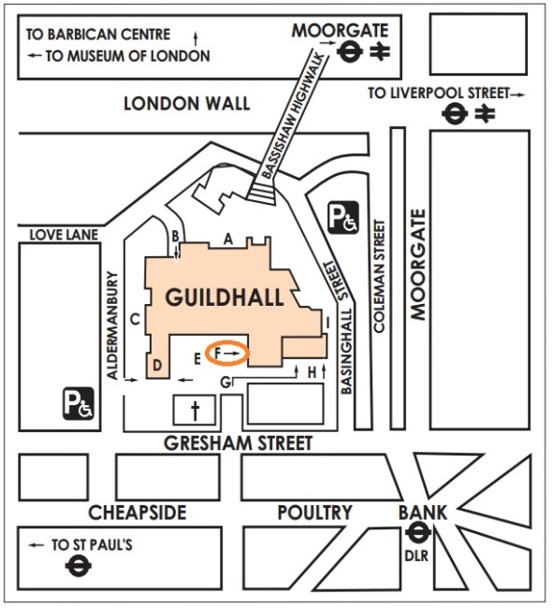
Location & travel
The Guildhall (art gallery entrance circled ‘F’ on map), Gresham Street, EC2V 7HH
You are advised to check on www.tfl.gov.uk for travel disruption. On 21 November there are planned engineering works on the District and Hammersmith & City lines.

The nearest tube stations: Moorgate (Hammersmith and City, Metropolitan, Circle and Northern), Bank (Northern, Central, Waterloo and City and DLR), Mansion House (District and Circle) and St Paul's (Central). The nearest train stations: Cannon Street, Liverpool Street & Blackfriars. There is no parking at the venue.

Programme for the day
09.15
Registration, refreshments and micro-surgery advice sessions*

10.00
Opening session chaired by John O’Brien, chief executive, London Councils
Mayor Jules Pipe, chair, London Councils
Mark Boleat, chair of policy and resources committee, City of London Corporation

10.20 – 11.10
Ben Page, chief executive of Ipsos MORI delivers the findings of research commissioned by London Councils into the views of Londoners on key issues in the capital

11.10 – 11.45
Refreshment break and micro-surgery advice sessions

11.45 – 1.00pm
What the future holds for boroughs after the Spending Review: panel discussion & Q&A
A discussion of the likely impact of next week’s Spending Review on London’s local public services and councils. The financial, service and political challenge will be considered, followed by a question and answer session.
Cont’d

Chaired by Cllr Lib Peck, leader, LB Lambeth and London Councils executive member for crime and public protection
Panellists: Tony Travers, director, London School of Economics, Joanna Killian, head of local government, KPMG UK, Ben Lucas, managing partner, Metro Dynamics

1.00–2.10
Lunch and micro-surgery advice sessions

2.10-3.10
Breakout 1: Keeping our boroughs green
Breakout 2: Getting more young people into work
Breakout 3: Transforming communities
See the event website for details www.londoncouncils.gov.uk/summit2015

3.10 – 3.20
Refreshment break

3.20 – 4.00
Tony Travers and Robert Gordon Clark review the General Election and take an early look at the elections for the London Mayor and Assembly, followed by Q&As, chaired by Heather Jameson, editor of The MJ.

4.00 CLOSE

* Micro-surgeries (informal drop-in advice sessions held during registration, the morning break and lunch):
Association for Public Sector Excellence: Income generation and commercialisation - Explore how your authority can generate new income through commercial approaches to service delivery.
London Councils: Freedom Pass - Talk to the Freedom Pass team about the concessionary travel scheme for older and disabled Londoners funded by boroughs, and the renewal programme starting in January 2016 that may affect your residents.

For further information visit the event website www.londoncouncils.gov.uk/summit2015

