***Greater London Provincial Council***

***Annual General Meeting***

|  |  |  |  |  |  |  |  |  |
| --- | --- | --- | --- | --- | --- | --- | --- | --- |
| Thursday 19 October 2023 11.30am (or on the rising of the Employer/ Union sides) | | | | | | | | |
|  | | | | | | | | |
| Employers’ Side: | | Virtual Meeting via MS Teams | | | | 10.45am | | |
| Union Side: | | Virtual Meeting via MS Teams | | | | 10.45am | | |
| Contact Officer: | | Debbie Williams | | | | | | |
| Telephone: | | 020 794 9964 | Email: | debbie.williams@londoncouncils.gov.uk | | | | |
|  | | | | | | | | |
| Agenda item | | | | | | |  | |
| **1.** | **Apologies for Absence** | | | | | |  | |
| 2. | Election of Chair and Vice-Chair for 2023-24 (The Chair alternates between the two sides. This year it is the turn of the Trade Union Side to Chair the GLPC). | | | | | |  | |
| 3. | Listing of the membership of the GLPC as determined by Leaders Committee and Co-Secretaries of the GLPC | | | | | | Attached | |
| 4. | **Notes of previous meeting held on 18 May 2023 including any matters arising** | | | | | | Attached | |
| 5. | **Hybrid Working arrangements –** Steve Davies, Employers Side Secretary | | | | | | Attached | |
| 6. | **Local Government Pay Claim 2023 –** Steve Davies, Employers Side Secretary | | | | | | Attached | |
| 7. | **National Association of Regional Employers (NARE) Data Project – Information Item** – Steve Davies, Employers’ Side Secretary | | | | | | Attached | |
| 8. | **Schedule of Outstanding Differences** | | | | | | Attached | |
| 9. | Any Other Business | | | | | |  | |
| 10. | **Date of Next Meeting – Thursday 6 June 2024** (Group meetings 10am and Joint Meeting 11.30am) | | | | | |  | |
| Helen Reynolds  Union Side Secretary  1st Floor, Congress House, Great Russell Street,  LONDON WC1B 3LS  Tel: 0845 3550845 | | | | | Steve Davies  Employers’ Side Secretary  59 1/2 Southwark Street  LONDON SE1 OAL  Tel: 020-7934 9960 | | |

**ITEM 3**

**GLPC Representatives – 2023-24**

|  |  |  |
| --- | --- | --- |
|  |  |  |
| |  |  |  | | --- | --- | --- | | **Borough** | **Rep** | **Party** | |  |  |  | | Barking & Dagenham | Sade Bright | Lab | | Brent | Muhammed Butt | Lab | | Bromley | Pauline Tunnicliffe | Con | | Camden | Richard Olszewski | Lab | | Ealing | Steve Donnelly | Lab | | Hackney | Carole Williams | Lab | | Harrow | David Ashton | Con | | Hounslow | Shantanu Rajawat | Lab | | Kensington & Chelsea | Kim Taylor-Smith | Con | | Lambeth | Jacqui Dyer | Lab | | Lewisham | Amanda De Ryk | Lab | | Southwark | Stephanie Cryan | Lab | | Sutton | Bobby Dean | LD | | Waltham Forest | Paul Douglas | Lab | | TBC | TBC | Con | |  |  |
|  |  |  |

**UNISON**

Helen Reynolds

Sean Fox

Mary Lancaster

Gloria Hanson

Clara Mason

Andrea Holden

April Ashley

Christine Lander

Simon Steptoe

Karen Westwood

**GMB**

Keith Williams

Penny Robinson

George Sharkey

Donna Spicer

Sonya Davies

**UNITE**

Gary Cummins

Mary Summers

Kath Smith

Susan Matthews

Jane Gosnell  
TBC (*Danny Hoggan’s replacement*)

**Minutes of the Greater London Provincial Council Joint Meeting**

**held on Thursday 18 May 2023 held at London Councils offices**

**In Attendance**

Employers Side

Cllr Muhammed Butt London Borough of Brent

Cllr Pauline Tunnicliffe London Borough of Bromley

Cllr Steve Donnelly London Borough of Ealing

Cllr Carole Williams London Borough of Hackney

Cllr Josh Rendell Royal Borough of Kensington & Chelsea

Cllr Alison Holt (Sub) Royal Borough of Kingston

Cllr Amanda De Ryk London Borough of Lewisham

Cllr Stephanie Cryan London Borough of Southwark

Cllr Paul Douglas London Borough of Waltham Forest

Union Side

Sean Fox UNISON

Gloria Hanson UNISON

George Sharkey GMB

1. **Apologies for Absence**

Apologies were received from Cllr Richard Olszewski (Camden), Cllr David Ashton (Harrow), Cllr Shantanu Rajawat (Hounslow), Cllr Richard Clifton (Sutton), Andrea Holden (UNISON) Helen Reynolds (UNISON), Christine Lander (UNISON), Mary Lancaster (UNISON), Clara Mason (UNISON) , April Ashley (UNISON), Simon Steptoe (UNISON), Clare Keogh (Unite), Danny Hoggan (Unite), Gary Cummins (Unite), Jane Gosnell (Unite), Kath Smith (Unite), Susan Matthews (Unite) and Keith Williams (GMB), Penny Robinson (GMB), Donna Spicer (GMB) and Sonya Davies (GMB).

1. **To receive the minutes of the meeting held on 18 October 2023 and take any Matters Arising**

The minutes of the meeting held on 18 October 2023 were agreed as a correct record.

Matters Arising

It was noted that the date in the last sentence at the bottom of Page 7 of the minutes should have been 18 May 2023 and not 28 May 2023.

There were no further matters arising.

1. **Settlement of dispute raised by the London Unions in relation to the non-deletion of the bottom point from the London pay spines on 1 April 2023**

Cllr Muhammed Butt (Brent) stated that it was good to see a good resolution on this issue, conversations have taken place with all parties and agreement reached. The outcome across London boroughs is for an uplift in pay for individuals, particularly part-time workers.

Sean Fox (UNISON) that the outcome was welcomed, and it was good that we did not have to go through a formal decision to get this agreed and implemented. Would be good if a survey be undertaken to find out if boroughs have implemented the uplift and if not, when they planned to do so.

Steve Davies, Employers Side Secretary responded that he is happy to undertake a survey.

Cllr Carole Williams (Hackney) asked if the question could also be asked on whether boroughs used the scales to do an uplift. Hackney does not use scale point 1 and 2 but would be good to know what other London boroughs do.

The report was noted.

1. **Local Government Pay Claim 2023**

Cllr Muhammed Butt (Brent) statedconversations were still taking place and that we are awaiting for the result of all three unions ballots.

Sean Fox (UNISON) stated that in general, we are balloting and that all authorities will have received letters of intent. UNISON’s ballot starts on 23 May, ends on 4 July. We have said to the National Employers that we are open to talk so would request that London Councils and members of this committee as National colleagues if they could come back to the table to have a further conversation and re-open negotiations. From a regional body this would be good.

George Sharkey (GMB) stated that GMB are going out to ballot members again on the actual action, which will be disaggregated balloting.

Cllr Muhammed Butt (Brent) stated that no one wants industrial action to happen, so we are all on the same page and am sure that the unions are aware of the extra added pressures councils are under currently especially with the cost-of-living crisis, rise in inflation etc. All of us as employers are asking central government for extra funding, which I know the unions are also doing so we will take this away.

Sean Fox (UNISON) responded that some joint lobbying of central government would never go amiss.

1. **London Living Wage Update**

Cllr Muhammed Butt (Brent) stated that it was encouraging to see that a few more councils had signed up to be London Living Wage (LLW) employers, we now have 26 London boroughs including the City of London. It is a good initiative to support staff as well as contractors along with supporting and encouraging our local businesses to come on board and pay the LLW.

Sean Fox (UNISON) stated that it was encouraging to see that more boroughs had signed up especially as it now crosses the political boundaries. We still have concerns about whether testing and monitoring is happening to actually make sure those organisations who have signed up are actually paying the LLW. Appreciate that with procurement that sometimes the conversations will need to take place when contracts are up for renewal.

Cllr Muhammed Butt (Brent) stated that most councils do look at the renewal date of contracts and start the conversations early about paying the LLW. We also must acknowledge that the single big cost to councils is the pay bill and bearing in mind the challenges we are facing the impact on councils is quite significant so when we end up having these conversations it is on the back of a lot of services being cut the bone.

Cllr Alison Holt (Kingston) stated that it is challenging times for all but have gone through the LLW foundation and have found them very helpful. It is challenging negotiating when contracts come up for renewal but also a helpful conversation. The process for contract renewal can be a long process so this needs to be raised.

Cllr Stephanie Cryan (Southwark) stated that that it is about having robust procurement procedures in place, so it is in every tender a borough does. If a contractor does not pay, then the council should not consider giving them the contract.

Cllr Muhammed Butt (Brent) stated that we will make sure that we continue to promote the LLW.

1. **Schedule of Outstanding Differences**

The report was noted that there were no outstanding differences.

1. **Any Other Business**

There was no further business.

**The meeting concluded at 11.37am**

**Date of Next Meeting –** Thursday 19 October 2023

Joint Meeting at 11.30am

Possibly online meeting



|  |  |  |  |  |  |  |  |
| --- | --- | --- | --- | --- | --- | --- | --- |
| Greater London Provincial Council | | | | | | | |
|  | | | | | | | | | |
| **Hybrid Working arrangements** | | | | | | |  | Item: 5 | |
| **Report by:** | | Steve Davies | | **Job title:** | | Regional Employers’ Secretary | | | |
| **Date:** | | 19 October 2023 | | | | | | | |
| **Contact Officer:** | | Steve Davies | | | | | | | |
| **Telephone:** | | 020 7934 9963 | **Email** | | [Steve.davies@londoncouncils.gov.uk](mailto:Steve.davies@londoncouncils.gov.uk) | | | | |

1. **Introduction/ Background**
   1. During the Coronavirus Covid-19 lockdown, social distancing and safe working arrangements that the Government and Public Health introduced between March 2020 and the summer of 2021, London boroughs had significant numbers of staff (over 60%) working from home or in an agile working arrangement. This has resulted in a fundamental change of approach to agile working.
   2. During the pandemic the union side joint secretaries and a group of London borough heads of HR had regular virtual meetings to share information about the way in which London boroughs were supporting staff and how working arrangements were being managed. These meetings were collaborative and helpful.
   3. Intelligence from the boroughs highlighted that most employees adapted well to the enforced agile working arrangements and have preferred to maintain a balance working arrangement between the office and home following the end of Covid 19 restrictions. This arrangement has led to the use of a relatively new term: *hybrid working* to describe it*.*
   4. This report summarises the approach the London boroughs have taken to the introduction of hybrid working.

1. **Key considerations for working in a Hybrid Way** 
   1. It should be emphasised that employee relations with union representatives was positive and productive during the pandemic and has continued in the approach that has been undertaken by boroughs towards hybrid working arrangements.

* 1. Effective communication is critical for hybrid working to be successful. Communications with staff was at the forefront during the pandemic and has continued during hybrid working with more intentional communication between team members.
  2. Technology plays a critical role in hybrid working. As a result of the pandemic many employees have had to get up to speed with new technologies such as online meetings and different communication tools.
  3. It is important to understand that agile or flexible working is not the same as remote working. Remote work focuses on a location. Agile/ flexible working covers a number of areas, including the how of work e.g the structure of tasks and responsibilities; when work is scheduled and how long it is scheduled for; and where the work needs to be done.
  4. Employee wellbeing support was a key consideration during COVID-19 and this has continued with signposting to workplace wellbeing champions, wellbeing information and/ or Employee Assistance Providers.
  5. When employees are working remotely or more flexibly assessment of performance is focussed on outcomes, contribution and value.

* 1. Hybrid/ virtual teams should have a common working timeframe that they operate within to ensure that team members can collaborate effectively together. There may be an expectation for coming into work on certain days or at certain times, and therefore arrangements need to be identified and specified within a relevant service/team/ amongst work colleagues that may be dependent on each other for work performance. It may also be possible for arrangements to be made specific to an individual, as opposed to a team if taking account of particular needs, e.g. personal health or caring arrangements.

* 1. Many more people are attracted to employers that provide flexible working arrangements and boroughs have been utilising their approaches in recruitment campaigns for jobs.

1. **London borough approaches to Hybrid Working** 
   1. All London boroughs have embraced the principles of hybrid working and have been working with staff and unions to ensure appropriate working arrangements are implemented for their workforce.
   2. London borough heads of HR have provided information about their approaches to hybrid ways of working. Responses were provided by 31 boroughs. Note – one borough failed to respond, and Richmond & Wandsworth provide a combined response for their organisations.

* 1. Outlined below is a summary of the responses to the survey questions.

1. Approx what percentage of your workforce is currently hybrid working?

|  |  |  |
| --- | --- | --- |
| 80% + | 60 - 79% | Less than 60% |
| 9 | 15 | 7 |

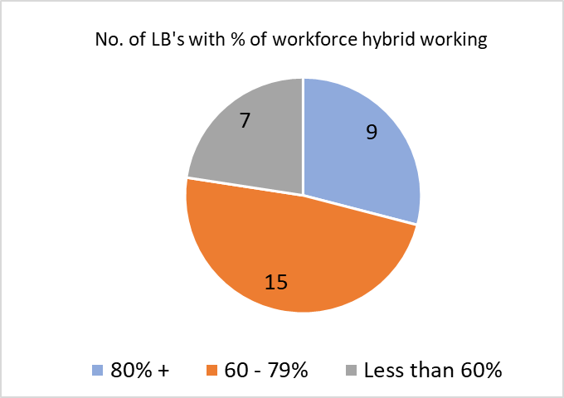

1. What is the current typical weekly approximate percentage occupancy level of your office accommodation?

|  |  |  |
| --- | --- | --- |
| Less than 20% | 21 - 40% | 41 - 60% |
| 6 | 9 | 14 |

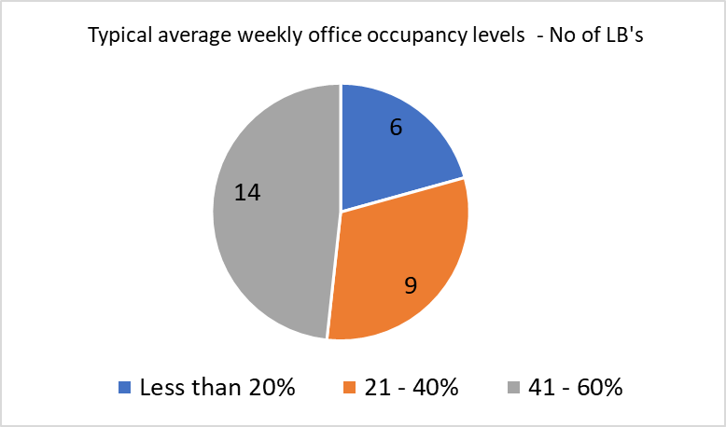

1. Describe your plans for hybrid working and office occupancy levels?

* In total 9 London boroughs highlighted plans for redesigning offices to more collaborative workspaces and reducing office accommodation - Barking & Dagenham, Barnet, Brent, Enfield, Greenwich, Haringey, Hounslow, Islington, Tower Hamlets.
* 14 LB's outlined Hybrid working arrangements.
* 6 LB's highlighted Hybrid working approaches and targets for getting staff in to the office at least 2 days per week.

1. Will you be offering full time homeworking contracts?

|  |  |  |
| --- | --- | --- |
| No | Only for a few staff by agreement | Yes |
| 24 | 5 | 1 |

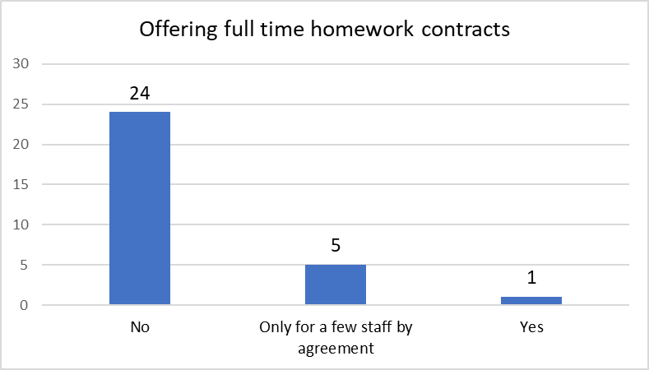

1. Will you permit contracts working from abroad?

|  |  |  |
| --- | --- | --- |
| No | In exceptional cases and for short term periods | Policy being developed, but only in exceptional cases |
| 17 | 4 | 9 |

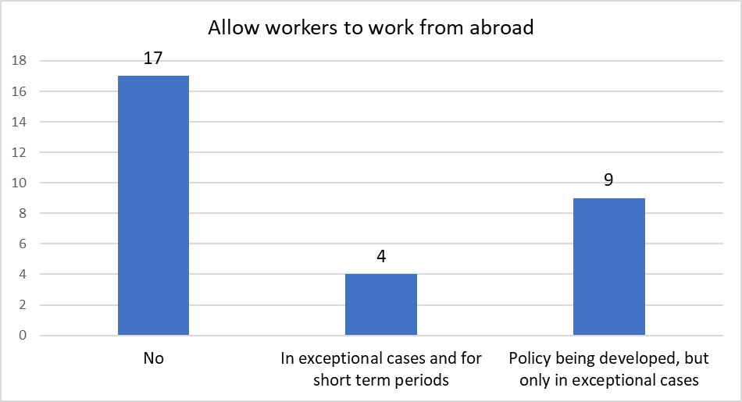



|  |  |  |  |  |  |  |  |
| --- | --- | --- | --- | --- | --- | --- | --- |
| Greater London Provincial Council | | | | | | | |
| **Local Government Pay Claims 2023** | | | | | | |  | Item: 6 | |
| **Report by:** | | Steve Davies | | **Job title:** | | Regional Employers’ Secretary | | | |
| **Date:** | | 19 October 2023 | | | | | | | |
| **Contact Officer:** | | Steve Davies | | | | | | | |
| **Telephone:** | | 020 7934 9963 | **Email** | | [Steve.davies@londoncouncils.gov.uk](mailto:Steve.davies@londoncouncils.gov.uk) | | | | |

**Purpose:** To report on the local government pay claims for 2023.

1. **Summary of the pay claims** 
   1. The NJC unions - UNISON, GMB and Unite - submitted their pay claim on 30 January 2023 for:

RPI (10.70 per cent as at Nov22) + 2.0 per cent on all pay points, plus a number of other things including a review of family leave, a review of the national pay spine, additional annual leave for personal or well-being purposes and a reduction in the working week by two hours.

* 1. The Chief Officers claim is for RPI (10.70 per cent) + 2%, plus an additional day of annual leave and an additional day for personal or well-being purposes (as per NJC 2023 claim).
  2. The Chief Executives claim is for a pay increase of the same percentage increase as SCP43 on the NJC pay spine (or, if NJC award is a cash figure, the equivalent percentage) and a direct link to increases to SCP43 going forward. They also asked for a review of Chief Execs’ 30-day minimum annual leave if the NJC is awarded an extra day.
  3. During February, Local Government Association officers together with National Joint Council Employer representatives conducted pay briefings with regional employer organisations.

1. **The National Employers offer and what it means for London pay**
   1. The National Employers agreed unanimously to make the following one-year (1 April 2023 to 31 March 2024), full and final offer to the unions representing the main local government NJC workforce:

* With effect from 1 April 2023, an increase of £1,925 (pro rata for part-time employees) to be paid as a consolidated, permanent addition on all NJC pay points 2 to 43 inclusive.
* With effect from 1 April 2023, an increase of 3.88 per cent on all pay points above the maximum of the pay spine but graded below deputy chief officer *(in accordance with Green Book Part 2 Para 5.42)*
* With effect from 1 April 2023, an increase of 3.88 per cent on all allowances *(as listed in the 2022 NJC pay agreement circular dated 1 November 2022)*
  1. This offer would achieve a bottom rate of pay of £11.59 with effect from 1 April 2023 (which equates to a pay increase of 9.42 per cent for employees on pay point 2) and everyone on the NJC pay spine would receive a minimum 3.88 per cent pay increase.
  2. The National Employers’ have identified that this offer, if accepted, means an employee on the bottom pay point in April 2021 (earning £18,333) will have received an increase in their pay of £4,033 (22.0 per cent) over the two years to April 2023. For an employee at the mid-point of the pay spine (pay point 22), their pay will have increased over the last two years by £3,850 (13.99 per cent).
  3. **In London** the national pay offer equates as follows:
  + An offer of £2,226 on Outer London pay points up to and including spine point 48.
  + An increase of £2,352 on Inner London pay points up to and including spine point 50.
  + Above pay points 48 and 50 on the respective London pay spines an increase of 3.88 per cent will apply.
  + Allowances, including overtime rates, to be increased by 3.88%
  1. In relation to other elements of the pay claim the National Employers’ proposed that the Joint Secretaries enter into exploratory *‘without prejudice’* informal discussions in order to map out the practical considerations **of how and when the pay spine might be reviewed** once the future policy direction of the National Living Wage has been confirmed. They have also offered again this year to “enter into discussions on the broader***family leave and pay issues*** (raised in the previous 2 years but not engaged with by the unions).
  2. The National Employers’ rejected the other elements of the unions claim, including extra leave and reduction of working hours.

*Chief Officers and Chief Executive’s*

* 1. The National Employers’ made a pay increase offer to Chief Executives of 3.5% from 1 April 2023.

* 1. An offer of 3.5% was also made to Chief Officers and the Employers’ rejected the claim for any additional day’s annual leave.
  2. On 5 May agreement was reached on the pay award for JNC Chief Officers applicable from 1 April 2023 (covering the period 1 April 2023 to 31 March 2024). There was increase to annual leave.

1. **The Unions response** 
   1. On Wednesday 8 March, the unions formally rejected the pay offer and signalled their intent to conduct ballots for industrial action.

* 1. All unions balloted on a disaggregated basis, which means strike action could be taken at each individual council or school where a turn-out of over 50 per cent is secured.

* 1. The GMB’s consultative ballot on the National Employers’ full and final pay offer closed on Friday 28 April. Unite’s consultative ballot closed on Monday 1 May. Both unions were recommending their members to vote to reject the offer.
  2. Both Unite and GMB unions secured strong numbers in favour of rejecting the pay offer and announced they were moving to formal ballots for industrial action.

* 1. Unite’s industrial action ballots were completed at the end of July and notification of outcomes announced during August/September. The requirements for industrial action were passed in 23 employers across the country and Unite members have been announcing industrial action across regions in England and Wales over the last 2-3 weeks. Unite is also re-balloting in certain councils, where action is strongly supported by reps and members.
  2. GMB has announced it will be conducting an industrial action ballot of members in over 2,000 employers in September and October, asking members to vote for strike action.
  3. On the 22 August, UNISON reported that the ballot was conducted with 345,000 members in more than 4,300 employers. They said that support during the ballot and pay campaign from UNISON members across England and Wales has been incredible; the turnout was a huge improvement on the 2021/22 industrial action ballot and that groundswell of feeling will only build as we continue to campaign on pay. UNISON stated that due to the Tory anti-trade union laws, we can only take industrial action in employers where we achieved a turnout of 50% or more (with a majority voting for action) and unfortunately while we passed this turnout threshold in a number of employers, most of these were smaller employers. Given the legal restrictions that are in place from the Government, we have decided that it would not be effective to ask our members to take industrial action at this time.
  4. UNISON said they are currently in the process of talking to the other local government unions, GMB and Unite, so that they can now resolve this year’s pay dispute and get that pay increase into pockets as soon as possible.
  5. Unite is currently engaged in industrial action in a small number of councils based on successful ballots in for either local government services staff Unite members or craft worker Unite members. Across London this has been within Haringey, Newham, Southwark and Tower Hamlets London boroughs.
  6. GMB is conducting industrial action ballots, targeted at some councils and schools, which close on 24 October 2023.
  7. The unions have agreed to reconvene within a few days of GMB’s strike ballots closing.



|  |  |  |  |  |  |  |  |
| --- | --- | --- | --- | --- | --- | --- | --- |
| Greater London Provincial Council | | | | | | | |
|  | | | | | | | | | |
| **National Association of Regional Employers (NARE) Workforce data project** | | | | | | |  | Item: 7 | |
| **Report by:** | | Steve Davies | | **Job title:** | | Regional Employers’ Secretary | | | |
| **Date:** | | 19 October 2023 | | | | | | | |
| **Contact Officer:** | | Steve Davies | | | | | | | |
| **Telephone:** | | 020 7934 9963 | **Email** | | [Steve.davies@londoncouncils.gov.uk](mailto:Steve.davies@londoncouncils.gov.uk) | | | | |

1. **Introduction/ Background**
   1. The ability for local authorities to measure, understand and assess the capacity of their workforces to deliver services to their communities is fundamental.
   2. There is a recognition that any strategic decisions, for example for funding and resources, prioritisation or other investment need to be developed and framed from an evidential approach which can be validated and held up as robust and based on specific and validated data.
   3. A project group of officers interested in workforce information and planning from the regional employers’ organisations have been meeting since the start of the year, to determine and agree an approach to collecting workforce related information on a consistent basis from all English local authorities. Colleagues from the LGA and DLUHC have also been key contributors.
2. **Aim, vision and challenges**
   1. The local government sector needs to take control of the workforce information it holds and provides to Government departments.
   2. The aim is to use workforce metrics to understand their capacity, assess performance and benchmark by comparing various metrics and characteristics against other “like” councils, whether it’s their nearest neighbour geographically or by other definitions will provide insights into how a local authority measures up to its peers and identify opportunities for improvement and innovation.
   3. The collection of useful workforce information can also help with identification of workforce resource capacity, ability to deliver services and potential system pressures.
   4. The vision is to develop and collect workforce metrics that all local authorities can use for reporting and assessment of local authority workforce capacity. This will support them in understanding delivery of services to their communities and enable comparison of workforce capacity to others with the aim of facilitating improvement and innovation.

* 1. Reporting will enable local authorities to view their own data and benchmark with other types of local authority – county, unitary, metropolitan, London borough, district/ (borough), and/or regional employer grouping.
  2. Reporting will also facilitate analysis of trends and understanding system pressures.
  3. To conduct successful workforce capacity benchmarking, local authorities must select relevant metrics that enable useful comparison and enhance understanding of capacity of the workforce to deliver the local authority’s objectives
  4. Collating and managing data is resource intensive, particularly if the data needs to have a level of granularity and detail to make it useful for government initiatives, regional projects or individual council end users.
  5. The way data is collected and reported needs to be consistent so that councils can be confident they are comparing “like for like”.
  6. There needs to be a central repository for the storing of data which is easy to access, can produce reports and is “secure”.

1. **The proposed system and metrics that will be initially collected** 
   1. London Councils has been successfully collecting and benchmarking HR metrics information for all London boroughs for many years and in the last few years has been providing the HR metrics service to councils in other regions, including South East, East of England and West Midlands.
   2. London Councils uses an HR Metrics online platform provider (currently provided by InfiniStats) to collect workforce metrics information and give users access to the data that enable analysis, benchmarking and reports on the workforce information in comparison with other types or groups of local authority.
   3. It has been agreed to collect a set of metrics that focus on headcount and full-time equivalent numbers of staff for different categories of data. This will help to identify the overall size and scope of the workforce within an authority and is sufficient to enable broad analysis and comparison with other types of authorities and/or regions.
   4. The Infinistats system will be used for this exercise.
   5. The local government Workforce Metrics – Annual Survey – will collect data as on 31 March. It excludes schools employees. The metrics cover the following aspects: -
   * Headcount and Full time equivalent (FTE) of employees
   * Headcount by Gender and Ethnicity
   * Percentage of Disabled Staff
   * Headcount in top 3 tiers of management
   * Agency worker headcount and FTE
   * Temporary employees headcount and FTE
   * Headcount by Age bands
   * Average age of employees
   1. The plan is roll out the national workforce metrics survey in phases with the aim of ensuring that by 2030 all 320 plus councils in England.

* 1. Councils can choose to subscribe to the full suite of HR metrics that the London HR metrics benchmark club provide. The full set of metrics include pay benchmark survey information and wider workforce metrics.



|  |
| --- |
| **Greater London Provincial Council** |

**19 October 2023 Item 8**

**List of differences and disputes as at October 2023**

**Outstanding cases**

**There are currently no outstanding differences and/or dispute cases.**

|  |  |
| --- | --- |
|  |  |
|  |  |

**\*\*\*\*\*\*\*\*\*\*\*\*\*\*\*\*\*\*\*\*\*\*\*\*\*\*\*\*\*\*\*\*\*\*\*\*\*\*\*\*\*\*\*\*\*\*\*\*\*\*\*\*\*\*\*\*\*\*\***

There are currently no outstanding job evaluation appeals.