

The New Performance Framework for Local Authorities & Local Authority Partnerships:
Single Set of National Indicators

The New Performance Framework for Local Authorities & Local Authority Partnerships:
Single Set of National Indicators

October 2007
Department for Communities and Local Government: London

Department for Communities and Local Government
Eland House
Bressenden Place
London
SW1E 5DU
Telephone: 020 7944 4400
Website: www.communities.gov.uk

© Crown Copyright, 2007

Copyright in the typographical arrangement rests with the Crown.

This publication, excluding logos, may be reproduced free of charge in any format or medium for research, private study
or for internal circulation within an organisation. This is subject to it being reproduced accurately and not
used in a misleading context. The material must be acknowledged as Crown copyright and the title of the
publication specified.

Any other use of the contents of this publication would require a copyright licence. Please apply for a Click-Use
Licence for core material at www.opsi.gov.uk/click-use/system/online/pLogin.asp, or by writing to the Office of
Public Sector Information, Information Policy Team, St Clements House, 2-16 Colegate, Norwich, NR3 1BQ.
Fax: 01603 723000 or email: HMSOlicensing@cabinet-office.x.gsi.gov.uk

If you require this publication in an alternative format please email alternativeformats@communities.gsi.gov.uk

Communities and Local Government Publications
PO Box 236
Wetherby
West Yorkshire
LS23 7NB
Tel: 08701 226 236
Fax: 08701 226 237
Textphone: 08701 207 405
Email: communities@twoten.com
or online via the Communities and Local Government website: www.communities.gov.uk

October 2007

Product Code: 07 LGSR 04876
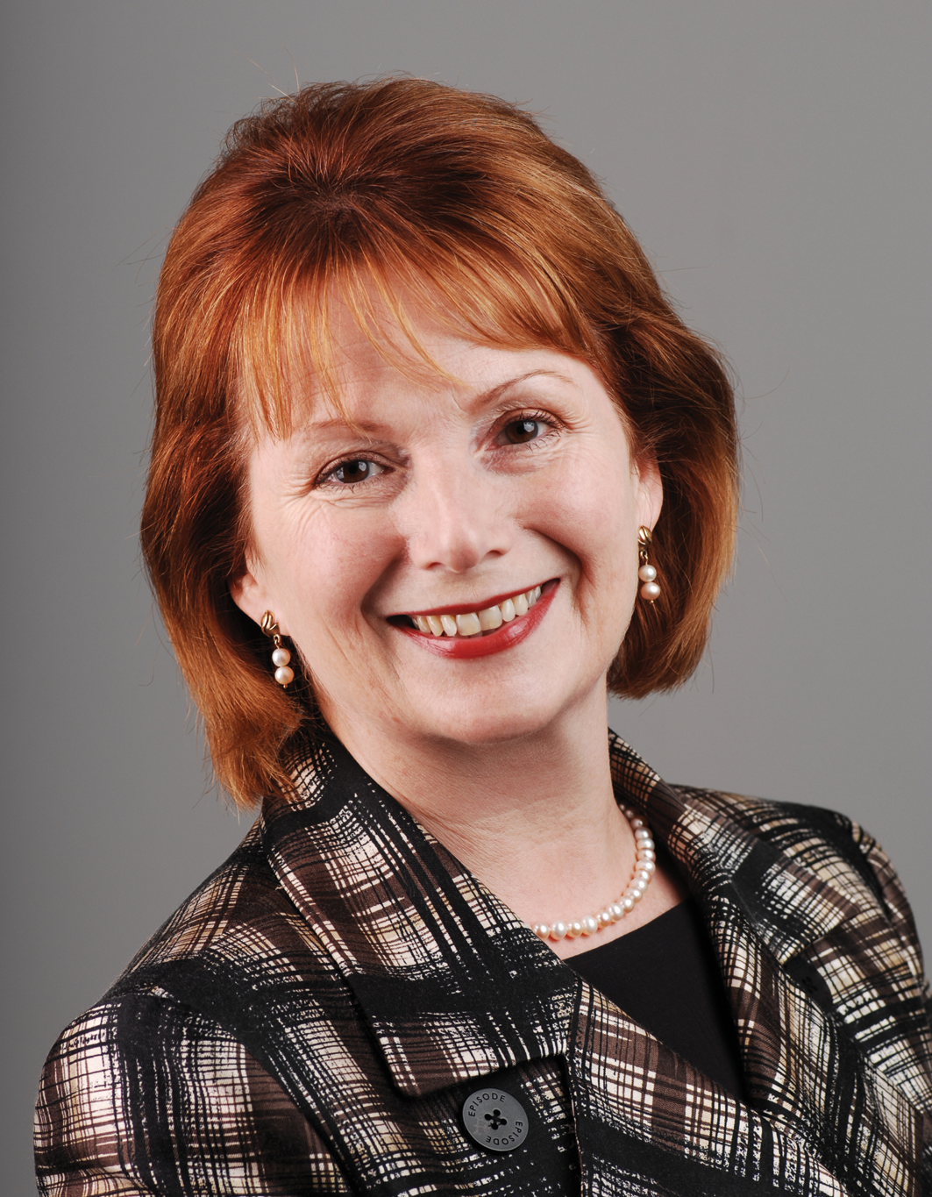
Foreword
Effective local government is the backbone of strong
communities, of prosperous towns and villages. It is
responsible for aspects of everyday life that people care about
deeply – from green parks, to well-stocked libraries, to clean streets.
In 1997, local government was under-resourced, run-down and
demoralised. Since then, funding has increased 39% in real
terms. Performance has risen year on year, and today three
quarters of councils are rated very good or excellent.
But if we are to continue to improve public services in the way communities expect and deserve, and if we are to enable local government to live up to its full potential, Whitehall today needs to step back and give it the space to lead.
That is why the Prime Minister has called for “a reinvention of the way we govern”, an historic transfer of power from Whitehall to the town hall, and direct to communities.
This local devolution is the key to reinvigorating the grass roots of democracy, to making public services reflect what communities want, and to facing up to some of the most complex challenges we face today, such as climate change and community cohesion. To tackle such agendas the need for local authorities and their public services providers to work together in partnership is even greater.
The 2006 Local Government White Paper, Strong and Prosperous Communities, promised a new era of freedom for local government: greater flexibility to set priorities, greater discretion over how to meet them. This meant that, among other things, up to an estimated 1,200 indicators for assessing performance would be reduced to around 200.
This document shows that Government is delivering. It sets out a single set of just 198 measures representing what Government believes should be the national priorities for local government, working alone or in partnership, over the next three years. It rightly paves the way for local authorities and their partners to look less to Whitehall for legitimacy and direction, and more to the communities they serve.
Alongside measures such as moving £5bn into general non-ring fenced grants allowing councils to spend money on the issues that matter locally, the single set of national indicators marks a big step in turning the rhetoric of devolution into reality. As we put it into practice it will give local government the space to thrive, to continue improving services, and to give communities what they need. The onus is now on local authorities and their partners to rise to the challenge, and I am confident they can deliver.
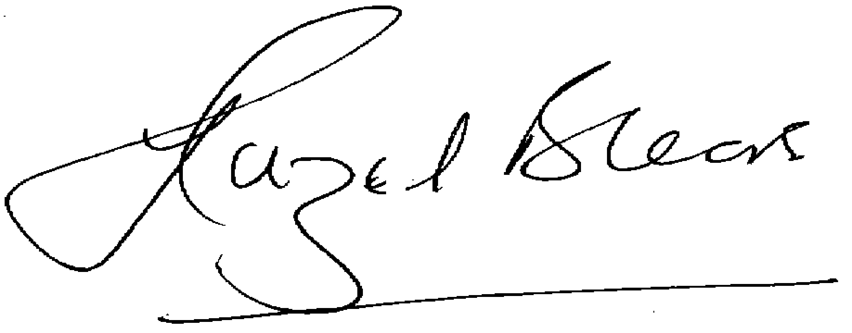
Rt Hon Hazel Blears MP
Secretary of State for Communities and Local Government
Introduction
This document sets out the headline definitions of the 198 indicators which will underpin the new performance framework. This national indicator set has been developed as part of the Comprehensive Spending Review 2007 so that it reflects the Government’s national priorities. Performance against each of the 198 indicators will be reported for every single tier and county council Local Strategic Partnership.
Local Government is also responsible for many other services and activities valued by local people: these are not directly reflected in the national indicator set. It does not mean those activities should stop. It means that it is right for local authorities, and not Whitehall, to set their own priorities, and monitor performance themselves.
The national indicator set will be the only measures on which central government will performance manage outcomes delivered by local government working alone or in partnerships. From April 2008, all other sets of indicators, including Best Value Performance Indicators and Performance Assessment Framework indicators, will be abolished.
As the new performance framework is focused on outcomes and their delivery through stronger partnership working, the same indicators will be used for different local partners as relevant. Therefore, many of the indicators in this set will also apply to the police, primary care trusts and other local bodies.
In each area, targets against the set of national indicators will be negotiated through new Local Area Agreements (LAAs). Each Agreement will include up to 35 targets from among the national indicators, complemented by 17 statutory targets on educational attainment and early years. There will be no other way of setting targets, no other way of Whitehall managing local authority performance.
Setting the targets will be the subject of genuine negotiation between central Government and the local area. Whitehall will not mandate them. Even where targets are set out for Public Service Agreements at national level, local areas will have the flexibility to respond to these national ambitions in the most appropriate way in negotiation with Government Offices.
The headline definitions for the 198 national indicators are outlined below. We will shortly consult on the technical definitions of the indicators, giving stakeholders an opportunity to give views on the methodology, frequency of reporting, and data source of each individual indicator. If in the interim period there are detailed questions relating to the indicators, these can be directed to nationalindicators@communities.gsi.gov.uk.
The National Outcome and Indicator Set
Outcome | National indicators
Stronger communities | NI 1 % of people who believe people from different backgrounds get on well together in their local area PSA 21  NI 2 % of people who feel that they belong to their neighbourhood PSA 21  NI 3 Civic participation in the local area PSA 15  NI 4 % of people who feel they can influence decisions in their locality PSA 21  NI 5 Overall/general satisfaction with local area CLG DSO  NI 6 Participation in regular volunteering CO DSO  NI 7 Environment for a thriving third sector CO DSO  NI 8 Adult participation in sport DCMS DSO  NI 9 Use of public libraries DCMS DSO  NI 10 Visits to museums or galleries DCMS DSO  NI 11 Engagement in the arts DCMS DSO  NI 12 Refused and deferred Houses in Multiple Occupation (HMO) license applications leading to immigration enforcement activity HO DSO  NI 13 Migrants English language skills and knowledge HO DSO  NI 14 Avoidable contact: The average number, of customer contacts per received customer request
Safer communities | NI 15 Serious violent crime rate PSA 23  NI 16 Serious acquisitive crime rate PSA 23  NI 17 Perceptions of anti-social behaviour PSA 23  NI 18 Adult re-offending rates for those under probation supervision PSA 23  NI 19 Rate of proven re-offending by young offenders PSA 23  NI 20 Assault with injury crime rate PSA 25  NI 21 Dealing with local concerns about anti-social behaviour and crime by the local council and police PSA 23  NI 22 Perceptions of parents taking responsibility for the behaviour of their children in the area HO DSO  NI 23 Perceptions that people in the area treat one another with respect and dignity HO DSO  NI 24 Satisfaction with the way the police and local council dealt with anti-social behaviour HO DSO  NI 25 Satisfaction of different groups with the way the police and local council dealt with anti-social behaviour HO DSO  NI 26 Specialist support to victims of a serious sexual offence PSA 23  NI 27 Understanding of local concerns about anti-social behaviour and crime by the local council and police HO DSO  NI 28 Serious knife crime rate HO DSO  NI 29 Gun crime rate PSA 23
Safer communities (continued) | NI 30 Re-offending rate of prolific and priority offenders HO DSO  NI 31 Re-offending rate of registered sex offenders PSA 23  NI 32 Repeat incidents of domestic violence PSA 23  NI 33 Arson incidents HO DSO  NI 34 Domestic violence – murder PSA 23  NI 35 Building resilience to violent extremism PSA 26  NI 36 Protection against terrorist attack PSA 26  NI 37 Awareness of civil protection arrangements in the local area CO DSO  NI 38 Drug-related (Class A) offending rate PSA 25  NI 39 Alcohol-harm related hospital admission rates PSA 25  NI 40 Drug users in effective treatment PSA 25  NI 41 Perceptions of drunk or rowdy behaviour as a problem PSA 25  NI 42 Perceptions of drug use or drug dealing as a problem PSA 25  NI 43 Young people within the Youth Justice System receiving a conviction in court who are sentenced to custody MoJ DSO  NI 44 Ethnic composition of offenders on Youth Justice System disposals MoJ DSO  NI 45 Young offenders engagement in suitable education, employment or training MoJ DSO  NI 46 Young offenders access to suitable accommodation MoJ DSO  NI 47 People killed or seriously injured in road traffic accidents DfT DSO  NI 48 Children killed or seriously injured in road traffic accidents DfT DSO  NI 49 Number of primary fires and related fatalities and non-fatal casualties, excluding precautionary checks CLG DSO
Children & Young People | Be Healthy  NI 50 Emotional health of children PSA 12  NI 51 Effectiveness of child and adolescent mental health (CAMHs) services DCSF DSO  NI 52 Take up of school lunches PSA 12  NI 53 Prevalence of breastfeeding at 6 – 8 weeks from birth PSA 12  NI 54 Services for disabled children PSA 12  NI 55 Obesity among primary school age children in Reception Year DCSF DSO  NI 56 Obesity among primary school age children in Year 6 DCSF DSO  NI 57 Children and young people’s participation in high-quality PE and sport DCSF DSO  NI 58 Emotional and behavioural health of children in care DCSF DSO

Outcome | National indicators
Children & Young People  (continued) | Stay Safe  NI 59 Initial assessments for children’s social care carried out within 7 working days of referral DCSF DSO  NI 60 Core assessments for children’s social care that were carried out within 35 working days of their commencement DCSF DSO  NI 61 Stability of looked after children adopted following an agency decision that the child should be placed for adoption DCSF DSO  NI 62 Stability of placements of looked after children: number of moves  DCSF DSO  NI 63 Stability of placements of looked after children: length of placement DCSF DSO  NI 64 Child protection plans lasting 2 years or more DCSF DSO  NI 65 Children becoming the subject of a Child Protection Plan for a second or subsequent time DCSF DSO  NI 66 Looked after children cases which were reviewed within required timescales DCSF DSO  NI 67 Child protection cases which were reviewed within required timescales DCSF DSO  NI 68 Referrals to children’s social care going on to initial assessment  DCSF DSO  NI 69 Children who have experienced bullying DCSF DSO  NI 70 Hospital admissions caused by unintentional and deliberate injuries to children and young people DCSF DSO  NI 71 Children who have run away from home/care overnight DCSF DSO
Enjoy and Achieve
NI 72 Achievement of at least 78 points across the Early Years Foundation Stage with at least 6 in each of the scales in Personal Social and Emotional Development and Communication, Language and Literacy PSA 10
NI 73 Achievement at level 4 or above in both English and Maths at Key Stage 2 (Threshold) PSA 10
NI 74 Achievement at level 5 or above in both English and Maths at Key Stage 3 (Threshold) PSA 10
NI 75 Achievement of 5 or more A*-C grades at GCSE or equivalent including English and Maths (Threshold) PSA 10
NI 76 Achievement at level 4 or above in both English and Maths at KS2 (Floor) DCSF DSO
NI 77 Achievement at level 5 or above in both English and Maths at KS3 (Floor) DCSF DSO
NI 78 Achievement of 5 or more A*-C grades at GCSE and equivalent including GCSEs in English and Maths (Floor) PSA 10
NI 79 Achievement of a Level 2 qualification by the age of 19 PSA 10
NI 80 Achievement of a Level 3 qualification by the age of 19 PSA 10
NI 81 Inequality gap in the achievement of a Level 3 qualification by the age of 19 DCSF DSO
NI 82 Inequality gap in the achievement of a Level 2 qualification by the age of 19 DCSF DSO
Children & Young People  (continued) | NI 83 Achievement at level 5 or above in Science at Key Stage 3 DCSF DSO  NI 84 Achievement of 2 or more A*-C grades in Science GCSEs or equivalent DCSF DSO  NI 85 Post-16 participation in physical sciences (A Level Physics, Chemistry and Maths) DCSF DSO  NI 86 Secondary schools judged as having good or outstanding standards of behaviour DCSF DSO  NI 87 Secondary school persistent absence rate DCSF DSO  NI 88 Number of Extended Schools DCSF DSO  NI 89 Number of schools in special measures DCSF DSO  NI 90 Take up of 14-19 learning diplomas DCSF DSO  NI 91 Participation of 17 year-olds in education or training DCSF DSO  NI 92 Narrowing the gap between the lowest achieving 20% in the Early Years Foundation Stage Profile and the rest PSA 11  NI 93 Progression by 2 levels in English between Key Stage 1 and Key Stage 2 PSA 11  NI 94 Progression by 2 levels in Maths between Key Stage 1 and Key Stage 2 PSA 11  NI 95 Progression by 2 levels in English between Key Stage 2 and Key Stage 3 PSA 11  NI 96 Progression by 2 levels in Maths between Key Stage 2 and Key Stage 3 PSA 11  NI 97 Progression by 2 levels in English between Key Stage 3 and Key Stage 4 PSA 11  NI 98 Progression by 2 levels in Maths between Key Stage 3 and Key Stage 4 PSA 11  NI 99 Children in care reaching level 4 in English at Key Stage 2 PSA 11  NI 100 Children in care reaching level 4 in Maths at Key Stage 2 PSA 11  NI 101 Children in care achieving 5 A*-C GCSEs (or equivalent) at Key Stage 4 (including English and Maths) PSA 11  NI 102 Achievement gap between pupils eligible for free school meals and their peers achieving the expected level at Key Stages 2 and 4 PSA 11  NI 103 Special Educational Needs – statements issued within 26 weeks DCSF DSO  NI 104 The Special Educational Needs (SEN)/non-SEN gap – achieving Key Stage 2 English and Maths threshold DCSF DSO  NI 105 The Special Educational Needs (SEN)/non-SEN gap – achieving 5 A*-C GCSE inc. English and Maths DCSF DSO  NI 106 Young people from low income backgrounds progressing to higher education PSA 11  NI 107 Key Stage 2 attainment for Black and minority ethnic groups DCSF DSO  NI 108 Key Stage 4 attainment for Black and minority ethnic groups DCSF DSO  NI 109 Number of Sure Start Children Centres DCSF DSO

Outcome | National indicators
Children & Young People  (continued) | Make a positive contribution  NI 110 Young people’s participation in positive activities PSA 14  NI 111 First time entrants to the Youth Justice System aged 10 – 17 PSA 14  NI 112 Under 18 conception rate PSA 14  NI 113 Prevalence of Chlamydia in under 20 year olds DCSF DSO  NI 114 Rate of permanent exclusions from school DCSF DSO  NI 115 Substance misuse by young people PSA 14
Economic Wellbeing
NI 116 Proportion of children in poverty PSA 9
NI 117 16 to 18 year olds who are not in education, training or employment (NEET) PSA 14
NI 118 Take up of formal childcare by low-income working families DWP DSO
Adult health and wellbeing | NI 119 Self-reported measure of people’s overall health and wellbeing DH DSO  NI 120 All-age all cause mortality rate PSA 18  NI 121 Mortality rate from all circulatory diseases at ages under 75 DH DSO  NI 122 Mortality from all cancers at ages under 75 DH DSO  NI 123 16+ current smoking rate prevalence PSA 18  NI 124 People with a long-term condition supported to be independent and in control of their condition DH DSO  NI 125 Achieving independence for older people through rehabilitation/intermediate care PSA 18  NI 126 Early access for women to maternity services PSA 19  NI 127 Self reported experience of social care users PSA 19  NI 128 User reported measure of respect and dignity in their treatment DH DSO  NI 129 End of life access to palliative care enabling people to choose to die at home DH DSO  NI 130 Social Care clients receiving Self Directed Support (Direct Payments and Individual Budgets) DH DSO  NI 131 Delayed transfers of care from hospitals DH DSO  NI 132 Timeliness of social care assessment DH DSO  NI 133 Timeliness of social care packages DH DSO  NI 134 The number of emergency bed days per head of weighted population DH DSO  NI 135 Carers receiving needs assessment or review and a specific carer’s service, or advice and information DH DSO  NI 136 People supported to live independently through social services (all ages) PSA 18  NI 137 Healthy life expectancy at age 65 PSA 17  NI 138 Satisfaction of people over 65 with both home and neighbourhood  PSA 17  NI 139 People over 65 who say that they receive the information, assistance and support needed to exercise choice and control to live independently PSA 17
Tackling exclusion and promoting equality | NI 140 Fair treatment by local services PSA 15  NI 141 Number of vulnerable people achieving independent living CLG DSO  NI 142 Number of vulnerable people who are supported to maintain independent living PSA 17  NI 143 Offenders under probation supervision living in settled and suitable accommodation at the end of their order or licence PSA 16  NI 144 Offenders under probation supervision in employment at the end of their order or licence PSA 16  NI 145 Adults with learning disabilities in settled accommodation PSA 16  NI 146 Adults with learning disabilities in employment PSA 16  NI 147 Care leavers in suitable accommodation PSA 16  NI 148 Care leavers in employment, education or training PSA 16  NI 149 Adults in contact with secondary mental health services in settled accommodation PSA 16  NI 150 Adults in contact with secondary mental health services in employment PSA 16
Local economy | NI 151 Overall employment rate PSA 8  NI 152 Working age people on out of work benefits PSA 8  NI 153 Working age people claiming out of work benefits in the worst performing neighbourhoods DWP DSO  NI 154 Net additional homes provided PSA 20  NI 155 Number of affordable homes delivered (gross) PSA 20  NI 156 Number of households living in Temporary Accommodation PSA 20  NI 157 Processing of planning applications as measured against targets for ‘major’, ‘minor’ and ‘other’ application types CLG DSO  NI 158 % decent council homes CLG DSO  NI 159 Supply of ready to develop housing sites CLG DSO  NI 160 Local Authority tenants’ satisfaction with landlord services CLG DSO  NI 161 Learners achieving a Level 1 qualification in literacy PSA 2  NI 162 Learners achieving an Entry Level 3 qualification in numeracy PSA 2  NI 163 Working age population qualified to at least Level 2 or higher PSA 2  NI 164 Working age population qualified to at least Level 3 or higher PSA 2  NI 165 Working age population qualified to at least Level 4 or higher PSA 2  NI 166 Average earnings of employees in the area BERR DSO  NI 167 Congestion – average journey time per mile during the morning peak PSA 5  NI 168 Principal roads where maintenance should be considered DfT DSO  NI 169 Non-principal roads where maintenance should be considered DfT DSO  NI 170 Previously developed land that has been vacant or derelict for more than 5 years CLG DSO  NI 171 VAT registration rate BERR DSO  NI 172 VAT registered businesses in the area showing growth BERR DSO
Local economy (continued) | NI 173 People falling out of work and on to incapacity benefits DWP DSO  NI 174 Skills gaps in the current workforce reported by employers DIUS DSO  NI 175 Access to services and facilities by public transport, walking and cycling DfT DSO  NI 176 Working age people with access to employment by public transport (and other specified modes) DfT DSO  NI 177 Local bus passenger journeys originating in the authority area DfT DSO  NI 178 Bus services running on time DfT DSO  NI 179 Value for money – total net value of on-going cash-releasing value for money gains that have impacted since the start of the 2008-9 financial year CLG DSO  NI 180 Changes in Housing Benefit/ Council Tax Benefit entitlements within the year DWP DSO  NI 181 Time taken to process Housing Benefit/Council Tax Benefit new claims and change events DWP DSO  NI 182 Satisfaction of businesses with local authority regulation services BERR DSO  NI 183 Impact of local authority regulatory services on the fair trading environment BERR DSO  NI 184 Food establishments in the area which are broadly compliant with food hygiene law
Environmental sustainability | NI 185 CO₂ reduction from Local Authority operations PSA 27  NI 186 Per capita CO₂ emissions in the LA area PSA 27  NI 187 Tackling fuel poverty – people receiving income based benefits living in homes with a low energy efficiency rating Defra DSO  NI 188 Adapting to climate change PSA 27  NI 189 Flood and coastal erosion risk management Defra DSO  NI 190 Achievement in meeting standards for the control system for animal health Defra DSO  NI 191 Residual household waste per head Defra DSO  NI 192 Household waste recycled and composted Defra DSO  NI 193 Municipal waste land filled Defra DSO  NI 194 Level of air quality – reduction in NO_{x} and primary PM₁₀ emissions through local authority’s estate and operations. PSA 28  NI 195 Improved street and environmental cleanliness (levels of graffiti, litter, detritus and fly posting) Defra DSO  NI 196 Improved street and environmental cleanliness – fly tipping Defra DSO  NI 197 Improved local biodiversity – active management of local sites PSA 28  NI 198 Children travelling to school – mode of travel usually used DfT DSO

Public Service Agreements and Departmental Strategic Objectives to which the indicators relate
PSA or DSO | National Indicator number
PSA 2 Improve the skills of the population on the way to ensuring a world-class skills base by 2020 | NI 161, NI 162, NI 163, NI 164, NI 165
PSA 8 Maximise employment opportunity for all | NI 151, NI 152
PSA 9 Halve the number of children in poverty by 2010-11, on the way to eradicating child poverty by 2020 | NI 116
PSA 10 Raise the educational achievement of all children and young people | NI 72, NI 73, NI 74, NI 75, NI 78, NI 79, NI 80
PSA 11 Narrow the gap in educational achievement between children from low income and disadvantaged backgrounds and their peers | NI 92, NI 93, NI 94, NI 95, NI 96, NI 97, NI 98, NI 99, NI 100, NI 101,  NI 102, NI 106
PSA 12 Improve the health and well-being of children and young people | NI 50, NI 52, NI 53, NI 54
PSA 14 Increase the number of children and young people on the path to success | NI 110, NI 111, NI 112, NI 115, NI 117
PSA 15 Address the disadvantage that individuals experience because of their gender, race, disability, age, sexual orientation, religion or belief. | NI 3, NI 140
PSA 16 Increase the proportion of socially excluded adults in settled accommodation and employment, education or training | NI 143, NI 144, NI 145, NI 146, NI 147, NI 148, NI 149, NI 150
PSA 17 Tackle poverty and promote greater independence and well-being in later life | NI 137, NI 138, NI 139, NI 142
PSA 18 Promote better health and well-being for all | NI 120, NI 123, NI 125, NI 136
PSA 19 Ensure better care for all | NI 126, NI 127
PSA 20 Increase long term housing supply and affordability | NI 154, NI 155, NI 156
PSA 21 Build more cohesive, empowered and active communities | NI 1, NI 2, NI 4
PSA 23 Make communities safer | NI 15, NI 16, NI 17, NI 18, NI 19, NI 21, NI 26, NI 29, NI 31, NI 32, NI 34
PSA 25 Reduce the harm caused by alcohol and drugs | NI 20, NI 38, NI 39, NI 40, NI 41, NI 42
PSA 26 Reduce the risk to the UK and its interests overseas from international terrorism | NI 35, 36
PSA 27 Lead the global effort to avoid dangerous climate change | NI 185, NI 186, NI 188
PSA 28 Secure a healthy natural environment for today and the future | NI 194, NI 197
BERR DSO Promote the creation and growth of business and a strong enterprise economy across all regions | NI 166, NI 171, NI 172
BERR DSO Ensure all departments and agencies deliver better regulation for the private, public and third sectors | NI 182, NI 183
CLG DSO Support local government that empowers individuals and communities and delivers high quality services efficiently | NI 179
CLG DSO Improve the supply, environmental performance and quality of housing that is more responsive to the needs of individuals, communities and the economy | NI 141, NI 158, NI 160
CLG DSO Build prosperous communities by improving the economic performance of cities, sub-regions and local areas, promoting regeneration and tackling deprivation | NI 5, NI 170
CLG DSO Provide a more efficient, effective and transparent planning system that supports and facilitates sustainable development, including the Government’s objectives in relation to housing growth, infrastructure delivery, economic development and climate change | NI 157, NI 159,
CLG DSO Ensure safer communities by providing the framework for the Fire and Rescue Service and other agencies to prevent and respond to emergencies | NI 49
CO DSO Build an effective UK intelligence community in support of UK national interests, and the capabilities to deal with disruptive challenges to the UK | NI 37
CO DSO Drive delivery of the Prime Minister’s cross-cutting priorities to improve outcomes for the most excluded people in society and enable a thriving third sector | NI 6, NI 7
DCMS DSO Encourage more widespread enjoyment of culture and sport | NI 8, NI 9, NI 10, NI 11
DCSF DSO Secure the well-being and health of children and young people | NI 51, NI 55, NI 56,  NI 57, NI 58
DCSF DSO Close the gap in educational achievement for children from disadvantaged backgrounds | NI 76, NI 77, NI 83,  NI 84, NI 86, NI 87,  NI 88, NI 89
DCSF DSO Safeguard the young and vulnerable | NI 59, NI 60, NI 61,  NI 62, NI 63, NI 64, NI 65, NI 66, NI 67, NI 68, NI 69, NI 70, NI 71
DCSF DSO Achieve world class standards in education | NI 81, NI 82, NI 103,  NI 104, NI 105, NI 107, NI 108, NI 109
DCSF DSO Ensure young people are participating and achieving their potential to 18 and beyond | NI 85, NI 90, NI 91
DCSF DSO Keep children and young people on the path to success | NI 113, NI 114
Defra DSO: Climate change tackled internationally; and through domestic action to reduce greenhouse gas emissions | NI 187
Defra DSO: Economy and society resilient to environmental risk and adapted to the impacts of climate change | NI 189, NI 190
Defra DSO: Sustainable patterns of consumption and production | NI 191, NI 192, NI 193
Defra DSO A healthy, resilient, productive and diverse natural environment | NI 195, NI 196
DfT DSO To sustain economic growth and improved productivity through reliable and efficient transport networks | NI 167, NI 168, NI 169, NI 177, NI 178
DfT DSO To enhance access to jobs, services and social networks including for the most disadvantaged | NI 175, NI 176,
DfT DSO To strengthen the safety and security of transport | NI 47, NI 48
DH DSO Ensure better health and well-being for all | NI 119, NI 121, NI 122
DH DSO Ensure better care for all | NI 124, NI 128, NI 129, NI 131, NI 132, NI 133, NI 135
DH DSO Better value for all | NI 134
DIUS DSO Improve the skills of the population throughout their working lives to create a workforce capable of sustaining economic competitiveness, and enable individuals to thrive in the global economy | NI 174
HO DSO Help people feel secure in their homes and local communities | NI 22, NI 23, NI 24, NI 27
HO DSO Cut crime, especially violent, drug and alcohol related crime | NI 28, NI 30, NI 33
HO DSO Secure our borders and control migration for the benefit of our country | NI 12, NI 13
DWP DSO Maximise employment opportunity for all | NI 118, NI 153, NI 173
DWP DSO Pay our customers the right benefits at the right time | NI 180, NI 181
MoJ DSO Support the efficient and effective delivery of justice | NI 43, NI 44, NI 45, NI 46

