[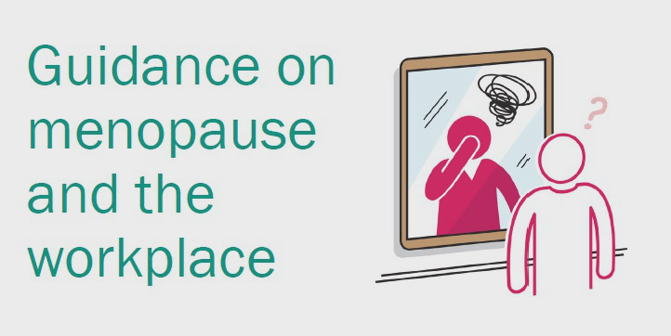](https://www.google.co.uk/url?sa=i&rct=j&q=&esrc=s&source=images&cd=&ved=2ahUKEwjxloDi-73jAhVz5-AKHQBABl0QjRx6BAgBEAU&url=https%3A%2F%2Fwww.fom.ac.uk%2Fhealth-at-work-2%2Finformation-for-employers%2Fdealing-with-health-problems-in-the-workplace%2Fadvice-on-the-menopause&psig=AOvVaw3FcPFv5_cxGbZ1c1X5RPlH&ust=1563522054458922)



**Q. What symptoms can women experience during the perimenopause?**

A. They can vary between women, with some women experiencing no symptoms at all. Many women will experience a combination of the following symptoms;

* Hot flushes
* Palpatations
* Headaches
* Night sweats
* Sleep disturbance
* Poor concentration
* Fatigue
* Skin irritation and dryness
* Mood disturbance
* Need to pass urine more often
* Heavy, irregular periods
* Vaginal discomfort
* Anxiety

**Q. I am a manager and have an employee who is going through the menopause. I really don’t know much about the menopause, where can I find out more;**

A. There is lots of information available, and we would recommend;

<https://www.youtube.com/watch?v=8BHGcU7__ag&feature=youtu.be>

[http://www.nhs.uk/Conditions/Menopause/Pages/Introduction.aspx.](http://www.nhs.uk/Conditions/Menopause/Pages/Introduction.aspx)

<https://www.health.harvard.edu/womens-health/perimenopause-rocky-road-to-menopause>

<https://www.nhs.uk/conditions/menopause/>

[www.womens-health-concern.org](http://www.womens-health-concern.org)

<https://menopauseintheworkplace.co.uk>

[www.menopausecafe.net](http://www.menopausecafe.net)

<https://www.bbc.co.uk/news/av/health-48400161/menopause-what-are-the-symptoms-and-why-does-it-happen>

But also, be led by your employee; they will be able to tell you how they are feeling.

**Q. I am an employee and work in a male environment and my line manager is a man, who can I talk to about my menopause?**

A. It can seem difficult to talk to your line manager but do try; they’ll be the ones that you will need to agree any adjustments with. If it really is too difficult then you can talk to HR, your Union, OH or the EAP

Try preparing for a discussion with your line manager by;

* Write down the symptoms you are experiencing and how you feel they are affecting performance at work;
* Consider what adjustments/changes to the role would help alleviate your symptoms and how you feel these can be implemented within their role (including any recommended GP/Health Care Professional advice);
* Consider providing some real life scenarios you are facing to help the line manager understand how it is affecting work for example, you experiencing night sweats which is preventing you from sleeping and therefore you are tired at work making it difficult to concentrate;
* Invite the line manager to a meeting in private setting to avoid interruptions

**Q. I am a male employee and my partner is going through the menopause, can I contact our EAP to discuss how to best support her?**

A. Yes, the services of EAP are available to all employees and they can discuss any particular worries you have. It can be a difficult time for partners, who are unsure what to expect or do. You might also like to read the following material;

<https://www.nhs.uk/conditions/menopause/>

<https://www.relate.org.uk/relationship-help/help-relationships/feeling-unsatisfied-your-relationship/menopause-affecting-our-relationship-how-do-i-talk-my-partner>

**Other useful sources of information**

<https://www.bbc.co.uk/programmes/p05tpw79>

<https://www.menopause-exchange.co.uk/>

<https://www.menopausecliniclondon.co.uk/understanding-menopause>

<https://www.tuc.org.uk/menopauseatwork?language=en>

<https://www.fom.ac.uk/health-at-work-2/information-for-employers/dealing-with-health-problems-in-the-workplace/advice-on-the-menopause>

<https://www.health.harvard.edu/womens-health/perimenopause-rocky-road-to-menopause>

<https://www.nhs.uk/conditions/menopause/>