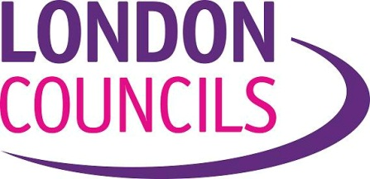

Application to record London Councils’ meetings
If you wish to record, by film, audio recording or any other means, any meeting of London Councils: Leaders’ Committee, Transport and Environment Committee, Grants Committee, Audit Committee or any other London Councils meeting, you should fill in this form and submit it to London Councils Director of Communications no less than 48 hours before the start of the meeting.
The guidance issued by the Government that advises local authorities and local authority bodies such as London Councils ‘that councils should allow the public to film council meetings’ adds the following caveat:
‘Councils may reasonably ask for the filming to be undertaken in such a way that it is not disruptive or distracting to the good order and conduct of the meeting. As a courtesy, attendees should be informed at the start of the meeting that it is being filmed; we recommend that those wishing to film liaise with (London Council(s)) staff before the start of the meeting.’
London Councils would advise the chair of a meeting to refuse an application to record if the applicant fails to agree to comply with the following stipulations:
- The recording device or the person doing the recording will remain static and be at a reasonable distance from those filmed. A tripod or monopod may be used by arrangement as long as its position does not inhibit the free flow of individuals to and from and within the meeting room;
- The working of the recording device will not disrupt or distract from the meeting through, for example, the emission of noise;
- No artificial lighting can be used.

To ensure that London Councils can fulfil its obligations in ensuring the good conduct of meetings applicants are asked to complete the following questions:
- Name of Applicant…………………………………………………………………………………………………..

Name of Organisation………………………………………………………………………………………………

- Contact details:
Address………………………………………………………………………………………………………………
e-mail ………………………………………………………………………………………………………………

Telephone………………………………………..Mobile………………………………………………………….

- Which meeting is this application for? ……………………………………………………………………….

- What type of recording equipment is intended to be used? .......................................................................

- Is it intended to use a tripod/monopod? ...............................................................................................

- To what end is the filming/recording being made? …………………………………………………………….
- Is it intended for screening/broadcast/ transmission at public meetings? Yes/No

- Is it intended to post it online? Yes/No

- Is it intended to add commentary/music/effects to emphasis aspects of the meeting? Yes/No

Any other comments:

………………………………………………………………………………….............................

Please return this form by email to:
James Odling-Smee
Director of Communications
James.odling-smee@londoncouncils.gov.uk

Reviewed November 2018

