London Councils’ Transport and Environment Committee
Electric Vehicles and Car Clubs Update Report |  |  |  |  |  | Item No: | 07
Report by: | Nick Lester-Davis  Katharina Winbeck |  | Job titles: |  | Corporate Director  Head of Transport, Environment & Infrastructure
Date: | 13 October 2016
Contact Officer: | Nick Lester-Davis
Telephone: | 020 7934 9905 | Email: |  | Nick.lester-davis@londoncouncils.gov.uk

Summary: | This report updates members on progress on electric vehicles and on car clubs.
Recommendations: | Members are asked to:  - Note the update on the Go Ultra Low City Scheme  - Give an in principle agreement to London Councils TEC taking on the Delivery Partner Strategy role as outlined in paragraphs 12-16  - Note the findings of the car plus survey on use of car clubs  - Agree that charters for both EV charging networks and car clubs, setting out the public interest in their use, should be prepared.

Electric Vehicles and Car Clubs Update Report

Overview

- A background paper to Vehicle Electrification was presented to TEC in December 2015, which gave an overview of the grant award from the Office of Low Emission Vehicles, included the ULEV Delivery Strategy and how this fit into the general context of encouraging electric vehicle use in London.

- In addition, TEC and TEC Executive have discussed progress on the London Go Ultra Low Emission Scheme on numerous occasions, lastly at TEC Executive in February and full TEC in June 2016.

- Car Clubs have also been an area of great interest to TEC Members and reports have been debated, most recently, in March 2015 with the adoption of the car club strategy.

- The purpose of this report is to inform members and boroughs on the recent progress and decisions likely to be needed in the future, given this fast moving policy agenda.

- This report joins the previously separately considered policies of electric vehicle charging and car clubs, given the joint policy aim of improving air quality in London and the increasing overlap through the expressed interest of car clubs in electrifying their fleets.

- A number of issues are emerging in this policy arena, which this report highlights;

  - Local authorities will continue to play an important role in delivering charging networks in order to assist electric vehicles to become a viable alternative to petrol and diesel vehicles.
  - The principle for charging for the electricity used for electric vehicles is being established (Source London recently announced that their members will have to pay a monthly fee and pay-as-you-go tariffs for charging).
  - It is now clear that London will operate in an environment of multiple charging networks.
  - There is an increased acceptance of the role car clubs can play in an effective and sustainable transport strategy for London, within the context of ongoing modal shift to more sustainable modes.

Electric Vehicles

OLEV Go Ultra Low City Scheme

Background

- London was announced as one of the winners of the Office for Low Emission Vehicles (OLEV) Go Ultra Low City Scheme (GULCS) on Monday 25 January 2016. It has been awarded £13m in capital funding to be used to drive the uptake of ultra-low emission vehicles in the period 2015/16-2019/20. The award followed the submission of a bid prepared and agreed by TfL, GLA and London Councils in October 2015.

- A governance structure was agreed that sees London Councils, TfL and the GLA represented on a steering group that will guide the implementation of the proposals in the GULCS bid. London Councils is represented on this at a political level, through the Chair and Conservative and Labour Vice-Chairs of TEC.

- There are four main streams to the GULCS;

- Increase ULEV charging infrastructure in residential areas by establishing a London-wide delivery partnership for providing, managing and maintaining these.

- Retrofit car club bays with EV charging points, with management and maintenance of the infrastructure being undertaken by the partnership responsible for residential charging infrastructure (point a).

- Support the increase of rapid EV chargers.

- Neighbourhoods of the Future (NoF) - local schemes to prioritise and encourage the uptake of ULEVs.

- The GULCS bid was very ambitious, wanting London to become the “Go Ultra-Low emission vehicle Capital”. London therefore needs an extensive and convenient charging infrastructure whilst not costing the boroughs excessively in time or money to install or maintain. In addition, the GULCs programme is aligned to the Mayor’s ambitions to improve air quality and to ensure the commitment in his manifesto that London is carbon free by 2050.

Residential and car club infrastructure – developing a new delivery partnership

- Following the last update to TEC in June, London’s GULCS consortium have engaged a consultancy to develop a series of options for a new Delivery Partnership/s that would install, manage and maintain the 1,150 residential and 1,000 car club electric vehicle charging points committed to in the bid. The options have to take account of European competition rules (state aid), the requirements of London Boroughs as well as the car club operators. Additionally, the consultants sought insights from the car manufacturers and the charging point industry to help inform the options development.

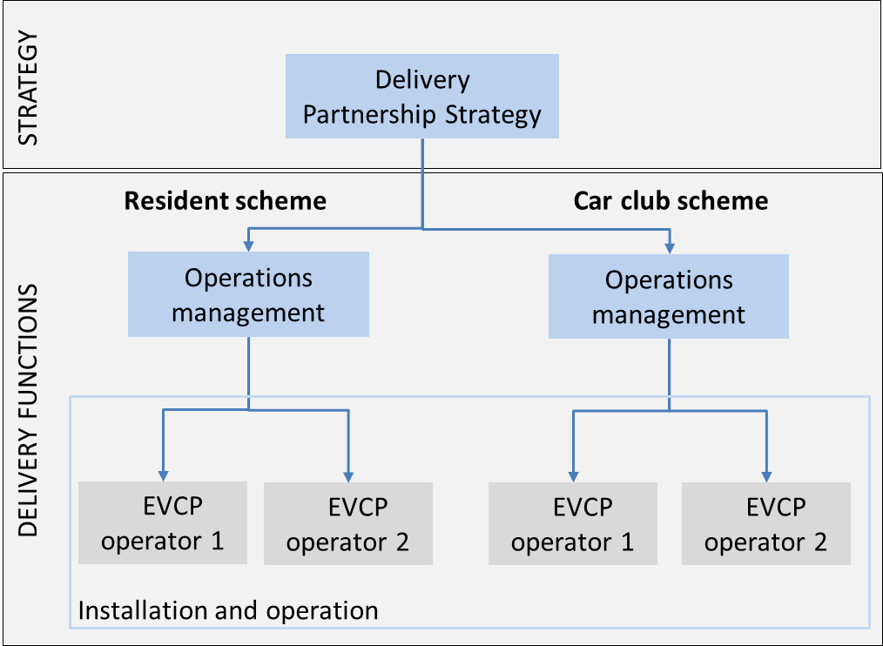
- Following discussion with the stakeholders outlined above, the consultants have identified the following structure for the partnership and its governance arrangements, and presented three options for its implementation.

The role definitions are as follows (not a comprehensive list);

Strategy Role
- Validate and test strategic decisions
- Agree funding policy and apportionment of costs/revenue to boroughs
- Oversee delivery performance
- Agree and set supply charges

Operations Management Role
- Analyse and report on Key Performance Indicators to the strategy board
- Main interface with boroughs, regarding for example providing updates to officers, gauging feedback from officers
- Contract management of operators
- Facilitating user interface, such as a Website and central database

Installation and Operation
- Install EVCPs, working with boroughs (e.g. Traffic Management Orders)
- Operate and maintain charge points

- The Steering Group decided at its meeting on 8 September that the strategy role should be undertaken by a public entity and it also indicated a preference for this role to be undertaken by London Councils TEC, given it is a trusted entity by boroughs.

- On 4 October, the steering Group considered a number of detailed options and decided that, without doubt, a public/private partnership would be the best option . This model would see a public/private partnership where the private sector is contracted to install, manage and operate the scheme for a period of time and is permitted to utilise the revenue as a co-investor of the scheme, to leverage a greater number of charge points. London Councils TEC would have a strategy role, delegating the operations management role to London Councils. In order for London Councils TEC to take on the strategy role, the TEC Agreement would have to be amended. For London Councils to take on the operational management role, officers will have to undertake further feasibility analysis.

- Members are therefore asked to agree in principle to London Councils TEC taking on the strategy role, with further information presented at December TEC.

Rapid Charging network

- TfL’s Ultra Low Emission Vehicle (ULEV) Delivery Plan sets out TfL’s ambition for 150 new rapid charge points in London by the end of 2018, rising to 300 by the end of 2020. The provision of rapid charging is viewed by TfL as a key factor for encouraging the increased uptake of electric vehicles, particularly within commercial fleets including taxis and private hire vehicles (PHVs).

- A private sector-led model is TfL’s preferred approach to delivering new rapid charging infrastructure across the capital. The principle of this approach is that private operators, rather than TfL or Boroughs, will be the owners/operators of charging points and will be responsible for the large capital investment and on-going operational and maintenance costs that rapid charge points will require.

- In March 2016 TfL started a procurement process to establish a framework contract of rapid charge point operators. The framework will be in place by April 2017 and will be available to TfL and the boroughs to select a rapid charge point operator for any rapid charging sites which have been identified. TfL will provide detailed briefings to boroughs in early 2017 on the framework contract and procedures for its use.

- TfL has been engaging with borough officers on the proposals for rapid charging and has requested that boroughs put forward sites that might be available to host new charge point infrastructure. TfL’s preference is for off-street sites which can host multiple charge points as part of a charging ‘hub’. For example, this could include any vacant land that is not earmarked for development or an existing car park. On-street locations will also be considered where appropriate.

- Having identified suitable sites for rapid charge points, TfL will work with the borough and fund upgrades to the power supply and/or enabling groundworks that are required to make the site suitable to host rapid charging infrastructure. All other costs relating to the supply, installation, operation and maintenance of the charge points will be met by the borough’s chosen charge point operator.

- In order for this approach to be commercially viable for charge point operators it is expected that they will require a guaranteed operating period of at least 8 years at a site. Over this period the borough will receive a revenue stream in the form of rental payments from the charge point operator and a percentage of the revenue generated from the charge points.

Neighbourhoods of the Future

- The Neighbourhoods of the Future (NoFs) schemes aim to develop and deliver innovative infrastructure, policy, and initiative driven projects in eight locations across London. These locations were identified in the original bid to OLEV and consisted of:

- LBs of Croydon and Sutton
- LBs of Hackney and Islington
- LB of Hammersmith & Fulham
- LB of Harrow
- LB of Haringey
- LB of Islington
- LB of Richmond upon Thames
- Heathrow Airport

- Officers from Transport for London (TfL) and London Councils have been working with the seven boroughs and Heathrow over the past few months to ensure that the revised proposals take account of the reduced funding allocation whilst still making sure that the key outputs are in line with the original bid submitted to OLEV. Officers from TfL and London Councils carried out site visits in the proposed NoF areas to help shape the final proposals.

- The boroughs and Heathrow were asked to explore options more thoroughly to secure third party funding to support their ambitions, and review whether the original proposals were still feasible. The NoF boroughs and Heathrow were asked to submit their final proposals by Friday 2 September.

- Representatives from TfL, London Councils and a borough (LB of Hounslow) formed part of an assessment panel to make recommendations on the final proposals. The next steps will be to inform the boroughs and OLEV of the outcomes and formally launch the NoF schemes using a press release in late October / early November. Following this, boroughs may wish to develop proposals further, such as through public consultation, before implementation between now and 2020.

Proposed Charter

- As far as charging networks are concerned, it is now clear that London will operate in an environment of multiple charging networks serving different purposes. These will include charging points on and off-street, with some networks serving specific purposes (such as residential or car clubs) and others (such as Source London) being commercial public networks.

- Local authorities will need to continue to have an involvement in electric vehicle charge points, whether or not they are delivered under the GULCS scheme, within the general strategy of encouraging the take up of electric vehicles to secure better air quality. There may be some instances, particularly where charging is entirely on private property, where there will be no specific involvement of the local authorities (or indeed the public sector more generally). This involvement will vary from that of a regulating authority, such as where charging points are proposed on the highway, or as a promoter, as is being proposed for the residential network through the Go Ultra Low City Scheme, or as a landowner, for example, for some of the rapid charging points.

- These different roles may potentially conflict and it is felt that there would be some benefits in agreeing some basic principles connected with the public interest in charging networks, which could be expressed in the form of a charter. These would not be the same as users’ interests and such a charter could not be binding on any provider, though it could provide an input to any legal agreements involving local authorities, which might in their own way be binding. Nor would it prevent any operator from setting up a network which did not comply. It would, however, provide a benchmark by which authorities could measure their involvement in charging in whatever role. It would also provide possible tender input for authorities where they are involved in procurement or delivery of charging points.

- The issues that could be covered in a charter include:

- Interoperability of payments
- public availability of all charging points
- widespread publication of any charges
- clear identification of the network
- easily available complaints procedures
- requirement to supply certain types of data to local authorities
- use of standardised plugs
- use of a standardised London EV charging logo for compliant operators

- If members agree the principle of such a charter then the GULCS Working Group could develop a draft for circulation to boroughs, network operators and others for comment before returning to TEC for agreement.

Car clubs

- Car clubs first arrived on London’s roads in 2003 and provide vehicles to members on a pay as you drive basis. This provides much of the convenience of owning a car but without the additional inconvenience and cost of running and maintaining a vehicle. Since 2003 there has been a significant expansion of the car club network with vehicles operating in the majority of London boroughs.

- It is widely accepted that promotion of car clubs can reduce overall car dependence by making access to cars more flexible, which in turn reduces pressure on the road space and encouraging sustainable transport. They also bring wider benefits such as freeing up parking spaces due to reductions in car ownership; improved air quality and reduced CO₂ and NOx emissions through the use of cleaner vehicles and ULEVs; increased familiarity with electric vehicles; and reduced costs of living and doing business.

- To facilitate the growth of the car club network in London, the Car Club Coalition was formed in 2014. This includes representatives of the car club operators, London Councils, GLA, TfL and industry bodies Carplus and the British Vehicle Rental and Leasing Association (BVRLA). Its main aim was developing a Car Club Strategy for London which would help grow the car club market to deliver the associated benefits outlined above.

- The Car Club Strategy for London was produced in 2015 and endorsed by TEC at the committee meeting on 19 March 2015 and set out the following main actions:

  - To develop a monitoring framework to assess and evidence the impact of car clubs
  - To work with key stakeholders to support car clubs
  - To transform London’s public sector fleets
  - To build capacity and create a framework for supportive policy development
  - To help Londoners make the switch from private cars
  - To make parking management smarter and easier
  - To drive the uptake of low emission vehicles – 50% by 2025
  - To transform the profile of car clubs in London
  - To drive the uptake of car clubs in London’s commercial fleets
  - To integrate car clubs

- The coalition agreed that an ambitious approach of growing car clubs could achieve 1 million users by 2025, which would achieve significant benefits for reducing the negative impact of cars in terms of traffic, congestion and emissions. This would be focussed particularly on areas where modal shift away from car use would result.

Car Club Models

- Currently in London there are three types of car club model operating. The most common is the round trip or back to base model, where the vehicle is returned to a dedicated bay after customer use. This type of car club is available in the majority of London boroughs and historically has been the proven model with regards to the known benefits of car club use.

- Over the last two years four boroughs (Hackney, Haringey, Islington and Waltham Forest) have introduced floating or flexible car club schemes with DriveNow. These do not require the vehicle to be returned to a dedicated bay, but permit the parking of vehicles in parking bays across the borough. Recent research into the flexible car club model indicates that the potential fears regarding modal shift away from walking, cycling and public transport and vehicle clustering have not been realised to significant levels. More research is required in London but it is clear that workable flexible car clubs will be vital in ensuring that London can reach the ambitious targets for car club membership and use, if this is to result in modal shift away from car use.

- The third variety, station-to-station car clubs are a hybrid between the previous two, with cars based at fixed locations but with users able to start and finish at any of the fixed locations, not needing to bring the car back to the place they started from. This is the model used by Auto’Lib in Paris and is particularly suited for electric vehicles. There is little information about the impact of this type of car club as the operations in London are very small.

- Carplus undertakes an annual survey, which provides information about the size of the car club sector, the travel behaviour of car club members and the emissions data of the car club fleet.

- In 2015/16 the survey was completed by over 4,100 round trip car club members and over 1,100 flexible car club members in London. This was the first annual survey to include members of flexible car clubs since the introduction of this model.

- Full details of the survey in London can be viewed at the link below but headline figures indicate the following positive information.

  - There has been an increase in car club members in London from 155,000 in 2014/15 to 205,000 in 2015/16 (32%)
  - The number of vehicles available has increased from 2,400 to 2,800 during the same period
  - There are now 70 round trip members per car up from 66 per car last year
  - Indications are that the growth highlighted above will achieve the strategy targets for number of vehicles by 2020, but fall slightly short on the number of members.
  - For each round trip car club vehicle, car club members sell or dispose of 10 private cars – that is 25,000 private cars sold or disposed of by members
  - A third of round trip car club members reported that they would have purchased a private car if they had not joined a car club. This means a deferred purchase of a further 54,000 cars (or 22 cars for each car club vehicle). If you include those deferred purchases by flexible car club members as well, the number increases to 58,000.
  - Joining a car club leads to reduced levels of car ownership, with 25% of round trip car club members and 22% of flexible car club members having sold or disposed of a car in the last 12 months.
  - An average reduction in annual miles driven of 730 for round trip members and 840 for flexible car club members
  - After joining a car club, members reduce their car use. Prior to joining a round trip car club 22% of new round trip members travel by car at least once a week, falling to 17% after joining. The respective fall for flexible car club members was 32% falling to 29% after joining.
  - Car club fleets are safer than the average car with 88% of the fleet meeting the NCAP 5+ star or 5 star standard.
  - Car club vehicles are cleaner with eight out of ten car club vehicles are in the lowest three emissions bands (A,B,C). The largest proportion of privately owned vehicles (16%) is in the heavier polluting Band G.
  - Ultra Low Emission Vehicles within the London car club fleet increased from 24 in 2014 to 251 in 2015 which is set to grow further. By contrast diesel vehicles are disappearing from car club fleets, down from 47% in 2014 to 30% in 2015.
  - Half of flexible car club members have used an electric vehicle, with 9% of round trip members having used one (up from 4% in 2014/15).

- It is clear from the above statistics that the popularity of car club membership and the benefits that this brings is increasing in London as the market matures. Increased focus on ULEVs and improving the range of vehicle options available as well as the continued research into the developing flexible car club model should aid expansion where this can achieve modal shift.

- The data now becoming available also suggests that the initial fears that flexible car clubs would lead to a net shift from public transport to car have not been realised. While the impact of flexible car clubs may not be as large as for conventional car clubs, it would appear to be in the same direction. That is, resulting in lower car ownership and reduced car mileage by members. Research undertaken by Steer Davies Gleaves (SDG) on behalf of Zipcar also suggests that a combination of both conventional and flexible car clubs could have a bigger combined impact in this way than either model on its own.

- Research elsewhere backs up these findings on flexible car clubs. Reliable data is now available from similar schemes in Munich and Vienna (both of which have multiple car clubs operating on different models) which give findings that both conventional and flexible car clubs lead to car ownership reductions and modal shift from cars to other modes of transport. Munich City Council has adopted a broad policy of support for all types of car clubs as a result of the research there and has added to their policy that:

  - Any parking spaces released by cars being disposed of (as a result of car clubs) should not be returned to the parking stock but should be converted to other uses; and
  - The city council should set out minimum standards for all the car clubs operating within the city’s area
In addition, research from 5 US cities which have adopted flexible car sharing schemes points in the same direction.

- Some boroughs have replaced fleet payments to their employees and use car clubs as part of their fleet, which is showing improvements in fleet efficiency and therefore reducing costs (also through less parking spaces required).

- As with charging networks, it is also clear that London is likely to see multiple car club operators offering differing models and styles of car clubs. In a commercial world this competition is healthy. However, there remains a public interest in car clubs both at a strategic level, in terms of reducing car use and improving air quality, and locally in places where regulating the highway may be needed, either to provide dedicated car club bays or in managing stopping points for flexible car club vehicles. It is suggested that a charter, similar to that for EV charging networks, setting out the public interest may also be valuable. This would not seek to replicate the charters and standards used by the BVRLA and Carplus, which set out users’ interests, but more what London would wish to see car club operators provide for London’s overall benefit. As with the proposed charging networks charter, this would not be legally binding, nor would it prevent anyone from setting up a car club which was not compliant. It could, though, provide a benchmark by which local authorities could asses the degree to which any particular car club supported London’s overall interest.

- Issues covered within such a charter could include:

- Membership of the car club coalition
- Provision of suitable data to local authorities
- Widespread publication of rates
- Inclusion of ULEVs and EVs within fleets
- Emission standards for fossil fuel operated vehicles
- Provision of information and complaints procedures
- Use of a Londonwide logo for compliant operators

- If members agree the principle of such a charter then a draft would be circulated to boroughs, network operators and others for comment before returning to TEC for agreement.

Recommendations

Members are asked to:

- Note the update on the Go Ultra Low City Scheme
- Give an in principle agreement to London Councils TEC taking on the Delivery Partner Strategy role as outlined in paragraphs 12-16
- Note the findings of the car plus survey on use of car clubs
- Agree that charters for both EV charging networks and car clubs, setting out the public interest in their use, should be prepared.

Financial Implications
There are no specific financial implications for London Councils from this report

Legal Implications
The addition of the strategic delivery role for TEC could require a change in the TEC constitution to add this as a function

Equalities Implications
There are no equalities implications of the recommendation.

Background Information
http://www.carplus.org.uk/wp-content/uploads/2015/03/Carplus-Annual-Survey-of-Car-Clubs-2015-16-London_Final-2.pdf
Evaluation: Car sharing - City of Munich; Team Red; February 2016
Can A Combined Car Club Mode Accelerate the Benefits of Car Clubs in London?; Steer Davis Gleave; October 2016
Car Sharing Study; City of Vienna; Spring 2016

http://www.carplus.org.uk/wp-content/uploads/2015/03/Carplus-Annual-Survey-of-Car-Clubs-2015-16-London_Final-2.pdf

