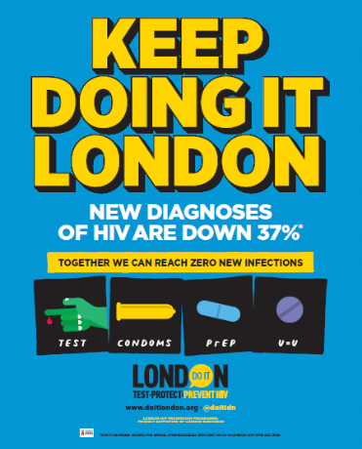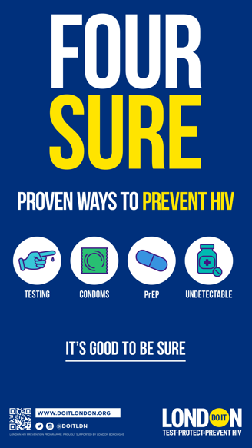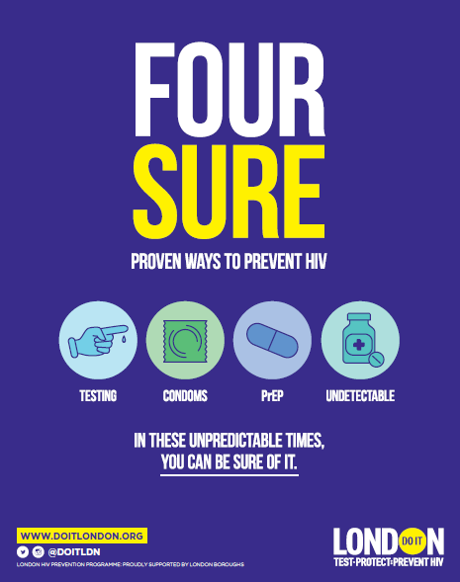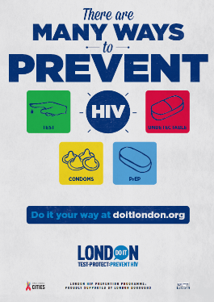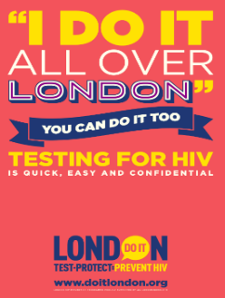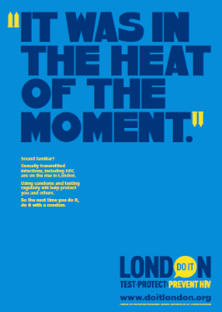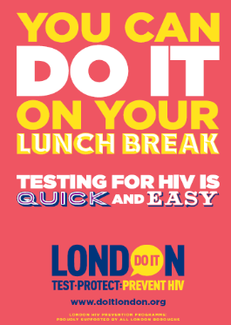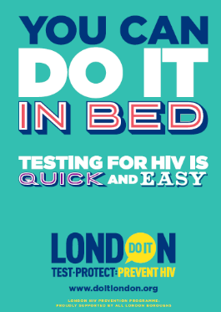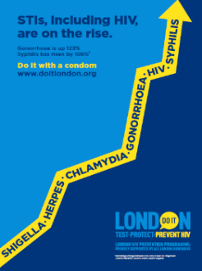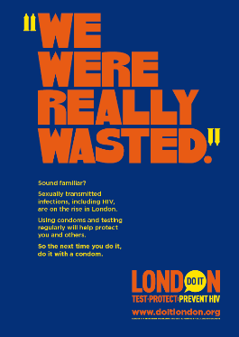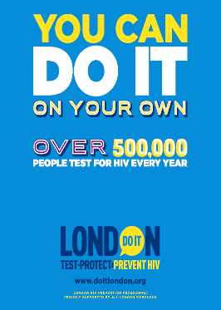

Winter 2021/22

Our latest campaign was a refreshed version of 2020/21 due to the continued relevancy of the messaging.

Winter 2020/21

This campaign contrasted the *sureness* of combination prevention with the wider uncertainty brought on by the Coronavirus pandemic.

Summer 2019

Continuing to promote combination prevention, this campaign highlighted the great work London had already achieved and urged Londoners to reject complacency.

Summer 2018

This campaign introduced the concept of combination prevention to Londoners. It was also the first campaign in the UK to promote PrEP and U=U as core methods of prevention.

Winter 2016/2017

In response to increasing STI rates, this campaign highlighted the effectiveness of condom use against all STIs, including HIV.

Summer 2015

This campaign encouraged Londoners to test for HIV by ‘cheekily’ demonstrating how quick, easy, and confidential testing can be.

Summer 2016

Evolving from the previous testing campaign, the tone shifted emphasising the personal responsibility of testing.

Winter 2015/16

Our first condom-focussed campaign brought to life Londoners’ common excuses for not using a condom with a range of eye-catching headlines.

Spring 2015

Our launch campaign normalised testing for HIV by highlighting the large number of Londoners already testing.