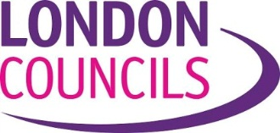

|  |  |  |  |  |  |  |  |  |  |
| --- | --- | --- | --- | --- | --- | --- | --- | --- | --- |
| Leaders’ Committee | | | | | | | | | |
|  | | | | | | | | | |
| London HIV Prevention Programme | | | | | | | | Item | 4 |
|  | | | | | | | | | |
| Report by: | | Valerie Solomon | | Job title: | | Policy Manager | | | |
| Date: | | 8 February 2022 | | | | | | | |
| Contact Officer: | | Valerie Solomon | | | | | | | |
| Telephone: | | 020 934 9507 | Email: | | [Valerie.solomon@londoncouncils.gov.uk](mailto:Valerie.solomon@londoncouncils.gov.uk) | | | | |
| **Summary** | This report provides members with a background to the London HIV Prevention Programme (LHPP), an outline of the LHPP review and proposals for the future of the programme from April 2022. | | | | | | | | |
| **Recommendations** | Leaders are asked to:   * Note and comment on the impact of the London HIV Prevention Programme. * Endorse the proposal to continue funding the programme for a one-year transitional period from April 2022 to March 2023. * Undertake a commitment for London Councils to continue to work with LB Lambeth and stakeholders to develop a set of proposals to secure the long-term sustainability of the programme to April 2023. | | | | | | | | |

|  |
| --- |
|  |

The London HIV Prevention Programme

**Introduction**

1. The London HIV Prevention Programme is London’s flagship HIV public health programme and has been supporting London’s efforts to reduce HIV infections since 2014. It was established to provide a city-wide approach to HIV prevention following the transfer of public health to local government in 2013. The LHPP is making a valuable contribution to the UK NHS ambition of achieving zero new HIV infections by 2030.
2. London Councils’ Leaders' Committee agreed in November 2013 to set up and run a three-year London-wide HIV prevention programme from 1 April 2014 until March 2017. The programme has since been renewed on two occasions in 2015, for two years, and in 2019 for 3 years until March 2022.
3. The LHPP is funded entirely by London boroughs, totalling £1.063milion (2019-2022) from borough local public health budgets. The financial contribution varies across London (between £2,000 and £113,000) and is determined proportionately by HIV diagnoses (based on 2017 HIV prevalence data), and a methodology developed by Directors of Public Health.
4. There are three overarching aims of the LHPP; which is to reduce new HIV infections and increase earlier diagnosis of HIV; increasing the uptake of HIV testing, promoting condom use and promoting safer sexual behaviours.
5. The LHPP has two main components and are contracted separately; a health prevention awareness campaign element called ‘Do It London’[1] delivered through the provision of a multi-channel social media and messaging. This is aimed at all Londoners aged between 18 and 65 years, with additional focus on the men who have sex with men (MSM) community and Black Africans.
6. Secondly, and a sexual health promotion outreach service, this includes a delivery of targeted outreach and HIV at commercial and community venues and the distribution of free condoms and lubricant service and the provision of advice to access HIV treatments.

**HIV in London**

1. In 2017 there were more than 38,600 people in London living with diagnosed HIV, representing 38% of all people living with an HIV in England. HIV remains a public health concern as it has an unequal impact on ethnic minorities and minority groups affecting London’s health inequalities.
2. Despite this disproportionality, London continues to witness record falls in new HIV diagnoses and late diagnoses since 2015. Annual statistics data published by the UKSHA HIV In The UK, 2021 Report[2], illustrated that overall new HIV diagnoses decreased by 41% in London (from 1,616 in 2019 to 955 in 2020). Furthermore, this represents a 63% decrease from 2015 (from 2,564 in 2015 to 955 in 2020).

**New HIV Diagnoses and deaths, London residents, 2010 to 2019[3]**



1. Whilst this is good progress improvements are needed to reduce the number of people who are diagnosing late to medical services. In 2020, 42% of new HIV diagnoses in London were late (332 out of 782), an increase from 37% of cases in 2019. This disproportionately applies to the population groups at greatest risk of HIV infection are men who have sex with men (MSM) and black African communities.

**LHPP Campaign Delivery**

1. The LHPP have been highly successful since it was first commissioned in 2014 and Do It London campaigns launched in 2015. A summary of the evolution of Do it London campaigns is attached at the end if this report.
2. The campaign was the first in the UK to promote “combination prevention” – including PrEP and Undetectable (U=U) status since 2017. In 2019, the LHPP was fully recommissioned and re-procured and advocated the importance of promoting PrEP and U=U via public health campaigns and ensured that HIV testing within community-based settings took place.
3. An important component of the recent ‘Four Sure’ campaign which ran from November 2020 to February 2021 is to promote the use of Pre-exposure prophylaxis (PrEP) drug, is almost 100% effective when taken as prescribed. In 2019, the government announced the routine commissioning of PrEP which was achieved a result of successful lobbying by London Councils to secure the additional funding of PrEP by awarding £5.2 million to London’s sexual health clinics. This was in response to the huge uptake of the nationwide PrEP IMPACT Trial which began in 2017.
4. The impact of the Coronavirus pandemic and social distancing restrictions resulted in tailored radio ads to amplify national social distancing messaging, producing Safe Sex and Covid-19 guidelines. The evaluation results reported there were 553, 409 views to the ‘Do It London webpages; 901,816 condoms were issued; and 904,700 lubricants, digital display ads ran throughout the campaign and delivered 10.1 million impressions and 24,412 clicks a record number.
5. The Covid-19 pandemic provided challenges and alternatives were sought to deliver contracted face-to-face outreach support and HIV testing, as lockdown restrictions prevented nightclub establishments and social venue opening. During the period, LB Lambeth worked with providers to deliver alternative solutions to align with lockdown measures for the sexual promotion service.

**The HIV Prevention Programme Review**

1. In June 2021, the LHPP Board, instructed LB Lambeth to commission an independent rapid evaluation and future review and to ensure that the programme continues to provide added value over and above the existing provision from NHS services and other prevention activities. RSM consulting were appointed to examine the current service scope, delivery record, and to assess what will be required of the programme in the future.
2. The report findings concluded the following

* There is a solid economic case for the continuation of a pan-London ‘Do It London’ health awareness programme.
* Alternative approaches to deliver outreach work as part of a sexual health promotion response should be explored requiring possible re-specification, considering relevant epidemiological and population trends. These services may not be best commissioned at a pan-London level but at a local level.
* Communications materials per borough could be adapted to enhance the media impact and client reach, particularly for black African men and for MSM communities.
* The governance of the programme is strengthened requiring greater participation and engagement with representatives from local public health teams.

1. It was clear that the RSM report provided some challenges and to fully consider the recommendations and develop an agreed approach that provides a longer timescale to develop options for a sexual health promotion service.

**Transitional Proposals for 2022/2023**

1. In December 2021, all Directors of Public Health across London agreed to support proposals to fund the LHPP in 2022/23 for a transitional period. This buy provides a positive signal that boroughs wished to see a continuation of the LHPP.
2. Subject to an agreement by the Leaders’ Committee immediate actions will be required to examine existing contracts with a view to re-commissioning or to extend contracts, subject to contractual provisions. It is suggested that during the transitional period, the following work is undertaken to maintain a continuity of service and provide stability for the providers;

* Continue the existing ‘Do It London’ campaign and associated communications and marketing work in order to continue to provide a social media presence.
* Re-commission existing contracts for the sexual health promotion services, with a re-specification of contracts, allowing an examination of the condom distribution and increased testing approaches.

**Longer term Proposals**

1. In the longer term during 2022, work is required to develop a response to the RSM report recommendations. London Councils is committed to continue to work with LB Lambeth and stakeholders to develop a sustainable LHPP. Essential to this will be to engage fully with the Directors of Public Health, sexual health commissioners and clinicians and the HIV voluntary sector.

* It is suggested the following areas of work will be undertaken;
* Develop a series of options to shape a new approach to providing the sexual health promotion and outreach component from April 2023.
* Enhance the communications and marketing strategy to develop local borough identities,
* Explore ways to strengthen the future governance and hosting arrangements and how is can be best delivered.
* Develop the future scope of the programme using current HIV data and the current landscape such as FastTrack Cities initiative; the HIV Action Plan objectives and national HIV programmes.

1. London Councils’ Leaders Committee will be kept informed of the outcome of these discussions at the end of the year, with a view to putting forward a set of proposals for further consideration and agreement from March 2023.

**Financial Implications for London Councils**

None

**Legal Implications for London Councils**

None.

**Equalities Implications for London Councils**

None.

**APPENDIX A – The evolution of Do It London’s campaigns (2015 – 2022)**

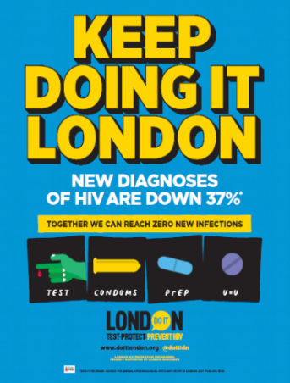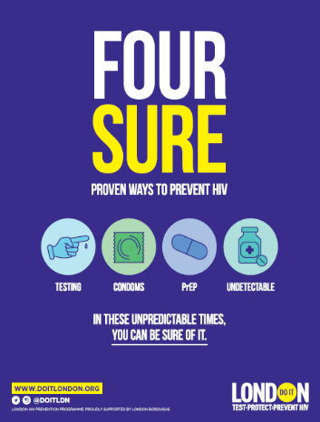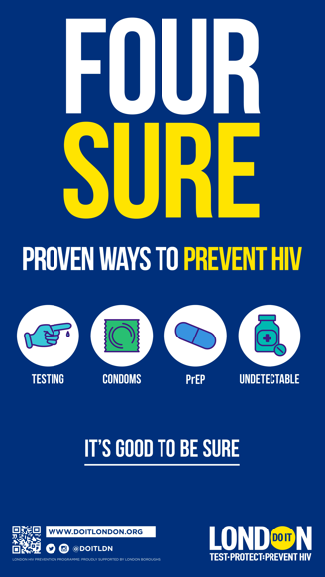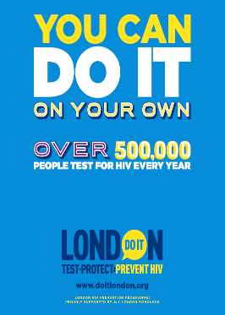

Spring 2015

Our launch campaign normalised testing for HIV by highlighting the large number of Londoners already testing.

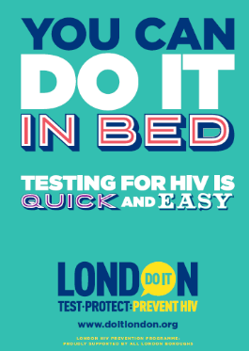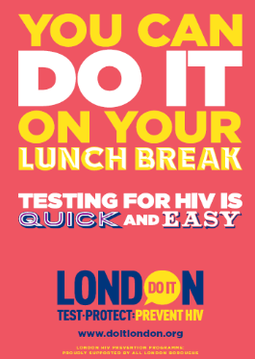

Winter 2015/16

Our first condom-focused campaign brought to life Londoners’ common excuses for not using a condom with a range of eye-catching headlines.

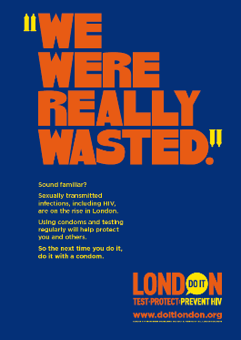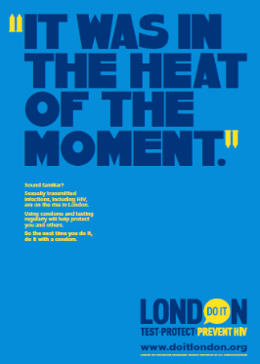

Summer 2015

This campaign encouraged Londoners to test for HIV by ‘cheekily’ demonstrating how quick, easy, and confidential testing can be.

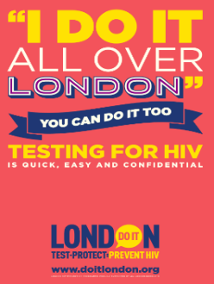

Summer 2016

Evolving from the previous testing campaign, the tone shifted emphasizing the personal responsibility of testing.

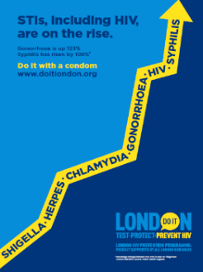

Winter 2016/2017

In response to increasing STI rates, this campaign highlighted the effectiveness of condom use against all STIs, including HIV.

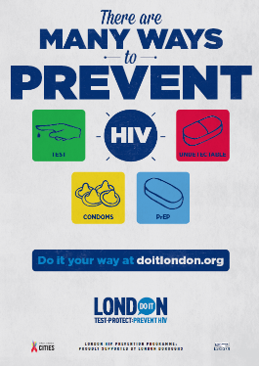

Summer 2018

This campaign introduced the concept of combination prevention to Londoners. It was also the first campaign in the UK to promote PrEP and U=U as core methods of prevention.

Summer 2019

Continuing to promote combination prevention, this campaign highlighted the great work London had already achieved and urged Londoners to reject complacency.

Winter 2020/21

This campaign contrasted the *sureness* of combination prevention with the wider uncertainty brought on by the Coronavirus pandemic.

Winter 2021/22

Our latest campaign was a refreshed version of 2020/21 due to the continued relevancy of the messaging.

1.
2. The annual official statistics data release (data to end of December 2020)

   <https://assets.publishing.service.gov.uk/government/uploads/system/uploads/attachment_data/file/1037215/hiv-2021-report.pdf>

   Source: Public Health England, HIV and Aids New Diagnosis Database (HANDD).
3.