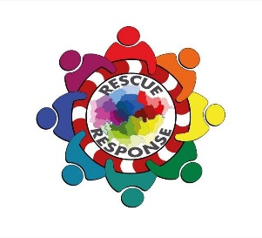
rescue and response – pan London service
This project will develop and deliver a support service for young people who are vulnerable and caught up in county lines drug distribution networks across our region. This issue brings together gangs, national policing strategy, CSE, trafficking, exploitation and vulnerability; underpinned by a complex range of social and structural disadvantage. The need has been identified but is so far only partly understood and sporadically mapped, with support models untested at any scale.

This project will be the first county lines support service that:
- Operates at scale - pan London and for three years
- Includes both support providers and intelligence analysis working together
- Is led by a coalition of London boroughs with support from MPS special commands and the boroughs and highly experienced London based gangs’ agencies.

Three elements to this project will be delivered throughout 3 year project period
- Rescue & Response – there is an urgent need to provide an immediate and flexible rescue and response service.
- Intelligence Development – to inform prevention and focus the limited resources on those most in need and on the cusp of exploitation.
- Breaking the Cycle – upskilling front line professionals across London to better identify and divert young people away from this exploitation at the earliest possible stage

- Rescue & Response through a third sector consortium approach lead by St Giles Trust (SGT) and incorporating Abianda to deliver:
- A credible and capable caseworking service that can engage with young people at the time of need, including immediate safety planning for the young person and their family/ network. This includes debriefing missing young people for improved intelligence and profiling.
- Utilising “teachable moments” to effectively engage with young people and gain their trust to deliver ongoing casework as required. An out-of-hours callout service will allow immediate response from caseworkers when most beneficial.
- SGT and Abianda have combined their expertise in working with high risk, high vulnerability young people. Both will deploy their complimentary and unique models of practice to increase likelihood of engagement and positive outcomes for young people.
- Service brokerage and links with other agencies, not limited by borders. SGT delivers gang exit services in 13 boroughs, ensuring a smooth and effective handover of cases when a local service is available and appropriate.
Safer London Foundation will provide a fast tracked referral route into the London Gang Exit service, specifically for those young people from boroughs without gangs services.
- Provide gender specific interventions for gang/network affected females that are rooted in evidence based practice which addresses the barriers that young women typically face in accessing services. To incl. proactive work to increase identification of young females engaged in such criminal networks/trafficking.
- Proactive work to help identify young people involved in trafficking and criminal exploitation,
- Work in partnership with local borough gang delivery group partners, Trident, MPS Sexual Exploitation Team, OCU and specialist CSE provision already linked to boroughs.
- Link into existing infrastructure including borough provision via community safety lead, Safer School Officers.
- Link into added value services delivered by partner agencies such as: SGT’s range of projects, Safer London’s Empower service.
- Objective:
  - To ensure all young and vulnerable Londoners identified as being exploited through county lines are made safe, supported and then diverted into positive activities.

- Intelligence Development through:
- 2x Hubs (North & South London) working collaboratively to use the intelligence gained from front line practitioners, third sector providers, partners, police and social media to understand the criminal networks and identify vulnerable young people caught up in them. Delivered by 4 recruited analysts (2 per hub) to cover the North, South, East and West regions. Linking in with pan London MPS intelligence command, who have direct links to the SPOCs for CSE and Modern Day Slavery in the counties. Emerging data from Hubs and AVA social media monitoring (see 5.1) will be captured to build regional profile via creating I2 networks, case management reports, intel system development, which are shared across the relevant enforcement and safeguarding practitioners.
- 4 Single Point of Contacts (SPOCs) (one per region, 2 within each Hub), to provide the coordination and proactive tasking of intelligence / response, ensuring wrap around services are deployed and in place, providing the conduit between the third sector and statutory agencies. Linking in and following the key Safeguarding professional practices locally as well as specialist CSE provision/YOS where required.

- Objective:
- To ensure all young and vulnerable people identified as being exploited through county lines are known and protected through local safeguarding channels.
- To identify those responsible for running county lines and exploiting vulnerable people to aid in bringing them to justice.

- Breaking the Cycle by:
- Third sector consortium brings tremendous experience which will be used to deliver training and support to front line practitioners across London, alongside other local voluntary groups.
- Developing good practice based on experiential learning to continually reshape the project; sharing this learning with sector stakeholders.
The partnership will engage with local and national politicians and front line expertise to help shape policy and legislative change.
- The service is based on current best practice in borough based services and will seek to incorporate other best practices such as contextual safeguarding, trauma informed approaches, the restorative approach, solution focused therapy and a peer support model; many of which are already in use by consortium partners.
- Carry out regular reviews of the project and delivered service as well as gathering learning from other county lines work (St Giles).
- Supporting the Safer Schools officers through training to help them deliver prevention and awareness programmes through bespoke training incorporating learning from the project ensuring emerging trends are captured.
- Objectives:
  - To support local authorities and other stakeholders partners through communicating better understanding of how county lines are operating.
  - Increased awareness and knowledge for front line practitioners regarding county lines issues in London.

Project outcomes for full 3 year project (evidence/ measure in brackets):
- Minimum of 600 YP (under 25yrs) case worked (case records)
- Reduction in their recorded criminal behaviour (PNC)
- Increase in number of YP identified as being exploited (analyst stats)
- Increased engagement with services (case records)
- Better understanding of the problem and networks (evaluation)
- Increase in number of YP identified as being at risk
- Increased knowledge of the risk for young women associated with county lines/criminal networks (service user led)
- Increased feelings of safety and reduced feelings of vulnerability (service user led)
- 400 front line workers trained across (outcome of training/feedback forms)
- Increase in referrals to NRM
- Increase in referrals to family support services
- Increase in number of CSE cases referred to safeguarding. Improved links between London and regional services (evaluation).
- Decrease missing episodes to engaging cohort

Client centred outcomes:
- Feelings of safety/ risk reduction (service user led, attitudinal questionnaires).
- Increased knowledge of the risk for young women associated with county lines/criminal networks (service user led).
- Increased feelings of safety and reduced feelings of vulnerability (service user led).
- Increased knowledge of issues regarding CSE, sexual violence and victimisation in context of gangs (evaluation).
- Increased skills to keep safe in different contexts (service user led).
- Increased ability to positively manage relationships and create healthy attachments (service user led, measurement tools).
- Increased resilience and ability to influence key life decisions (evaluation, measurement tools, service user led).

Evidence Base

Every London borough is experiencing the tragic impact of the exploitation of young people by organised criminals. The NCA² assessed that gangs & OCNs utilise vulnerable children because they are inexpensive to employ and easy to control.

This project is addressing the following gaps in current provision:
- Almost no support services with the flexibility to effectively work with young people from London who are caught up in county lines.
- Detailed analytical overview across London to identify those most in need of intervention.
- Development of the “Team around the Network” approach across borders rather than solely individual focused.
- A greater understanding of how county lines, CSE, missing and gang related offending is interrelated across London.
- A greater understanding of the extent to which young women and girls are involved with, or affected by, county line activity.
- Consistent approach to work force training and development for front line practitioners working with vulnerable young people at risk of or victim to exploitation.
- Promoting related Modern Day Slavery legislation and the National Referral Mechanism as tools to help practitioners, feeding in project learning.
- Closing the gap and increasing service collaboration in service provision delivered by the third and statutory sector.

The NCA recognise that for children reported missing, known to social care, attending an alternative school provision, a frequent absentee or living in a gang affected area, the risk of exploitation is high². It is conceivable that gang members also use county line drug dealing as an opportunity to also target young females for sexual exploitation². Most Home Office Gang peer reviews in London have evaluated that County Lines were an issue in all boroughs.

Met data shows that there is currently 3777 (01.08.17) gang affected people on the matrix. Young people under 25yrs make up 80% of the whole gang matrix whilst those 18yrs and under make up more than 20%. It is identified that 15-16yrs is the most common age of being exploited for county lines¹. Lewisham have been using the SaVvy matrix and a Missing, exploited and trafficked (MET) approach which considers the multiple risk, harm and vulnerabilities to focus partnership work. Based on the Lewisham figures it is guesstimated that there would be approximately more like 5400 people across London engaged with exploitation activities linked to organised crime and drug networks. This highlights a numerical difference between the MPS matrix and the SaVvy in terms of agencies focusing on different indicators. This is further supported by Safer London Foundation figures who suggest that over 4000 young people they are working with show as having risk indicators for being ‘exploited’ by a form of criminal network in London.

It remains a challenge to provide accurate figures for the number of children being exploited². Children that meet multiple risk indicators are the starting point for any current intervention however we are aware that further network analysis to identify other children at risk is often not progressed or avoided due to multiple agency/borough involvement. Further indicators highlighting the scale of the issue include NCA data from their most recent assessment (Nov 2017) whereby 38 out of 42 Police forces across the UK stated they had a problem with county lines with the majority confirming line links to London. The NCA are currently aware of around 720 county lines across the UK, with 283 originating from London. Indicators from this new NCA assessment suggest that 65% of those regions reporting to have county lines have issues with the exploitation of children within these activities, 35% of the regions also reported related sexual exploitation and 21% reported related sexual violence. This highlights the link of criminal exploitation with child exploitation and child sexual exploitation, with figures that can only be seen as a starting figure to try and understand the scale of the issue.

Vulnerable young people (Under 25yrs) living across all 32 London Boroughs who are at risk or actually being exploited by criminal networks through drug dealing (cross border) and other organised crime. St Giles have already completed some pilot work to aid our project success and to evidence further the need. County lines support services in South Wales and Kent (Home Office funded) have been running for some months now and the emerging findings are:
- The level of need is high - referrals have complex needs, involvement of multiple agencies and high risk concerns.
- Agencies outside London have welcomed SGT’s support around these issues as they recognise their own lack of expertise, are beginning to recognise that enforcement is not appropriate for many young people and are keen to embrace an alternative.
- Information about county lines tends to be held by a range of agencies and is not brought together in most areas, meaning the new service will need excellent cross agency communication skills.
- All London boroughs report substantial numbers of young people going on county lines, but few are clear where their young people are going, and know that it can quickly change.
- SGT has had difficulty attracting referrals of Londoners to the services, it is hoped that this service will not have the same issues as the area the young person is going to won’t be an issue for the referrer.
- Scoping work with areas outside London indicates that there is a huge willingness to engage with specialist gangs’ provision from London, and a casework service is considered essential to successful interventions.

Practitioners currently struggle to manage young people who have been exploited due to the absence of tangible support and expertise. They will benefit from a better intelligence picture and from direct support and training from expert practitioners via the Intelligence Hub and commissioned providers. Better risk assessments and joint work cross border should emerge.

This project will better identify vulnerable young people which services are more to often not focusing their intervention on due to resource/capacity/information sharing and operational issues. The Home Office recognise that county lines is a harm which is relatively little known about or recognised by those best placed to spot its potential victims¹. The project aims for proactive prevention intervention following intelligence sharing.

6.2 Logic Model (1200 words)

Rescue and Response Logic Model - Assumptions
- Co-location of St Giles Trust, Abianda and the two Hubs workers’ allows for effective collaboration between the delivery partners.
- Young people perceive caseworkers as credible.
- 1:1 relationship between young people and caseworkers allows for ongoing challenging of negative behaviours.
- Young people feel rewarded for small steps.
- Young people are willing to change their attitudes & behaviours.
- Improved housing/ family environment is available for the young people.
- Caseworkers are competent, knowledgeable about the system & motivated to effect positive change.
- Appropriate selection of young people most in need of support.
(108 words)

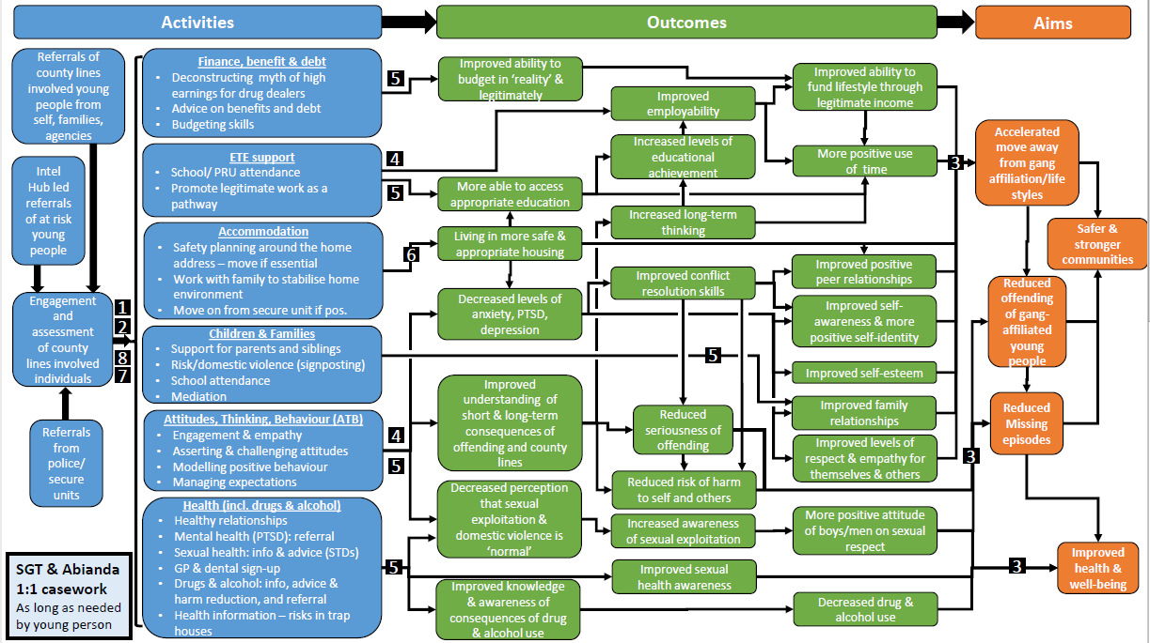
Monitoring and Evaluation

Monitoring:
Service delivery and contract monitoring completed by service manager. To ensure effective outcomes and delivery process adequate. Will report into Delivery board for review. Delivery Board will meet monthly for first 6 months, moving to quarterly post 6months if appropriate.

Evaluation:
The main element of the project evaluation would be conducted by the Contextual Safeguarding team at the University of Bedfordshire who are based in their International Centre: Researching Child Sexual Exploitation, Trafficking and Violence. The team have a track record of researching, and developing practice responses to, issues which compromise the safety and well-being of young people – particularly those which are extra-familial. They will draw upon: their knowledge of London responses to extra-familial risk (gathered through audits of local practices in 12 London boroughs over the past three years); learning they are building through the contextual safeguarding network and London safeguarding adolescents steering group; and their knowledge of international research in the field of safeguarding young people and vulnerable adults to design and deliver this evaluation plan.

Evaluation Objectives:
It is our view that the evaluation should be targeted at particular components of the project (in the context of the wider brief). As such the objectives of the evaluation would be to:
- Identify the mechanisms for achieving a ‘Team around the Network’ model – from prevention, through to identification, disruption and where required ‘rescue’.
- Identify the critical elements of ‘teachable moment’ practices for young people affected by County Lines – and how best to identify and utilise them
- Assess the relationship between the activity of hubs and the ‘breaking the cycle activities’ as a means of preventing the exploitation of young people who access/or are part of identified hotspots/networks (such as peer groups, education provisions, care homes etc.)
- Explore the ability of the model to leverage improved safeguarding responses to children and vulnerable adults (under-25) who are impacted by county lines
- Assess whether the model increases practitioner awareness of the vulnerability of those affected by county lines (linked to identified outcomes related to increase referrals into family support, social care etc.)
- Better understand the nature, and impact, of county lines activity across London
- Evidence the impact that county lines, and the interventions offered, have the young people and families’ sense of safety
- Feed iterative learning from the evaluation into the development of the model and in particular the content of training materials and policy briefings used during the project
- Identify opportunities to sustain, develop or enhance delivery of the model beyond the lifespan of the project
Evaluation Methodology:
The evaluation team will draw upon situational crime prevention and ecological theories of human development when using contextual safeguarding theory to design the evaluation. Through a contextual safeguarding lens they will analyse prevention, identification, intervention and recovery across contexts as well as individuals – and therefore best capture the ‘team around the network’ element of the model. A mixed-methods approach would be used including:
- Narrative review of safety plans, action logs and de-briefs
- A minimum of three contextual case reviews (which can be turned into training activities to be used during the project)
- Embedding research staff into the hubs to conduct practitioner observation and co-create products with analysts using ‘side-by-side’ learning techniques
- Follow-up semi-structured interviews with a sample of participants who engage with awareness-raising activities and a tracking of the context that they are in (i.e. a school or youth club)
- Telephone semi-structured interviews with practitioners involved in the management of cases
Outputs:
Evaluators would produce annual ‘project briefings’ to share emerging learning from the project. At the close of the evaluation we would aim to publish a series of ‘thematic briefings’ to share the themes of the evaluation with practitioners, policymakers and commissioners, in addition to producing other accessible and practical resources to sustain the impact of the model beyond the life of the project.

This evaluation would help the project team look into further funding sources from year 2 through both qualitative data via the University of Bedfordshire as above and quantitative evaluation through overarching strategic needs assessment created by the analysis team over the 3 year period.

Quantitative Additional Evaluation:
The intelligence gained from this project will be fed in to create a Strategic Needs Assessment, outlining the extent and scale of the issue affecting London and the surrounding counties. The scale of the issues is currently unknown meaning there is a lack of an evidence base to command the resource investment it is believed this area warrants. This information will hopefully help gain further funding and insight to help further reduce and eradicate ongoing criminal exploitation of young people.

2 NCA National Briefing Report: County Lines Gang Violence, Exploitation & Drug Supply 2016
1 Home Office: Criminal Exploitation of children and vulnerable adults: County Lines guidance
Some of the outcomes listed can be captured by monitoring frameworks already embedded into the work and therefore won’t need additional oversight by the research team.

