London Councils Summit 2016, Saturday 26 November
Event page is www.londoncouncils.gov.uk/summit2016

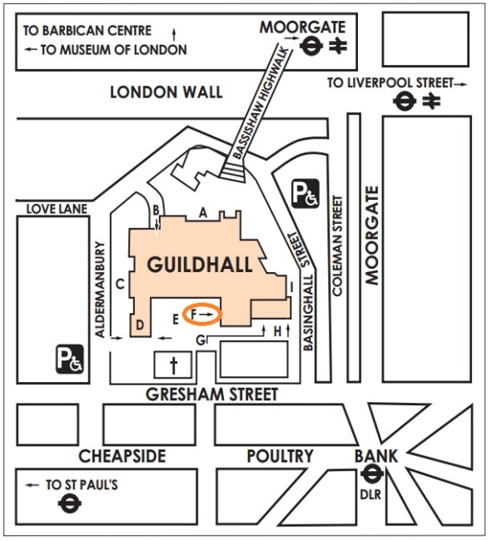
Location & travel
The Guildhall (art gallery entrance circled ‘F’ on map), Gresham Street, EC2V 7HH
You are advised to check on www.tfl.gov.uk for travel disruption before you start your journey

The nearest tube stations: Moorgate (Hammersmith and City, Metropolitan, Circle and Northern), Bank (Northern, Central, Waterloo and City and DLR), Mansion House (District and Circle) and St Paul's (Central). The nearest train stations: Cannon Street, Liverpool Street & Blackfriars. There is no parking at the venue.

Programme for the day (timings subject to change)
09.15
Registration, refreshments

10.10
Opening session
Cllr Claire Kober, chair, London Councils
Mark Boleat, chair of policy and resources committee, City of London Corporation

10.30 – 10.45
Mayor Sadiq Khan, Mayor of London

10.45 – 11.20
Refreshment break

11.20 – 12.50pm
Shaping public services
What will our services look like in 2020 and how will Londoners experience them? Our panel discusses the impact of the financial environment, the opportunities of continuing digital innovation, and how we can ensure London’s growth benefits all Londoners. Followed by a question and answer session.
Panel chair:
John O’Brien, chief executive, London Councils

Panellists:
Stephanie Flanders, Chief Market Strategist for UK and Europe, JP Morgan Asset Management
Catherine Howe, Solutions Director, Capita
Rob Whiteman, chief executive, Chartered Institute of Public Finance and Accountancy

12.50–2.10
Lunch

2.10-3.10
Breakout 1: Skills – no Londoner left behind
How can boroughs improve the life chances of all Londoners by creating a skills system that works? Expert speakers will discuss the challenges and the opportunities presented by the devolution of the skills budget and how boroughs can work with local colleges and businesses to match skills with industry needs.

Breakout 2: Making integration of health and care work
What is the role of local democratic leadership in improving health and care services for our residents? Speakers will share their insights into how we can best use and influence the strategic opportunities to transform health and wellbeing in London through health devolution, Sustainability and Transformation Plans and the Health and Well-being Boards.
Breakout 3: Building safer communities
How London’s public services work together to keep our communities safe is a crucial shared responsibility. Speakers will discuss the role of the police and councils in building strong working relationships across partner agencies and how changes to London’s policing could impact at borough level.

3.10 – 3.20
Refreshment break

3.20 – 4.00
Closing session with Robert Gordon Clark (London Communications Agency) and Professor Tony Travers (London School of Economics) reviewing the London Mayoral election and looking forward to the critical challenges for the parties over the next 12 months through to the London local elections in 2018 followed, by Q&As

