Guidance for your grants online application

We would strongly advise you PRINT THE GUIDANCE and READ BEFORE completion of each question to maximise the points you can score and also refer to FAQs webpage (which will be updated regularly).

Before you begin writing your application:
- Check you are eligible - there is no point spending hours on the form if you are not eligible for a London Councils grant.
- Check your deadline. The deadline for Priorities 1 and 2 is
12 noon, Thursday 15 September 2016.
Once the deadline has passed it is no longer possible to submit an application for funding. Leave yourself enough time to complete, review, amend and submit your online form before the deadline. Deadline days are often busy and you may not be able to reach a member of London Councils staff if you have any technical queries with submitting the form.
- See the principles and priorities of the London Councils Grants Scheme. All applicants must be able to demonstrate they meet all the principles and one priority.
- Each priority has a specification. Priority 1 and 2 have been divided into a number of service areas. Read the specification for the service area you wish to make a grant application to deliver.
- Use this guidance to help you complete the online form.

Partnership applications
We will accept funding proposals from partnerships (organisations that want to seek funding jointly from London Councils) but one of the partner organisations must be made the lead organisation, or a new partnership organisation must be set up. If one organisation is seeking funding on behalf of other organisations, then the lead organisation needs to
- Supply us with a letter from each organisation in the partnership confirming their role in the service.
- Provide an attachment listing details on each partner (including the lead partner) using the template provided (this includes information on the role the partner will play in the project and confirmation that the partner organisation is solvent and eligible for London Councils funding).
- List the partner organisations in the application form
You will also be required to send us a partnership agreement form signed by each partner before funding can start. The partnership agreement must meet the criteria for partnership organisations which will be sent out to successful organisations. If successful, the relationship will be between London Councils and the lead partner. Payments will be made to the lead partner and the lead partner will be responsible for submission of monitoring information, reporting any changes and for reviewing the financial viability of the partners as well as promoting the project through liaison with boroughs. You should therefore ensure that this role is adequately resourced with the project budget. Service users that move across a partnership should be tracked using a single service user number to ensure robust monitoring information.

Things to remember about your online form:
Once you have created a log-in to our form, you can save your on-line application at any point and come back to it later.

Once you have saved your on-line application you can open and change the form from any computer.

Help: If you need further assistance/ information.
- Firstly read this guidance document.
- Secondly refer to the FAQs (these will be updated regularly)
- Thirdly if you still have not been able to find an answer then please email us. funding@londoncouncils.gov.uk Your question and our response may be posted on the FAQs page. Please send your questions no later than one week before the deadline as we may be unable to answer questions after that date. The application deadline is 12 noon, Thursday 15 September.
Step One: Create an account login and access the online form

Click on the following link

https://www.GrantRequest.com/SID_668?SA=SNA&FID=35053

to create a login and access a new form,

(or copy and paste into your internet address bar).

Now you will see this screen, where you create your account and login.

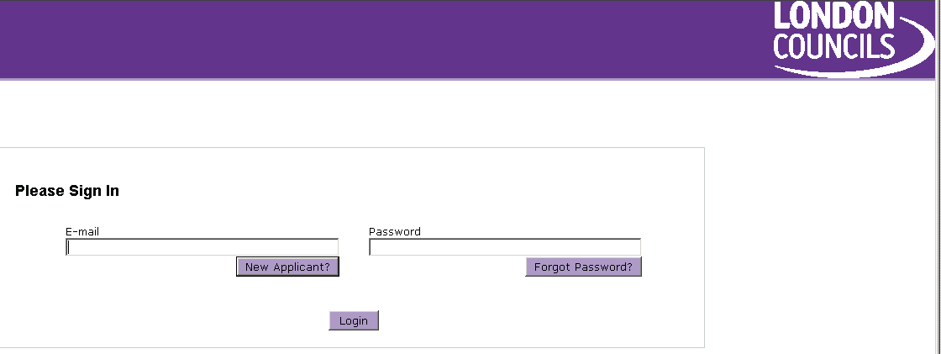

- Click on ‘New Applicant’

Important:
If you are currently funded or have applied for funding previously then you should enter your existing login details here and you will be taken to a new form. If you can not remember your password you should enter your email address and click on ‘Forgot Password’ and you will be sent a temporary password.

Important:
If you are trying to set up as a new applicant and get an error message stating ‘Invalid e-mail or password’ it may be that you have created an account before (even years ago). You should click on ‘Return to Login’ and then enter your email address and then click on ‘Forgot Password’ and you will be sent a temporary password.

- You will be taken to a new page
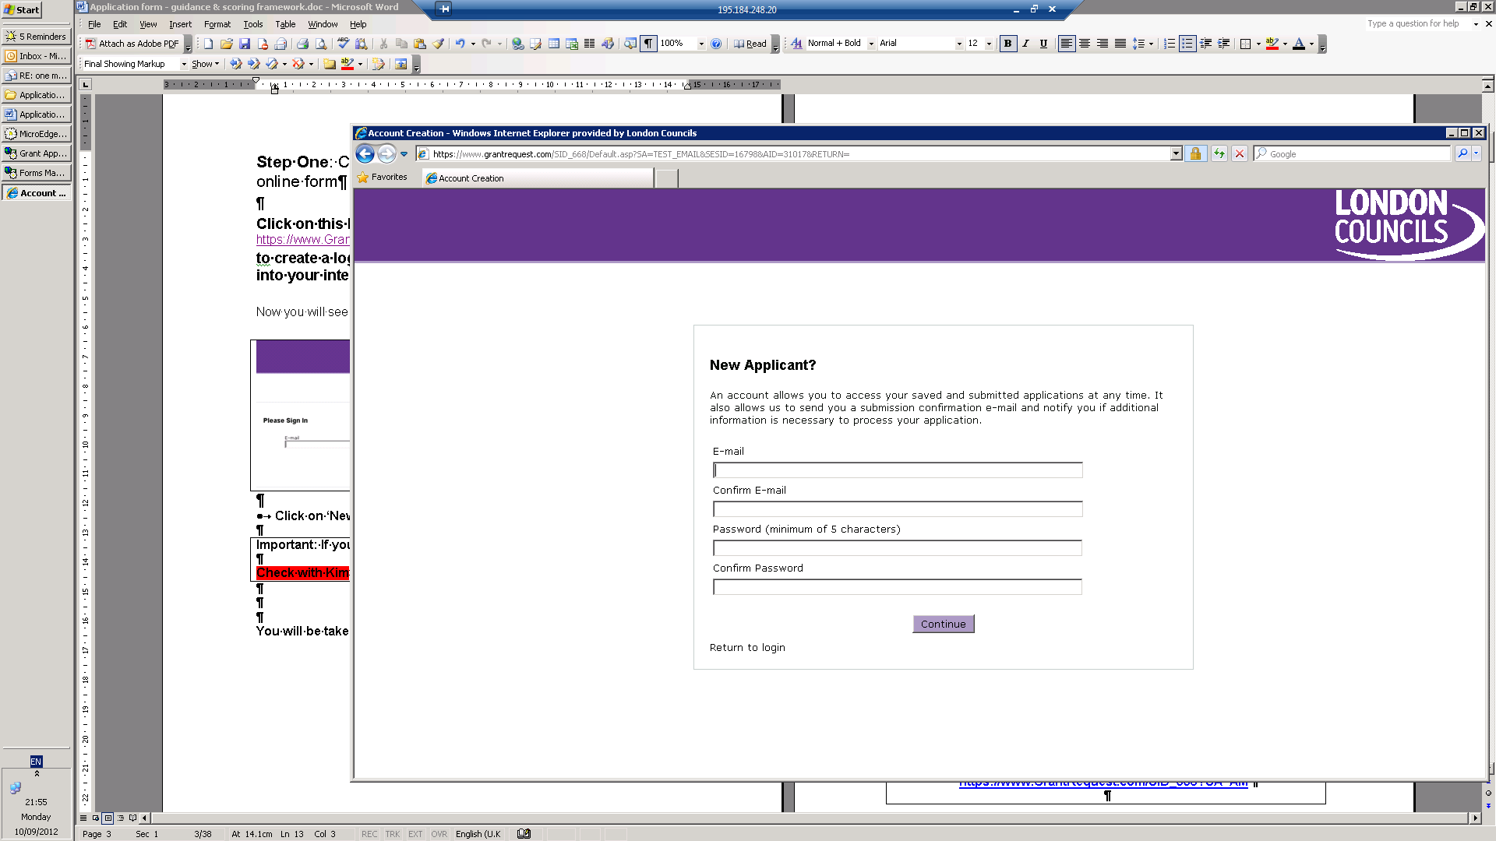

- Enter your email address. The email address must work as we will be using this to contact you about your application and you need it to access a form that you have already started.

- Verify your email address (by typing it again)

- Create a password. It must be at least five letters long - for example -‘Lychee’.

- Verify password (by typing it again)

- Click on the button marked ‘continue’ and you will move straight into the online form.

- The form starts with a quick eligibility quiz. The list is not exhaustive and you should refer to the eligibility information on the link above.

You must remember your email address and password
as you will need it every time you log into your account.

You can save and close your form, by clicking on ‘save and finish later’ now and at any time and return to the form by accessing you account.

To return to your account (where you can access forms already started) click on:
https://www.GrantRequest.com/SID_668

Step two: Complete the online form
Important information

Please make sure you have read the service specification before you attempt to complete the form.

This part of the guidance covers:

- technical help for using the online form
- help with answering the questions.

Technical help for using the online form
The information below will take you through how to use the online form to answer the questions.

For most of the form you are asked to simply type your answers into a box next to the question.

Sometimes you are required to tick a box or select from options and we will explain exactly what you need to do.

Mandatory fields
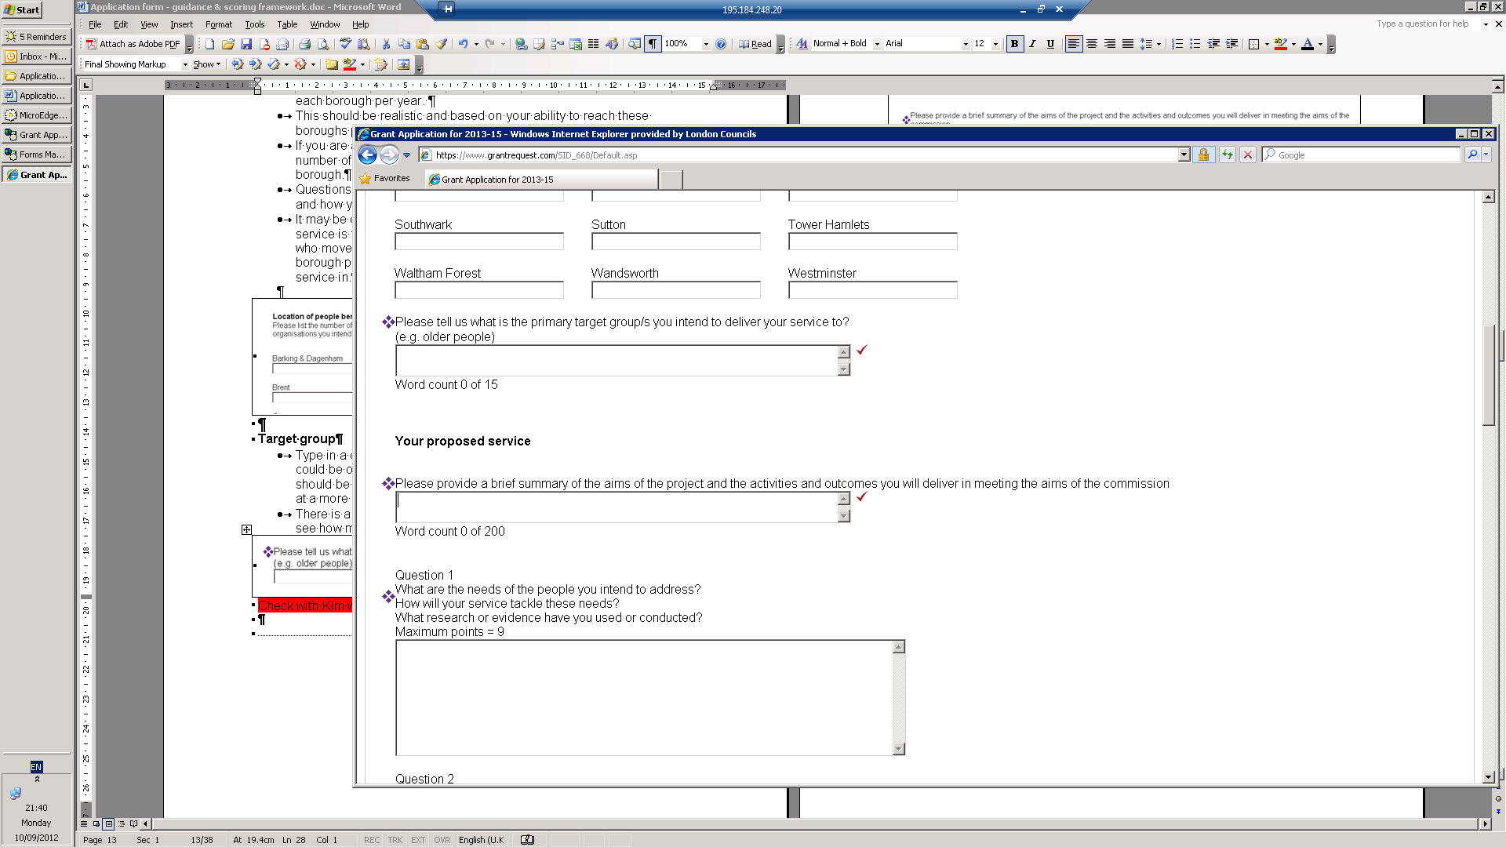
You must answer all questions marked with a purple diamond. If you do not answer these questions you will not be able to submit your application.

Spell check
Where you see a red tick you can click on it to perform a spell check.

Help
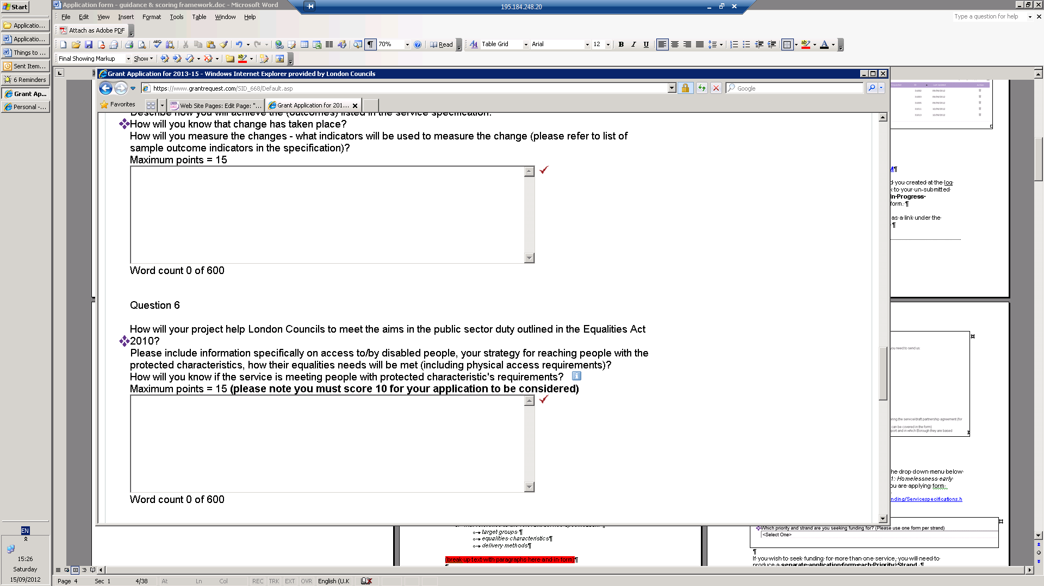
Where you see an ‘I’ in a blue box this means there is more information available, if you click on it.

Word limit

There is a word limit to some questions. Where this is the case the counter will show you how many words are left from the total allowed.

How to save, print and return to your form
Saving your work
Firstly you may wish to draft your answers in a word document and then paste this into the form.
Once you are into the question part of the form you can save what you’ve done and come back to it at any point by pressing the ‘save and finish later’ button.
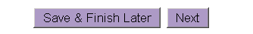
We strongly advise you to save your form as you go along. If you have not saved and your computer crashes you will loose all your work.
Once you have saved your work you will be taken to this screen (below). Simply click on your proposal and carry on working.
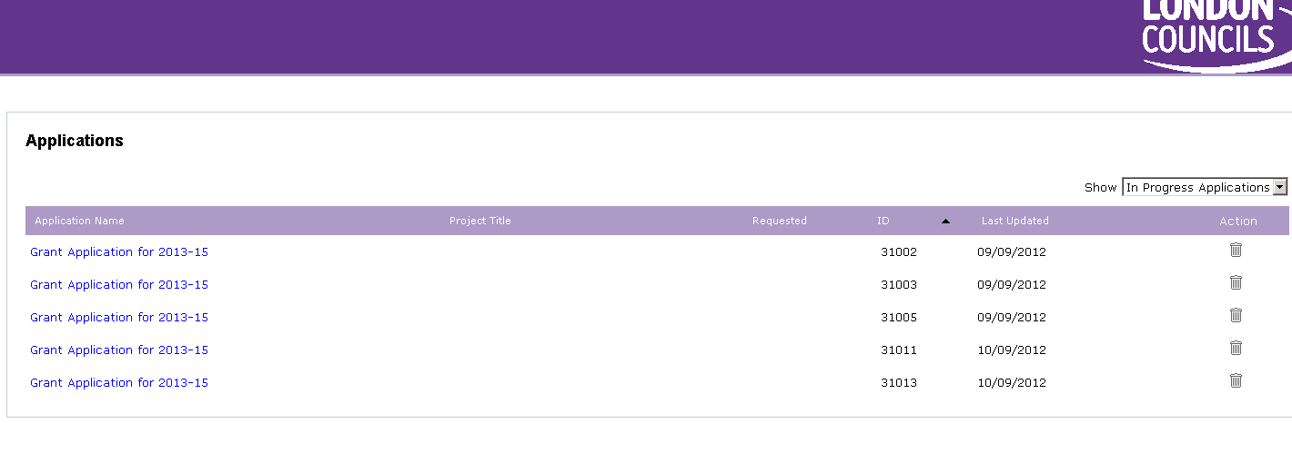

To return to your form
Click on the following link. https://www.GrantRequest.com/SID_668
Log into your account using the email and password you created at the log in stage. You will see the screen above. To go back to your un-submitted application make sure the drop down menu states ‘In Progress Applications’ click onto the link to go back to your form.
If you have submitted your form you can still view it as a link under the ‘Submitted Applications’ in the drop down menu.
To print
Click Save and finish, come back to your form. Click on button ‘printer friendly version’ to print.
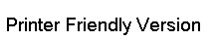

Please note you always need to click ‘save’ before printing your application so that your most up to date version prints out.
Do not send us your printed version; simply use it to check your work. London Councils can only accept online applications (unless in exceptional circumstances in which a group has written in advance (by 31 August 2016 to seek permission).

Completing the form – questions

The form starts with introductory text covering the assessment of applications. Please read this carefully.

Answering the Questions
The information below will give you guidance on the information required to answer each question. Your proposal will be assessed according to criteria set out in Appendix 1 of this document.

The questions are assessed using scores and the maximum score possible is shown at the end of the question.

Documents you will need
- The first page of the form tells you exactly which documents you will need to upload at the end of the form.
- There are 8 required documents
- 4 documents that must also be added where relevant.
- Please see information regarding what is required and how to upload a document.

Priority/ Service Area
All applications must meet the principles and one priority. Select the Priority/service area you are applying for from the drop down menu below the question (for example Priority 1, Service Area 1.1 = 1.1: Homelessness Prevention and Targeted Intervention). To check which one you are applying for please see the specifications. Link to specifications: https://www.GrantRequest.com/SID_668

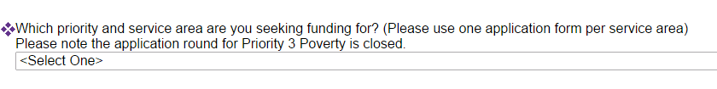

If you wish to seek funding for more than one service, you will need to produce a separate application form for each Priority/ Service Area.

Organisation details

Type in:
- Your organisation’s name
- Your organisation’s address
- Your organisation’s website address (pleas type in Not Applicable if you do not have a website)

  - In which local authority area is your organisation located?
      - Select this from the drop-down box
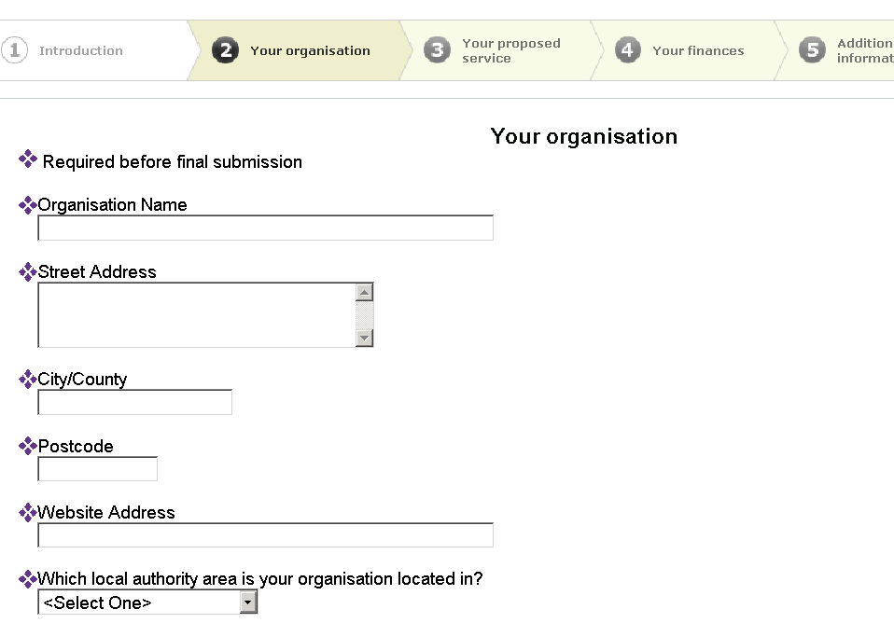

Partnership applications
If your application is in partnership you need to list all the partners (further details need to be provided in the attachments section using the partnership template).

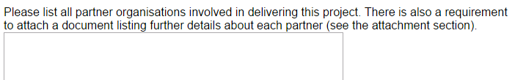

  - Is the organisation part of a larger organisation?
- If you are part of a larger organisation then tick the box to confirm that the parent organisation supports the proposal and type the name of the parent organisation.
- Otherwise do not tick the box and leave the text box blank.
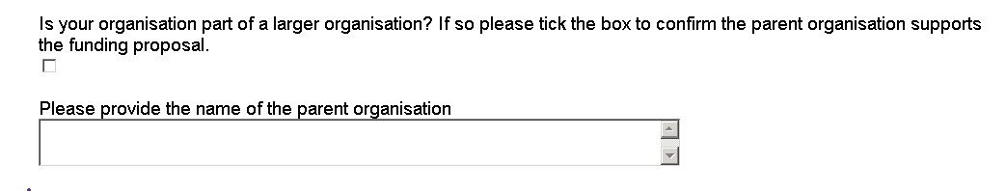

- Type in a description of the management structure of the project and the governing body. You will be asked to provide details of a trustee at the end of the form.
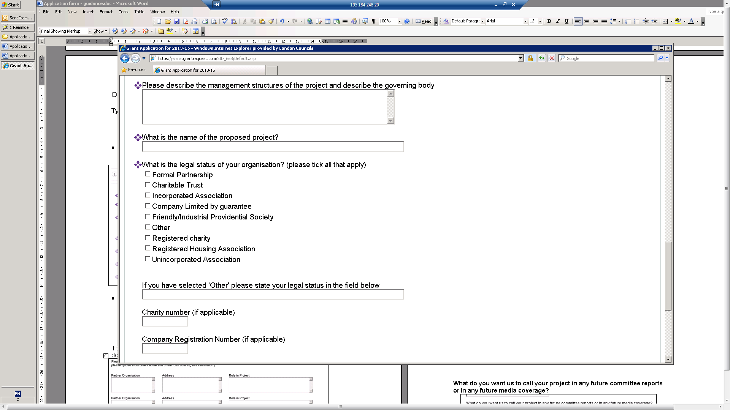

- Type in the name of the project you are seeking funding for?

- What is the legal status of your organisation? Please tick all that apply. If you are in doubt about your organisation’s eligibility please read the following advice on eligibility.

- Type in your registered charity number (where applicable)
- Type in your company registration number (where applicable)

Who should we contact when we want to tell you whether your application has been successful?

Type in:
  - Contact person’s prefix (e.g. Mr, Mrs, Dr)
  - Contact person’s first name
  - Contact person’s surname
  - Contact person’s job title
  - Organisation’s phone numbers (daytime phone number should be a landline)
  - Contact person’s e-mail address

These are mandatory fields. We can not assess your form without contact details.

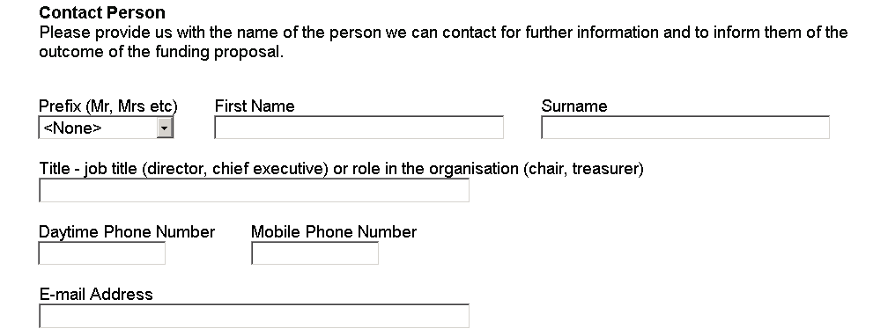

Your proposed service

Location of people benefiting
  - Type into each of the boxes how many people you expect to serve in each borough per year.
  - You should refer to the indicative service delivery levels per borough in the service specification and aim to match the percentage distributions as closely as possible.
  - Service areas 1.3, 2.4, and 2.5 do not have borough levels tables. You should fill in the table to provide a good spread of services across London.
  - If you are applying under service area 1.3 or 2.5 please include the number of organisations you intend to support per year in each borough.
  - The numbers should be realistic and based on your ability to reach these boroughs previously.
  - Questions 2 and 3 will ask more about your links to these boroughs and how you can demonstrate your service is pan-London.
  - It may be difficult to estimate where service users will come from if your service is for people who move around London frequently or people who move to London for the first time. If this is the case, tell us in which borough people are currently living or which borough they use your service in.

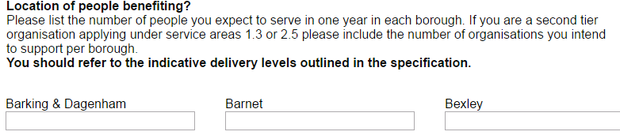

Target group
  - Type in a description of your primary target group/s. For example this could be older people, south Asian women, young people, etc. This should be if your project has a particular focus. If your project is aimed at a more general group then please state this.
  - There is a word limit of 15 words. A counter under the box helps you to see how many words you have left.

Summary of project
  - Type in no more than 200 words a description of the activities and outcomes you are seeking funding for. A counter under the box helps you to see how many words you have used.

Questions 1- 11

You will now go through a series of questions. You should refer to the following guidance for each question as well as the scoring matrix included in Appendix 1 below.

Question 1
  - Type in a description of the needs of people you intend to address with the project.
  - Describe how your project will tackle these needs.
  - Include references to research or evidence that you have used or conducted into the needs of the people you will be working with.
  - There is a word limit of 800 words. A counter under the box helps you to see how many words you have used.
  - This question can score up to 18 points.
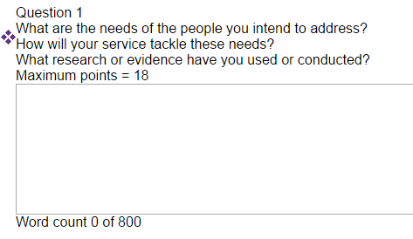

Question 2

- Type in a description on how and from where you will attract people to your project. For services 1.3 and 2.5 please describe how you will attract user organisations.
- Above you typed in numbers of people (or organisations) you intend to serve per borough each year. How will you ensure people from different boroughs will access the project?
- It is very important that the service complements local provision and that local authority officers are able to refer into the service and value the service.
- Describe how you will ensure local authority officers are aware of referral pathways and describe how the service will fit with local provision.
- Describe your current referral routes and contacts (such as schools, local council officers, networks etc).
- You should provide information relating to each of the 33 London boroughs.
- There is a word limit of 800 words. A counter under the box helps you to see how many words you have used.
- This question can score up to 24 points.

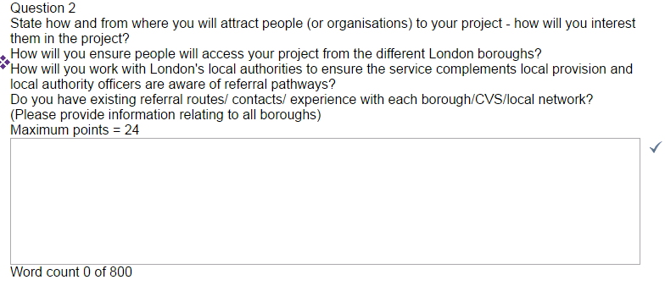

Question 3
- Type in a description of how your project meets all the principles of the London Councils Grants Scheme. The principles can be found on the first page of the online form and via the following link:
http://www.londoncouncils.gov.uk/node/30013
- Describe how you will ensure the service is genuinely London-wide and does not duplicate local provision?
- How will you work with other providers to make this happen?
- Ensure that you cover all boroughs in your answer.
- There is a word limit of 800 words. A counter under the box helps you to see how many words you have used.
- This question can score up to 12 points.
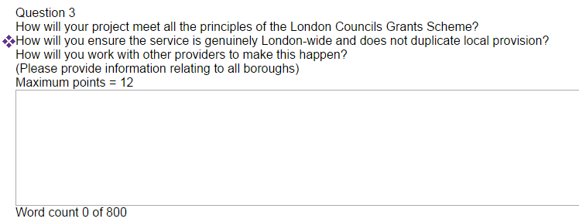

Question 4
- The service specification contains standard outcomes.
- Where there is a number of bullet points under each outcome area you should choose one or two of these (or the number indicated in the specification).
- Where one of the bullet point indicators have the word ‘mandatory’ this indicator must be included in your application.
- Where the specification has listed ‘example indicators’ you can include your own examples.
- Type in a description of how your project will achieve the outcomes in the specification.
- How will you know that the outcome (or change in the service user) has taken place?
- How will you measure the change? What information will you collect to evidence this?
- Include figures of how many people you anticipate will achieve these outcomes.
- London Councils will report on the numbers of service users per borough and the number of service users that have achieved each outcome per borough. For this reason you should describe how you will ensure that you will achieve your target outcomes level in the different boroughs, any anticipated challenges and how you will address these.
- This question can score up to 24 points.
- There is a word limit of 900 words. A counter under the box helps you to see how many words you have used
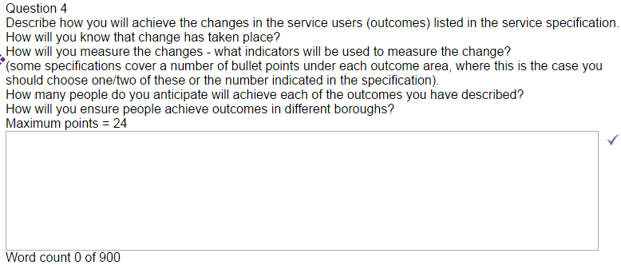

Question 5
- Type in a description of the activities that will be delivered by your project (the outputs).
- These should relate directly to the outcomes from the service specification.
- The outputs must be relevant to delivering the outcomes of the project.
- They must also be related to the specific project you are seeking funding for, rather than the wider activities of your organisation.
- Figures should be added (for example, numbers of people, sessions, hours, etc) and you should state if these are per month or per quarter (for example, ‘The project will deliver 40 hours of advice to 20 young people at risk of homelessness per month.’)
- Include the unit cost (number of outputs divided by the total funding sought).
- There is a word limit of 600 words. A counter under the box helps you to see how many words you have used.
- This question can score up to15 points.
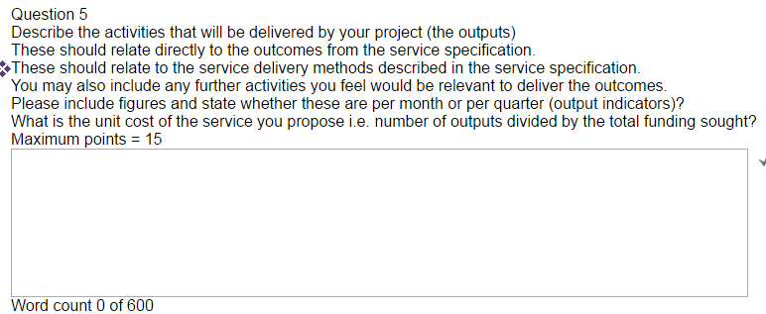

Question 6
- You will be asked to upload your equalities policy and objectives at the end of the form. This question is about how you implement this policy and objectives in relation to the project you are bidding funding for.
- Type in a description of how your project will help London Councils to meet the 3 aims in the public sector duty outlined in the Equality Act 2010. These are as follows:
- eliminate discrimination, harassment, victimisation and any other conduct that is prohibited by or under this Act;
- advance equality of opportunity between persons who share a relevant protected characteristic and persons who do not share it;
- foster good relations between persons who share a relevant protected characteristic and persons who do not share it.
- How will you ensure your project is accessible to people with the protected characteristics as outlined in the Act. These are as follows:
  - Age
  - Disability
  - Gender reassignment
  - Pregnancy and maternity
  - Marriage and Civil Partnership
  - Race
  - Religion
  - Sex
  - Sexual orientation
- Describe how the project will be accessible to these different groups and your organisation’s strategy.
- You should specifically describe access for disabled people.
- Finally, how will you know that your project is meeting the requirements of people from the groups highlighted above?
- There is a word limit of 600 words. A counter under the box helps you to see how many words you have used.
- This question can score up to 15 points. You must score a minimum of 10 points to proceed.
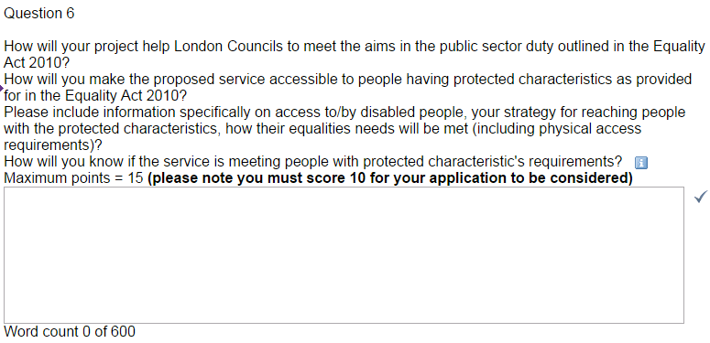

Question 7
- Describe your organisation’s experience of delivering a similar project.
- If you are a new project or newly working in this area, describe how you will ensure the project is effective, building on the experience of your organisations and staff.
- If you are a lead partner you should also include your experience of leading a partnership or other relevant experience to this role.
- Focus on your experience of working with this target group, delivering this kind of service and outcomes.
- There is a word limit of 600 words. A counter under the box helps you to see how many words you have used.
- This question can score up 9 points
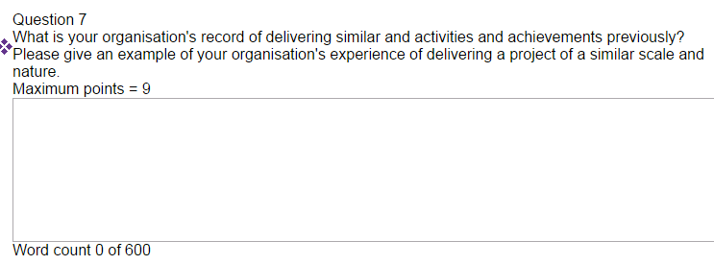

Question 8
- Type in a description of how your project will be delivered over the 4 years of funding. You will also be asked to upload a document covering your 4-year delivery plan at the end of the form.
- How will your project meet the specific requirements set out in the specification?
- Describe any risks or challenges that the project might experience and how you might overcome these?
- In particular you should refer to how management of risk will be integrated into broader management structures and how this will be managed on a day to day basis.
- If you are a partnership bid, you should include risk relating to partners/ partnership working and how you will mitigate these.
- There is a word limit of 600 words. A counter under the box helps you to see how many words you have used.
- This question can score up to 13 points.
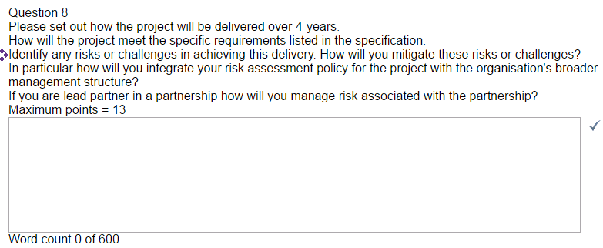

Question 9
- Type in a description of the staffing structure of the project. Which staff are involved in delivering/overseeing the project and their roles?
- How will the staff involved in the project be managed? How will your organisation ensure they deliver the project effectively?
- How will volunteers be recruited and retained?
- What experience/ skills do staff have or need?
- How will staff be accountable to the governing body?
- How will you report achievements to users, funders and management bodies?
- There is a word limit of 600 words. A counter under the box helps you to see how many words you have used.
- The question can score up to 9 points.

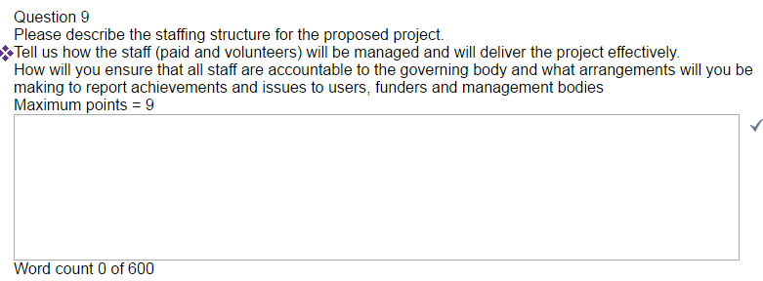

Question 10
- Type in how you will monitor the project?
- How will you measure the progress of service users?
- What systems will you put in place to collect, analyse and report data
- If you are a partnership how will your monitoring be adapted including cross-partnership systems?
- Will service users tell you if they are satisfied with the project?
- Will you engage service users in ways that you adapt the project in the future?
- Do you use quality systems/ standards and if so which ones (these could be your own or more widely recognised ones)? How are these applied to the delivery of this project?
- What additional benefits would your proposal bring? This could be additional income, volunteers etc.
- There is a word limit of 600 words. A counter under the box helps you to see how many words you have used.
- The question can score up to 9 points.
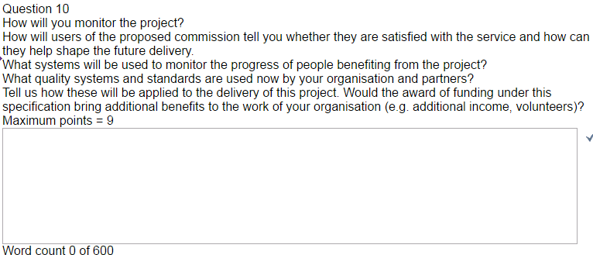

Your Finances

Question 11
Project start date:
- Please type in the date, or click on the calendar button on the right and select the date. The date can not be prior to 1 April 2017.
- Your project end date can be not later than 31 March 2021. So if you wish to deliver a four year project you should select a date that you can realistically start on as soon after 1 April 2017 as possible.
- For example if you felt you could realistically start on 15 April 17 you could apply for up to the following period 15 April 2017 – 31 March 2021.

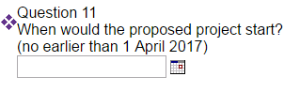

Requested amount:
- Please type in your requested levels of funding for one year.
- Funding can be applied for up to 4 years.
- This box requires an annual figure that you are requesting for one year of the service.
- You may not carry funding over from one year to the next without the consent of London Councils. Funding is subject to continuing resources being available and deliverance of outcomes and adherence to the grant conditions.
- The boxes for this question will only accept numbers - do NOT use the ‘£’ sign or commas and full stops. Round any figures up to the nearest pound.
For example 15123 (not £15,122.56)

Grants Committee has agreed indicative amounts of money available per specification. These can be found on the following link. http://www.londoncouncils.gov.uk/node/30036
These amounts are not fixed and may change when the budget is set in November/December 2016 and when decisions on applications are taken in February 2017.

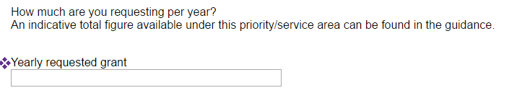

Budget and financial reporting
- You will be asked to upload a detailed budget on the next page of the form.
- Guidance on what the budget should include and how to access a template is found further down this guidance document.
- Type into the text box anything you need to explain about the budget, including whether you have or anticipate funding in place for the full cost of the service (including from other sources/ pending funding applications).
- Tell us how funds will be allocated to partners or different aspects of the project.
- If successful, you will be expected to demonstrate Value for Money during the life of the grant. How does your project represents value for money and how you will demonstrate this during the life of the grant?
- You could include, information on added value, how much additional resources having London Councils funding levers into your organisation, avoiding duplication with existing services, social impact value, service user involvement. This list is not exhaustive.
- Describe your organisation’s financial controls and financial reporting.
- Tell us how the finances of the organisation are reviewed by the management committee/board and which senior member(s) of your management structure are responsible for financial reporting. How do you monitor that the staff follow the organisation’s financial regulations?
- There is a word limit of 500 words. A counter under the box helps you to see how many words you have used.
- This score can attract up to 15 points.
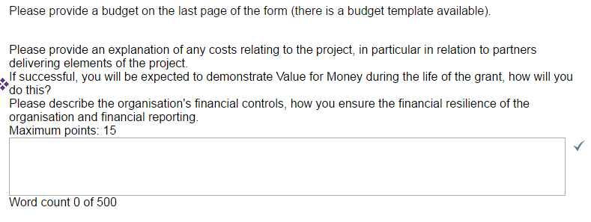

Additional information

This is the final page of the form.

Board/ Trustee member
- You are now required to enter the contact details of a board/ trustee member.
- This is so that we can copy them into correspondence when relevant.
- Chose a board member/ trustee and then type in their:
  - prefix (Mrs, Mr, Dr)
  - first name
  - last name
  - title (role in the organisation – chair, treasurer)
  - phone numbers
  - email address
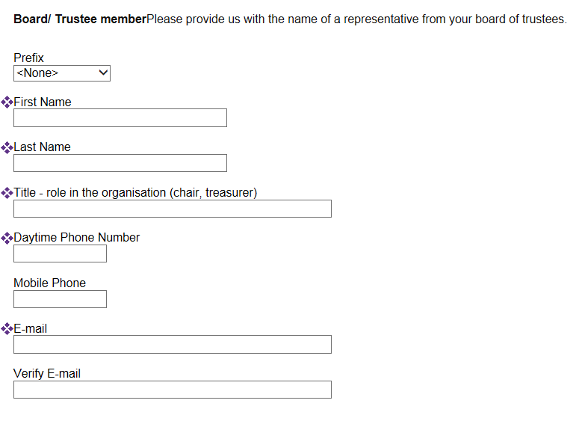

Attachments
- You are now required to upload a number of attachments.

Before you can attach the documents online you need electronic versions of your documents saved onto your computer.

If you don’t have electronic copies then you can scan the paper copies and save them in a folder on your computer.

The maximum size for all attachments combined is 50MB. Files with .exe .com .vbs or .bat will not upload.

- Uploading a document is similar to attaching a document to an email.
- To do this click on the ‘browse’ button next to the attachment you wish to upload.
- This will take you to documents on your pc/network. Search for the correct folder.
- Select the correct document and click ‘open’.
- Now click on the button ‘upload’.
- If you do not click ‘upload’ your document will not be uploaded to the form.
- If you have uploaded the wrong document simply click on ‘remove’.

- Signed copy of your Constitution or Memorandum and Articles of Association.
- Ensure that it is the most up to date and signed copy.
You will have already checked (above) that your organisation is eligible for London Councils funding using the London Councils webpage on eligibility.
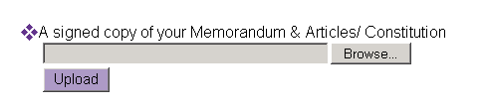

- Equalities Policy and objectives
- Upload your most recent Equalities (Equal Opportunities) Policy and objectives
- If your equalities objectives are a separate document you should scan both documents together so that you can upload one document.
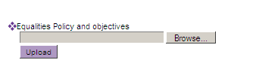

- Latest Accounts
- London Councils requires all funded organisations to provide fully audited accounts. If your organisation is not currently funded by London Councils you may submit accounts appropriate to the size of your organisation. If successful you will need to produce audited accounts for the first year you receive funding.
- You are required to submit three sets of accounts
- This should be 2015-16, 2014-15, 2013-14 (or 2012-13 if the 2015-16 are not available yet).
- If your organisation has not been in existence long enough to have 2012-13 accounts you should state this in a word document uploaded (because the form requires three documents to be uploaded) . You may be asked for additional information as part of London Councils Due Diligence process.
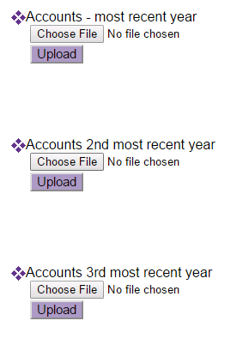

- Public Liability Insurance
Upload your current public liability insurance certificate.
As part of London Councils due diligence process we require funded organisations to have pubic liability insurance at a level of £5m.
You should upload your current policy.
If you are successful and your current policy is for a lower value you will be required to amend the value of your policy.

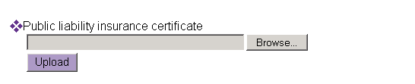

- Employer’s liability insurance
Upload your current employer’s liability insurance certificate.
As part of London Councils due diligence process we require funded organisations to have employer’s liability insurance at a level of £10m.
You should upload your current policy.
If you are successful and your current policy is for a lower value you will be required to amend the value of your policy.

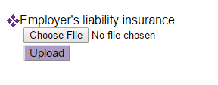

- Budget
- You must provide and upload a detailed budget for the service.
- You can either use the template provided via the following link in
http://www.londoncouncils.gov.uk/node/30010
Or use your own format
- Please include relevant start-up costs for the service and indirect costs (such as marketing, management and administrative support), as well as the direct costs of providing the service (such as staffing for the service).
- You may include costs related to the organisation proportionate to the project (‘full cost recovery’ or ‘overheads’). These should be no more than 15% of the level of funding requested.
- Our funding cannot be used to buy large capital items (such as buildings or vehicles).
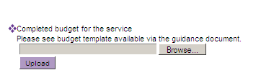

- 4 year delivery plan
- Question 8 asks you about your delivery plan.
- Upload your 4-year delivery plan here.
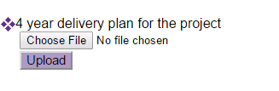

- A reference
- You are required to upload a reference using the template provided.
- You should use the template provided via the following link in
http://www.londoncouncils.gov.uk/node/30010
- This should be a London local authority (council), funder or an organisation that you have delivered services for.
- You should submit two references if you are seeking funding of more than £1m per year (scanning both references together to make one document).

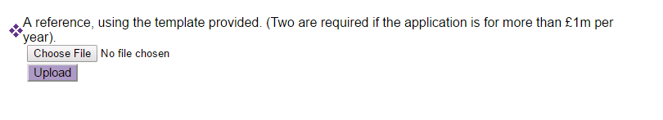

Where relevant you must also send us

Safeguarding policy
- If you work with children, young people of vulnerable adults, you must send your safeguarding policy
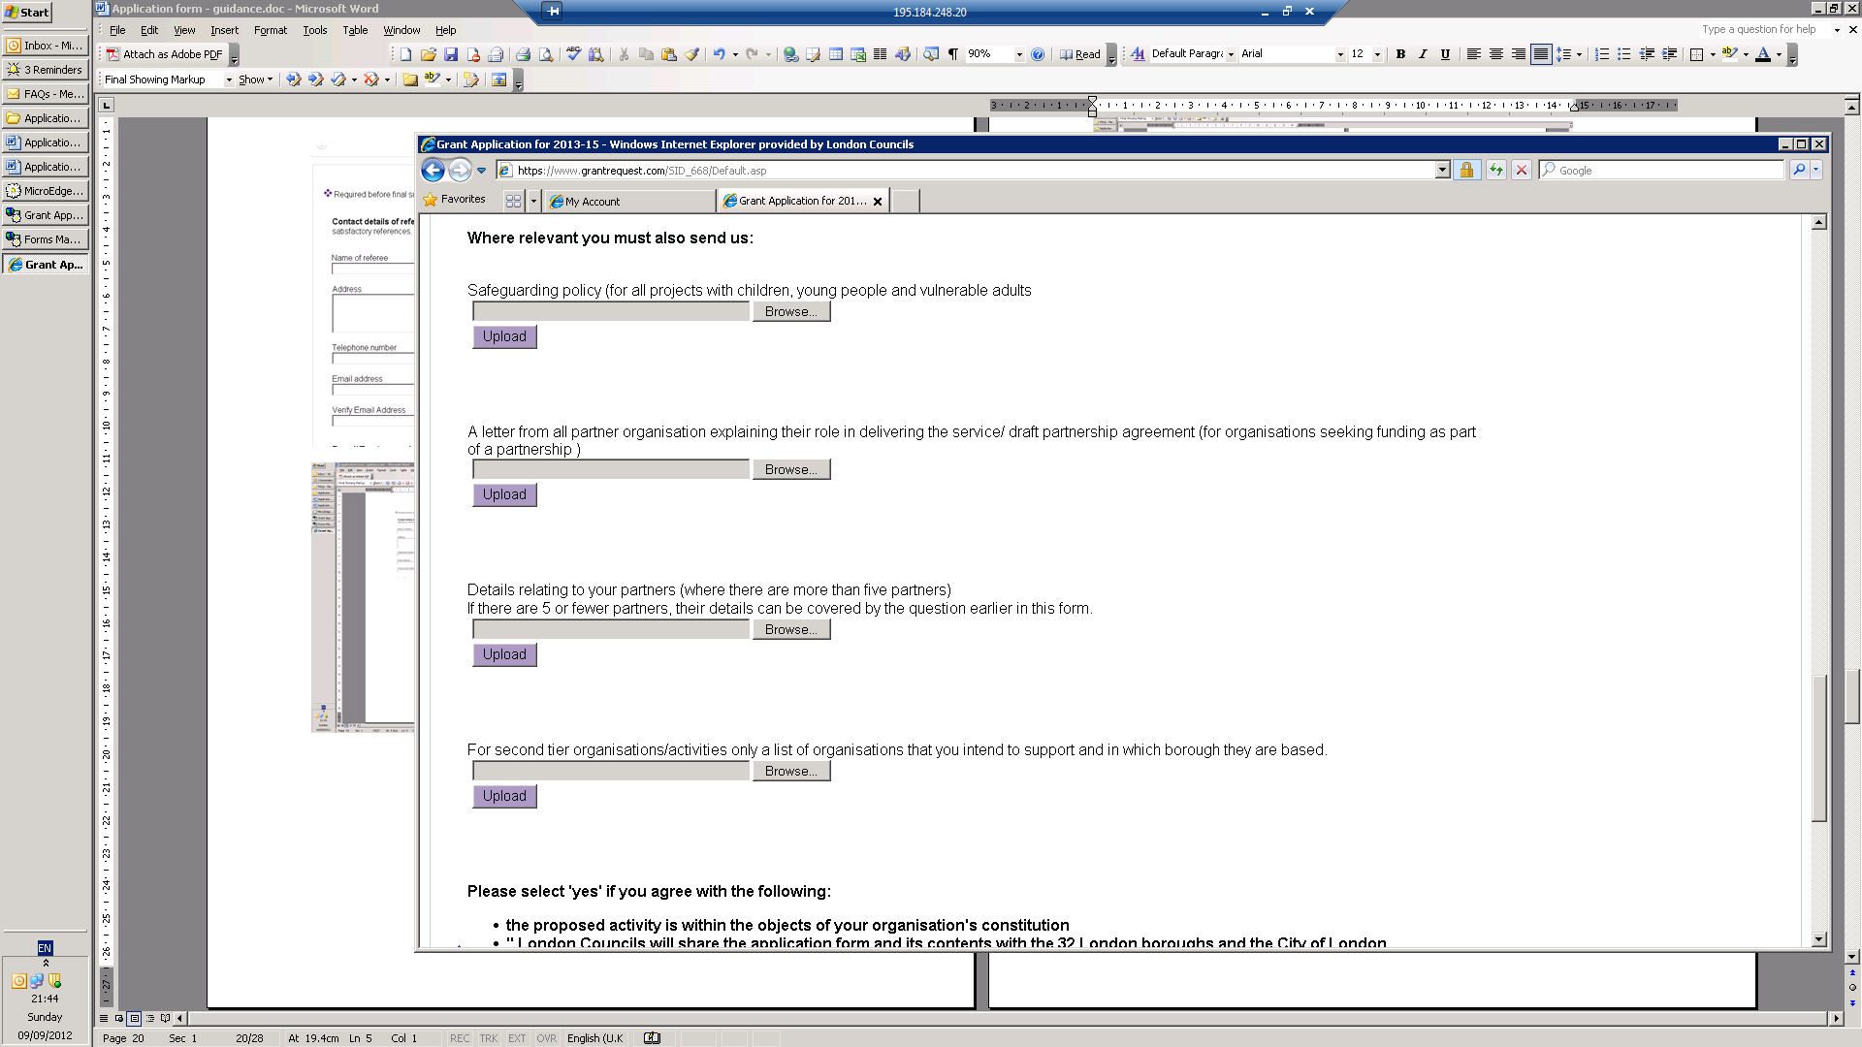

A letter from all partner organisations or a draft partnership agreement
- If you are applying as a partnership/ consortium bid then each partner organisation must provide a letter explaining their role in delivering the service, which you must upload here. You will need to scan all the letters together to form one document.
- Alternatively a draft partnership agreement can be uploaded covering all partners.

Details relating to your partners
- If you are bidding as a partnership bid please submit the partnership template available on the following link in
http://www.londoncouncils.gov.uk/node/30010
Or use your own format

- You need to include details about your own organisation as the lead partner
- If you have more than four partners please copy and paste the table to add more partners.
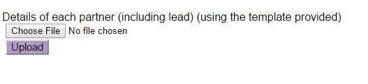

Second tier list of organisations for service area 1.5 and 2.3
- If you are a second tier organisation and will be supporting organisations rather than individuals you must upload a list of organisations that you intend to benefit from the project and the Boroughs in which they are based.
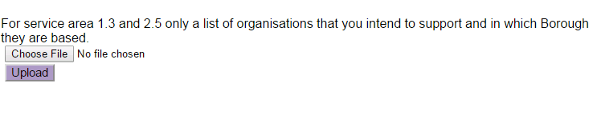

Your organisation’s agreement
- Finally you must select ‘yes’ from the drop down menu if you agree that:
  - the proposed activity is within the objects of your organisation's constitution
  - London Councils will share the application form and its contents with the 32 London boroughs and the City of London
  - this application has the support of your organisation's governing committee/board of trustees/senior management
  - all the information you have supplied is accurate
  - the information you have supplied about the proposed service is a realistic indication of what your organisation could achieve.
IMPORTANT:
You must select ‘YES’ for your bid to be assessed.

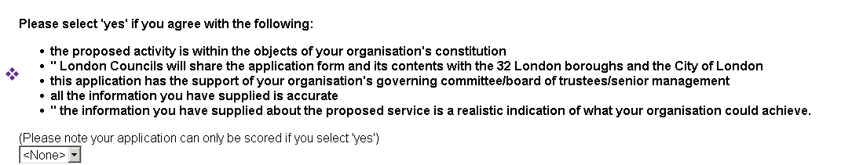

Requirements

If you are aware that submitting an application may give rise to a potential conflict of interest please inform London Councils. A conflict of interest may be where you are related to a member or staff officer of London Councils or you have privileged information about London Councils that places you at an unfair advantage over other applicants in the application process.

London Councils is subject to the requirements of the Freedom of Information Act 2000. You should be aware that the information you submit may be subject to a request for information from the public and London Councils may be required to provide information to external parties.
Finishing the form

- Now you are at the end of the form you may:
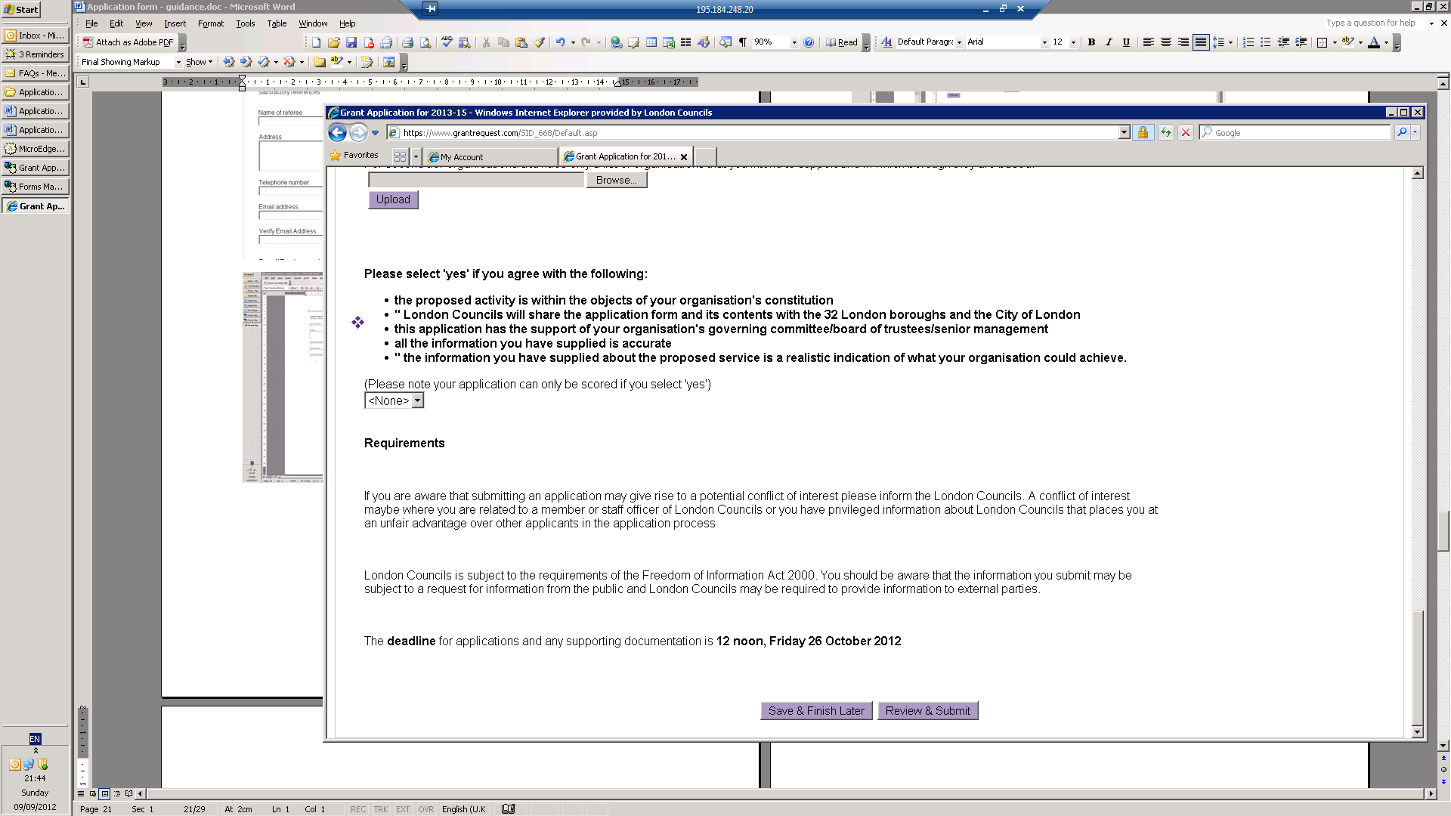

- You may wish to save and finish later. You may wish to print a copy to proof read it and save it.
- When you are ready to submit – click on ‘review and submit’.
- If you have left any mandatory fields blank, or submitted the wrong kind of information (for example text in a box that can only accept numbers) a list of errors will appear in red as below.
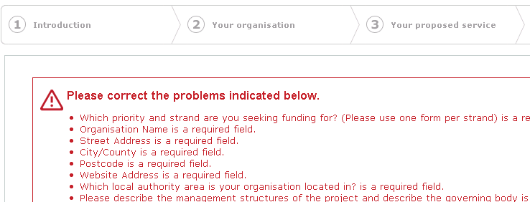
- The red warning sign and red text will then appear next to any field that you need to amend.

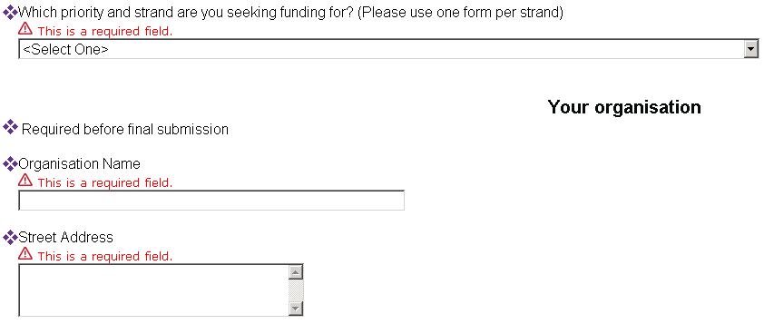

- IMPORTANT: Once you have amended the fields, click on the button marked ‘update’ or the changes will not be saved.

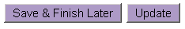
- Once you have amended the fields and clicked ‘update’ a final version will appear for you to review.
- Once you are happy click on the button marked ‘submit’.

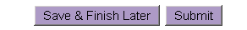

- You will be taken to your account page, where you will see the following message.

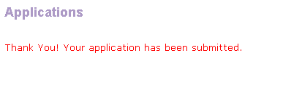

Important information

You must click ‘submit’ to send each application.

You will automatically be sent a confirmation email with a copy of your submitted form.

If you do not receive a confirmation email, you have not submitted your online form correctly.
Please check and submit again.

Once submitted you can not amend your form but you can view it through your account.
To return to your account click on the following link
https://www.GrantRequest.com/SID_668

Receiving funding from London Councils

You should read the following information about London Councils funding before submitting your application.

Due Diligence
London Councils undertakes due diligence checks as part of its risk mitigation. There are a number of checks that will be undertaken before awarding a grant. This is followed up with annual checks for successful organisations. Organisations that are rated as higher risk may require additional material to be submitted on a more regular basis to address the increased risk.

At application stage organisations will be assessed for eligibility, financial viability (including grant to turnover ratio) and that the relevant policies and procedures are in place.

If you are successful you will also need to submit the following documents
- Health and Safety Policy
- Sustainability Policy
- Public liability insurance of at least £5m (if the policy submitted at application stage was for a lower value)
- Employer’s liability insurance of at least £10m (if the policy submitted at application stage was for a lower value)

Monitoring
London Councils uses a performance monitoring framework to monitor grants. This was agreed in February 2013 and can be viewed on the following link.
http://www.londoncouncils.gov.uk/node/21980

The frame work is under review. It is anticipated that a report on the review of the framework will be considered by the November meeting of the Grants Committee. You may wish to review this.
http://www.londoncouncils.gov.uk/node/29972

The monitoring framework is relatively complex. It includes quarterly submission of a performance report, reporting database (with data per outcome and per borough) and case study. There are also monitoring visits and annual submission of information for the due diligence measures as above.

You should ensure there are adequate resources in your budget to undertake the monitoring requirements.

Value for money
The form asks you for details on how you will measure Value for Money. At a time of increasingly limited budgets members of the Grants Committee are particularly keen to see that commissions offer value for money. London Councils may introduce further measures to monitor value for money.

Borough liaising
In the recent Grants Review a concern was raised about how well London Councils funded commissions are linked into local provision, including local authority officers. You are expected to demonstrate how you will link to local authority officers in your application. If successful you may be required to also address this through attending borough officer meetings, responding to ad hoc queries from boroughs and local authority members or officers may attend monitoring visits.

Appendix 1
Grants Scoring Framework

Priority and Service Area:

Organisation Name:

Is the organisation eligible?
- Is the organisation constituted to allow delivery of the service for which they have bid (which must be delivered in more than one borough area)?
- Is it constituted not-for profit?
- Is it a voluntary/ community organisation? (A body the activities are carried out otherwise than for profit but does not include any public or local authority.)
- Is the organisation solvent?
- Is the organisation going to deliver the services within the 33 London boroughs?

Information required to support the application (Have all attachments been received?)
Mandatory
  - A signed copy of your Memorandum & Articles or Constitution
  - Equalities Policy and Equalities Objectives
  - Audited Accounts for the three most recent years 2012-13, 2013-14, 2014-15 (or 2015-16 if available)
  - Public liability insurance
  - Employer’s liability insurance
  - Completed budget for the service (see template)
  - 4 year delivery plan for the project
  - A reference (using the template provided) (two are required if the application is for more than £1m per year)

Where applicable
- Safeguarding policy (for all projects with children, young people or vulnerable adults)
- A letter from each partner organisation explaining their role and responsibilities in delivering the service or a draft partnership agreement
- Details of each partner (including lead) (using the template provided)
- For service area 1.3 and 2.5 only a list of organisations that you intend to support and in which Borough they are based.

Assess accounts
- Are the accounts sufficient for the size of the organisation? What is the financial position of the organisation? Are concerns raised? How much of an increase in income would this application represent?
(Not scored – officers to make notes and raise concerns where necessary)

Applications will be recommended for funding based on having a high score against the answers provided to the application questions and based on a number of other criteria as set out below. This is to ensure services are commissioned both in accordance with the principles and relevant priority of the Grants Programme 2017-21, and across all priority areas to enable funding of the best possible spread of Pan-London services to meet the needs of target groups identified in the relevant service specification and within the budget available. This assessment may therefore result in officers not recommending the highest scoring bids. Commissions may be awarded to more than one applicant to deliver a joint or complementary service to meet the requirements of the relevant service specification and the Grants Programme.

These additional criteria are:

- receipt of mandatory information (including satisfactory references);
- available budgetary resources i.e. services across the Grants Programme as a whole will be commissioned on the basis of the total budget available; and
- with reference to the relevant service specification:
  - target groups
  - equalities characteristics
  - delivery methods
Only eligible organisations will progress to being scored.

Question 1
What are the needs of the people you intend to address? How will your service tackle these needs? What research or evidence have you used or conducted?

Please fill in your score in the right hand column to indicate the extent to which the answer covers the following statements: |  | Fully covered |  | Mainly covered | Partially covered | Not covered | SCORE
1.a The applicant has provided a clear and convincing description of the needs of the people/ organisations it intends to work with |  | 6 |  | 3 | 1 | 0
1.b The applicant has provided a clear and realistic description of how the service will effectively address the needs. |  | 6 |  | 3 | 1 | 0
1.c The applicant has included properly referenced evidence from reliable research |  | 6 |  | 3 | 1 | 0
Maximum score | 18
Total score

Question 2
State how and from where you will attract people (or organisations) to your project - how will you interest them in the project? How will you ensure people will access your project from the different London boroughs? How will you work with London’s local authorities to ensure the service complements local provision and local authority officers are aware of referral pathways. Do you have existing referral routes/ contacts/ experience with each borough/CVS/local network? (Please provide information relating to all Boroughs)

Please fill in your score in the right hand column to indicate the extent to which the answer covers the following statements: |  | Fully covered |  | Mainly covered | Partially covered | Not covered | SCORE
2.a The applicant has given examples of clear and effective links to the target group of people and named links to places they will engage people. |  | 4 |  | 2 | 1 | 0
2.b The recruitment methods are convincing and appropriate, keeping in mind the boroughs the organisation has listed. |  | 4 |  | 2 | 1 | 0
2.c The number of users is explained and is realistic. (refer to borough table) |  | 4 |  | 2 | 1 | 0
2.d Either (1) the organisation has worked with people from all boroughs (it intends to work with) before or (2) the application provides a convincing description of how it will attract people from boroughs where it has not delivered services to before. |  | 4 |  | 2 | 1 | 0
2.e The applicant has provided details of their referral routes/contacts/ experience relating to each borough and has explained how it will ensure the service complements local provision and local officers will be aware of the referral routes. |  | 8 |  | 4 | 2 | 0
Maximum score | 24
Total score

Question 3
How will your project meet the principles of the London Councils Grants Scheme? How will you ensure the service is genuinely London-wide and does not duplicate local provision? How will you work with other providers to make this happen? (Please provide information relating to all Boroughs)

Please fill in your score in the right hand column to indicate the extent to which the answer covers the following statements: |  | Fully covered |  | Mainly covered | Partially covered | Not covered | SCORE
3.a The application clearly describes how the project will meet the principles of the Grants Programme |  | 3 |  | 2 | 1 | 0
3.b The application clearly outlines how it will achieve pan-London coverage and not duplicate local provision. |  | 3 |  | 2 | 1 | 0
3.c The application clearly outlines how it will work with other providers to make this happen. |  | 3 |  | 2 | 1 | 0
3.d Either (1) all boroughs are referenced (2) where links do not exist the application explains clearly how links will be made. |  | 3 |  | 2 | 1 | 0
Maximum score | 12
Total score

Question 4
Describe how you will achieve the changes in the service users (outcomes) listed in the service specification. How will you know that change has taken place? How will you measure the changes - what indicators will be used to measure the change? (some specifications cover a number of bullet points under each outcome area, where this is the case you should choose one/two of these or the number indicated in the specification). How many people do you anticipate will achieve the outcomes you have described? How will you ensure people achieve outcomes in different boroughs?

Please fill in your score in the right hand column to indicate the extent to which the answer covers the following statements: |  | Fully covered |  | Mainly covered | Partially covered | Not covered | SCORE
4.a The application clearly describes how it will achieve the outcomes listed in the service specification. |  | 4 |  | 2 | 1 | 0
4.b The description of how the outcomes will be achieved is convincing and realistic. The application describes a range of outcome indicators/ signs that change has taken place. |  | 8 |  | 4 | 2 | 0
4.c Methods of measuring the change have been described and are realistic. |  | 4 |  | 2 | 1 | 0
4.d The numbers listed of people that it is anticipated will reach the outcomes is realistic. The application demonstrates how it will achieve outcomes in different boroughs (including challenges and solutions) |  | 8 |  | 4 | 2 | 0
Maximum score | 24
Total score

Question 5
Describe the activities that will be delivered by your project (the outputs). These should relate directly to the outcomes from the service specification. These should relate to the service delivery methods described in the service specification. You may also include any further activities you feel would be relevant to deliver the outcomes. Please include figures and state whether these are per month or per quarter (output indicators)? What is the unit cost of the service you propose i.e. number of outputs divided by the total funding sought?

Please fill in your score in the right hand column to indicate the extent to which the answer covers the following statements: |  | Fully covered |  | Mainly covered | Partially covered | Not covered | SCORE
5.a Activities are clearly described |  | 3 |  | 2 | 1 | 0
5.b Activities could realistically deliver the outcomes listed in the specification. |  | 3 |  | 2 | 1 | 0
5.c Figures have been included detailing numbers per month or quarter (output indicators) |  | 3 |  | 2 | 1 | 0
5.d The levels of activity are realistic given timescales and budget |  | 3 |  | 2 | 1 | 0
5.e A realistic unit cost has been provided |  | 3 |  | 2 | 1 | 0
Maximum score | 15
Total score

Question 6
How will your project help London Councils to meet the aims in the public sector duty outlined in the Equality Act 2010? How will you make the proposed service accessible to people having protected characteristics as provided for in the Equality Act 2010? Please include information specifically on access to/by disabled people, your strategy for reaching people with the protected characteristics, how their equalities needs will be met (including physical access requirements)? How will you know if the service is meeting people with protected characteristic’s requirements?

Please fill in your score in the right hand column to indicate the extent to which the answer covers the following statements: |  | Fully covered |  | Mainly covered | Partially covered | Not covered | SCORE
6.a The application clearly describes how the project will be accessible to people from the protected equalities characteristics (as listed in the 2010 Act). Methods for reaching people and meeting their needs are effectively outlined. |  | 3 |  | 2 | 1 | 0
6.b All eight characteristics are well covered. |  | 3 |  | 2 | 1 | 0
6.c The application clearly describes how it will:  (a) tackle discrimination, harassment, victimisation and any other conduct that is prohibited by or under this Act; |  | 3 |  | 2 | 1 | 0
6.d The application clearly describes how it will:  (b) advance equality of opportunity between persons who share a relevant protected characteristic and persons who do not share it; |  | 3 |  | 2 | 1 | 0
6.e The application clearly describes how it will:  c) foster good relations between persons who share a relevant protected characteristic and persons who do not share it. |  | 3 |  | 2 | 1 | 0
Maximum score | 15
Total score
This question must be scored 10 or above for the application to be considered.

Question 7
What is your organisation’s record of delivering similar activities and achievements previously? Please give an example of your organisation’s experience of delivering a project of a similar scale and nature.

Please fill in your score in the right hand column to indicate the extent to which the answer covers the following statements: |  | Fully covered |  | Mainly covered | Partially covered | Not covered | SCORE
7.a The example provided is a similar scale to the application. (leading a partnership should be covered if applicable). |  | 3 |  | 2 | 1 | 0
7.b The example provided is a similar type of project to the one described in the application (activities, target group and needs met) |  | 3 |  | 2 | 1 | 0
7.c The example provides information on what was achieved |  | 3 |  | 2 | 1 | 0
Maximum score | 9
Total score

Question 8
Please set out how the project will be delivered over 4-years. How will the project meet the specific requirements listed in the specification. Identify any risks or challenges in achieving this delivery. How will you mitigate these risks or challenges? In particular how will you integrate your risk assessment policy for the project with the organisation’s broader management structure? If you are lead partner in a partnership how will you manage risk associated with the partnership?

Please fill in your score in the right hand column to indicate the extent to which the answer covers the following statements: |  | Fully covered |  | Mainly covered | Partially covered | Not covered | SCORE
8.a The description of delivery is logical, realistic and achievable. |  | 3 |  | 2 | 1 | 0
8.b The project clearly describes how it will meet the specific requirements set out in the specification |  | 3 |  | 2 | 1 | 0
8.c Realistic challenges/ risks are identified (including risks associated with the partnership if it is a partnership bid). |  | 3 |  | 2 | 1 | 0
8.d The application provides information on effective means of mitigating against these risks, including how they will integrate the risk management into the broader management structures. Also if they are a lead partner, how they will manage risk associated with the partnership. |  | 4 |  | 2 | 1 | 0
Maximum score | 13
Total score

Question 9
Please describe the staffing structure for the proposed project. Tell us how the staff (paid and volunteers) will be managed and will deliver the project effectively. How will you ensure that all staff are accountable to the governing body and what arrangements will you be making to report achievements and issues to users, funders and management bodies?

Please fill in your score in the right hand column to indicate the extent to which the answer covers the following statements: |  | Fully covered |  | Mainly covered | Partially covered | Not covered | SCORE
9.a Levels and roles of staff/ volunteers are realistic for the delivery of the project. (where volunteers are mentioned how these will be recruited and retained). If the project is to be delivered in partnership this should be covered. |  | 3 |  | 2 | 1 | 0
9.b The application covers delivery, financial administration and management of the project. |  | 3 |  | 2 | 1 | 0
9.c The applicant gives examples of previous relevant staff experience or skills. |  | 3 |  | 2 | 1 | 0
Maximum score | 9
Total score

Question 10
How will you monitor the project? How will users of the proposed commission tell you whether they are satisfied with the service and how can they help shape the future delivery? What systems will be used to monitor the progress of people benefitting from the project? What quality systems and standards are used now by your organisation and partners? Tell us how these will be applied to the delivery of this project. Would the award of funding under this specification bring additional benefits to the work of your organisation (e.g. additional income, volunteers)?

Please fill in your score in the right hand column to indicate the extent to which the answer covers the following statements: |  | Fully covered | Mainly covered |  | Partially covered | Not covered | SCORE
10.a Realistic monitoring systems have been clearly described and can demonstrate progress of service users. |  | 3 | 2 |  | 1 | 0
10.b Has user involvement in the shaping of the service been clearly described. |  | 3 | 2 |  | 1 | 0
10.c Have a range of additional benefits been identified |  | 3 | 2 |  | 1 | 0
Maximum score | 9
Total score

Question 11
- Requested level of funding.
- Budget attachment.
- Please provide an explanation of any costs relating to the project, in particular in relation to partners delivering elements of the project. If successful, you will be expected to demonstrate Value for Money during the life of the grant, how will you do this? Please describe the organisation's financial controls, how you ensure the financial resilience of the organisation and financial reporting.

Please fill in your score in the right hand column to indicate the extent to which the answer covers the following statements: |  | Fully covered |  | Mainly covered | Partially covered | Not covered | SCORE
11.a The budget offers value for money and the application clearly describes how the project will demonstrate value for money during the life of the grant. |  | 3 |  | 2 | 1 | 0
11.b Costs are clearly outlined. |  | 3 |  | 2 | 1 | 0
11.c All costs relating to the project are outlined |  | 3 |  | 2 | 1 | 0
11.d The organisation explains the roles responsible for different elements of financial management. |  | 3 |  | 2 | 1 | 0
11.e The management committee or governing body receive regular updates. |  | 3 |  | 2 | 1 | 0
Maximum score | 15
Total score

Funded at £20,000 per year or over.

