London Sexual Health Transformation Programme
Update April 2016
Welcome to the April briefing note from the London Sexual Health Transformation Programme.

The programme is entering a new phase of work now. At the last Programme Board Mike Cooke, Chief Executive of Camden who chairs the programme board summarised our focus as being on three separate but clearly linked elements:

- Developing and procuring the new e services model to better signpost patients and provide home testing kits where clinically appropriate
- Agreeing a new pricing mechanism that supports flexibility and planning and ensures services are paid for fairly
- Supporting the sub regions as they commission face to face service
Our decision making and activity is now focused on these three work streams
The Case for Change
As we get more and more into the details of what the new system might look like and what the e services portal might provide, there is a danger of losing sight of the bigger picture – why are we doing this?
The LSHTP was initially set up as a result of the transfer of sexual health services to local authorities and the continued pressure on public sector finances, and the reduction of public health budgets. It was felt that there was a compelling case to review how we best provide these vital services. The aim of the Transformation Programme is to design, agree and procure a system that will deliver measurably improved and cost effective public health outcomes, meet increasing demand and deliver better value.
So the five key drivers for change are:
- The need for sexual health services in London is significantly higher than the England average, and has risen significantly in recent years.
- There are noticeable variations in access and activity across London boroughs, with high numbers of residents from across London accessing services in central London.
- Given London’s complex pattern of open access services, there are important advantages for London boroughs to transform and commission services together
- We must continue to ensure strong clinical governance, safeguarding and quality assurance arrangements are in place for commissioning open access services
- We want to respond to current and future financial challenges, and ensure we are making the best use of resources available
Survey Monkey
The survey monkey survey closed at the end of March. Thank you to everyone who has publicised and contributed to the survey that received over 1700 responses. The responses are being analysed at the moment and we will report further in the next briefing.
Integrated Tariff
A letter was sent to each borough last week setting out the initial findings of the audit and due diligence work on Integrated Sexual Health tariff undertaken by Jonathan O’Sullivan. A meeting was then held this week to discuss the analysis and the implications for services across London. Boroughs are in the process of considering the findings in their sub regions and a full report will be presented to the next programme Board on 27th April.
End of Year Report
The Programme Board have signed off a report looking at the work of the programme over the last year and setting out priorities for the year ahead. The full report is available on the programme website at http://www.westlondonalliance.org/WLA/wlanew.nsf/Files/WLF-73/$FILE/Item%202%20160314%20Final%20LSHTP%20end%20of%20year%20report.pdf or by clicking HERE
Governance
The Programme Board has agreed a new governance structure to reflect the developing work and to support decision making in 2016/17.
It has been agreed that the CELC Heath Sub Group will now be the programme sponsor, with the Programme Board meeting quarterly. Two key task groups will then report into the Programme Board: System Redesign Group (chaired by Andrew Howe) and E Systems Implementation (Chaired by Dan Gascoyne). These task groups and the Programme board will be supported by a Clinical Advisory Group (chaired by Penny Bevan). The new structure is designed to ensure decision making happens at the right level with the right people involved and streamlines the number meetings being held.
The Terms of Reference for each group and the membership will be signed off at the next Programme Board on 27th April. Details of these will be published on the website (http://www.westlondonalliance.org/wla/wlanew.nsf/pages/WLA-385) following this meeting. Governance structures will be kept under review as we progress

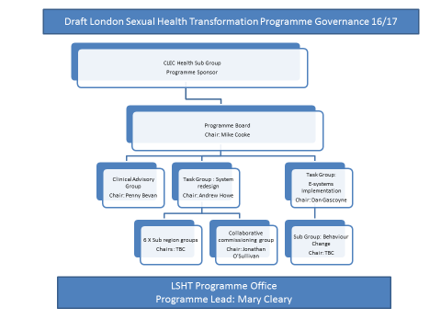
Channel Shift
A small group has also been set up, reporting in to the E Systems Implementation Group, to discuss the need for a behaviour change campaign. The purpose of this campaign will be to ensure that the planned new e-services are targeted at the appropriate population groups and that appropriate patients access them. The groups will agree desired outcomes and objectives and take expert advice on behaviour change before recommending the way forward to the Programme Board.

Please do pass this briefing on to anyone who might be interested, and have a look at our website at www.wla.london/wla/wlanew.nsf/pages/WLA-385 or contact those named at the end of this briefing if you have any specific questions.
The next briefing will be issued around the 11th May. If there are subjects you would like to see covered, or have any comments about the briefing, please let us know.
For further details on the Programme please contact
Dr Andrew Howe, Programme Director, 07535 624828, Andrew.Howe@harrow.gov.uk
Mary Cleary, Programme Lead, 07948 506 584, mary.clearylyons@cluthamanagement.com
Mark Wall, Communications Lead, 0790 999 3278 mark@markwall.co.uk

