Local Housing Allowance Reform Update
February 2015

About
This briefing updates London borough officers on the effects of the allocations made under the second year of the Targeted Affordability Fund and their effect on the affordability of private rents in London. It also analyses the latest figures on London’s Local Housing Allowance caseloads.

Contact daniel.drillsma-milgrom@londoncouncils.gov.uk

Headlines

- London will be the main beneficiary from the second year of the Targeted Affordability Fund, with 41 of its 70 LHA rates increasing by more than 1%
- Despite this, 68 of London’s 70 LHA rates will be set below the 30th percentile rent level next year
- The LHA caseload continues to rise in outer London and fall in inner London
- In-work LHA caseload continues to grow in all parts of London

Setting LHA rates
- Local Housing Allowance (LHA) rates are now set annually.

- London is split into 14 Broad Market Rental Areas (BMRA).

- There are 5 LHA rates in each BRMA representing different property sizes.

- Annual uprating of all working age benefits, including LHA, will be limited to 1% until 2016

- LHA reforms implemented in 2011 were intended to peg maximum LHA awards to the lowest 30% of local rents (the 30th percentile). Maximum LHA caps introduced at the same time mainly affected London.

Local Housing Allowance rates

Local Housing Allowance was introduced in 2008 with the aim of linking housing benefit awards more closely with household composition, breaking the direct link with rent levels. This followed rent officers being given responsibility for ensuring housing benefit awards were proportionate and were not fuelling rent rises.

Despite this, LHA expenditure has increased steadily. And upon taking office, the coalition Government implemented fresh reforms to the way LHA rates were set, as described below.

The LHA Reforms
- LHA rates limited to the 30th percentile of local rents (previously 50th percentile).

- Nationally applicable caps on weekly LHA receipt implemented.

- Shared room rate age eligibility increased from 25 to 35.

- Non-dependant deductions increased for three years.

- All working age benefit rates including LHA uprated by only 1% for 3 years (from Apr ’14)

Following lobbying from London Councils, London received around three-quarters of a ‘Targeted Affordability Fund’ (TAF) announced by the Government in recognition of the increasing unaffordability to HB recipients of private sector rents. As a result, half of London’s LHA rates increased by 4% in 2014, the only exception to the national cap of 1% on the uprating of benefits.

Current rent levels and year two TAF allocations

Rent levels have largely continued to rise across most parts of London and for most types of housing. However, the increases have not been as widespread as those seen in 2013.

During 2014, the 30th percentile rent level rose in 55 of the 70 LHA rate areas. In 27 of London’s 70 rate areas, the 30th percentile rent level rose by 5% or more. The 30th percentile rent level held steady in two LHA rate areas.

Rents fell in 13 LHA rate areas:
- Shared rate in inner south-west London and north-west London*
- One bedroom rate in inner east London*, inner west London*, outer east London* and outer north-east London
- Two bedroom rate in inner east London, inner west London* and outer north-east London
- Three bedroom rate in inner north London and outer east London*
- Four bedroom rate in inner north London and outer north London
(*Rate fell by less than 1%)

While the increases in rent levels were slightly less widespread in 2014 than in 2013, and rents fell in more LHA areas, there have still been significant increases. The most significant year-on-year 30th percentile rent rises, by property type, were:
- Shared rate – Outer south-west London (+24.7%)
- One bedroom – Outer west London (+6.4%)
- Two bedroom – Outer west London (+10.2%)
- Three bedroom – Inner south-east London (+10.0%)
- Four bedroom – Outer west London (+10.5%)

In addition, those LHA areas that saw rent levels fall in 2013 experienced significant rent increases in 2014.
- Shared rate in outer north-east London: fell by 1.0% in 2013; rose by 8.2% in 2014
- Three bedroom rate in central London: fell by 1.5% in 2013; rose by 8.6% in 2014
- Four bedroom rate in outer west London: fell by 1.9% in 2013; rose by 10.5% in 2014

The Government has now announced which LHA rates will benefit from the second year of the TAF. Across the country, 191 rates will increase by more than 1%. In London, 40 or the 70 LHA rates will increase by 4% (one more – the four bedroom rate in outer south-west London – will increase by 2.2% as a result of hitting the overall cap level).

It is estimated that London will receive almost 60% of the TAF in 2015-16.

A full breakdown of the new LHA rates and the reference rents is available at Appendix 1

The above-inflation increases permitted for those LHA rates to benefit from the TAF means that they will be less out of step with rents than they otherwise would be.

However, there are still large disparities between many LHA rates and 30th percentile rent levels. Of the 41 LHA rates to receive an increase of more than 1%, less than a third (13) made up any ground on rent levels. In total, only 25 of London’s 70 LHA rates made up any ground on rent levels.

The biggest percentage shortfalls between the 30th percentile rent levels and actual LHA rates by property type are:
- Shared rate in outer south-west London (26.2% shortfall)
- One bedroom rate in central London (29.6% shortfall)
- Two bedroom rate in central London (39.5% shortfall)
- Three bedroom rate in central London (49.0% shortfall)
- Four bedroom rate in central London (53.4% shortfall)

Latest caseload data

The Government spent a little over £24bn on housing benefit in 2013-14. The amount spent on tenants in the private rented sector (PRS) accounted for the largest share at £9.3bn, compared to those in housing associations (£8.9bn) and local authority tenants (£5.9bn). Of the amount spent on housing benefit for PRS tenants, LHA expenditure accounted for almost 83%, at £7.7bn.

While the mean weekly HB claim for a local authority tenant in London is £113.57 and for a housing association tenant £126.22, the figure for the LHA caseload is £183.51.

Over the past year, the number of housing benefit recipients in London fell slightly, by 2% from 844,000 to 828,000. Within this, the total LHA caseload also fell from 236,000 to 233,000 but actually increased as a share of the total housing benefit caseload – 27.9% of the total to 28.2%.

While the total LHA caseload for London has begun to fall slightly, this masks a picture of a shift in the caseload from out-of-work claimants to in-work claimants, and from inner London to outer London. The chart below gives a broad indication of this picture:

The table overleaf shows how the in-work and out-of-work LHA caseloads have changed for each borough since the coalition’s April 2011 reforms.

While the in-work LHA caseload continues to grow in almost all boroughs – all but the City of London have seen an increase over the past year and all but six have seen an increase over the past quarter – this is generally being marginally outweighed by greater falls in the out-of-work LHA caseload.

As a result, the share of London LHA recipient households where a member is in work now stands at 56%.

London is still the only region where there are more working households in receipt of LHA than recipient households where no-one works.

Total LHA caseloads for inner London have now almost returned to the levels they were in April 2011 when the reforms were introduced. However the composition of this caseload has significantly altered, with a third fewer out-of-work households and a third more in-work households.

In outer London, the total LHA caseload remains 20% higher than it was in April 2011. Again, the in-work caseload is more than 40% higher than it was. It remains to be seen whether the slight fall in the total LHA caseload in outer London seen over the past quarter marks a genuine turning point or if it will begin to rise again.

The maps on the following pages give a finer-grained picture of how total, in-work and out-of-work LHA caseloads have changed over the past year by giving figures at the medium super output area level.

Month | Nov-14
Detailed Housing Type | Private deregulated tenant (LHA) (PRS) |  |  |  | Change over the past three months |  |  | Change over the past year |  |  | Change since April 2011
 | Total | In work | Out of work |  | Total | In work | Out of work | Total | In work | Out of work | Total | In work | Out of work
Camden | 3211 | 1406 | 1805 |  | -1.80% | 2.03% | -4.60% | -3.67% | 7.04% | -12.02% | -5.85% | 18.35% | -24.71%
City of London | 18 | 12 | 6 |  | -30.77% | -7.69% | -53.85% | -77.78% | -33.33% | -166.67% | -111.11% | 8.33% | -350.00%
Hackney | 8544 | 4983 | 3561 |  | -2.23% | 0.50% | -5.82% | -3.86% | 5.30% | -16.68% | 3.34% | 23.98% | -25.55%
Hammersmith and Fulham | 2970 | 1387 | 1583 |  | 0.07% | 2.21% | -1.74% | -2.69% | 5.26% | -9.67% | -2.66% | 23.94% | -25.96%
Haringey | 11962 | 6658 | 5304 |  | -1.84% | 0.83% | -5.00% | -2.42% | 6.70% | -13.88% | 11.40% | 34.15% | -17.16%
Islington | 2775 | 1204 | 1571 |  | -3.24% | 0.25% | -5.76% | -9.26% | 3.90% | -19.35% | -15.68% | 21.51% | -44.18%
Kensington and Chelsea | 1938 | 843 | 1095 |  | -0.62% | 3.82% | -3.78% | -3.15% | 13.05% | -15.62% | -42.93% | 0.00% | -75.98%
Lambeth | 6469 | 3447 | 3022 |  | -2.96% | -0.09% | -6.03% | -10.11% | 2.15% | -24.09% | -0.54% | 26.78% | -31.70%
Lewisham | 9572 | 4950 | 4622 |  | -2.93% | 0.55% | -6.40% | -10.76% | 1.98% | -24.41% | -9.59% | 24.77% | -46.39%
Newham | 12499 | 7661 | 4838 |  | -0.26% | 2.30% | -4.07% | 4.15% | 12.82% | -9.57% | 35.24% | 52.93% | 7.23%
Southwark | 3787 | 2030 | 1757 |  | -3.47% | 0.59% | -7.77% | -10.17% | 0.05% | -21.97% | -3.59% | 34.78% | -47.92%
Tower Hamlets | 4460 | 2657 | 1803 |  | -0.95% | 2.43% | -5.55% | -1.46% | 13.47% | -23.46% | -3.21% | 36.13% | -61.18%
Wandsworth | 6924 | 3944 | 2980 |  | -1.17% | 0.87% | -3.75% | -5.04% | 2.66% | -15.23% | -6.21% | 19.02% | -39.60%
Westminster | 4001 | 1740 | 2261 |  | -3.75% | -2.36% | -4.80% | -9.50% | 0.92% | -17.51% | -62.21% | -26.84% | -89.43%
Barking and Dagenham | 6920 | 3972 | 2948 |  | 0.67% | 4.12% | -3.63% | 3.48% | 16.52% | -14.08% | 27.02% | 55.54% | -11.40%
Barnet | 14206 | 8132 | 6074 |  | 0.08% | 2.62% | -3.13% | 4.97% | 11.55% | -3.84% | 30.47% | 48.12% | 6.83%
Bexley | 4561 | 2087 | 2474 |  | -1.47% | 2.50% | -4.59% | -2.06% | 9.63% | -11.92% | 19.49% | 46.48% | -3.27%
Brent | 15528 | 9283 | 6245 |  | -0.03% | 1.68% | -2.47% | 2.12% | 7.89% | -6.45% | 18.10% | 34.71% | -6.58%
Bromley | 4554 | 2224 | 2330 |  | -1.56% | 1.55% | -4.35% | -4.44% | 4.41% | -12.88% | 10.96% | 39.52% | -16.31%
Croydon | 14204 | 7594 | 6610 |  | -1.52% | 2.41% | -5.68% | -1.86% | 9.84% | -15.30% | 17.02% | 44.89% | -14.99%
Ealing | 12861 | 7702 | 5159 |  | -0.83% | 1.61% | -4.27% | 1.84% | 10.05% | -10.43% | 22.15% | 40.47% | -5.19%
Enfield | 16682 | 9315 | 7367 |  | -0.96% | 1.98% | -4.45% | 1.20% | 12.52% | -13.11% | 25.49% | 52.99% | -9.27%
Greenwich | 5312 | 2330 | 2982 |  | -1.14% | -0.13% | -1.91% | -4.31% | 3.30% | -10.26% | 19.43% | 40.43% | 3.02%
Harrow | 8607 | 5506 | 3101 |  | -0.80% | 0.82% | -3.55% | 0.91% | 7.43% | -10.67% | 23.72% | 43.28% | -11.00%
Havering | 4534 | 2057 | 2477 |  | -0.48% | 3.94% | -3.88% | -0.18% | 12.06% | -10.34% | 23.11% | 50.66% | 0.24%
Hillingdon | 7755 | 4366 | 3389 |  | 0.70% | 3.71% | -2.92% | 2.23% | 12.67% | -11.21% | 23.89% | 46.84% | -5.67%
Hounslow | 6826 | 4034 | 2792 |  | -0.71% | 0.50% | -2.41% | 2.02% | 8.06% | -6.70% | 21.13% | 40.48% | -6.84%
Kingston upon Thames | 3381 | 1914 | 1467 |  | -0.06% | 0.84% | -1.21% | 2.69% | 5.07% | -0.41% | 18.63% | 32.97% | -0.07%
Merton | 4718 | 2798 | 1920 |  | -2.30% | 0.21% | -5.74% | -1.31% | 4.97% | -10.47% | 17.15% | 33.27% | -6.35%
Redbridge | 8776 | 5428 | 3348 |  | -1.36% | 0.56% | -4.32% | 3.02% | 12.56% | -12.46% | 21.87% | 48.31% | -21.00%
Richmond upon Thames | 2329 | 1247 | 1082 |  | -1.44% | -0.56% | -2.43% | 2.75% | 6.01% | -1.02% | 13.40% | 31.52% | -7.49%
Sutton | 4438 | 2569 | 1869 |  | 0.63% | 3.09% | -2.55% | -1.42% | 9.26% | -16.10% | 22.42% | 44.34% | -7.70%
Waltham Forest | 7860 | 4826 | 3034 |  | -4.03% | -0.56% | -9.08% | -8.64% | 2.76% | -26.76% | -4.62% | 20.49% | -44.56%
Inner London | 79130 | 42922 | 36208 |  | -1.89% | 1.02% | -5.13% | -4.42% | 6.22% | -17.02% | 0.44% | 29.06% | -33.48%
Outer London | 154052 | 87384 | 66668 |  | -0.83% | 1.72% | -3.99% | 0.60% | 9.49% | -11.05% | 20.54% | 42.80% | -8.65%
London | 233182 | 130306 | 102876 |  | -1.19% | 1.49% | -4.39% | -1.10% | 8.41% | -13.15% | 13.72% | 38.27% | -17.39%

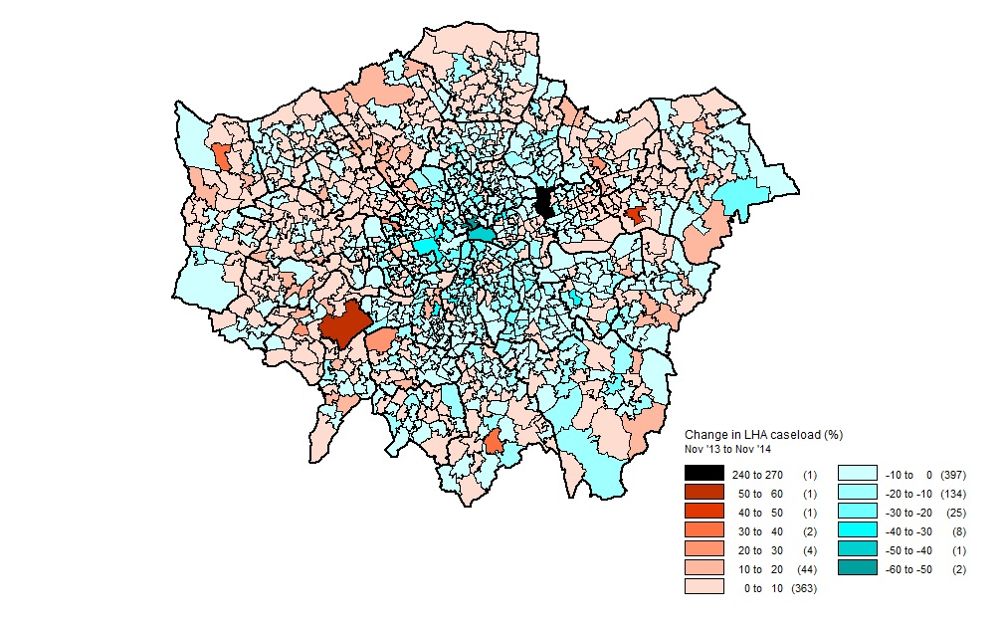
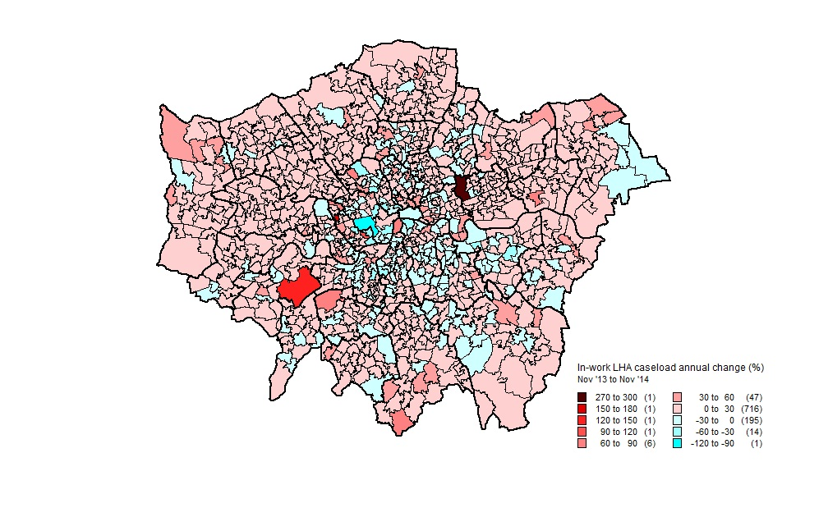
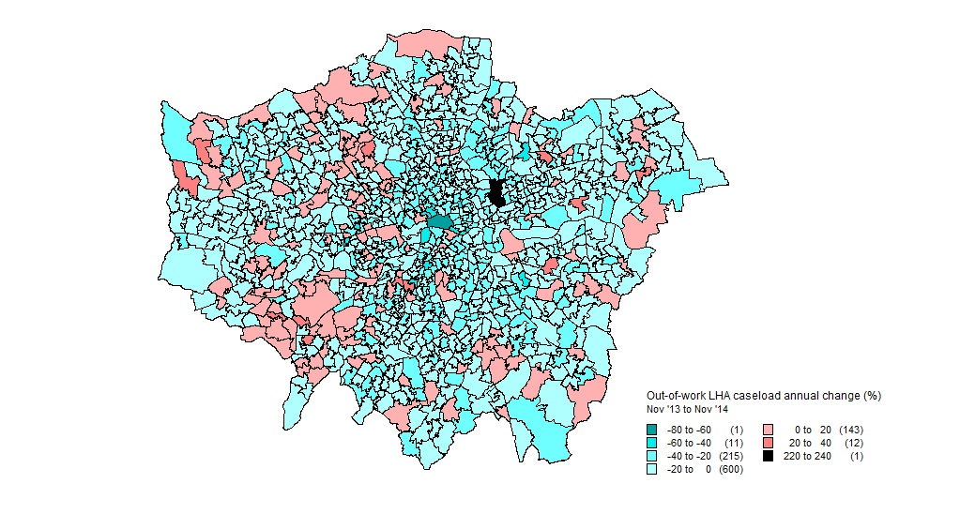
Appendix 1 – Divergence between 30th percentile rent levels and 2015-16 LHA rates

BRMA - Shared rate | Old 30th percentile (14/15) | New 30th percentile (15/16) | New LHA rate (15/16) | LHA % change | Shortfall between LHA rate and 30th percentile (£, 15/16) | Shortfall between LHA rate and 30th percentile (%, 15/16) | Change in 30th percentile rent (%)
Central London | £140.00 | £178.01 | £136.52 | 4.00% | £41.49 | 23.31% | 27.15%
Inner East London | £108.50 | £118.50 | £102.09 | 4.00% | £16.41 | 13.85% | 9.22%
Inner North London | £118.50 | £130.00 | £97.83 | 4.00% | £32.17 | 24.75% | 9.70%
Inner South East London | £96.15 | £103.56 | £95.18 | 4.00% | £8.38 | 8.09% | 7.71%
Inner South West London | £106.15 | £103.56 | £94.38 | 4.00% | £9.18 | 8.86% | -2.44%
Inner West London | £108.50 | £113.50 | £110.54 | 4.00% | £2.96 | 2.61% | 4.61%
North West London | £92.35 | £92.09 | £87.40 | 4.00% | £4.69 | 5.09% | -0.28%
Outer East London | £87.50 | £92.09 | £76.56 | 4.00% | £15.53 | 16.86% | 5.25%
Outer North East London | £74.49 | £80.59 | £75.15 | 4.00% | £5.44 | 6.75% | 8.19%
Outer North London | £92.35 | £99.65 | £90.64 | 4.00% | £9.01 | 9.04% | 7.90%
Outer South East London | £83.08 | £86.34 | £84.27 | 4.00% | £2.07 | 2.40% | 3.92%
Outer South London | £80.81 | £87.49 | £82.46 | 4.00% | £5.03 | 5.75% | 8.27%
Outer South West London | £92.31 | £115.11 | £84.91 | 4.00% | £30.20 | 26.24% | 24.70%
Outer West London | £80.81 | £84.62 | £82.41 | 4.00% | £2.21 | 2.61% | 4.71%

BRMA - One bedroom | Old 30th percentile (14/15) | New 30th percentile (15/16) | New LHA rate (15/16) | LHA % change | Shortfall between LHA rate and 30th percentile (£, 15/16) | Shortfall between LHA rate and 30th percentile (%, 15/16) | Change in 30th percentile rent (%)
Central London | £360.00 | £370.00 | £260.64 | 1.00% | £109.36 | 29.56% | 2.78%
Inner East London | £265.00 | £264.20 | £257.35 | 1.00% | £6.85 | 2.59% | -0.30%
Inner North London | £280.00 | £290.00 | £260.64 | 1.00% | £29.36 | 10.12% | 3.57%
Inner South East London | £207.69 | £219.90 | £204.08 | 4.00% | £15.82 | 7.19% | 5.88%
Inner South West London | £254.00 | £265.00 | £253.82 | 4.00% | £11.18 | 4.22% | 4.33%
Inner West London | £253.85 | £253.15 | £243.18 | 4.00% | £9.97 | 3.94% | -0.28%
North West London | £189.92 | £195.62 | £185.81 | 1.00% | £9.81 | 5.01% | 3.00%
Outer East London | £184.62 | £184.11 | £181.80 | 1.00% | £2.31 | 1.25% | -0.28%
Outer North East London | £160.85 | £155.57 | £155.57 | 0.48% | £0.00 | 0.00% | -3.28%
Outer North London | £196.00 | £207.12 | £199.68 | 4.00% | £7.44 | 3.59% | 5.67%
Outer South East London | £161.54 | £166.85 | £161.02 | 4.00% | £5.83 | 3.49% | 3.29%
Outer South London | £167.31 | £172.60 | £167.22 | 4.00% | £5.38 | 3.12% | 3.16%
Outer South West London | £207.69 | £218.63 | £209.77 | 1.00% | £8.86 | 4.05% | 5.27%
Outer West London | £173.08 | £184.11 | £175.74 | 4.00% | £8.37 | 4.55% | 6.37%

BRMA - Two bedroom | Old 30th percentile (14/15) | New 30th percentile (15/16) | New LHA rate (15/16) | LHA % change | Shortfall between LHA rate and 30th percentile (£, 15/16) | Shortfall between LHA rate and 30th percentile (%, 15/16) | Change in 30th percentile rent (%)
Central London | £495.00 | £500.00 | £302.33 | 1.00% | £197.67 | 39.53% | 1.01%
Inner East London | £335.00 | £325.00 | £302.33 | 1.00% | £22.67 | 6.98% | -2.99%
Inner North London | £350.00 | £350.00 | £302.33 | 1.00% | £47.67 | 13.62% | 0.00%
Inner South East London | £276.92 | £287.67 | £265.29 | 4.00% | £22.38 | 7.78% | 3.88%
Inner South West London | £323.08 | £330.00 | £302.33 | 1.00% | £27.67 | 8.38% | 2.14%
Inner West London | £323.00 | £322.19 | £302.33 | 1.00% | £19.86 | 6.16% | -0.25%
North West London | £242.31 | £253.15 | £242.33 | 4.00% | £10.82 | 4.27% | 4.47%
Outer East London | £230.77 | £237.20 | £229.58 | 4.00% | £7.62 | 3.21% | 2.79%
Outer North East London | £196.15 | £192.62 | £192.62 | 0.87% | £0.00 | 0.00% | -1.80%
Outer North London | £253.85 | £264.66 | £255.34 | 4.00% | £9.32 | 3.52% | 4.26%
Outer South East London | £196.15 | £207.12 | £198.11 | 1.00% | £9.01 | 4.35% | 5.59%
Outer South London | £207.69 | £219.23 | £210.57 | 4.00% | £8.66 | 3.95% | 5.56%
Outer South West London | £280.38 | £287.67 | £280.60 | 4.00% | £7.07 | 2.46% | 2.60%
Outer West London | £219.23 | £241.64 | £222.96 | 4.00% | £18.68 | 7.73% | 10.22%

BRMA - Three bedroom | Old 30th percentile (14/15) | New 30th percentile (15/16) | New LHA rate (15/16) | LHA % change | Shortfall between LHA rate and 30th percentile (£, 15/16) | Shortfall between LHA rate and 30th percentile (%, 15/16) | Change in 30th percentile rent (%)
Central London | £640.00 | £695.00 | £354.46 | 1.00% | £340.54 | 49.00% | 8.59%
Inner North London | £465.00 | £460.00 | £354.46 | 1.00% | £105.54 | 22.94% | -1.08%
Inner East London | £410.00 | £430.75 | £354.46 | 1.00% | £76.29 | 17.71% | 5.06%
Inner South West London | £414.23 | £415.00 | £354.46 | 1.00% | £60.54 | 14.59% | 0.19%
Inner West London | £415.00 | £415.00 | £354.46 | 1.00% | £60.54 | 14.59% | 0.00%
Inner South East London | £334.62 | £367.99 | £330.72 | 4.00% | £37.27 | 10.13% | 9.97%
Outer South East London | £242.31 | £264.66 | £242.40 | 4.00% | £22.26 | 8.41% | 9.22%
Outer South West London | £346.15 | £356.71 | £336.96 | 4.00% | £19.75 | 5.54% | 3.05%
Outer West London | £265.38 | £287.67 | £272.50 | 4.00% | £15.17 | 5.27% | 8.40%
Outer East London | £300.00 | £299.18 | £286.98 | 4.00% | £12.20 | 4.08% | -0.27%
Outer North East London | £242.31 | £253.15 | £242.40 | 4.00% | £10.75 | 4.25% | 4.47%
Outer South London | £276.92 | £287.67 | £279.14 | 4.00% | £8.53 | 2.97% | 3.88%
North West London | £305.77 | £310.68 | £303.00 | 1.00% | £7.68 | 2.47% | 1.61%
Outer North London | £305.77 | £322.19 | £315.12 | 4.00% | £7.07 | 2.19% | 5.37%

BRMA - Four bedroom | Old 30th percentile (14/15) | New 30th percentile (15/16) | New LHA rate (15/16) | LHA % change | Shortfall between LHA rate and 30th percentile (£, 15/16) | Shortfall between LHA rate and 30th percentile (%, 15/16) | Change in 30th percentile rent (%)
Central London | £850.00 | £895.00 | £417.02 | 1.0% | £477.98 | 53.4% | 5.29%
Inner North London | £587.43 | £575.34 | £417.02 | 1.0% | £158.32 | 27.5% | -2.06%
Inner South West London | £553.85 | £569.59 | £417.02 | 1.0% | £152.57 | 26.8% | 2.84%
Inner West London | £530.00 | £540.82 | £417.02 | 1.0% | £123.80 | 22.9% | 2.04%
Inner East London | £500.00 | £530.00 | £417.02 | 1.0% | £112.98 | 21.3% | 6.00%
Inner South East London | £449.00 | £460.27 | £417.02 | 1.0% | £43.25 | 9.4% | 2.51%
Outer South West London | £438.46 | £460.27 | £417.02 | 2.2% | £43.25 | 9.4% | 4.97%
Outer East London | £334.62 | £356.71 | £331.61 | 4.0% | £25.10 | 7.0% | 6.60%
Outer West London | £305.77 | £338.00 | £318.00 | 4.0% | £20.00 | 5.9% | 10.54%
North West London | £369.23 | £390.08 | £374.40 | 4.0% | £15.68 | 4.0% | 5.65%
Outer North London | £415.38 | £402.74 | £388.65 | 1.0% | £14.09 | 3.5% | -3.04%
Outer South London | £346.15 | £356.71 | £344.38 | 4.0% | £12.33 | 3.5% | 3.05%
Outer North East London | £311.54 | £322.19 | £312.77 | 1.0% | £9.42 | 2.9% | 3.42%
Outer South East London | £311.54 | £322.19 | £312.77 | 1.0% | £9.42 | 2.9% | 3.42%

